**Syncrude – F5 BIG-IP External Load Balancer Technical Specification**

Table of Contents

❖ Introduction 4

➢ Purpose of the Document 4

➢ Target Audience 4

➢ Overview on working principal for BIG IP 4

❖ External BIG-IP device Information 4

➢ General Information 4

➢ License Information 4

➢ Network Connected to F5 4

➢ Uplink and Downlink Connections 5

➢ BIG-IP Self IP and VIP Information 5

❖ Routing and Traffic Flow 5

➢ Routing 5

➢ Traffic Flow 5

➢ Example VIP configuration 5

➢ Connectivity Diagram Snap 5

Document change control

|  |  |  |  |
| --- | --- | --- | --- |
| **Version** | **Author** | **Date** | **Comment** |
|  |  |  |  |
|  |  |  |  |
|  |  |  |  |
|  |  |  |  |
|  |  |  |  |

## Introduction

## Purpose of the Document

This document has been created to provide information external F5 Load balancer setup for Syncrude environment.

## Target Audience

This will be a reference technical guide for IT stuff, who will be managing f5 services as per the need.

## Overview on working principal for BIG IP

The BIG-IP platform is a smart evolution of Application Delivery Controller (ADC) technology. Solutions built on this platform are load balancers plus full proxies that give visibility into, and the power to control, all the traffic that passes through your network. Each applications leverages separate virtual IP address, Pools and configuration. Will discuss more on External Load balancer placed in Syncrude network and the services offering currently.

## External BIG-IP device Information

## General Information

Device Name: CASYNIGW-APNADC001

Mgmt IP: 142.69.64.236

GUI Access: https://casynigw-apnadc001/xui/

CLI Access: 142.69.64.236

HW Version: N/A (Virtual Edition)

Software Version: 14.1.4

Hosting VM Name: SYNVHS01-05

## License Information

PO Number - 3955501

Line #1 - F5-ADD-BIG-APM-VE-3G Qty : 1

---------------------------------------------

UHUBFIL-ETDKHLP

---------------------------------------------

PO Number - 3955501

Line #2 - F5-BIG-LTM-VE-3G-V18 Qty : 1

---------------------------------------------

OWOZN-GFZTT-JZCAD-ULFXS-RGLXUXX

---------------------------------------------

PO Number - 3955501

Line #3 - F5-BIG-LTM-VE-1G-V18 Qty : 1

---------------------------------------------

CKJUF-BDTSZ-KWNSH-AQUDE-NVMRPQI

## Network Connected to F5

VLAN ID: 3112, 3113, 3114

SUBNET: 198.161.173.6/26, 198.161.174.6/24, 198.161.173.66/26

## Switches that the VM servers connect to

CASYNIGW-LANDCO001 – 142.69.53.154

## BIG-IP Self IP and VIP Information

Self IP Information: 198.161.173.6/26, 198.161.174.6/24, 198.161.173.66/26

VIP (MDLSEC102_198.161.173.68) Any 80/443

VIP (Cloud-connector.syncrude.com) 198.161.173.11 443

VIP (ext-mail.syncrude.com) 198.161.173.10 443

VIP (meet.syncrde.com) 198.161.173.9 443

VIP (quasar.syncrude.com) 198.161.173.8 443

## Routing and Traffic Flow

## Routing

BIG-IP use static routing only. The default Gateway is pointed towards VRF58 in CASYNIGW-LANDCO001 Device on 3112 dot1q tagging. The 192.161.173.0/28 will be routed from CASYNIGW-LANDCO001 to Northbound devices via Static/BGP.

## Traffic Flow

Each application has a virtual IP (VIP) associated with service on BIG-IP. To reach the application server, user should be routed to virtual IP address. This F5 placed on external zone so traffic from Internet will be hitting to this virtual server and F5 will be pointing that traffic towards internal F5 to get the actual server nodes. SNAT is enabled here. So while leaving the traffic from external F5 to internal F5 the source address of IP packet will be changed to its self IP.

## Example VIP configuration

Application: Internet

Virtual Server: MDLSEC102_198.161.173.68_OUT

Application: Cloud-connector.syncrude.com

Virtual Server: 198.161.173.11

Pool: cloud-connector.syncrude.com-443-pl

Application: ext-mail.syncrude.com

Virtual Server: 198.161.173.10

Access Profile: ext-mail.syncrude.com-access

Acceleration Profile: xt-mail.syncrude.com-443-vs_oneconnect

Application: meet.syncrde.com

Virtual Server: 198.161.173.9

Policies: skype4business-syn-prd-fwd-pol

Application: quasar.syncrude.com

Virtual Server: 198.161.173.8

Pool: quasar.syncrude.com-443-pl

Policies: quasar.syncrude.com-un-filter

## Connectivity Diagram Snap

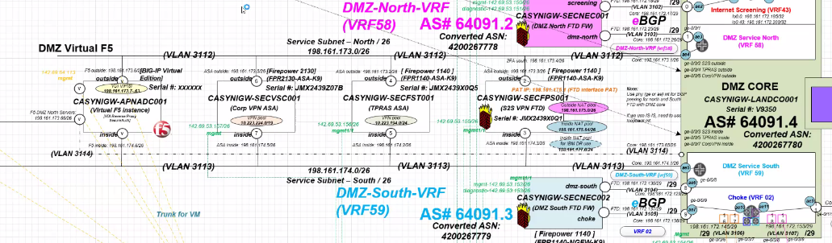

Thank you for your patience