How-to use Opennms ReST API

Contents

Access 3

Authentication 3

List of all Supported ReST API 4

Sample REST API Requests 5

Opennms has extensive ReSTful interface that allows user to access the information collected and stored in the application

# Access

To access the data, use the base link below:

S2M Lab:

<http://x1xgen002.inf-na.xomlab.com/opennms/rest/>

Development:

<http://hoeldonnet200.ups.xom.com/opennms/rest/>

Production UI clusters:

<https://onmsapi.ups.xom.com/opennms/>rest

# Authentication

To connect to production UI clusters OpenNMS API, obtain and use a **secondary** AD account. You must specify the account domain (e.g. [nvsabcdef@na.xom.com](mailto:nvsabcdef@na.xom.com)) as the username and the account must have a valid password. This secondary AD account would need to be added into group **NA\OPENNMSAPIRO.UG**.

For testing and development purpose, any **secondary** AD account. You must specify the account domain (e.g. [nvsabcdef@na.xom.com](mailto:nvsabcdef@na.xom.com)) as the username and the account must have a valid password and needs to be added to group **NA\GBL.NTW.OTH.LG**.

For S2M Lab OpenNMS, contact GSC-EMIT-NS-TAM-AP [GSC-EMIT-NS-TAM-AP@exxonmobil.com](mailto:GSC-EMIT-NS-TAM-AP@exxonmobil.com) to obtain the credential for ReST API connection.

# List of all Supported ReST API

The link below in Opennms documentation contains the latest supported ReST API call and examples:

<https://docs.opennms.com/horizon/28.0.0/development/rest/rest-api.html>

Note:

All end points that is related to administrative task and configurations below are not allowed by default:

/opennms/rest/groups

/opennms/rest/users

/opennms/rest/requisitions

/opennms/rest/foreignSources

/opennms/rest/sched-outages

/opennms/rest/snmpConfig

/opennms/rest/config/snmptrap-nbi

/opennms/rest/config/email-nbi

/opennms/rest/config/javamail

/opennms/rest/config/yslog-nbi

/opennms/api/v2/business-services

/opennms/api/v2/discovery

/opennms/rest/availability (currently disabled)

If you do need to use the above ReST APIs, contact GSC-EMIT-NS-TAM-AP [GSC-EMIT-NS-TAM-AP@exxonmobil.com](mailto:GSC-EMIT-NS-TAM-AP@exxonmobil.com)

# Sample REST API Requests

**Method**: GET

**Resources API**

Retrieve the tree of resources of a node

Example: Cisco node **USDID-SECVSC001** in requisition **DID**

[https://onmsapi.ups.xom.com/opennms/rest/resources/node%5B](https://onmsapi.ups.xom.com/opennms/rest/resources/node%5BDID:USDID-SECVSC001%5D)**[DID:USDID-SECVSC001](https://onmsapi.ups.xom.com/opennms/rest/resources/node%5BDID:USDID-SECVSC001%5D)**[%5D](https://onmsapi.ups.xom.com/opennms/rest/resources/node%5BDID:USDID-SECVSC001%5D)

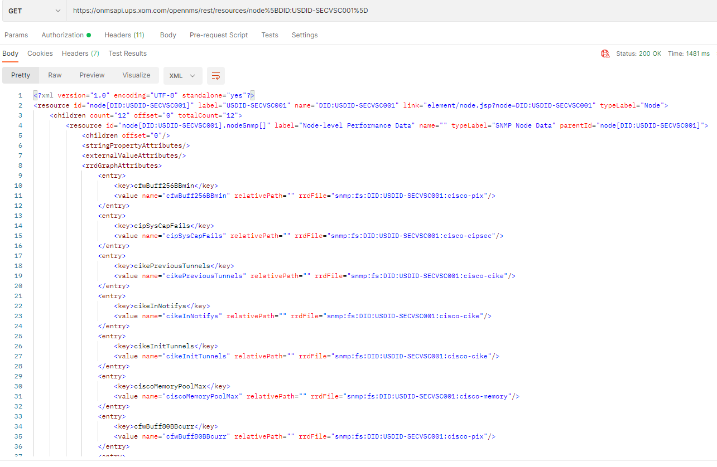

Retrieve a resource of a node

Example: Cisco node **USDID-SECVSC001** for resource SNMP Node Data (**nodeSnmp**)

[https://onmsapi.ups.xom.com/opennms/rest/resources/node%5BDID:USDID-SECVSC001%5D.](https://onmsapi.ups.xom.com/opennms/rest/resources/node%5BDID:USDID-SECVSC001%5D.nodeSnmp%5B%5D/)**[nodeSnmp](https://onmsapi.ups.xom.com/opennms/rest/resources/node%5BDID:USDID-SECVSC001%5D.nodeSnmp%5B%5D/)**[%5B%5D/](https://onmsapi.ups.xom.com/opennms/rest/resources/node%5BDID:USDID-SECVSC001%5D.nodeSnmp%5B%5D/)

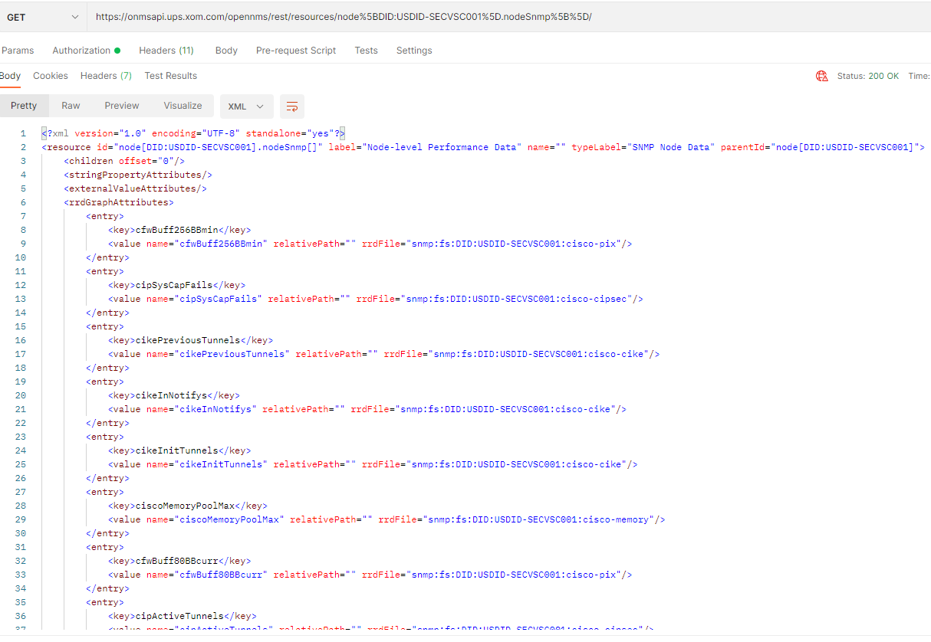

**Measurements API**

**NOTE:** Measurements API can be used to render the values of the attributes associated with a particular resource

Retrieve the measurements for a single attribute from a resource of a node

Example: Cisco node **USDID-SECVSC001** for attribute CPU utilization (**cpmCPUTotal5minRev**) in resource Node-level Performance Data (**nodeSnmp**)

[https://onmsapi.ups.xom.com/opennms/rest/measurements/node%5B](https://onmsapi.ups.xom.com/opennms/rest/measurements/node%5BDID:USDID-SECVSC001%5D.nodeSnmp%5B%5D/cpmCPUTotal5minRev)**[DID:USDID-SECVSC001](https://onmsapi.ups.xom.com/opennms/rest/measurements/node%5BDID:USDID-SECVSC001%5D.nodeSnmp%5B%5D/cpmCPUTotal5minRev)**[%5D.](https://onmsapi.ups.xom.com/opennms/rest/measurements/node%5BDID:USDID-SECVSC001%5D.nodeSnmp%5B%5D/cpmCPUTotal5minRev)**[nodeSnmp](https://onmsapi.ups.xom.com/opennms/rest/measurements/node%5BDID:USDID-SECVSC001%5D.nodeSnmp%5B%5D/cpmCPUTotal5minRev)**[%5B%5D/](https://onmsapi.ups.xom.com/opennms/rest/measurements/node%5BDID:USDID-SECVSC001%5D.nodeSnmp%5B%5D/cpmCPUTotal5minRev)**[cpmCPUTotal5minRev](https://onmsapi.ups.xom.com/opennms/rest/measurements/node%5BDID:USDID-SECVSC001%5D.nodeSnmp%5B%5D/cpmCPUTotal5minRev)**

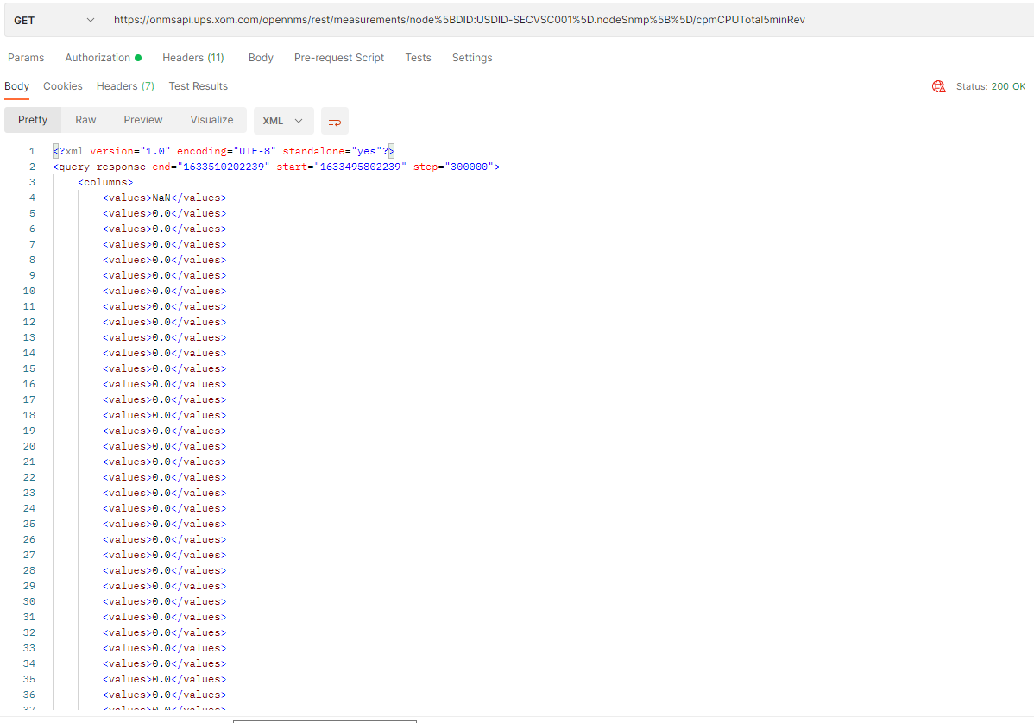

Example: Cisco node **USDID-SECVSC001** for attribute Memory used (**ciscoMemoryPoolUsed**) in resource Node-level Performance Data (**nodeSnmp**)

[https://onmsapi.ups.xom.com/opennms/rest/measurements/node%5BDID:](https://onmsapi.ups.xom.com/opennms/rest/measurements/node%5BDID:USDID-SECVSC001%5D.nodeSnmp%5B%5D/ciscoMemoryPoolUsed)**[USDID-SECVSC001](https://onmsapi.ups.xom.com/opennms/rest/measurements/node%5BDID:USDID-SECVSC001%5D.nodeSnmp%5B%5D/ciscoMemoryPoolUsed)**[%5D.](https://onmsapi.ups.xom.com/opennms/rest/measurements/node%5BDID:USDID-SECVSC001%5D.nodeSnmp%5B%5D/ciscoMemoryPoolUsed)**[nodeSnmp](https://onmsapi.ups.xom.com/opennms/rest/measurements/node%5BDID:USDID-SECVSC001%5D.nodeSnmp%5B%5D/ciscoMemoryPoolUsed)**[%5B%5D/](https://onmsapi.ups.xom.com/opennms/rest/measurements/node%5BDID:USDID-SECVSC001%5D.nodeSnmp%5B%5D/ciscoMemoryPoolUsed)**[ciscoMemoryPoolUsed](https://onmsapi.ups.xom.com/opennms/rest/measurements/node%5BDID:USDID-SECVSC001%5D.nodeSnmp%5B%5D/ciscoMemoryPoolUsed)**

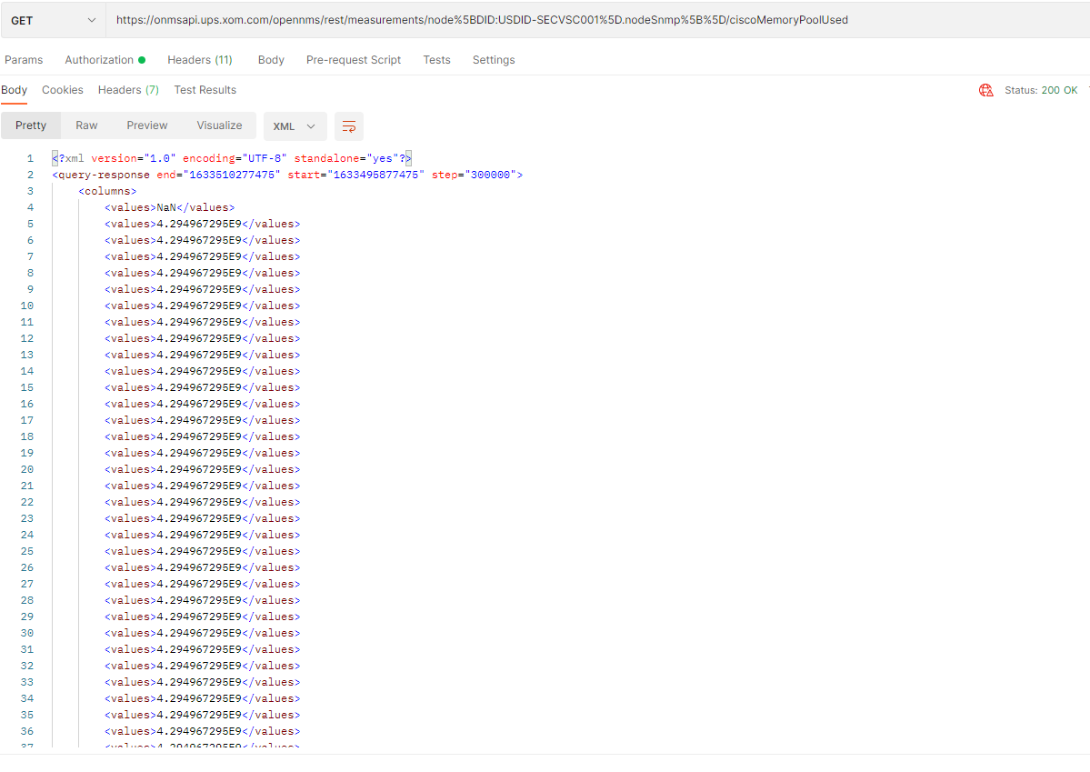

Example: Juniper node **USDALIGW-WANRTI00** for attribute CPU usage (**jnxOpCpu**) in resource **Routing Engine**

[https://onmsapi.ups.xom.com/opennms/rest/measurements/node%5BDAL:](https://onmsapi.ups.xom.com/opennms/rest/measurements/node%5BDAL:USDALIGW-WANRTI001%5D.jnxOperatingTable%5BRoutingEngine%5D/jnxOpCpu)**[USDALIGW-WANRTI001](https://onmsapi.ups.xom.com/opennms/rest/measurements/node%5BDAL:USDALIGW-WANRTI001%5D.jnxOperatingTable%5BRoutingEngine%5D/jnxOpCpu)**[%5D.jnxOperatingTable%5B](https://onmsapi.ups.xom.com/opennms/rest/measurements/node%5BDAL:USDALIGW-WANRTI001%5D.jnxOperatingTable%5BRoutingEngine%5D/jnxOpCpu)**[RoutingEngine](https://onmsapi.ups.xom.com/opennms/rest/measurements/node%5BDAL:USDALIGW-WANRTI001%5D.jnxOperatingTable%5BRoutingEngine%5D/jnxOpCpu)**[%5D/](https://onmsapi.ups.xom.com/opennms/rest/measurements/node%5BDAL:USDALIGW-WANRTI001%5D.jnxOperatingTable%5BRoutingEngine%5D/jnxOpCpu)**[jnxOpCpu](https://onmsapi.ups.xom.com/opennms/rest/measurements/node%5BDAL:USDALIGW-WANRTI001%5D.jnxOperatingTable%5BRoutingEngine%5D/jnxOpCpu)**

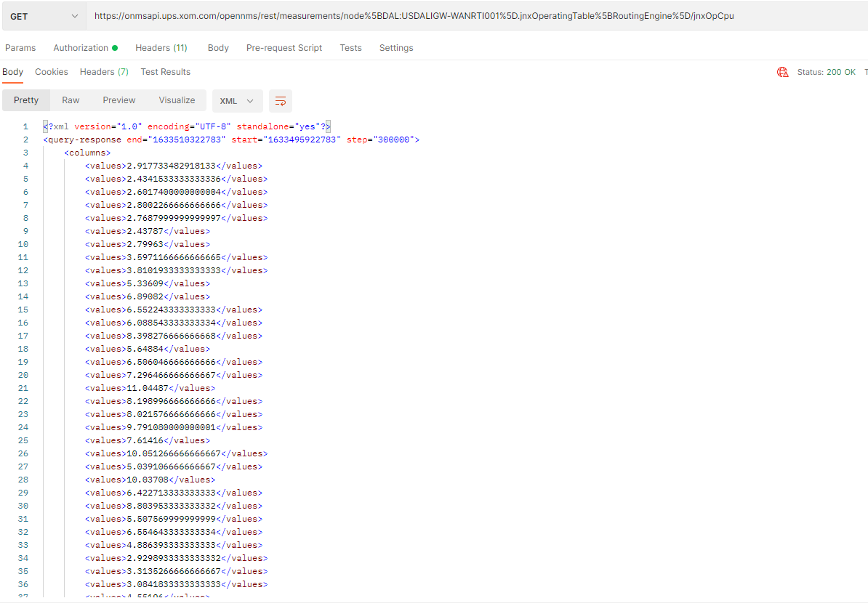

**Method**: POST

Measurement API

Example: Cisco node **GYGYD-WANRTV001** for attribute (**ifHCInOctets**) in Resource Node-level Performance Data

<https://onmsapi.ups.xom.com/opennms/rest/measurements>

Body:

{

    "start":1589076545616,

    "end":1589076545616,

    "step":60000,

    "source": [

        {

            "aggregation": "MAX",

            "attribute": "ifHCInOctets",

            "label": "miya",

            "resourceId":"node[GYD:GYGYD-WANRTV001].interfaceSnmp[Gi0_0_0-d4789bf35182]",

            "transient":"false"

        }

    ]

}

Header - Content Type: application/json

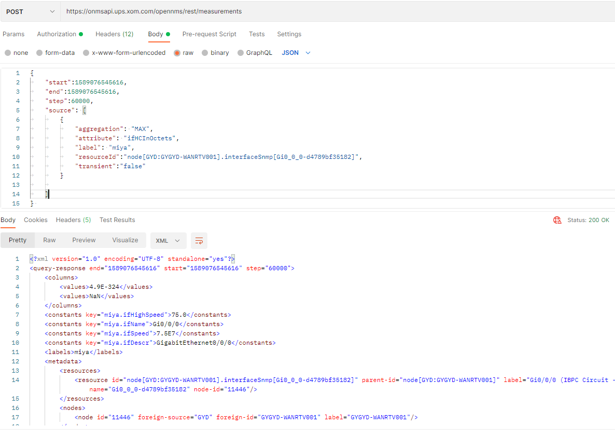

Note: Remove “/” (if any) at the end of the URL (e.g. <https://…/measurements/>) to avoid Error 403: Access is denied”

Example: Cisco node **USEMCCF1M-LANBMS003** for attribute (**ifHCInDiscards &** **ifHCOutDiscards**) in Resource Node-level Performance Data

<https://onmsapi.ups.xom.com/opennms/rest/measurements>

Body:

{

    "start": 1581677792883,

    "end": 1581681392883,

    "step": 600000,

    "maxrows": 500,

    "source": [

        {

            "aggregation": "MAX",

            "attribute": "ifInDiscards",

            "fallback-attribute": "ifHCInDiscards",

            "label": "USEMCCF1M-LANBMS003-Po1-ifHCInUcastPkts",

            "resourceId": "node[EMC:USEMCCF1M-LANBMS003].interfaceSnmp[Po1-60735c6417b1]",

            "transient": "false"

        },

        {

            "aggregation": "MAX",

            "attribute": "ifOutDiscards",

            "fallback-attribute": "ifHCOutDiscards",

            "label": "USEMCCF1M-LANBMS003-Po1-ifHCOutUcastPkts",

            "resourceId": "node[EMC:USEMCCF1M-LANBMS003].interfaceSnmp[Po1-60735c6417b1]",

            "transient": "false"

        }

    ]

}

Header - Content Type: application/json

