1. Source Code

view-form-matakuliah.php > application/views

view-data-matakuliah.php > application/views

Matakuliah.php > application/controllers

1. URL

<http://localhost/pustakabooking/index.php/Matakuliah>

http://localhost/pustakabooking/matakuliah/cetak

1. Capture Output Program

* view form matakuliah
* 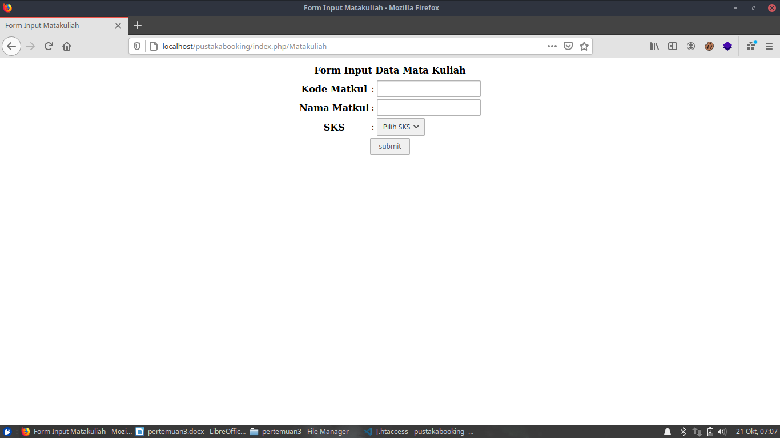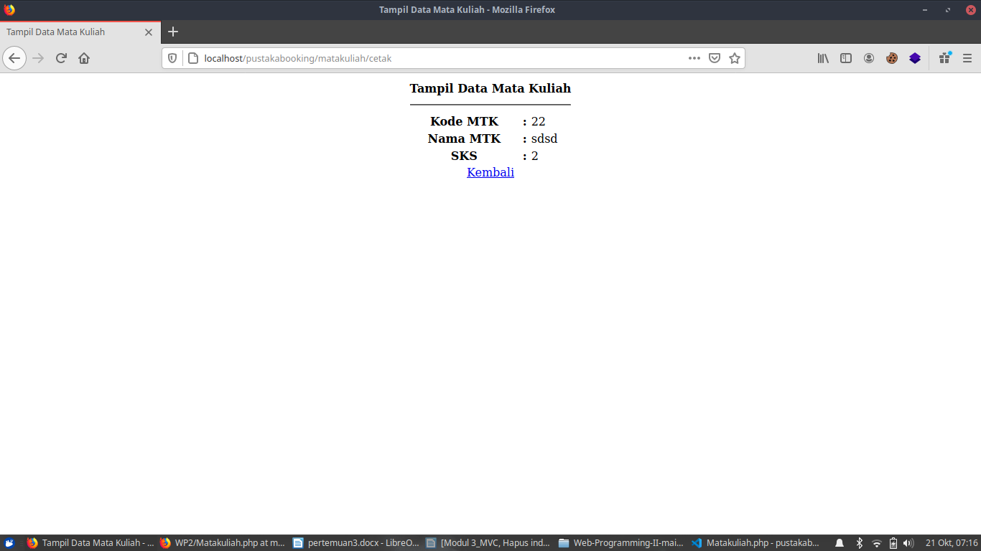view data matakuliah