No.Q/CCTV/${howmonth}/${numbering}

CCTV SINAR SEJAHTERA

JL. Penganten Ali III, No. 167

RT 07/06, Ciracas, Jakarta Timur

Jakarta 13740

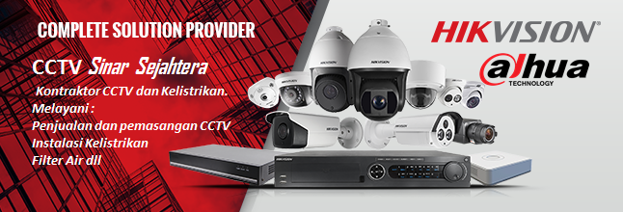Kepada : ${nama_pembeli}

Di :

Perihal :

|  |
| --- |
| **QUOTATION** |

|  |  |  |  |  |
| --- | --- | --- | --- | --- |
| Item | Type / Serial | Kebutuhan | Satuan | Total |
| ${itemId} | ${model_produk} | ${qty} | ${harga _satuan} | ${harga} |
|  |  |  | Grand Total | ${harga_total} |

Hormat Kami

Ordionova Isa

|  |  |  |
| --- | --- | --- |
| No | Detail Produk | |
| ${productId} | ${model_produk} | ${foto_produk} |
| ${manufacture) |
| ${deskripsi_produk} |