**approve a credit card classification MVP**

**project goals:**

Based on clients order records, who would be good to approve a credit card request? in this project i believe can be answer and help banks ​chooses between many clients requests

**The data:**

This dataset can be found at Kaggle.

Following main steps were used:

1. Importing libraries.

# Extracting data using two data sources

# application_record

# credit_record.

Combine between dataset with (merge)

1. Fill missing values with mode

* Null values (check all the dataset ) I find 3 columns and fixed

(OCCUPATION_TYPE, MONTHS_BALANCE, STATUS)

* Duplicates (remove Rowes duplicates (ID))
* Change status feature( if any values not numeric)
* Remove Columns if not needed in my goals .

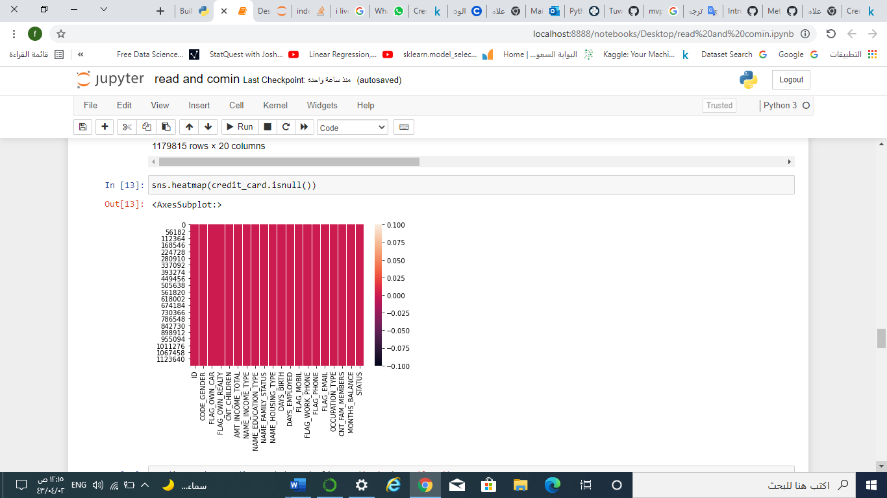

1. Find correlation between features

I find relation between

* Status
* ID

**Future work**

* Complete the linear-regression model
* Get the result