Blockchain Course - Semester Project Report
Re-implementing "Fake Media Detection Based on NLP and Blockchain Approaches" on MultiChain
Student: Faris Bin Asif Roll No.: 25k-7619 Date: 4 October 2026
Paper: Z. Shahbazi and Y.-C. Byun, IEEE Access, vol. 9, pp. 128442-128453, 2021, DOI 10.1109/ACCESS.2021.3112607

1. Paper summary
Problem. Social media is a major channel for news, but fake news and fake accounts spread easily and readers have no trustworthy signal about who published an item or whether it is genuine. Existing ML/NLP detectors classify text but do not establish trust in the publisher or provide an auditable record of the decision.
Proposed solution. The authors combine (i) NLP text analysis, (ii) a reinforcement-learning (RL) model that improves with feedback, and (iii) a permissioned blockchain (Hyperledger Fabric with Composer) so that only registered, authenticated participants can publish. Participants (user, publisher, validator, news organisation) carry a credibility score; validators check published news and the result is recorded on the ledger with a Proof-of-Authority (PoA) style consensus. The goal is to prevent, rather than only detect, the spread of fake news and to keep a backlog of fake items for future detection.
Original architecture. An off-chain data lake feeds a data-analysis module (time-series, gender, news-type) and an NLP + RL analysis module (MDP with state, action, reward; features fake score, real score, sim-matched). Predictions go to a Fabric network of peers with smart contracts and a ledger, accessed through a Composer REST server (Table 7 of the paper). Data: 900,000 news records (2015-2019) from Twitter, Facebook and news sites, 70/30 train-test split.
Reported results. Transaction latency about 1300 ms for 250 users and 1497 ms for 500 users; RL model RMSE 318.0, MAE 173.5, R2 0.968 compared with XGBoost, Random Forest, RNN and LSTM (Table 9).
Conclusion / future direction. The paper closes by stating that the shared-information platform contains fake news and that it is a beneficial challenge "to enhance and investigate the Proof-of-Authority protocol and user validation."

2. Original architecture and platform
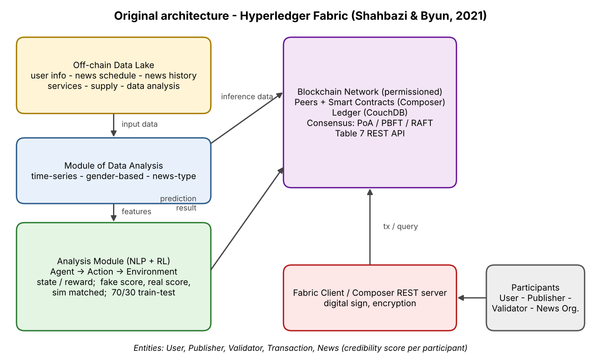
Figure 1 - Original architecture redrawn from Fig. 1 of the paper (Hyperledger Fabric + Composer).

Platform and components
- Blockchain: Hyperledger Fabric run in Docker on Ubuntu 18.04, business network designed in Composer Playground, ledger in CouchDB, client access through composer-rest-server (POST / GET / PUT / DELETE on resources such as /api/userProfile, /api/news/supply).
- Access and consensus: permissioned network - participants register and obtain enrolment certificates through an identity manager; the news validation consensus is PoA driven by each validator's credibility score. The performance section also benchmarks PBFT, RAFT and Solo ordering.
- Entities: User (credibility score), Publisher (a user who posts; has a hash/foreign key and location), Validator (user with enough credibility who votes real/fake), Transaction (acceptance/rejection record with user, validator and publisher IDs), News (news ID + publisher ID hash).
- Smart contract: smart contract = Composer model (participants, assets, transactions, access-control rules); it holds the business rules and ledger queries.
- Off-chain intelligence: NLP pipeline (cleaning, tokenisation, stop-words, embedding) -> features fake score, real score, fake/real domain, sim matched -> RL agent (MDP) trained to extract fake news and fake accounts.
Data flow: publisher posts news -> network checks identity/credibility -> validators vote -> transaction with verdict is written to the ledger -> verdict and analysis feed the RL model, which improves future predictions.

3. Proposed MultiChain architecture
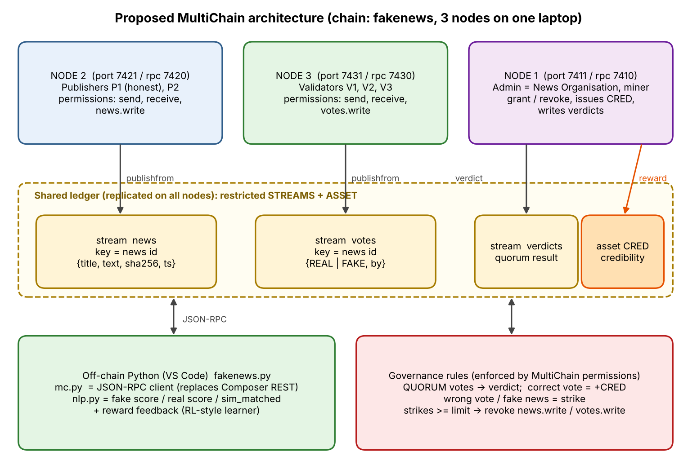
Figure 2 - Proposed MultiChain design: one chain (fakenews), three nodes, three streams and one asset.

How it works
- Admin (node 1) creates the chain with anyone-can-connect/send/receive/create/issue/mine = false (permissioned) and is the only initial miner/admin.
- Node 2 (publishers) and node 3 (validators) join only after the admin runs grant ... connect (replaces Fabric enrolment).
- Admin creates restricted streams news, votes, verdicts and issues the credibility asset CRED; each participant receives an initial balance.
- A publisher posts a news item to stream news (key = news id, value = title, text, SHA-256 hash, timestamp). Only addresses holding news.write can do so.
- Validators with votes.write publish REAL or FAKE into stream votes. The NLP module gives each validator a hint (fake/real score, similarity to previously confirmed fake items).
- When QUORUM (2) votes exist, the admin writes the majority result to stream verdicts. Correct voters (and the publisher of verified-real news) receive CRED; wrong voters and publishers of fake news get a strike (derived from the verdicts stream, so it is auditable).
- Strikes >= STRIKE_LIMIT (2): admin runs revoke <address> news.write (or votes.write). The chain then rejects further posts or votes from that address.
- The verdict is the reward signal for the RL-style NLP learner (reward +1 if its prediction matched, -1 otherwise and the word weights are updated); confirmed fake texts form the backlog used for the sim-matched feature.

4. Mapping: original component vs. MultiChain equivalent
Original (paper) | MultiChain equivalent | Justification
Permissioned Fabric network, enrolment certificates, identity manager | Chain with anyone-can-connect=false; grant <addr> connect,send,receive by the admin | MultiChain permissions are the native membership control; only granted addresses can connect or transact.
User / Publisher / Validator / News Organisation roles | Addresses with different permissions: publishers (send, receive, news.write), validators (votes.write), admin (admin, mine, issue, create) | Roles are expressed as permission sets, so the chain itself enforces who may do what.
Peers / multiple organisations | Three nodes (node1 admin, node2 publishers, node3 validators) with separate datadirs and ports | Reproduces a multi-party network on one laptop.
Proof-of-Authority consensus by credible validators | Permissioned mining (mine permission) with round-robin and mining-diversity; optional second miner node; validator authority via votes.write | Block production is limited to authorised miners; news validation authority is limited to addresses holding votes.write.
News ledger / transactions (ID, hash, timestamp) | Stream news, key = news id, JSON {title, text, sha256, ts} | Streams are append-only, timestamped and key-indexed, ideal for news records and later audit.
Validator votes and transaction records | Stream votes (key = news id) and stream verdicts | Separate streams keep raw votes and the final result auditable.
Credibility score | Asset CRED balance + strikes derived from verdicts | Assets are native, transferable, and queryable per address; rewards are real transactions.
Penalty for fake publishers / bad validators | revoke <addr> news.write / votes.write | Revocation is enforced by all nodes - stronger than an off-chain flag.
Composer smart contract (business rules) | Stream permissions + admin policy script (fakenews.py); optional stream filters (JS) | MultiChain has no Solidity/chaincode style contracts; rules are split between native permissions and a trusted policy engine.
Composer REST server (Table 7) | MultiChain JSON-RPC API through mc.py | Every MultiChain command (create, grant, publishfrom, liststreamitems ...) is already an RPC.
CouchDB ledger / Docker / Ubuntu | MultiChain node database on Windows, no Docker | Simpler to deploy; no containers needed.
NLP + RL analysis (fake score, real score, sim matched) | nlp.py (off-chain): lexicon scores, Jaccard similarity to confirmed-fake backlog, reward-based weight update | Learning stays off-chain (as in the paper); only inputs/outputs (votes, verdicts) are on-chain.
Data lake (user info, history, schedule) | On-chain streams plus local JSON files (roles.json, nlp_weights.json) | Scaled-down version of the lake.

5. Future direction addressed
Statement in the paper's conclusion: "... enhance and investigate the Proof-of-Authority protocol and user validation." The paper does not detail further limitations. From the text we also infer: (a) validator authority and credibility are static in the described design, (b) penalties for bad actors are described but not enforced by a mechanism, and (c) the evaluated consensus (PBFT/RAFT/Solo) differs from the PoA that is claimed.
What this project resolves: Dynamic, enforceable user validation and a more accountable PoA-style authority model.
- User validation: nobody can join, send or receive without an admin grant; publishing and voting need per-stream write permission.
- Quorum PoA: a news item is accepted only after a quorum of independent validators (not a single authority) has voted.
- Dynamic authority: validators earn CRED for correct votes; wrong votes or fake publications create strikes; at the limit the admin revokes the permission, so authority is earned and can be removed. Optionally a second node is granted mine so block creation rotates between authorised miners.
How MultiChain helps: grant/revoke give instant, network-enforced identity control; restricted streams give per-topic write access; assets give a native credibility currency; all state is auditable from the streams. No chaincode deployment is required.

6. Implementation (step-by-step)
Environment: Windows, MultiChain 2.3.3 Community (D:\UniWork\multichain-windows-2.3.3), Python 3.14.7, VS Code. The Python code uses only the standard library. Node folders live in D:\UniWork\mc.

6.1 Environment check
multichaind -version
python --version

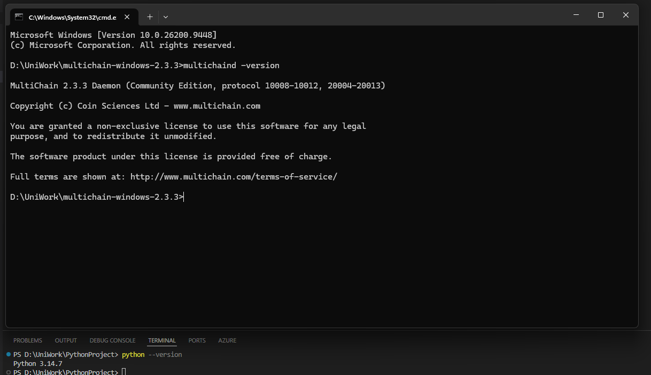

6.2 Create the chain and edit params.dat
mkdir D:\UniWork\mc
multichain-util create fakenews -datadir=D:\UniWork\mc\node1

params.dat parameter | Value | Reason
chain-description | Fake news trust chain (MultiChain) | Documentation
anyone-can-connect / send / receive | false | Only admin-approved addresses (permissioned, like Fabric enrolment)
anyone-can-create / issue / mine / activate | false | Only admin creates streams and assets and mines blocks (PoA-like)
target-block-time | 5 | Faster demo (default 15 s)
default-network-port / default-rpc-port | 7411 / 7410 | Fixed ports so the three nodes do not clash

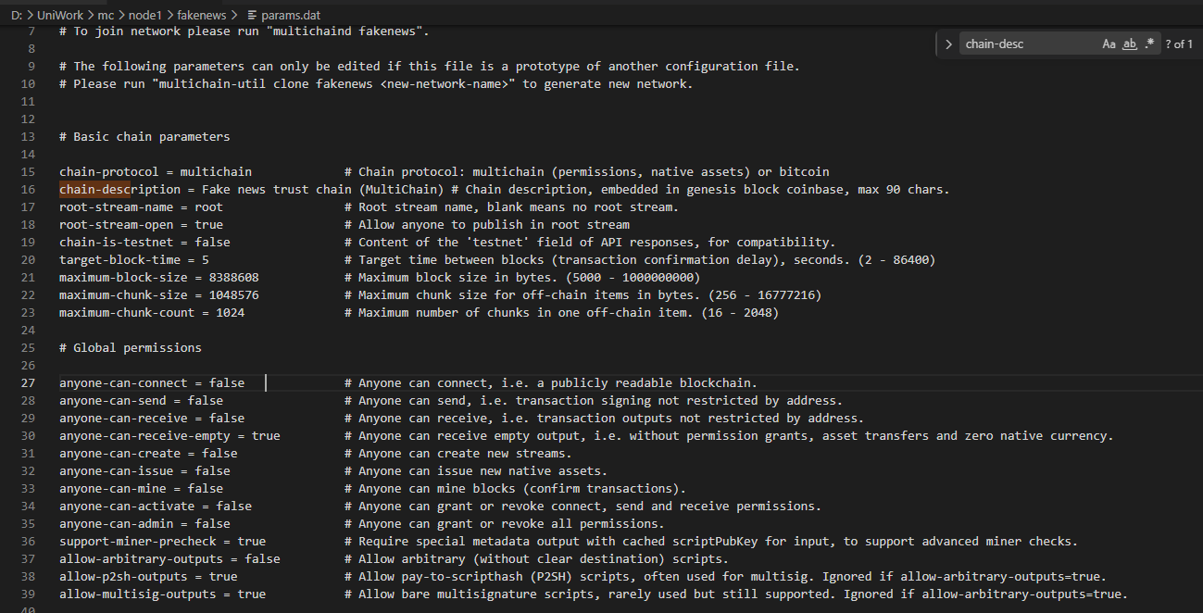

6.3 Start node 1 and add node 2 and node 3
REM Terminal 1
multichaind fakenews -datadir=D:\UniWork\mc\node1

REM Terminal 2 - first run prints the address to approve
multichaind fakenews@127.0.0.1:7411 -datadir=D:\UniWork\mc\node2 -port=7421 -rpcport=7420
REM Terminal 4 - admin grants it
multichain-cli fakenews -datadir=D:\UniWork\mc\node1 grant <ADDR2> connect,send,receive
REM Terminal 2 - run the node2 command again

REM Terminal 3 - same with node3 (ports 7431 / 7430), grant <ADDR3>
Node 1:
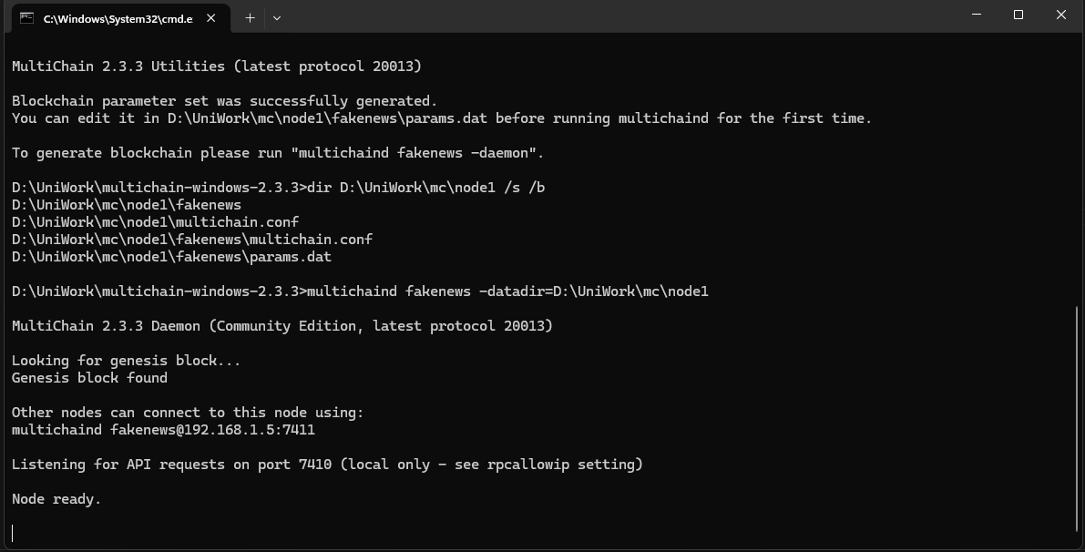
Node 2:
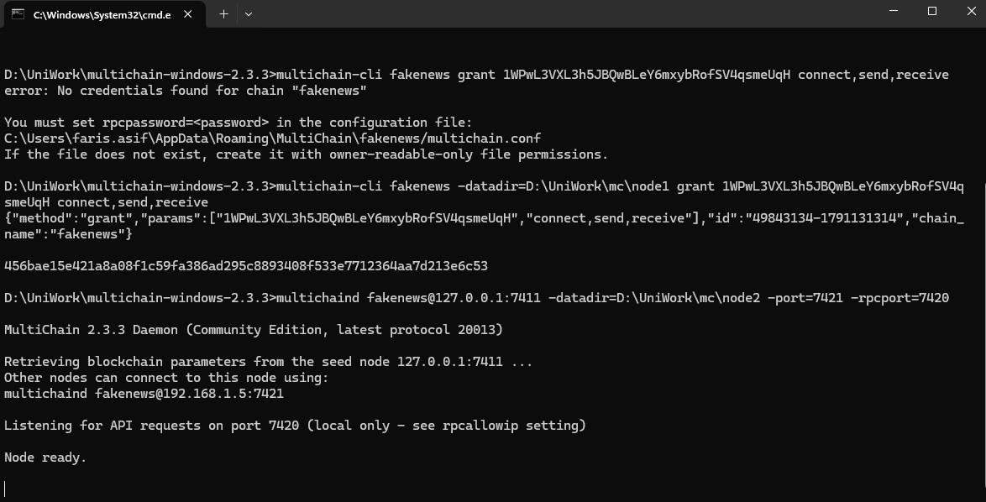
Node 3:
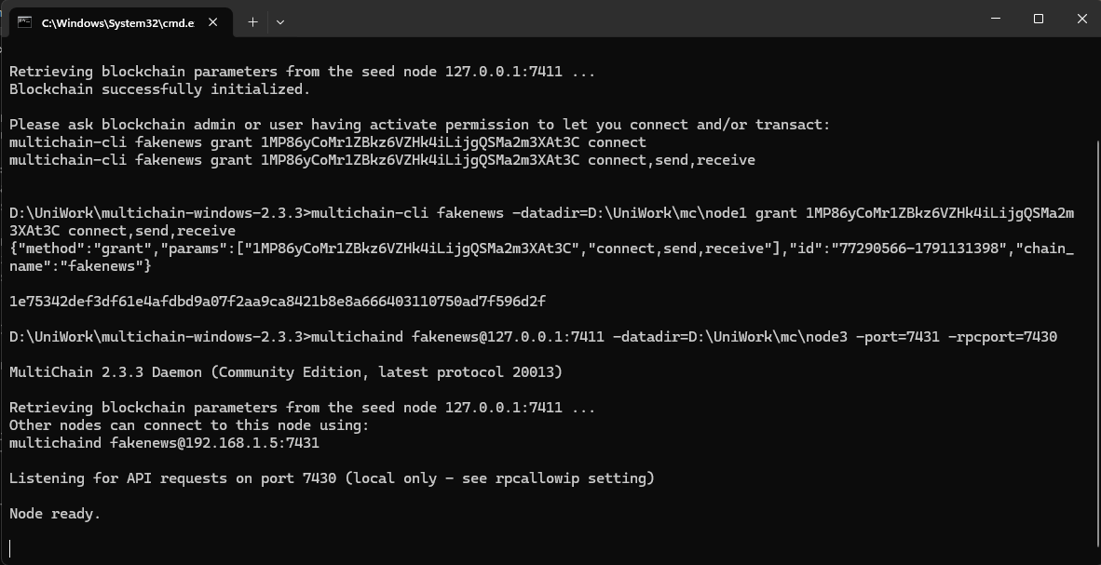
Verification: getinfo reports connections = 4. These are the two peer nodes (node2 and node3), each connected in both directions - once through the LAN address 192.168.1.5 and once through 127.0.0.1 - as the four entries in getpeerinfo show.
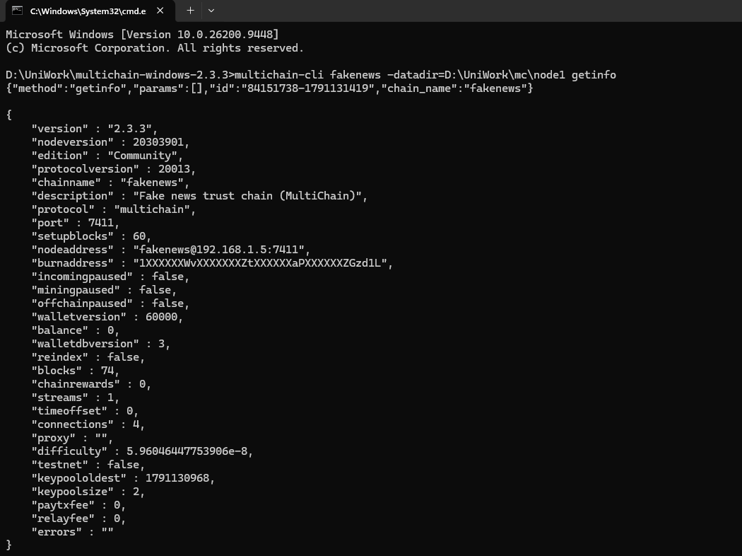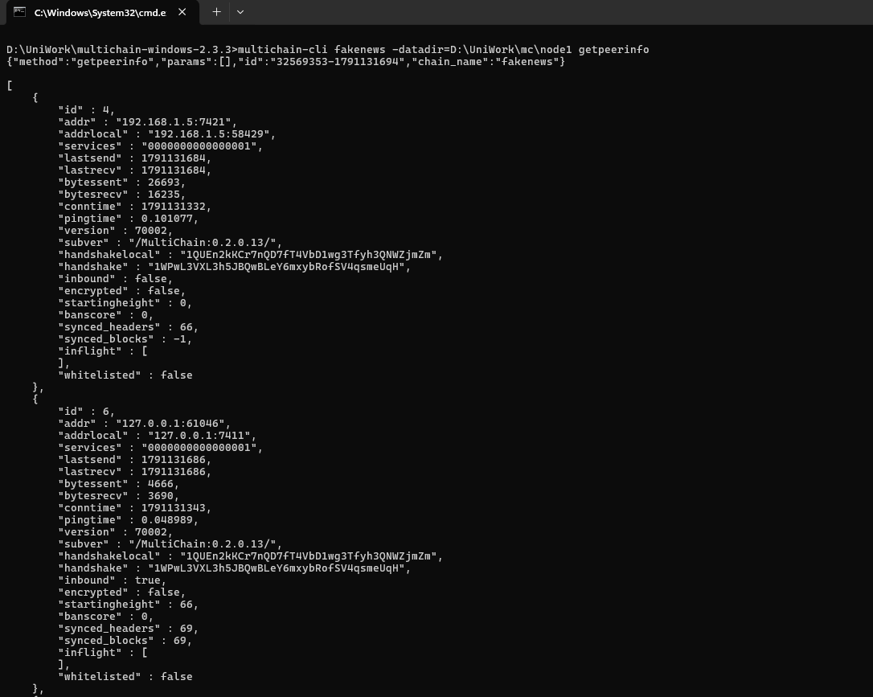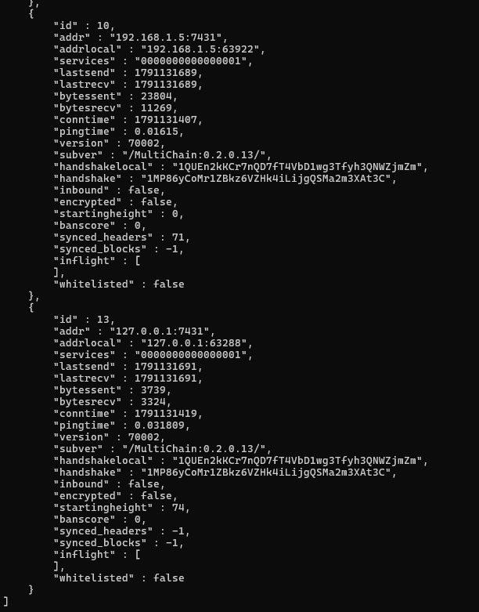

6.4 Bootstrap: roles, streams, asset
python fakenews.py bootstrap

This creates addresses for P1, P2 (node 2) and V1-V3 (node 3), grants send/receive, creates streams news/votes/verdicts (restricted), issues the CRED asset, grants news.write to publishers and votes.write to validators, and sends the initial CRED balance.
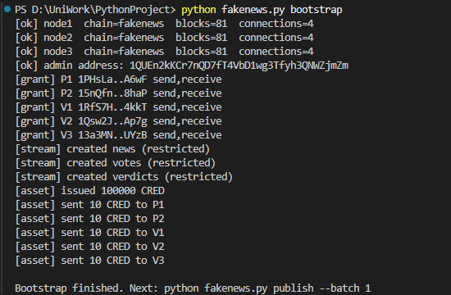

multichain-cli fakenews -datadir=D:\UniWork\mc\node1 liststreams
multichain-cli fakenews -datadir=D:\UniWork\mc\node1 listassets
multichain-cli fakenews -datadir=D:\UniWork\mc\node1 listpermissions news.write

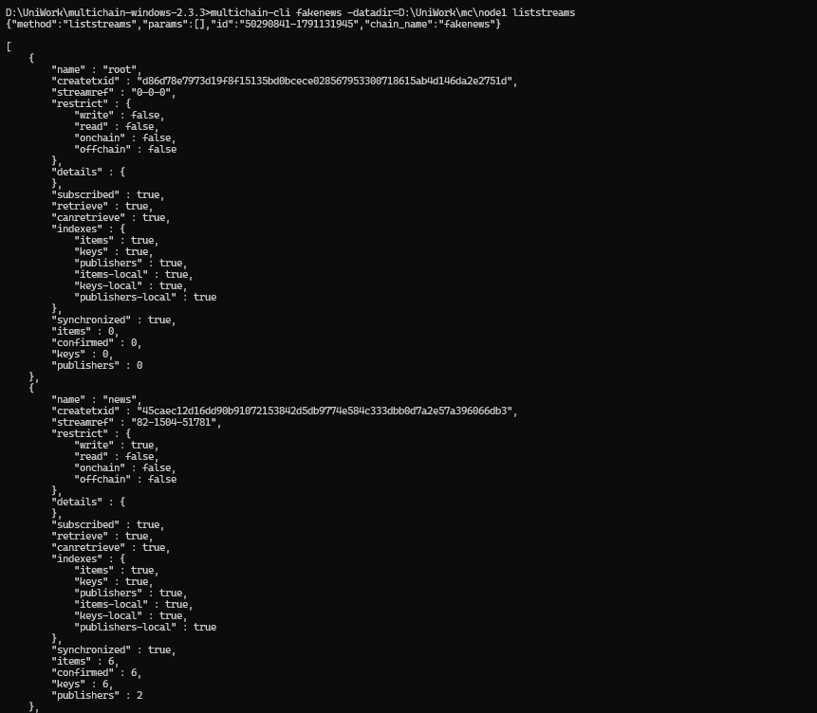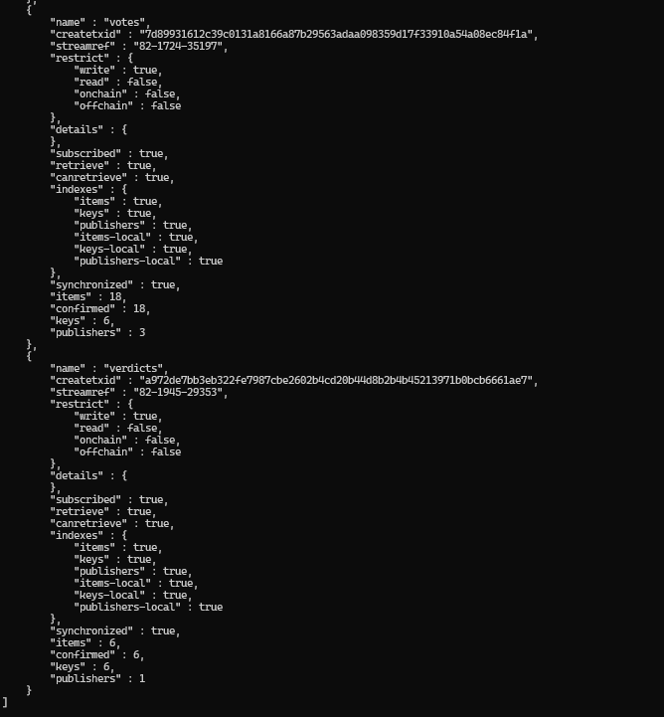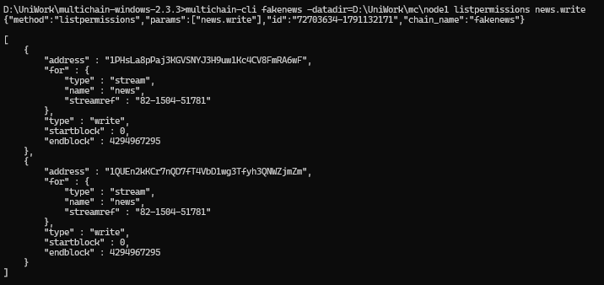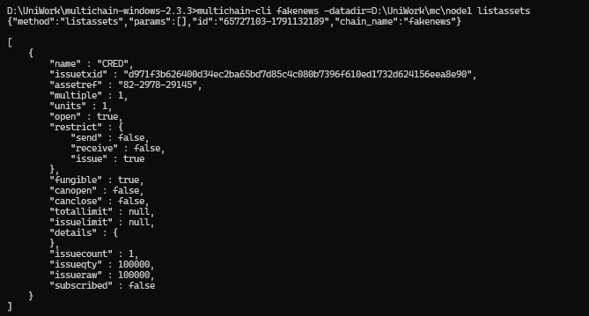

6.5 Publish, vote, finalize (batch 1)
python fakenews.py publish --batch 1
python fakenews.py vote
python fakenews.py finalize
python fakenews.py status

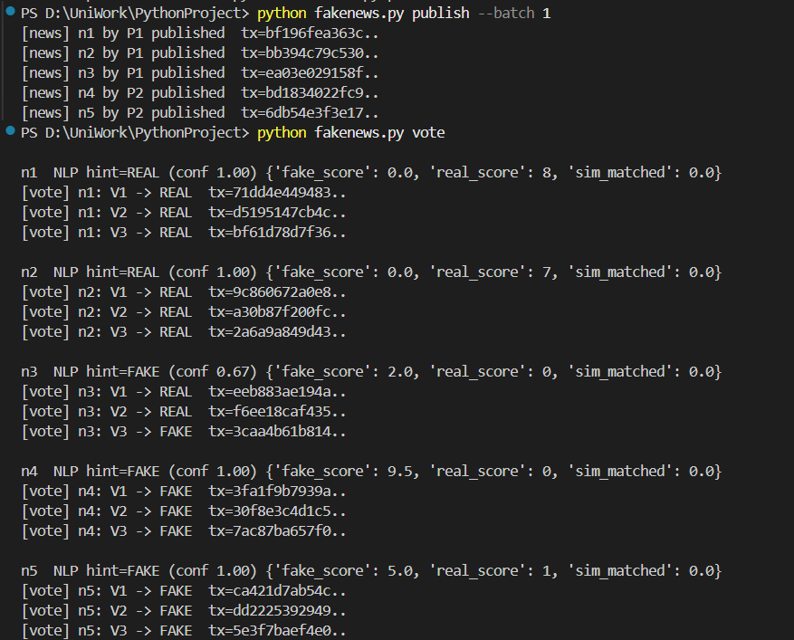
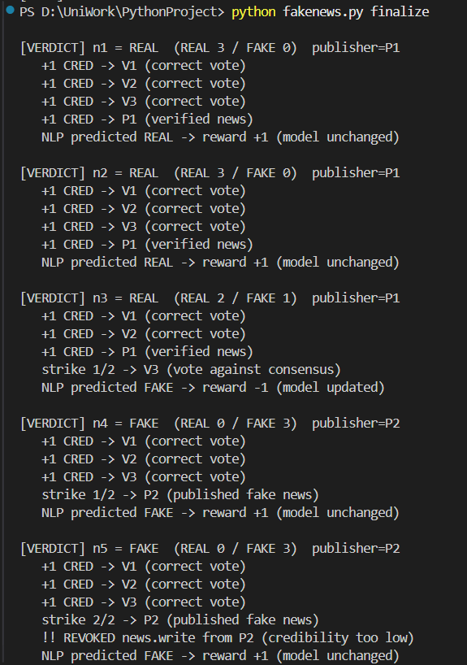
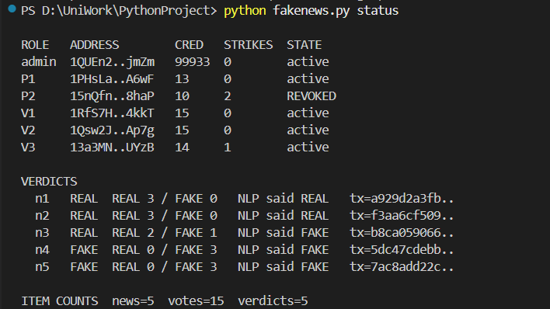

multichain-cli fakenews -datadir=D:\UniWork\mc\node1 liststreamitems verdicts

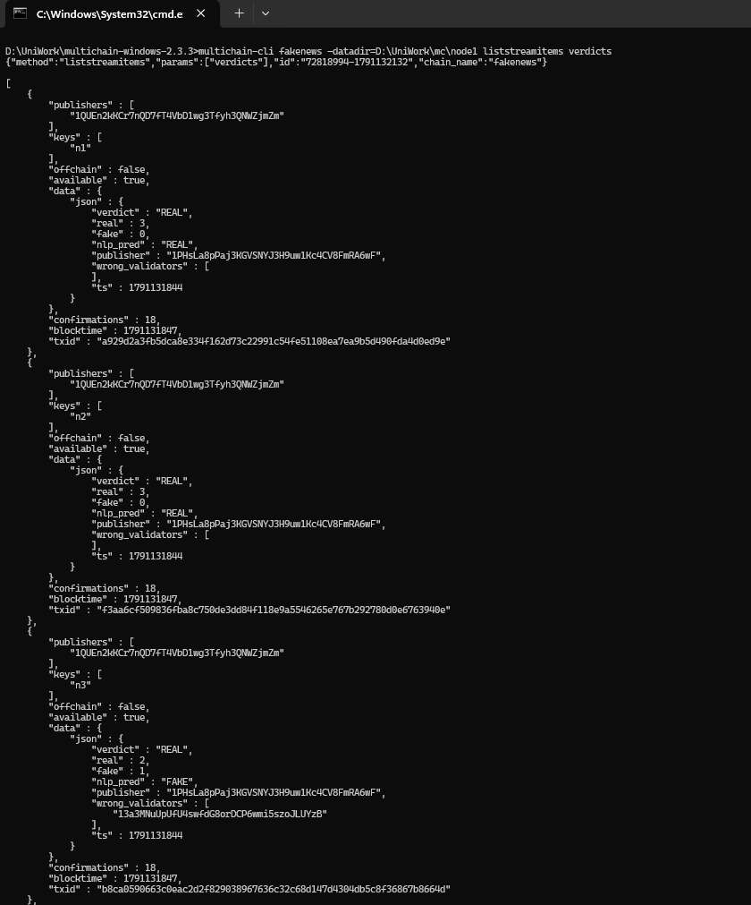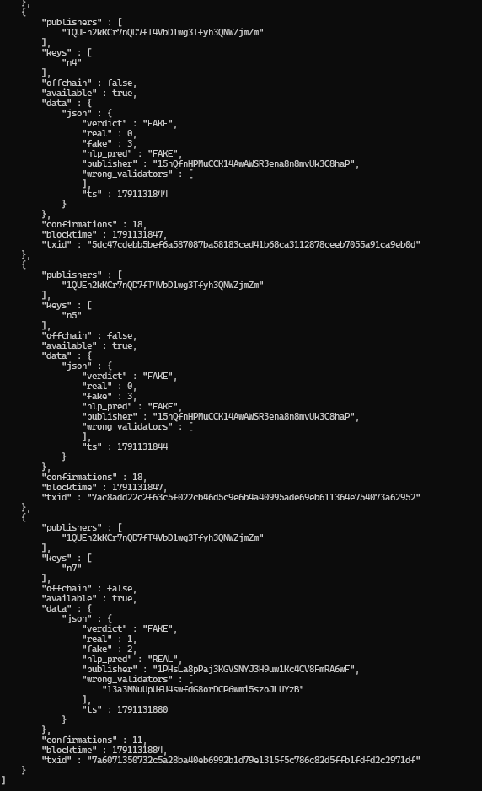

6.6 Enforcement after revocation (batch 2)
python fakenews.py publish --batch 2
python fakenews.py vote
python fakenews.py finalize
python fakenews.py status
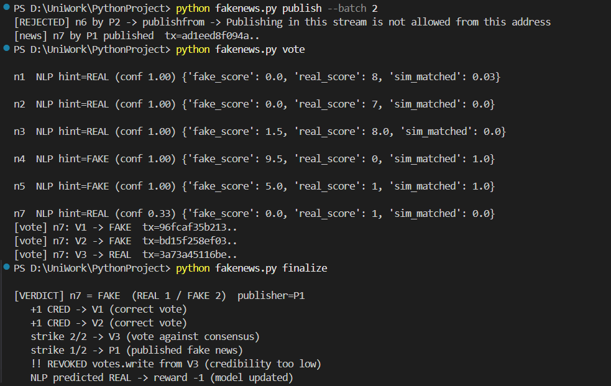
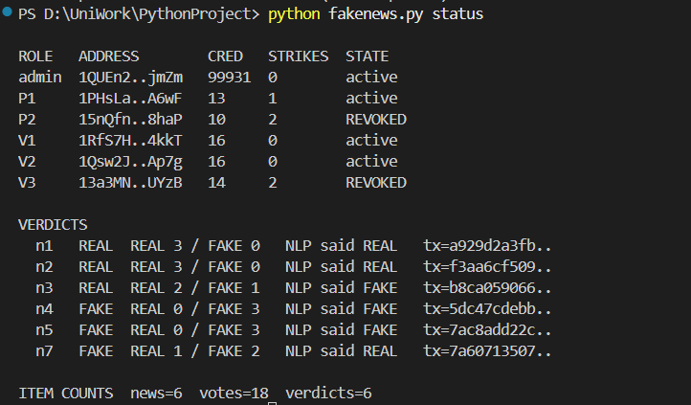

6.7 Code structure
File | Purpose
config.py | Paths, ports, stream/asset names, QUORUM, STRIKE_LIMIT, REWARD
mc.py | Minimal MultiChain JSON-RPC client (replaces Composer REST server)
nlp.py | Fake score, real score, sim-matched features; reward-based learner
dataset.py | Fictional demo news with ground truth (used only to simulate expert validators)
fakenews.py | Commands: bootstrap, publish, vote, finalize, status

7. Results and discussion
Observed results of the demo run on the real MultiChain network (screenshots in Section 6.5 and 6.6):
News | Publisher | Truth | Votes (V1,V2,V3) | Verdict | Consequence
n1, n2 | P1 | REAL | REAL x3 | REAL | Voters +1 CRED, P1 +1 CRED
n3 (sensational wording, true) | P1 | REAL | REAL, REAL, FAKE | REAL | V3 (NLP-only) strike 1
n4, n5 | P2 | FAKE | FAKE x3 | FAKE | P2 strike 1 then 2 -> news.write revoked
n6 | P2 | FAKE | - | - | Rejected by chain (no permission)
n7 (fake in sober wording) | P1 | FAKE | FAKE, FAKE, REAL | FAKE | V3 strike 2 -> votes.write revoked; P1 strike 1
Final on-chain state after both batches (output of python fakenews.py status):
Role | Address (short) | CRED | Strikes | State
admin | 1QUEn2..jmZm | 99931 | 0 | active
P1 (publisher) | 1PHsLa..A6wF | 13 | 1 | active
P2 (publisher) | 15nQfn..8haP | 10 | 2 | REVOKED (news.write)
V1 (validator) | 1RfS7H..4kkT | 16 | 0 | active
V2 (validator) | 1Qsw2J..Ap7g | 16 | 0 | active
V3 (validator, NLP-only) | 13a3MN..UYzB | 14 | 2 | REVOKED (votes.write)
Totals on the ledger: 6 news items, 18 votes, 6 verdicts. P2's post of n6 was rejected by the chain with "Publishing in this stream is not allowed from this address", which shows that revocation is enforced by the network.

What worked
- Permissioned membership, per-stream write control and revocation are enforced by the network itself.
- News, votes and verdicts are timestamped, append-only and independently readable from every subscribed node (auditability).
- Credibility is a real on-chain asset; strikes are recomputed from the verdicts stream, so the admin's decisions can be verified.
- The NLP learner improves from verdict feedback (e.g. after n3 the word weights shift towards REAL for similar official-sounding text).
- Complete setup needs no Docker, no Composer and no pip packages.

Limitations that remain
- Policy engine is centralised: the admin script applies quorum, rewards and revocation. The chain enforces permissions but not the voting logic itself; the admin is trusted. MultiChain 2.x stream filters (JavaScript) or multiple admins (admin-consensus parameters) could move more logic on-chain.
- Publisher privacy: MultiChain items expose the publisher address, so the paper's idea of hiding the publisher from validators is only achieved by a pseudonymous address.
- Toy ML and simulated users: validators V1/V2 are simulated with ground truth and the NLP is a small lexicon + similarity model on seven fictional items; no accuracy or large-scale evaluation (the paper's 900,000-record dataset and Table 9 metrics are not reproduced).
- Scale and consensus: all nodes run on one laptop, so there is no real network latency or throughput measurement (the paper's PBFT/RAFT latency study is not replicated). MultiChain Community edition has no PBFT; consensus is round-robin mining among permitted miners.
- Sybil resistance: a bad actor can create a new address; the admin must verify identity before granting connect/send (out of scope here).
- Paper inconsistency: the paper claims PoA but its performance section reports PBFT, RAFT and Solo ordering; our comparison is therefore conceptual.

8. References
[1] Z. Shahbazi and Y.-C. Byun, "Fake Media Detection Based on Natural Language Processing and Blockchain Approaches," IEEE Access, vol. 9, pp. 128442-128453, 2021, doi: 10.1109/ACCESS.2021.3112607.
[2] G. Greenspan, "MultiChain Private Blockchain - White Paper," Coin Sciences Ltd, 2015. https://www.multichain.com/download/MultiChain-White-Paper.pdf
[3] Coin Sciences Ltd, "MultiChain Developer Documentation: API, command-line, parameters, permissions, streams, assets." https://www.multichain.com/developers/
[4] M. Castro and B. Liskov, "Practical Byzantine Fault Tolerance and Proactive Recovery," ACM Trans. Comput. Syst., vol. 20, no. 4, pp. 398-461, 2002.
[5] Y. Wang et al., "Weak Supervision for Fake News Detection via Reinforcement Learning," Proc. AAAI, vol. 34, pp. 516-523, 2020.
[6] Course lecture notes and chapters, Blockchain (project files: Lecture 1, Chapters 3 and 4).

