AMAZON WEB SERVICES
JIT Access Manager
A Just-in-Time Privileged Access Platform on AWS
Cloud Computing Capstone Project — Proposal Submission
Prepared by: Faris K
Cloud Platform: Amazon Web Services (AWS)
Submission Date: October 3, 2026

AWS Cloud Project Proposal
Capstone Project — Amazon Web Services

1. Project Title
JIT Access Manager: A Just-in-Time Privileged Access Platform on AWS

2. Project Objective
This project aims to build a self-service system that replaces standing privileged access with time-boxed, on-demand access. In most organizations, employees accumulate elevated permissions over time — admin access granted for one project that is never revoked once the project ends — and that standing access sits unused as a growing attack surface. This project addresses that problem directly: an employee requests a specific elevated permission for a specific, short duration; a manager approves it; the system grants exactly that access; and the access is automatically and verifiably revoked the moment it expires, with no manual cleanup step for anyone to forget.
The problem it addresses is that access reviews are usually periodic and manual — a quarterly audit that catches forgotten permissions months after the risk was introduced. The expected outcome is a working platform where every grant of elevated access has an expiry attached before it is ever issued, where every request, approval, grant, and revocation is fully logged, and where a failed revocation triggers an alarm rather than going unnoticed.

3. Project Description
The application is a small internal access-request service, with both an API and a lightweight browser dashboard for employees and managers. An employee signs in and submits a request describing the permission needed and how long it is needed for. A designated approver receives a notification and approves or denies the request from an authenticated dashboard or endpoint. On approval, the system attaches a scoped IAM policy to the requester's role and, in the same action, schedules its own automatic revocation for the requested expiry time — the revocation is never a separate manual step that could be forgotten. When the scheduled time arrives, the system removes the granted policy without any human involvement and records the outcome. Every stage of this lifecycle — request, approval, grant, revocation, and any failure along the way — is written to a durable audit log.

4. AWS Services
The following AWS services are planned for this project (11 total, listed below with their purpose):
1. Amazon Cognito — Authenticates both the employee requesting access and the manager approving it.
2. Amazon API Gateway — Exposes the request and approval endpoints, validating requests before anything reaches Lambda.
3. AWS Lambda — Runs four functions — request_access, approve_access, revoke_access, and list_requests — each triggered only when needed, with no persistently running server.
4. AWS IAM — The core of the system: policies are attached to grant temporary access and removed to revoke it, with a separate least-privilege role for each Lambda function.
5. Amazon EventBridge Scheduler — Schedules a one-time, precise revocation event for each grant at the moment it is approved, so expiry is guaranteed rather than dependent on a recurring poll.
6. Amazon DynamoDB — Stores every request, its approval status, its grant and revocation timestamps, and forms the primary audit trail.
7. AWS KMS — Encrypts the request and audit data at rest.
8. Amazon SNS — Notifies the approver of a new request and alerts on any revocation that fails to complete.
9. Amazon CloudWatch — Collects logs and metrics from all four Lambda functions and alarms on errors, particularly any failure in the revocation path.
10. AWS CloudTrail — Logs every IAM policy attachment and detachment made by the system, providing an audit trail independent of the application's own DynamoDB log.
11. AWS Budgets — Tracks spending against a defined monthly threshold, relevant since this project runs primarily on AWS Free Tier.

5. Proposed Architecture
The diagram below shows the full request lifecycle. An employee and a manager both authenticate through Cognito. The employee's request reaches request_access through API Gateway and is logged to DynamoDB; the approver is notified through SNS. On approval, approve_access attaches a time-boxed IAM policy and, in the same action, schedules a one-time EventBridge event for the requested expiry. When that event fires, revoke_access removes the policy and updates the DynamoDB record. Everything feeds into a monitoring layer: CloudWatch alarms on any Lambda error (especially a failed revocation), CloudTrail independently records every IAM change, and Budgets watches overall account spend.
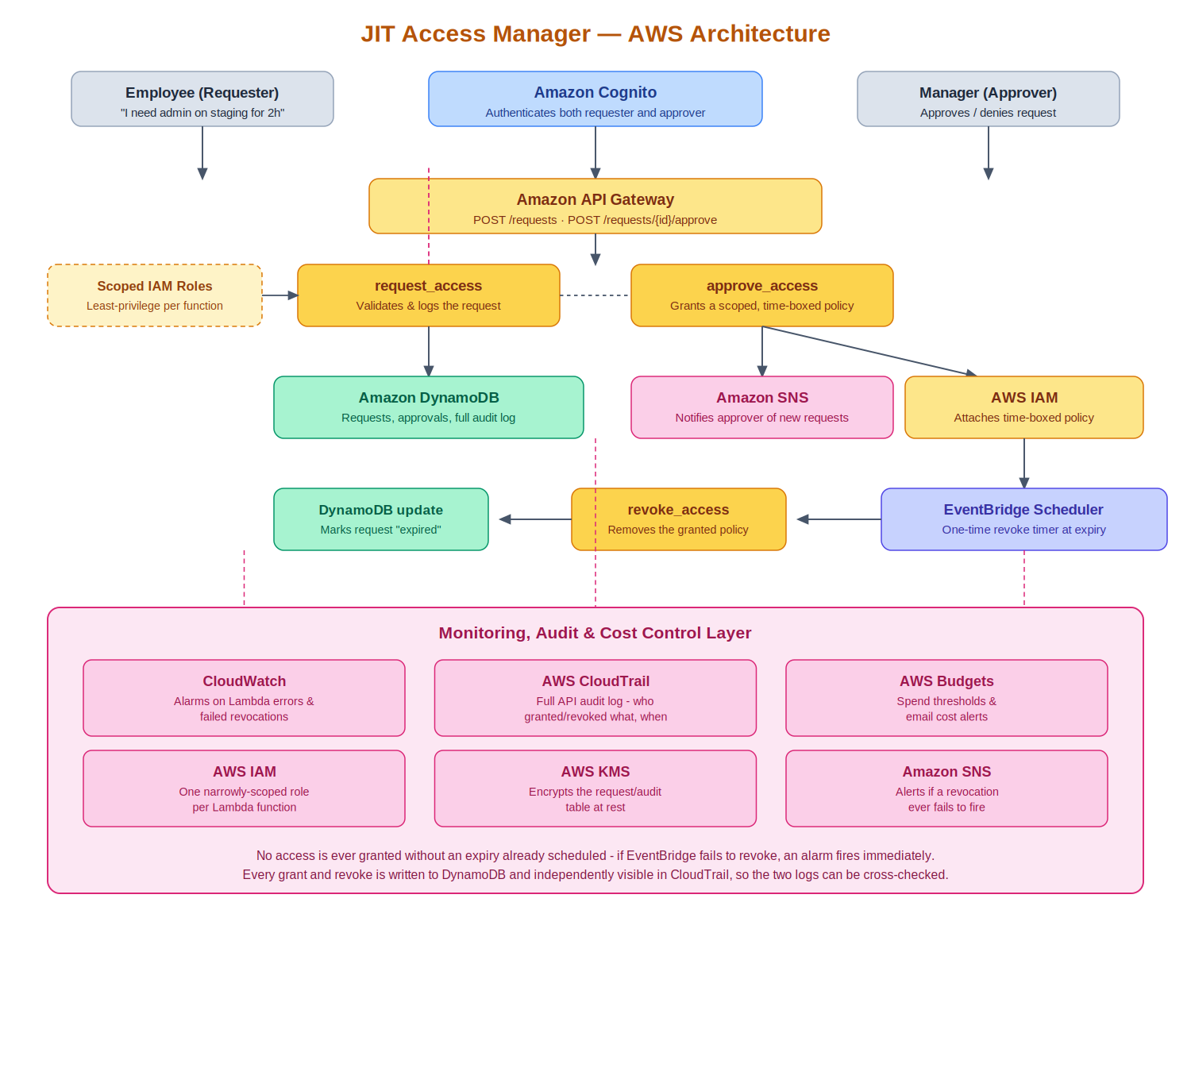

6. Implementation Plan
The project will be implemented in phases, so the request-and-approval pipeline is working before the automatic-revocation layer is built and tested on top of it:
- Planning: finalize the architecture, decide on naming conventions, and confirm which AWS Free Tier limits apply to each service being used.
- Identity and API setup: create the Cognito user pool and the API Gateway routes for submitting and approving requests.
- Resource deployment: deploy the DynamoDB table and the request_access and approve_access Lambda functions.
- Grant mechanism: implement the IAM policy attachment in approve_access, scoped to exactly the permission and resource requested.
- Automatic revocation: implement revoke_access and the EventBridge Scheduler wiring so every grant schedules its own expiry at the moment it is created.
- Security baseline: configure a distinct least-privilege IAM role for each Lambda function, and enable KMS encryption on the DynamoDB table.
- Monitoring and testing: wire up CloudWatch, SNS, and CloudTrail, then run test scenarios to confirm a revocation actually fires on schedule and that a deliberately failed revocation raises an alarm.

7. Automation Plan
Automation will primarily use AWS CloudFormation, since it is AWS-native and keeps the deployed environment defined as a template rather than something built manually through the console. AWS CLI will be used alongside this for day-to-day tasks such as submitting a test request or checking a stack's status, rather than relying on the console for repeated actions.
The plan is to automate the creation of the Cognito user pool, the DynamoDB table, all four Lambda functions with their IAM roles, and the API Gateway routes, so the entire environment can be torn down and rebuilt consistently from the template instead of depending on manual steps that are easy to get wrong the second time around.

8. Security & Monitoring Plan
Access control is the subject of this project as much as its implementation detail: every IAM policy the system attaches is scoped to exactly the permission and resource named in the request, never a broad role, and every attachment has an expiry scheduled before the grant is even returned to the requester. Each of the four Lambda functions runs under its own narrowly scoped role — for example, only approve_access can attach IAM policies, and only revoke_access can detach them.
Monitoring and logging are handled by CloudWatch, which alarms on any Lambda error, with particular attention to a failure in the revocation path, since a revocation that silently fails is the single most dangerous failure mode this system has. CloudTrail is designed to independently record every IAM policy attachment and detachment the system makes, deliberately kept separate from the application's own DynamoDB audit log so that the two can eventually be cross-checked against each other rather than relying on a single source of truth. Amazon SNS delivers alerts for genuine issues — a new request awaiting approval, or a revocation that failed to complete — rather than routine activity.
Implementation status at the time of submission: the CloudWatch alarm on failed revocations is deployed and has been tested with a deliberately simulated failure. CloudTrail cross-referencing and AWS Budgets spend alerts are designed into the architecture but not yet deployed in this environment. The DynamoDB table currently uses its default AWS-owned encryption key rather than a separate customer-managed KMS key, which is a lower-cost, equally-encrypted alternative suitable for a development-scale deployment.

9. Expected Outcome
The final project is expected to demonstrate a working just-in-time access system where a request can be submitted, approved, granted, and automatically revoked with no manual cleanup step at any point. The demo will show:
- An employee submitting a request and a manager approving it through an authenticated endpoint.
- The requested IAM policy being genuinely attached and usable immediately after approval.
- The policy being automatically and correctly removed at the scheduled expiry, with no human action taken.
- A complete, timestamped audit trail in DynamoDB showing every stage of one grant's lifecycle: pending, active, and expired.
- A deliberately simulated failed revocation being caught and alerted on by CloudWatch and SNS, rather than failing silently.

10. Estimated Cost / Free Tier Usage
This project is designed to run almost entirely within AWS Free Tier limits. Lambda, DynamoDB, API Gateway, EventBridge Scheduler, and SNS all offer generous always-free or 12-month free allowances that comfortably cover development and demo-scale testing. Amazon Cognito's free tier covers up to 50,000 monthly active users, far beyond what a capstone demo requires.
The only service with a small fixed cost is a customer-managed KMS key, at roughly $1 per month if used; the project can instead rely on DynamoDB's default AWS-owned encryption key, which carries no additional charge, if the budget needs to stay at zero. A spending budget with email alerts will be set up in AWS Budgets before any resource is deployed, so any unexpected charge is caught early rather than discovered on a bill.

