AMAZON WEB SERVICES
StreamFlow Cloud
A Scalable, Serverless Media Streaming Platform on AWS
Cloud Computing Capstone Project — Proposal Submission
Prepared by: Faris K
Cloud Platform: Amazon Web Services (AWS)
Submission Date: September 25, 2026

AWS Cloud Project Proposal
Capstone Project — Amazon Web Services

1. Project Title
StreamFlow Cloud: A Scalable, Serverless Media Streaming Platform on AWS

2. Project Objective
This project aims to build a media streaming platform on AWS where the central engineering problem is scale and delivery performance rather than access control. Media workloads behave differently from typical CRUD applications: file sizes are large, traffic to any given piece of content can spike unpredictably, and users expect playback to start instantly regardless of where they are located. This project is built around meeting those demands directly, using a fully serverless, event-driven architecture and a global content delivery network, rather than provisioning fixed-capacity servers sized for a guess at peak load.
The problem it addresses is that many small media or video-sharing projects serve files directly from a single storage bucket or a single server, with no caching layer, no separation between the upload path and the playback path, and no real cost control as usage grows. That approach works at small scale but degrades badly under real traffic and can generate unpredictable bills. The expected outcome is a working platform where uploads are validated and processed asynchronously, video is distributed through edge locations close to the viewer, metadata operations are decoupled from the video bytes themselves, and the entire system costs close to nothing while idle and scales automatically when demand increases.

3. Project Description
The application is a small video streaming service: a registered user signs in, uploads a video, and the file becomes browsable and streamable to other users shortly afterward. There is no traditional media server running continuously; video storage, delivery, and metadata management are each handled by managed AWS services that scale independently of one another. A user authenticates through Amazon Cognito and receives a temporary identity token. To upload, the client requests a pre-signed URL from a Lambda function through API Gateway and uploads the file directly to Amazon S3, which keeps large binary transfers off the compute layer entirely. Once the object lands in S3, a second Lambda function is triggered to validate the upload and write a metadata record — title, owner, duration, upload status — to Amazon DynamoDB. Playback requests are never served from S3 directly; instead, Amazon CloudFront caches and streams the video from the edge location nearest the viewer, which keeps latency low and shields the origin bucket from repeated reads of popular content.

4. AWS Services
The following AWS services are planned for this project (12 total, listed below with their purpose):
1. Amazon Cognito — Handles user sign-up, sign-in, and issues short-lived identity tokens used to authorize every subsequent API call.
2. Amazon API Gateway — Acts as the entry point for upload requests, catalog browsing, and stream requests, handling routing and request validation before anything reaches Lambda.
3. AWS Lambda — Runs the upload-validation logic, generates pre-signed S3 URLs, and writes metadata — all only when triggered, with no persistently running server.
4. Amazon S3 — Stores the video objects themselves, encrypted at rest, and acts as the origin that CloudFront pulls from.
5. Amazon CloudFront — Caches and streams video from edge locations close to each viewer, so playback starts quickly and the S3 origin isn't hit on every view.
6. Amazon DynamoDB — Stores video metadata — title, owner, upload status, view count — separately from the video bytes, so catalog browsing stays fast regardless of file size.
7. AWS IAM — Defines a distinct, narrowly scoped role for each Lambda function, so the upload-validation function, for example, can write to only its own table and bucket path.
8. AWS KMS — Manages the encryption keys behind S3 and DynamoDB, providing the key-management layer behind data-at-rest encryption.
9. Amazon CloudWatch — Collects logs, metrics, and alarms from Lambda, API Gateway, and CloudFront, since there is no server to log into directly.
10. AWS CloudTrail — Logs every API call made within the account, providing an audit trail of who did what and when.
11. Amazon SNS — Sends notifications when an upload finishes processing and routes CloudWatch alarms to email.
12. AWS Budgets — Tracks spending against a defined monthly threshold and sends an alert before any cost surprise, which matters most for a project relying on Free Tier limits.

5. Proposed Architecture
The diagram below shows the flow of a request. A user authenticates through Cognito, then reaches the system through API Gateway. Lambda validates uploads and writes metadata under a narrowly scoped IAM role, with KMS providing encryption behind both S3 and DynamoDB. Video objects land in S3, while metadata is written to DynamoDB in parallel. Playback is never served from the origin directly — CloudFront caches and streams video from the edge location nearest the viewer. All activity across these services feeds into a monitoring and audit layer, where CloudWatch captures logs and metrics, CloudTrail records every API call made in the account, SNS delivers notifications and alarms, and Budgets watches overall account spend.
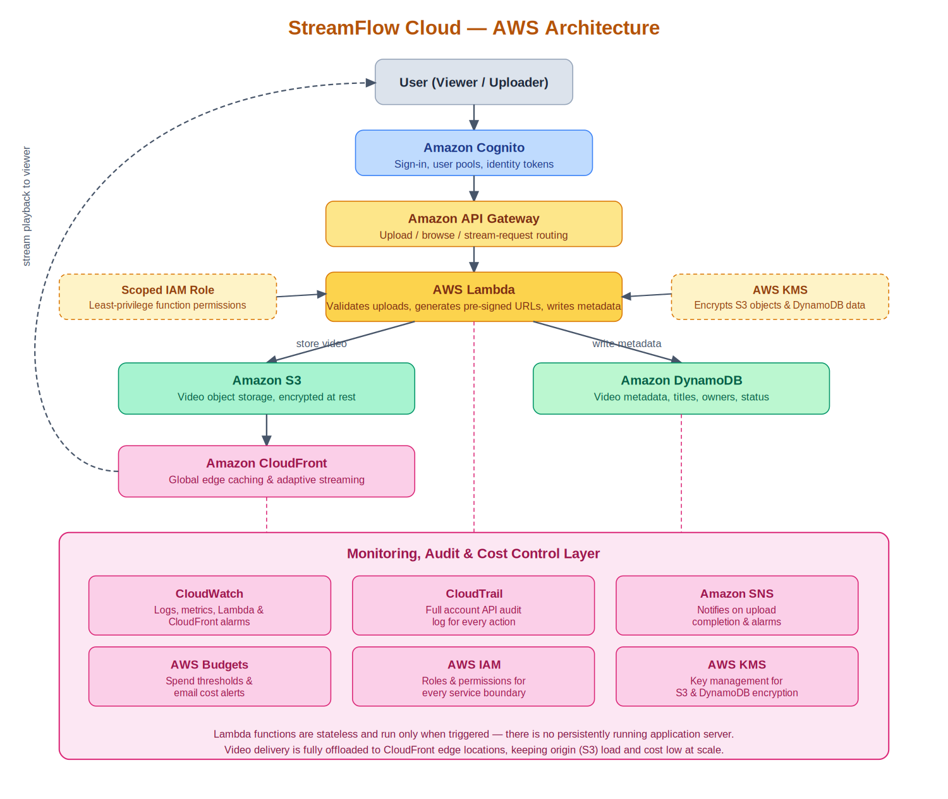

6. Implementation Plan
The project will be implemented in phases, so the core upload-and-playback pipeline is working and tested before the monitoring and edge-delivery layers are tuned on top:
- Planning: finalize the architecture, decide on naming conventions, and confirm which AWS Free Tier limits apply to each service being used.
- Identity and API setup: create the Cognito user pool, app client, and the API Gateway routes for upload, browse, and stream requests.
- Resource deployment: deploy the Lambda functions, the S3 bucket, and the DynamoDB table.
- Service integration: connect Lambda to S3 (pre-signed URLs) and to DynamoDB, and confirm an uploaded file produces a correct metadata record.
- Edge delivery: configure CloudFront in front of S3, restrict direct bucket access using an origin access control, and confirm playback is served from the edge, not the origin.
- Automation: script the repeatable parts of the deployment so the environment can be recreated consistently instead of built manually each time.
- Security baseline: configure IAM roles with least-privilege access, enable KMS encryption on S3 and DynamoDB, and turn on CloudTrail.
- Monitoring and load testing: wire up CloudWatch and SNS, then simulate concurrent uploads and playback requests to confirm the system scales without manual intervention.

7. Automation Plan
Automation will primarily use AWS CloudFormation (optionally through the AWS SAM CLI for the Lambda and API Gateway portion), since it is AWS-native and keeps the deployed environment defined as a template rather than something built manually through the console. AWS CLI will be used alongside this for smaller day-to-day tasks, such as checking the status of a deployed stack, uploading a test file, or triggering a redeployment, rather than relying on the console for repeated actions.
The plan is to automate the creation of the Cognito user pool, the S3 bucket and its CloudFront distribution, the DynamoDB table, and the Lambda functions with their API Gateway routes, so the entire environment can be torn down and rebuilt consistently from the template instead of depending on manual steps that are easy to get wrong the second time around.

8. Security & Monitoring Plan
Although the primary focus of this project is scalability and delivery performance rather than compliance, a baseline of good security practice is still built in rather than skipped. Access control is handled through AWS IAM, with each Lambda function assigned its own role scoped to only the specific S3 path and DynamoDB table it needs, rather than a single broad role shared across the system.
Data at rest is encrypted through AWS KMS for both the S3 bucket and the DynamoDB table. The S3 bucket itself has no public access; CloudFront reaches it through an origin access control, so video content cannot be pulled directly from the bucket URL. Monitoring and logging are handled by CloudWatch, which collects logs and metrics from Lambda, API Gateway, and CloudFront, and CloudTrail, which records every API call made in the account for audit purposes. Amazon SNS delivers alerts for genuine issues — repeated Lambda failures, unusual spikes in upload volume, or a budget threshold being crossed — rather than routine activity, since overly frequent alerting isn't useful in practice.

9. Expected Outcome
The final project is expected to demonstrate a working serverless media pipeline where a user can sign in, upload a video, see it appear in a browsable catalog, and stream it back with low startup latency, entirely without a persistently running server. The demo will show:
- A video being uploaded and appearing in the catalog with correct metadata shortly afterward.
- Playback being served from a CloudFront edge location rather than directly from S3, confirmed by checking response headers.
- The S3 bucket being unreachable directly (a request to the bucket URL is denied, while the CloudFront URL works).
- The system handling a burst of simulated concurrent uploads or playback requests without manual scaling action, since Lambda, DynamoDB, and CloudFront all scale automatically.
- A cost dashboard and Budgets alert configuration showing the project stayed within Free Tier limits throughout testing.

10. Estimated Cost / Free Tier Usage
This project is designed to run almost entirely within AWS Free Tier limits. Lambda, DynamoDB, API Gateway, and SNS all offer generous always-free or 12-month free allowances that comfortably cover development and demo-scale testing. Amazon Cognito's free tier covers up to 50,000 monthly active users, far beyond what a capstone demo requires. S3 storage for a handful of short test videos stays within the free storage and request allowances.
The service most likely to approach a cost boundary is CloudFront, since data transfer out to the internet is only free up to a monthly allowance before small per-GB charges apply; this is managed by keeping test video files short and limiting the number of playback tests during development. A customer-managed KMS key carries a small fixed monthly charge (roughly $1) if used; the project can instead rely on Amazon S3 and DynamoDB's default AWS-managed encryption keys, which carry no additional charge, if the budget needs to stay at zero. A spending budget with email alerts will be set up in AWS Budgets before any resource is deployed, so any unexpected charge is caught early rather than discovered on a bill. Expensive services such as AWS Elemental MediaConvert, MediaLive, or Kinesis Video Streams are deliberately excluded from this design, since they are not required for a Free Tier–eligible upload-and-stream workflow and would introduce meaningful cost.

