MPU9250 Datasheet
- A user-programmable gyroscope full-scale range of ±250, ±500, ±1000, and ±2000°/sec (dps), a user-programmable accelerometer full-scale range of ±2g, ±4g, ±8g, and ±16g, and a magnetometer full-scale range of ±4800μT.
- VDD operating range of 2.4V to 3.6V
- Communication with all registers of the device is performed using either I2C at 400kHz or SPI at 1MHz. For applications requiring faster communications, the sensor and interrupt registers may be read using SPI at 20MHz.
- When the device is placed on a flat surface, it will measure 0g on the X- and Y-axes and +1g on the Z-axis.

GYROSCOPE:
- Digital-output X-, Y-, and Z-Axis angular rate sensors (gyroscopes) with a user programmable full-scale range of ±250, ±500, ±1000, and ±2000°/sec and integrated 16-bit ADCs
- Digitally-programmable low-pass filter
- Gyroscope operating current: 3.2mA
- Sleep mode current: 8μA

ACCELEROMETER:
- Digital-output triple-axis accelerometer with a programmable full scale range of ±2g, ±4g, ±8g and ±16g and integrated 16-bit ADCs.
- Accelerometer normal operating current: 450μA.
- Low power accelerometer mode current: 8.4μA at 0.98Hz, 19.8μA at 31.25Hz.
- Sleep mode current: 8μA.
- User-programmable interrupts.
- Wake-on-motion interrupt for low power operation of applications processor.

MAGNETOMETER:
- 3-axis silicon monolithic Hall-effect magnetic sensor with magnetic concentrator
- Wide dynamic measurement range and high resolution with lower current consumption.
- Output data resolution of 14 bit (0.6μT/LSB)
- Full scale measurement range is ±4800μT
- Magnetometer normal operating current: 280μA at 8Hz repetition rate

ADDITIONAL FEATURES:

- Auxiliary master I2C bus for reading data from external sensors (e.g. pressure sensor)
- 3.5mA operating current when all 9 motion sensing axes and the DMP are enabled
- VDD supply voltage range of 2.4 – 3.6V
- VDDIO reference voltage for auxiliary I2C devices
- 512 byte FIFO buffer enables the applications processor to read the data in bursts
- User-programmable digital filters for gyroscope, accelerometer, and temp sensor

MOTIONPROCESSING:

Internal Digital Motion Processing™ (DMP™) engine supports advanced MotionProcessing and low power functions such as gesture recognition using programmable interrupts. Low-power pedometer functionality allows the host processor to sleep while the DMP maintains the step count.

SENSITIVITY SCALE FACTOR:

The Sensitivity Scale Factor is typically specified by the manufacturer and is expressed as a ratio or a conversion factor. It represents the number of output units produced by the gyroscope per unit of input angular rate. For example, if the Sensitivity Scale Factor of a gyroscope is 1000 (units/degree/second), it means that for every degree per second of angular rate input, the gyroscope will produce an output of 1000 units. This factor allows the raw gyroscope readings to be converted into angular velocity measurements in the desired units (e.g., degrees per second, radians per second).

GYROSCOPE SPECIFICATIONS:

Total RMS Noise DLPFCFG=2 (92 Hz) 0.1 º/s-rms
Low Pass Filter Response Programmable Range 5-250 Hz
Output Data Rate Programmable, Normal mode 4-8000 Hz

ACCELEROMETER SPECIFICATIONS:

Noise Power Spectral Density Low noise mode 300 μg/√Hz
Total RMS Noise DLPFCFG=2 (94Hz) 8 mg-rms
Low Pass Filter Response Programmable Range 5-260 Hz
Output Data Rate Low noise (active) 4-4000 Hz

ZERO-G INITIAL CALIBRATION TOLERANCE: The Zero-G Initial Calibration Tolerance in the MPU-9250 refers to the acceptable range of error or deviation during the initial calibration process for the accelerometer's zero-gravity (zero-g) measurement. During the calibration process, the MPU-9250 attempts to determine the accelerometer's output when it is subjected to zero-gravity conditions, which ideally should result in a measurement of zero acceleration along all axes. However, due to various factors such as manufacturing variances, temperature effects, and noise, it is challenging to achieve a perfectly accurate zero-g measurement.

POWER SPECTRAL DENSITY: Power spectral density specifies the power levels of the frequency components present in a signal. The PSD specifies the power of various frequencies present in the signal and we can determine the range of power over which the signal frequencies are operating at. Essentially, the PSD profile is a plot of the power over frequency. PSD can be used for the classification of different types of noise based on the PSD graph. Example: PSD of white noise is uniform and is independent of the signal frequency components. White noise PSD is represented as a straight line parallel to the frequency axis in the PSD plot.

MAGNETOMETER SPECIFICATIONS:

Full-Scale Range ±4800 μT
ADC Word Length 14 bits
Sensitivity Scale Factor 0.6 μT / LSB

In the context of the MPU-9250, the SMPLRT_DIV parameter refers to the Sample Rate Divider, which determines the sampling rate of the sensor data. When SMPLRT_DIV is set to 0, it typically means that the sample rate is not divided or reduced.

F-CHOICE:

In the MPU-9250, the Fchoice parameter is related to the Digital Low Pass Filter (DLPF) configuration for the accelerometer and gyroscope. It determines the bandwidth and the trade-off between noise reduction and responsiveness for these sensors. The Fchoice parameter can take three possible values: 0, 1, or 2.

Fchoice = 0: This setting bypasses the DLPF for both the accelerometer and gyroscope. It means that no filtering is applied, and the raw sensor data is directly accessible without any additional smoothing or noise reduction. This configuration allows for the highest responsiveness to changes in acceleration or angular rate but may be more susceptible to noise and high-frequency interference.

Fchoice = 1: This setting applies the DLPF to the accelerometer only, while bypassing it for the gyroscope. It means that the accelerometer data is filtered to reduce noise and attenuate high-frequency components, while the gyroscope data remains unfiltered. This configuration can provide a balance between noise reduction for the accelerometer and high responsiveness for the gyroscope.

Fchoice = 2: This setting applies the DLPF to both the accelerometer and gyroscope. It means that both sensor data streams are filtered to reduce noise and attenuate high-frequency components. This configuration provides the highest level of noise reduction and stability but may introduce some additional delay or phase shift in the sensor data.
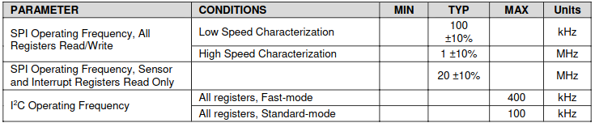
Absolute Maximum Ratings
Stress above those listed as “Absolute Maximum Ratings” may cause permanent damage to the device. These are stress ratings only and functional operation of the device at these conditions is not implied. Exposure to the absolute maximum ratings conditions for extended periods may affect device reliability.
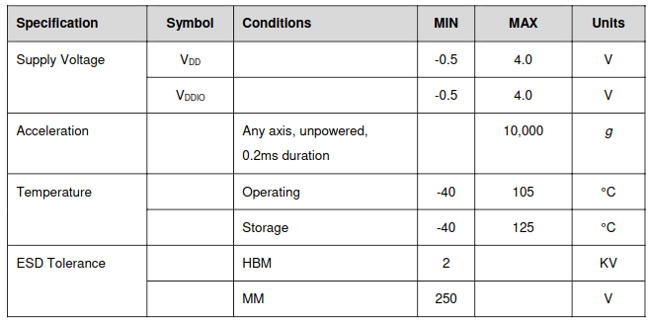

Digital Motion Processor
The embedded Digital Motion Processor (DMP) is located within the MPU-9250 and offloads computation of motion processing algorithms from the host processor. The DMP acquires data from accelerometers,gyroscopes, magnetometers and additional 3rd party sensors, and processes the data. The resulting data can be read from the DMP’s registers, or can be buffered in a FIFO. The DMP has access to one of the MPU’s external pins, which can be used for generating interrupts. This pin (pin 12) should be connected to a pin on the host processor that can wake the host from suspend mode. The purpose of the DMP is to offload both timing requirements and processing power from the host processor. Typically, motion processing algorithms should be run at a high rate, often around 200Hz, in order to provide accurate results with low latency. This is required even if the application updates at a much lower rate; for example, a low power user interface may update as slowly as 5Hz, but the motion processing should still run at 200Hz. The DMP can be used as a tool in order to minimize power, simplify timing, simplify the software architecture, and save valuable MIPS on the host processor for use in the application.

BYPASS_EN
In the MPU9250, the BYPASS_EN refers to the bypass mode enable bit. The BYPASS_EN bit is part of the MPU9250's control registers and is used to control the behavior of the auxiliary I2C bus. When the BYPASS_EN bit is set to 1, it enables the bypass mode, allowing direct access to the auxiliary I2C bus without going through the MPU9250's internal registers.
In bypass mode, the MPU9250 acts as a pass-through device, where the auxiliary I2C bus signals are directly connected to the primary I2C bus. This allows external devices to communicate directly with the auxiliary I2C bus devices without any interference from or interaction with the MPU9250's internal registers.

