**1. What does an empty dictionary's code look like?**

Ans No.1:  
An empty dictionary’s code looks like:  
a = {} # Empty dictionary

type(a) # Checking object_type

**2. What is the value of a dictionary value with the key 'foo' and the value 42?**

Ans No.2:

The value of a dictionary with one key value-pair would be 1. As a key and a value isn’t counted separately in dictionary.

**3. What is the most significant distinction between a dictionary and a list?**

Ans No.3:  
A dictionary contains a value which is bind with a key. On other hand list does not contain a key and its value is only accessed using index.

**4. What happens if you try to access spam['foo'] if spam is {'bar': 100}?**

Ans No.4:

It will result in KeyError. As spam does not have a key ‘foo’.

**5. If a dictionary is stored in spam, what is the difference between the expressions 'cat' in spam and 'cat' in spam.keys()?**

Ans No.5:

There’s no difference between 'cat' in spam and 'cat' in spam.keys() as both will check for the membership in dictionary(spam) and will return True / False as per the availability.

**6. If a dictionary is stored in spam, what is the difference between the expressions 'cat' in spam and 'cat' in spam.values()?**

Ans No.6:

The difference between 'cat' in spam and 'cat' in spam.values() is that 'cat' in spam will check for ‘cat’ as a key in spam dictionary. On other hand, 'cat' in spam.values() will check for ‘cat’ as a value in spam dictionary.

**7. What is a shortcut for the following code?**

if 'color' not in spam:

spam['color'] = 'black'

Ans No.7:  
spam.setdefault(‘color’, ‘black’)

This shortcut will check for the value of ‘color’ in spam. If the value would be present, it will return the value, if not then it will set the of the key(color) as ‘black’.

**8. How do you "pretty print" dictionary values using which module and function?**

Ans No.8:

We can use pprint module inside python inorder to pretty print the dictionary. The pprint module makes the output more readable and visually appealing. We can also customize the output format and indentation using optional parameters of the pprint() function.

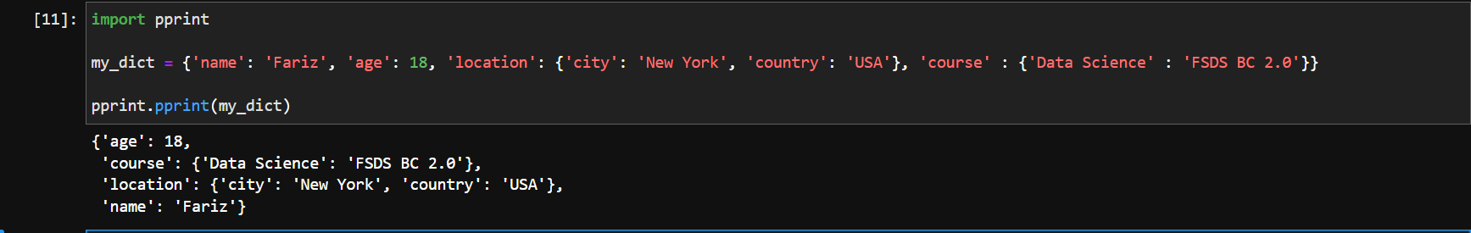

Note that the each key along with its value is on a new line.