**Khulna University of Engineering & Technology**



**ECE 3200: Electronics Project Design/ Development**

**Project Title: Traffic Signal Management & Control System Based on Density of Vehicles and Emergency Vehicles**

**Supervised By: Submitted By:**

Shafrin Sultana Farjana Afroz

Lecturer Roll: 2009032

Department of ECE Md. Shafe-ul-Alam

KUET, Khulna, Bangladesh Roll: 2009035

|  |  |
| --- | --- |
| **Table of Contents** | **Page Number** |
| Motivation | 3 |
| Objectives | 4 |
| Research Methodology & Implementation | 4-7 |
| Final Outcome Analysis | 7-8 |
| Work Timeline | 8 |
| Cost Analysis | 8-9 |
| Impact on Society and Environment | 9 |
| Addressing Complex Engineering Problems and Activities | 10 |
| Conclusions | 11 |
| Reference | 11 |

1. **Motivation :**

**Background and Motivation:**

We are excited to propose a project to design and build a "Traffic Signal Management & Control System Based on Density of Vehicles and Emergency Vehicles," which will significantly enhance urban traffic management. The motivation behind this project stems from our passion for smart technologies, our drive to make everyday life more efficient, and our commitment to solving real-world traffic challenges. In cities and congested areas, traffic delays are a major issue, leading to wasted time, increased fuel consumption, and pollution. By developing an intelligent system that adjusts traffic signals based on vehicle density, we aim to optimize traffic flow and reduce congestion. Moreover, our system will prioritize emergency vehicles, ensuring they can pass through traffic swiftly and safely, potentially saving lives in critical situations. This approach reduces human intervention, allowing the system to autonomously adjust signals in real time to respond to changing traffic conditions. The project also aligns with smart city initiatives, using modern technology to create safer and more efficient roads. Ultimately, this traffic management system will help reduce accidents, lower emissions, and improve the overall commuting experience.

* **Real-Time Traffic Density Monitoring**: Sensors continuously track vehicle numbers at intersections to provide accurate, real-time traffic data.
* **Dynamic Signal Timing Adjustment**: Traffic light timings are automatically adjusted based on traffic density to optimize the flow of vehicles.
* **Reduce Traffic Congestion**: The system adapts to fluctuating traffic conditions to reduce congestion and shorten wait times.
* **Emergency Override System**: Provides an automated override for emergency vehicles, ensuring they receive priority at intersections.
* **Intersection Coordination**: Synchronizes traffic lights across multiple intersections to enable a smoother flow, particularly during peak traffic periods.

**Conflicting Requirements:**

Balancing traffic flow efficiency with emergency vehicle prioritization requires handling conflicting objectives. Prioritizing emergency vehicles can disrupt regular traffic flow, leading to potential congestion. The system must use real-time adaptability and predictive modeling to manage signal timings effectively, minimizing delays once the emergency vehicle passes. Stakeholder collaboration is essential to address diverse needs, while system reliability is maintained through redundancy and rigorous testing. Additionally, machine learning can help the system adapt to evolving traffic patterns, optimizing for both regular and emergency traffic over time**.**

**Contribution:**

* Reduce traffic congestion and emissions.
* Improve emergency response times.
* Enhance safety and efficiency in transportation.
* Positively impact society as a whole.

This report has been structured into ten sections.

Section 1 is entitled “**Motivation**”. It explains the thoughts behind taking upon this project.

Section 2 is entitled “**Objectives**”. It explains the goals that were achieved by this project.

Section 3 is entitled “**Research Methodology & Implementation**”, It explains the method on which the project was established.

Section 4 is entitled “**Final Outcome Analysis**”. It explains the total output of the project altogether.

Section 5 is entitled “**Work Timeline**”. It explains the sessions of completion of this project displayed by Gantt chart.

Section 6 is entitled “**Cost Analysis**”. It explains the monetary expenses the project hold to make.

Section 7 is entitled “**Impact on Society and Environment**”. It explains the influence and aftermath of the project application at society and environment level.

Section 8 is entitled “**Addressing Complex Engineering Problems and Activities**”. It explains how the project tackles complex engineering challenges through innovative solutions, advanced technologies, and practical applications.

Section 9 is entitled “**Conclusions**”. It concluded the total idea of this project.

Section 10 is entitled “**References**”. This section lists the sources supporting the development of the project, ensuring credibility and aiding future research.

1. **Objectives:**

* To monitor the number of vehicles at an intersection in real time.
* To adjusts traffic light timings dynamically.
* To manually override the automated system in case of emergencies or special events
* To allow a smoother flow of vehicles through multiple intersections, especially during peak traffic hours.

1. **Research Methodology & Implementation:**

In designing our proposed traffic control system, we followed several procedures to identify, specify, select, process, and analyze key information. This ensured that we could implement the system practically and efficiently, addressing traffic management challenges without major issues. The concept map or design process of our proposed project is given bellow:

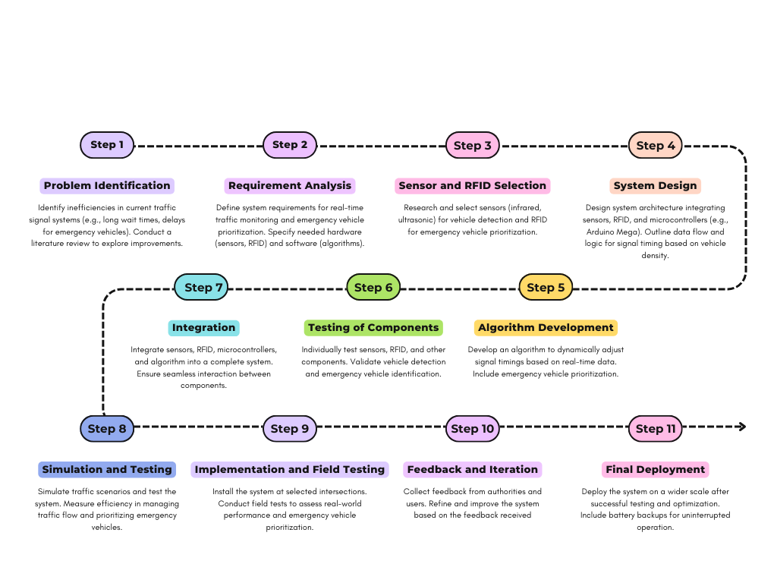

* **TECHNOLOGY USED** :

**Ultrasonic Sensor :**

An ultrasonic sensor is an instrument that measures the distance to an object using ultrasonic sound waves. An ultrasonic sensor uses a transducer to send and receive ultrasonic pulses that relay back information about an object's proximity.



**Fig.1 HC SR04 Ultrasonic Sensor**

**RFID tags:**

RFID tags are a type of tracking system that uses radio frequency to search, identify, track, and communicate with items and people. Essentially, RFID tags are smart labels that can store a range of information from serial numbers, to a short description, and even pages of data.



**Fig.2 RFID RC522 MODULE**

**Arduino Mega :**

Typically used to add a reset button to shields which block the one on the board. The Arduino Mega2560 has a number of facilities for communicating with a computer, another Arduino, or other microcontrollers. The ATmega2560 provides four hardware UARTs for TTL (5V) serial communication.



**Fig.3Arduino Mega2560**

**Arduino Nano:**

The Arduino Nano is a microcontroller-based device with 16 digital pins that can be used for various purposes. It can be used for almost every task, from minor to massive industrial-scale projects. It can also be used for prototyping and developing new applications.

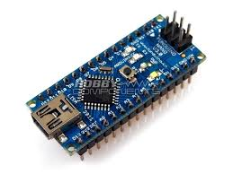

**Fig.4Arduino Nano**

* **Circuit diagram:**

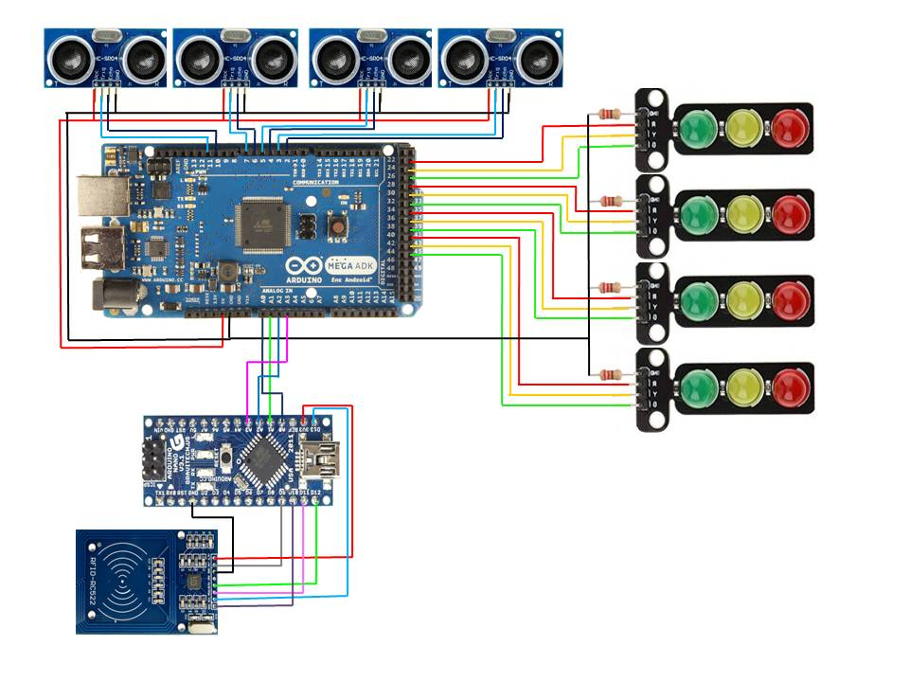

**Fig.5 circuit Diagram**

This system create a smart traffic system that optimizes traffic signal timings based on real-time vehicle density, lowering traffic, commute expenses, and pollution at junctions. This may be achieved by utilizing sensors, communication and algorithms. Additionally, it uses an RFID reader to assist as an emergency vehicle.

1. **Final Outcome Analysis:**

The **Traffic Signal Management and Control System** based on the density of vehicles and emergency vehicles is an innovative solution for improving traffic flow and ensuring efficient emergency response. This system minimizes delays and enhances overall traffic efficiency by dynamically adjusting traffic signals based on real-time vehicle density and giving priority to emergency vehicles when needed. It helps reduce congestion, ensures faster emergency response times, and improves road safety for both the public and emergency personnel. By incorporating features like real-time traffic density monitoring, junction priority control, and preemptive signal adjustments, the system significantly lowers the risk of accidents during emergency operations. Emergency vehicles are prioritized at traffic intersections, and alerts are sent to other drivers to give way, ensuring a clear path. Additionally, the system’s ability to adapt to changing traffic patterns and unexpected situations ensures optimal performance during peak hours, emergencies, or disasters. This proactive approach plays a critical role in reducing fatalities, minimizing property damage, and improving the overall safety and efficiency of traffic management.

1. **Work Timeline:**

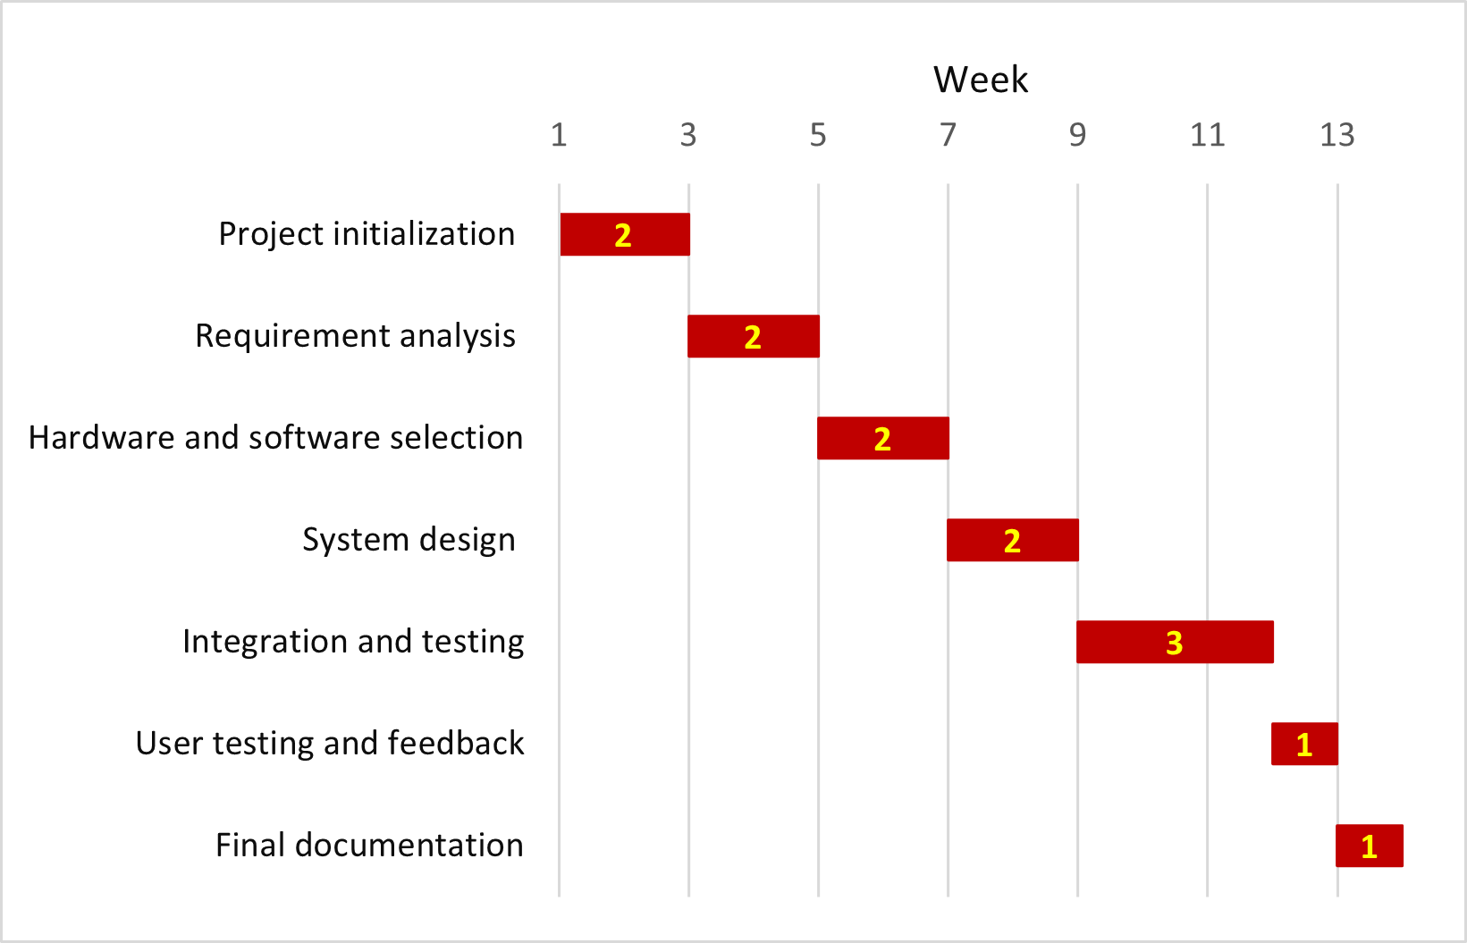

1. **Cost Analysis:**

|  |  |  |  |
| --- | --- | --- | --- |
| **Sl.** | **Item** | **Justification** | **Price (BDT)** |
| 1 | Arduino IDE | Free open-source platform for programming | 0 |
| 1 | Breadboard | For testing and prototyping connections | 100 |
| 2 | Arduino mega 2560 | Main microcontroller for handling complex tasks | 1895 |
| 3 | Arduino nano | |  | | --- | | Secondary controller for smaller tasks | | 410 |
| 4 | HC SR04 Ultrasonic sensor | Detect vehicle density at intersections | 420 |
| 5 | RFID RC-522 module | To identify and prioritize emergency vehicles | 195 |
| 6 | RFID Tags | For emergency vehicle detection | 120 |
| 7 | 220 Ohm Resistors | Current limiting for LEDs and other components | 10 |
| 8 | Signal light Module PCB | For controlling the traffic signal lights | 120 |
| 9 | 12V DC power supply | Provides power to the system | 110 |
| 10 | 7 Segment Display | Displays real-time information on traffic signals | 250 |
| 11 | Red, Green, Orange, LED | Indicator lights for traffic signals | 20 |
| 12 | Dotted veroboard | |  | | --- | | For assembling the components | | 130 |
| 13 | 74HC595 | Shift register for controlling multiple LEDs | 120 |
| 14 | Male, Female Header | For making connections between components | 100 |
| Total (BDT) | | | 4000 |
| In words: Four Thousand Taka only | | | |

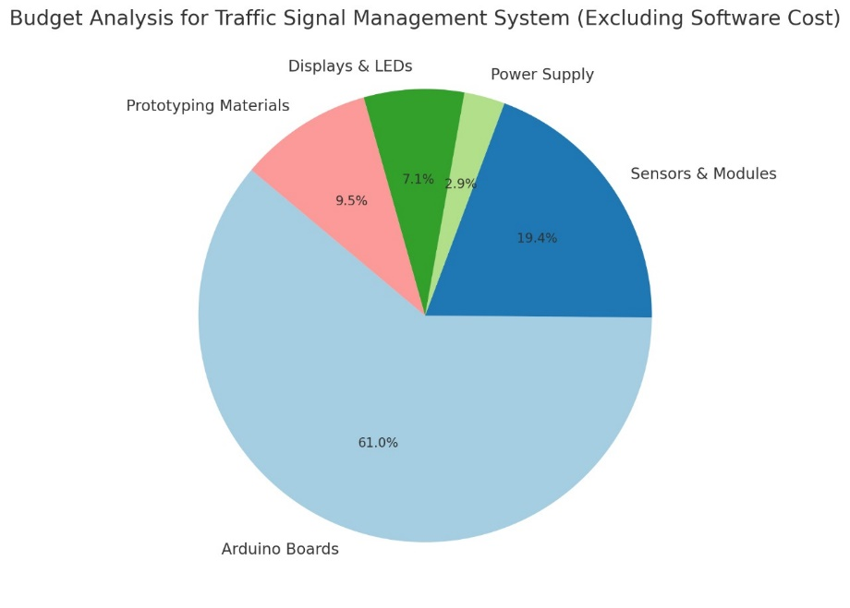

1. **Impact on Society and Environment:**

This project can improve traffic flow in urban areas, reducing congestion and wait times at intersections. By dynamically adjusting traffic signals based on real-time data, the system will optimize road usage, leading to shorter commutes, lower fuel consumption, and a reduction in air pollution, contributing to environmental sustainability. Additionally, the system's ability to prioritize emergency vehicles will have a direct impact on public safety, ensuring faster response times for ambulances, fire trucks, and police vehicles. This can potentially save lives in critical situations where every second counts. The system also reduces the need for manual traffic control and human intervention, minimizing the risk of accidents and making roads safer for drivers and pedestrians alike. Overall, this project will have a positive impact on society by improving transportation efficiency, enhancing emergency response, and contributing to the development of smarter, more sustainable cities.

1. **Addressing Complex Engineering Problems and Activities:**
   * **Addressing Complex Engineering Problems:**

|  |  |  |  |  |  |  |  |
| --- | --- | --- | --- | --- | --- | --- | --- |
|  | P1  Depth of Knowledge | P2  Range of Conflicting Requirements | P3  Depth of Analysis | P4  Familiarity of Issues | P5  Extent of Applicable Codes | P6  Extent of Stake-holder Involvement | P7  Interdependence |
| Tick | ✓ | ✓ | ✓ | ✓ |  |  | ✓ |
| Justifications | The project requires significant technical knowledge in traffic management, real-time systems, and hardware-software integration for signal control. | Balancing traffic flow with emergency vehicle prioritization while ensuring system efficiency introduces conflicting requirements that need careful handling. | Detailed analysis is needed to optimize signal timings based on vehicle density and ensure the correct functioning of RFID technology for emergency vehicles. | The project deals with familiar issues such as traffic congestion and emergency vehicle delays, making the problem well understood but challenging. |  |  | The system involves multiple interdependent components (sensors, RFID, signal controls), requiring synchronized functioning to ensure optimal performance. |

* + Addressing Complex Engineering Activities:

|  |  |  |  |  |  |
| --- | --- | --- | --- | --- | --- |
|  | A1  Range of resources | A2  Level of Interaction | A3  Innovation | A4  Consequences for society and the environment. | A5  Familiarity |
| Tick | ✓ | ✓ |  | ✓ | ✓ |
| Justifications | The project requires various resources including sensors, RFID technology, microcontrollers, power supplies, and coding skills, making the range of resources extensive. | The system interacts with multiple components (sensors, signals, RFID tags) and stakeholders (emergency services, traffic authorities), requiring high levels of interaction. |  | The system will reduce traffic congestion and emissions, improve emergency response times, and contribute to safer and more efficient transportation, positively impacting society. | The project's core issues, such as traffic management and emergency vehicle delays, are well-known problems but are being tackled with new technological approaches. |

1. **Conclusions:**

Throughout this project, we encountered numerous challenges and hardware issues that required extensive research and significant time to resolve. During the software development phase, we faced various bugs that needed meticulous debugging and analysis. After thorough research, testing, and refinement, we successfully developed and presented our proposed Traffic Signal Management and Control System. The system is now fully functional and capable of dynamically adjusting signal timings based on vehicle density and prioritizing emergency vehicles. It integrates real-time monitoring, object detection, and efficient signal control, ensuring smoother traffic flow and improved emergency response.

1. **Reference:**
   * Emergency Vehicle Traffic Management System Facilitating Expedited Response and Safety, 1Vishwa. V, 2Vishwa. R,3Tanveer Basha. M, 4Jerald. F,5V. Ramesh Babu, 6M. Anand
   * AlAttar, M.; Al-Mutairi, N. Quantification of time and fuel losses due to daily traffic congestion in Kuwait. Int. J. Crashworthiness 2021, 26, 258–269. [CrossRef]
2. Signature of the Student ………………………………….. Date …………………………
3. Signature of the Supervisor ……………………………….. Date…………………………