**Khulna University of Engineering & Technology**



**ECE 3208: Antenna Engineering Laboratory**

**Subject: Design and simulate a dual band microstrip patch antenna using CST Microwave Studio**

**Group:B1**

**Submitted To: Submitted By:**

Md. Minhajul Islam Arnab Sazin Ahmed

Lecturer Roll: 2009031

Department of ECE Farjana Afroz

KUET, Khulna, Bangladesh Roll: 2009032

Md. Sumon Mia

Naymur Rahman Roll: 2009033

Lecturer

Department of ECE

KUET, Khulna, Bangladesh

|  |  |
| --- | --- |
| **Report content** | **Page Number** |
| Abstract: | 3 |
| Introduction: | 3 |
| Motivation: | 3 |
| Design (Geometry) | 4-5 |
| Result Analysis & Discussing | 5-8 |
| Conclusion | 9 |
| Reference | 9 |

**Abstract:**

The design of a dual-band microstrip patch antenna for Wi-Fi operates at 4 GHz and 6 GHz. The antenna contains a rectangular patch with two rectangular slots. The first slot is incorporated in the patch, while the second slot is incorporated in the ground plane. The antenna is based on a microstrip-fed rectangular patch printed on the FR-4 epoxy substrate with a dielectric constant of 4.3 and a thickness of 1.5 mm, with a patch size of 23.75 mm × 18.25 mm.

The simulated result shows that the realized antenna successfully works on dual-band frequencies, achieving bandwidths of approximately 200 MHz and 250 MHz, with return losses of -23.72 dB and -18.27 dB at 4 GHz and 6 GHz, respectively. A stable omnidirectional radiation pattern is observed in the operating frequency bands.

**Introduction:**

The challenges in wireless communication antenna design stem from increasing demands for compact, multi-band, and efficient solutions, as conventional antennas face issues like coupling, low gain, narrow bandwidth, and low efficiency. Microstrip patch antennas are ideal for wireless applications due to their simplicity, flexibility, and compatibility with MMICs, traditionally operating in a single frequency band but evolving to support dual/multi-band operations such as 4/6 GHz for WLAN. Existing studies have explored dual-band and multi-band designs with varying success in achieving compact size, wideband characteristics, and omnidirectional radiation patterns; however, limitations persist, including non-uniform radiation, restricted broadband performance at higher frequencies (e.g., 6 GHz), and a lack of compact dual-band solutions. This study aims to address these challenges by designing a compact dual-band microstrip patch antenna (23.75×18.25 mm, 1.5 mm thick FR-4 substrate) for WLAN applications, featuring a rectangular patch with two slots, operating at 4 GHz (downlink) and 6 GHz (uplink), with return losses of -23.72 dB and -18.27 dB, and VSWR values of 1.139 and 1.277, supported by detailed design methodology, parametric analysis, and simulation results.

**Motivation:**

The rapid growth of wireless communication technologies and the increasing need for high-speed, reliable data transmission in applications like WLAN, IoT, and portable devices have highlighted the importance of efficient antenna designs. Traditional single-band antennas are no longer sufficient for modern systems, which require compact, multi-band, and high-performance solutions that operate across multiple frequency bands. Microstrip patch antennas are a promising option due to their lightweight design, easy fabrication, and compatibility with MMICs. However, challenges such as limited bandwidth, low gain, and difficulties in achieving compact dual-band designs remain. This project aims to overcome these challenges by designing a compact dual-band microstrip patch antenna that operates efficiently at 4 GHz and 6 GHz for WLAN applications. By improving key performance metrics like return loss, VSWR, and radiation patterns, this research will contribute to developing better antennas for next-generation wireless communication devices, meeting the growing demand for reliable and efficient solutions.

**Objectives:**

* To identify the specific frequency range required for the patch antenna to perform effectively for a given application.
* To understand the basic working principles of the patch antenna, including its ability to provide high efficiency and a stable radiation pattern.
* To describe the theoretical methodology used to calculate the dimensions of the patch antenna components, such as patch length, width, and substrate thickness, based on the desired operating frequency range.
* To implement all critical geometrical parameters of the patch antenna as variables in CST Microwave Studio, analyzing how changes in these parameters impact signal strength, efficiency, and radiation characteristics.

**Design (Geometry):**

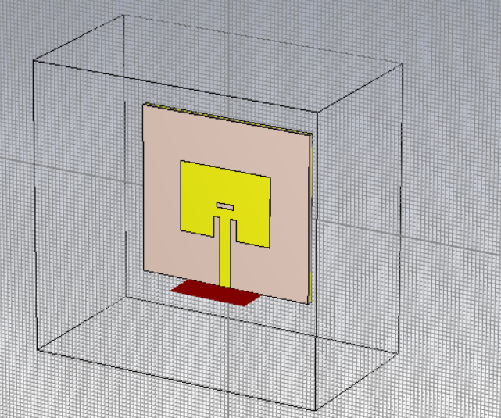 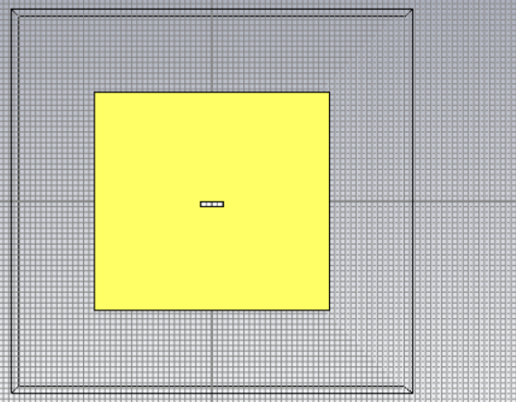

Fig 1: Geometry design of Patch Antenna

Table 1 The optimized parameters of the proposed Antenna Parameters Values

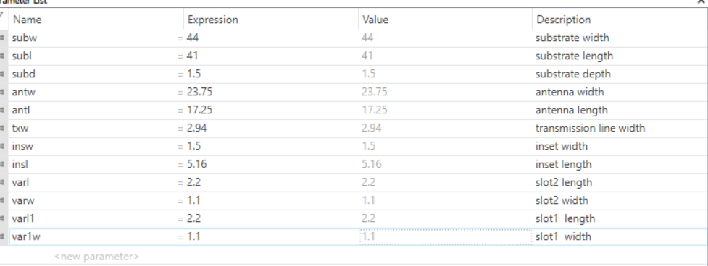

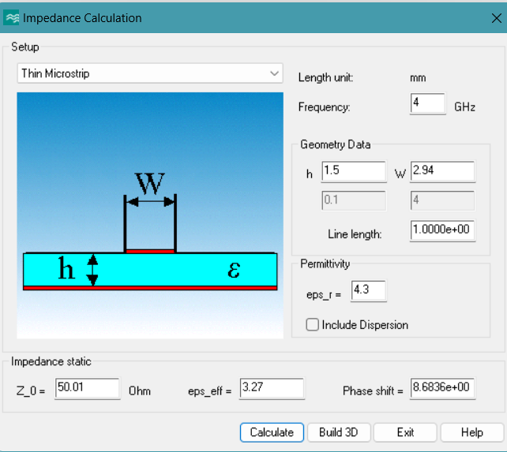

Fig 2: Impedance Calculation of Patch Antenna

**Result Analysis & Discussing:**

The simulated return loss for the proposed antenna is indicated in Fig. 3. The bandwidths of the antennas are determined from the results of |S11| > 10 dB and VSWR < 2. The first band appears in 3.995 GHz with about -23.71571 dB return loss. The second band appears in 5.999 GHz with about -18.27146 dB return loss. When the return loss is less than -10dB, the bandwidths are 200 MHz and 250 MHz which can meet the demand of WLAN in both frequency bands.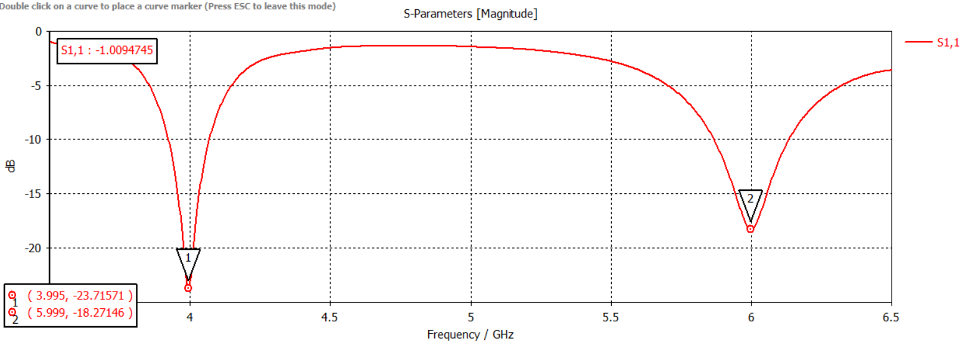

Fig 3: S- Parameter.

Here, the antenna is best matched to the transmission line at 3.995 GHz & 5.9991 GHz

The proposed antenna's Voltage Standing Wave Ratio (VSWR) simulated curve is shown in Fig. 4. For microstrip patch antennas, standard VSWR values are less than 2 within the operating bands. The achieved VSWR values for the proposed design are 1.139 and 1.277 for the downlink frequency at 4 GHz and uplink frequency at 6 GHz, respectively, indicating excellent transmission characteristics.

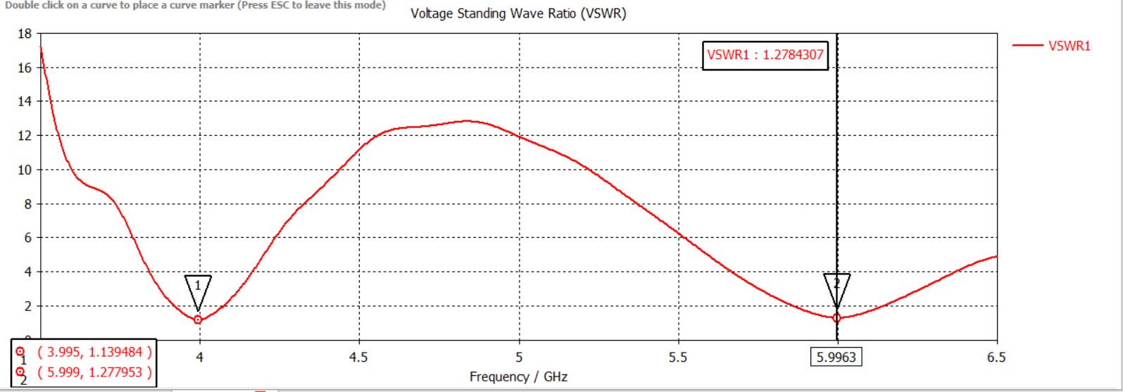

Fig. 4 VSWR of the proposed dual-band microstrip patch antenna

The simulated gain of the proposed antenna is indicated in Fig. 5. The achieved gain for the lower band is 2.86 dB and for the upper band is 2.67 dB.

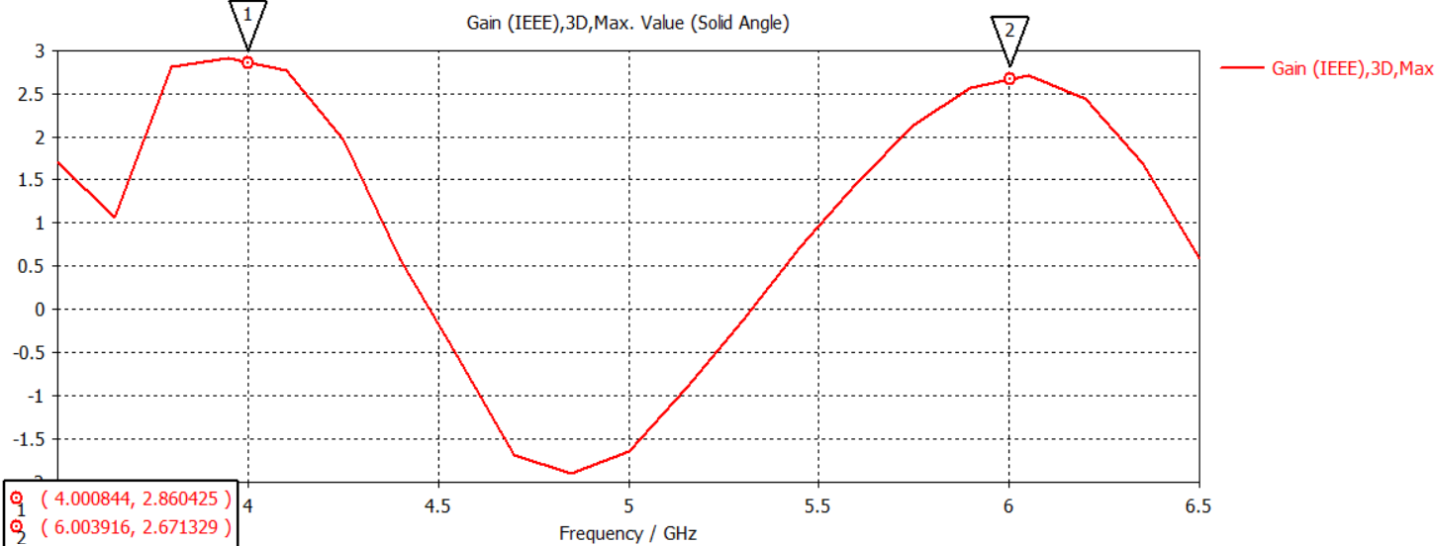

Fig. 5 Gain of the proposed dual-band microstrip patch antenna

Fig. 6 illustrates the current distribution of the proposed antenna for (a) 4 GHz (downlink) and (b) 6 GHz (uplink). The current vectors align along the patch length, and the feeding line carries a significant amount of current. At both operating frequency bands, the current vectors exhibit omnidirectional behavior. Consequently, the excitation is strong across all parts of the antenna for both the lower band at 4 GHz and the upper band at 6 GHz, with return losses of -23.72 dB and -18.27 dB, and VSWR values of 1.139 and 1.277, respectively.

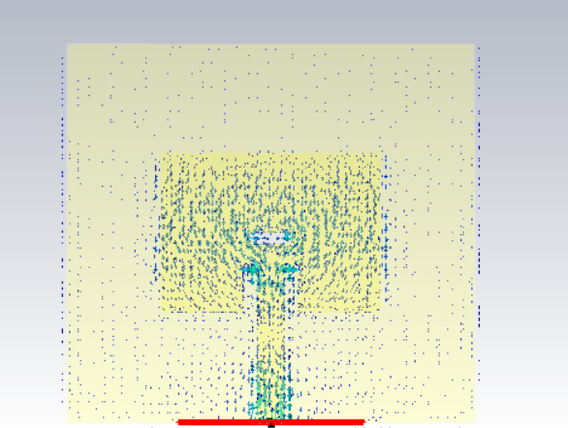 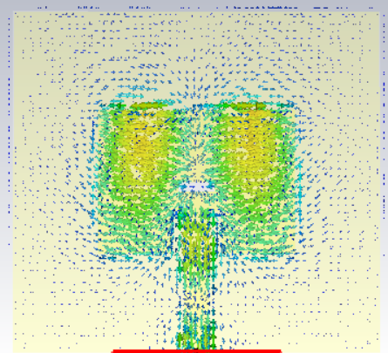

a) Current Distribution at 4 GHz (b) Current Distribution at 6GHz

Fig. 6 Surface Current Density Distribution of the proposed dual-band microstrip patch antenna

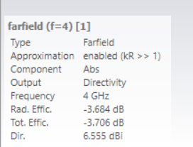 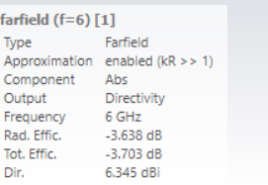

Fig. 7 & Fig. 8 shows the simulation results for the radiation pattern of the proposed antenna. The radiation pattern is nearly omnidirectional for both operating bands. The antenna gain is 2.87 dB for the 4 GHz (downlink) band and 2.71 dB for the 6 GHz (uplink) band, which meets the performance requirements. The simulated results are summarized in Table 2.

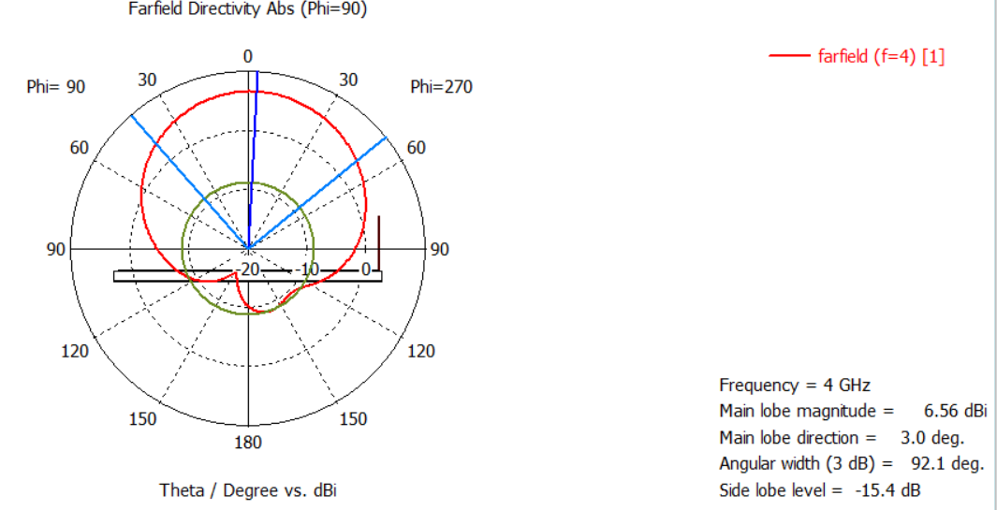

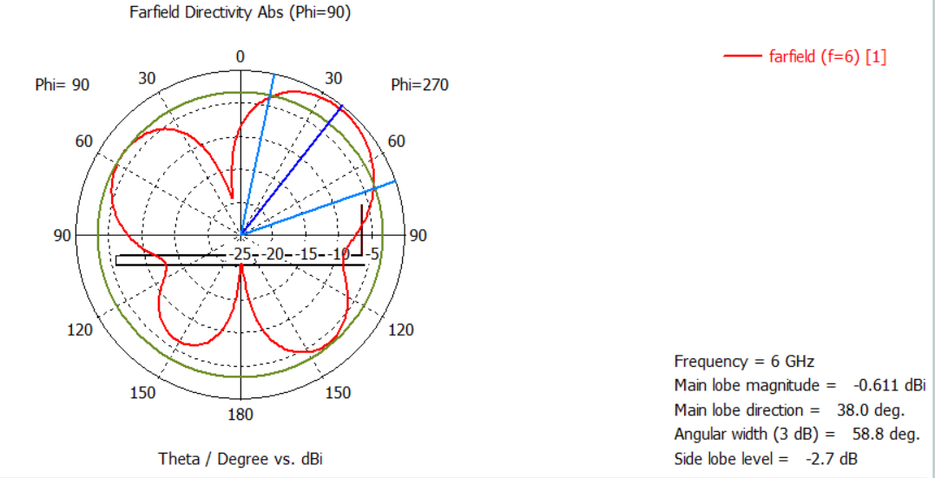 

Fig. 7 The simulated 1D radiation pattern of the proposed dual-band microstrip patch antenna

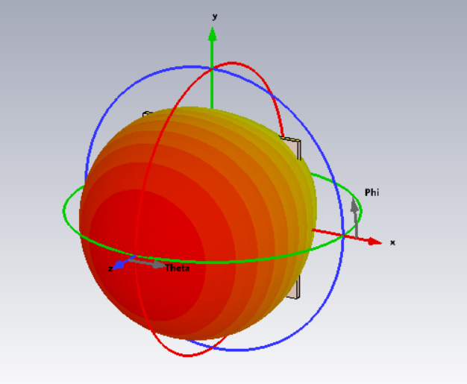 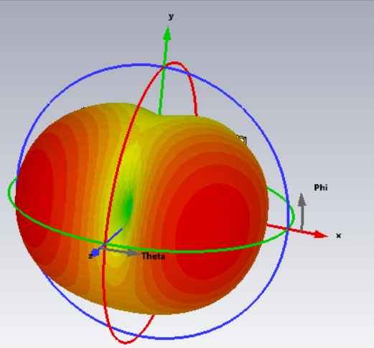

(a) Directivity at 4 GHz (b) Directivity at 6 GHz

Fig. 8 The simulated 3D radiation pattern of the proposed dual-band microstrip patch antenna

Table 2 The summarized simulated results

|  |  |  |
| --- | --- | --- |
| **Parameters** | **First Resonance (4GHz)** | **Second Resonance (6 GHz)** |
| **Frequency (GHz)** | 4 | 6 |
| **S11 (dB)** | -23.72 | -18.27 |
| **Bandwidth (GHz)** | 3.9–4.1=200 MHz | 5.875–6.125=250 MHz |
| **VSWR** | 1.139 | 1.277 |
| **Directivity (dB)** | 6.555 | 6.345 |
| **Radiation Efficiency (dB)** | -3.684 | -3.638 |
| **Gain (dB)** | 2.86 | 2.67 |

**Conclusion:**

In this project, the rectangular microstrip patch antenna is designed for dual-band operation, which operates at 4 GHz and 6 GHz. The proposed antenna is fully planar, low cost, and small in size. The first band appears at 4 GHz with about -23.72 dB return loss, and the second band appears at 6 GHz with about -18.27 dB return loss. The achieved values of VSWR are 1.14 and 1.29 in the respective operating bands. The simulated results demonstrate favorable transmission characteristics in both frequency bands, achieving bandwidths of approximately 200 MHz and 250 MHz, respectively. The antenna meets the required specifications for 802.11 WLAN standards. In the future, the designed antenna may be fabricated and tested in a real-time environment.

**Reference:**

* A Study on Dual-band Microstrip Rectangular Patch Antenna for Wi-Fi
* A circular microstrip patch antenna to operate in dual band for wireless communications
* Dual Band Microstrip Patch Antenna and its Gain Enhancement for X Band and Ku Band Application Using Metamaterial