PROJECT PROPOSAL
ONLINE LEARNING
PLATFORM
Database Design and System Overview

Project Information | Details
Project Type | Web-based Learning Management System
Database Name | online_learning
Database Server | MariaDB / MySQL
Development Technology | PHP, MySQL, HTML, CSS and JavaScript
Reference Application | SkillSet – Online Learning Platform

Prepared for Academic Project Presentation
SUBMITTED BY | STUDENT DETAILS
Name | Farjana Akter
Student ID | 1297023
Batch | PWAD 73

1. Introduction
The Online Learning Platform is a web-based application designed to make online education easier and more organized. Students can explore courses, enroll in courses, watch lessons, attend live classes, take quizzes and receive certificates. Instructors can publish courses and manage learning materials, while administrators can manage users and platform activities.
This project is planned with reference to the general features of the SkillSet Online Learning Platform. The database structure documented here is based on the SQL file supplied for this project.

2. Project Objectives
- Provide a single platform for online learning.
- Allow students to register, log in and manage their learning activities.
- Allow instructors to create courses and add sections and lessons.
- Support course enrollment and payment records.
- Provide quizzes, questions, answer options and quiz results.
- Support live class schedules, course reviews, wishlists and certificates.
- Organize information through a relational MySQL database.

3. Main User Roles
User Role | Main Responsibilities
Administrator | Manages users, courses, categories and overall platform information.
Instructor | Creates courses, adds course content, schedules live classes and supports learners.
Student | Browses courses, enrolls, makes payments, studies lessons, takes quizzes and reviews courses.

4. Main Features of the System
Feature | Description
User Management | Registration, login, user roles and account status.
Course Management | Course title, description, price, thumbnail, category and publication status.
Course Content | Sections and lessons containing video links and learning content.
Enrollment | Records which student has enrolled in which course.
Payment Management | Stores payment amount, method, transaction ID and payment status.
Quiz System | Stores quizzes, questions, answer options and correct-answer indicators.
Quiz Results | Stores student quiz attempts and obtained marks.
Live Classes | Stores class title, meeting link and scheduled start time.
Certificates | Stores certificate numbers and issue dates for students.
Reviews and Wishlist | Allows students to review courses and save courses for later.

5. Database Overview
The supplied SQL database is named online_learning. It contains 15 tables. The tables are connected through primary keys and foreign keys so that related information can be stored consistently.
No. | Table Name | Purpose
1 | users | Stores administrator, instructor and student accounts.
2 | categories | Stores course categories.
3 | courses | Stores course details and links each course to an instructor and category.
4 | course_sections | Stores the sections or chapters of each course.
5 | lessons | Stores lesson titles, video URLs and lesson content.
6 | enrollments | Stores student course enrollment records.
7 | payments | Stores student payments for courses.
8 | quizzes | Stores quizzes associated with courses.
9 | questions | Stores questions belonging to quizzes.
10 | quiz_options | Stores answer options and indicates the correct option.
11 | quiz_attempts | Stores student quiz attempts and obtained marks.
12 | certificates | Stores certificate details for students and courses.
13 | live_classes | Stores live class details and meeting links.
14 | course_reviews | Stores student ratings and written reviews for courses.
15 | wishlists | Stores courses saved by students.

6. Important Database Tables Explained
Table | Important Fields | Explanation
users | id (PK), name, email, password, phone, role, status, created_at | Stores all platform accounts. The role field identifies admin, instructor or student.
categories | id (PK), category_name, description, status | Groups courses into categories such as Programming, Design or Business.
courses | id (PK), instructor_id (FK), category_id (FK), title, description, price, thumbnail, status | Stores course information and identifies its instructor and category.
course_sections | id (PK), course_id (FK), section_title | Divides a course into chapters or sections.
lessons | id (PK), section_id (FK), lesson_title, video_url, content | Stores learning materials under a course section.
enrollments | id (PK), student_id (FK), course_id (FK), enrollment_date, status | Connects students with the courses they join.
payments | id (PK), student_id (FK), course_id (FK), amount, payment_method, transaction_id, status | Keeps a record of course payment information.
quizzes | id (PK), course_id (FK), title, total_marks, pass_marks | Stores assessments for a course.
questions | id (PK), quiz_id (FK), question, marks | Stores individual questions in a quiz.
quiz_options | id (PK), question_id (FK), option_text, is_correct | Stores possible answers for each question.
quiz_attempts | id (PK), student_id (FK), quiz_id (FK), obtained_marks, attempt_date | Records a student's quiz attempt and score.
certificates | id (PK), student_id (FK), course_id (FK), certificate_number, issue_date | Stores certificate information issued to students.
live_classes | id (PK), course_id (FK), instructor_id (FK), class_title, meeting_url, start_time | Stores scheduled online classes.
course_reviews | id (PK), student_id (FK), course_id (FK), rating, review | Stores student feedback about courses.
wishlists | id (PK), student_id (FK), course_id (FK) | Stores courses that students want to save.

7. Primary Key and Foreign Key
A Primary Key (PK) uniquely identifies each record in a table. A Foreign Key (FK) links a record to a related record in another table.
Key Type | Example from this database | Purpose
Primary Key (PK) | users.id | Uniquely identifies a user.
Foreign Key (FK) | courses.instructor_id | Links a course to its instructor in users.id.
Foreign Key (FK) | courses.category_id | Links a course to categories.id.
Foreign Key (FK) | enrollments.student_id | Links an enrollment to users.id.
Foreign Key (FK) | enrollments.course_id | Links an enrollment to courses.id.

8. Database Relationships
Parent Table(s) | Related Table | Relationship Explanation
users | courses | One instructor can create many courses.
categories | courses | One category can contain many courses.
courses | course_sections | One course can contain many sections.
course_sections | lessons | One section can contain many lessons.
users | enrollments | One student can have many enrollment records.
courses | enrollments | One course can have many enrolled students.
users and courses | payments | Each payment record is linked to a student and a course.
courses | quizzes | One course can contain many quizzes.
quizzes | questions | One quiz can contain many questions.
questions | quiz_options | One question can have multiple answer options.
users and quizzes | quiz_attempts | A student can make quiz attempts.
users and courses | certificates | A certificate is linked to a student and a course.
courses and users | live_classes | A live class is linked to a course and an instructor.
users and courses | course_reviews | A student can review a course.
users and courses | wishlists | A student can save courses to a wishlist.

9. Simplified ER Diagram
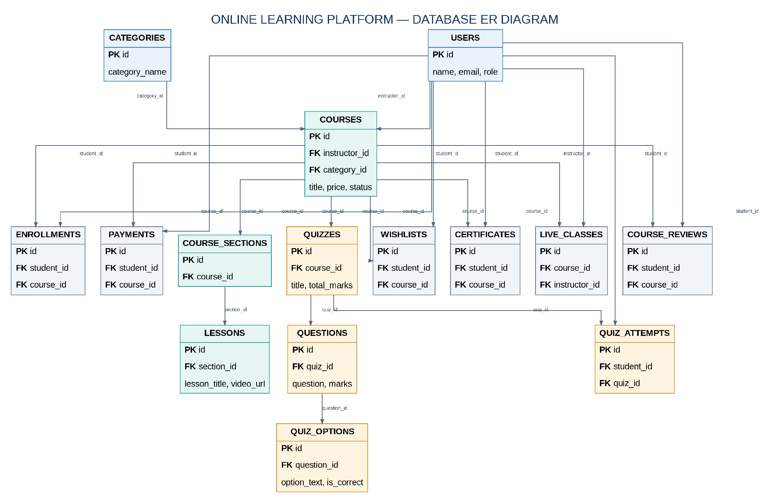
PK = Primary Key | FK = Foreign Key

10. System Workflow
- A user registers and logs in to the platform.
- The instructor creates a course and selects a category.
- The instructor adds course sections and lessons.
- The student browses available courses and selects a course.
- The student enrolls and the payment information is recorded.
- The student studies lessons and can join scheduled live classes.
- The student takes quizzes; questions, options and marks are stored.
- The platform can store course reviews and certificate details.

11. Technology Used
Technology | Use in the Project
HTML | Creates the structure of web pages.
CSS | Controls the design and layout.
JavaScript | Adds client-side interaction.
PHP | Handles server-side logic and database operations.
MySQL / MariaDB | Stores and manages application data.
Laragon / XAMPP | Provides a local development environment.
phpMyAdmin | Helps create and manage the database.

12. Expected Benefits
- Students can access course materials from one platform.
- Instructors can organize and publish learning content.
- Course enrollment and payment records are stored systematically.
- Quizzes and results help track student learning.
- Live class links, reviews, wishlists and certificates improve the learning experience.
- A relational database helps maintain organized and connected information.

13. Conclusion
The Online Learning Platform is designed to bring students, instructors and administrators together in one system. Its 15-table database supports user accounts, courses, lessons, enrollment, payments, quizzes, live classes, certificates, reviews and wishlists. This database provides a foundation for developing the application using PHP and MySQL.

14. Future Improvements
- Add lesson progress tracking and course completion rules.
- Add more detailed payment and refund management.
- Add notifications and messaging between students and instructors.
- Add downloadable learning resources and attendance tracking.
- Improve reporting and analytics for administrators.

15. Short Presentation Script
Good morning, respected sir. My name is Farjana Akter. My student ID is 1297023 and my batch is PWAD 73. Today I am going to present my project, Online Learning Platform. The main purpose of this project is to provide an online learning environment where students can learn courses, instructors can share educational content, and administrators can manage the platform. For this project, I designed a MySQL database named online_learning with 15 tables. These tables are connected using primary keys and foreign keys. The database stores users, courses, lessons, enrollments, payments, quizzes, live classes, certificates, reviews and wishlists. I plan to develop the application using PHP and MySQL. Thank you.
For this project, I designed a MySQL database named online_learning with 15 tables. The users table stores admin, instructor and student information. The courses table stores course details. Course sections and lessons organize the learning materials. Enrollments and payments store student course and payment records. The quiz system contains quizzes, questions, options and quiz attempts. The database also includes live classes, certificates, course reviews and wishlists.
These tables are connected using primary keys and foreign keys. I plan to develop the application using PHP and MySQL. Thank you.

Database Reference Note
This document follows the structure of the SQL dump supplied for the project. The supplied database is named online_learning and contains 15 tables. Field names and table names in this document follow that SQL file. The SkillSet application is used as a functional reference; this document does not claim to reproduce its private original database.

