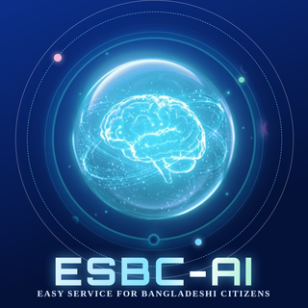 | PROJECT PROPOSAL  ESBC-AI  Easy Service for Bangladeshi Citizens  Farjana Ferdausi · AI & ML Engineering Bootcamp, Module-27, Batch-6, Ostad · October 2026
WEBSITE https://farjanaferdausi-cs50ai.github.io/ESBC-AI-Proposal/
REPOSITORY github.com/farjanaferdausi-cs50ai/ESBC-AI-Proposal GITHUB PROFILE github.com/farjanaferdausi-cs50ai
1. Problem statement
Government services in Bangladesh are essential, yet completing them is slow, costly and error-prone. Official information is scattered across portals, PDFs and circulars in formal Bangla and English, and the forms are hard to fill correctly. Many citizens therefore depend on agent shops, brokers and lawyers, and one typing or printing mistake can force them to pay again and restart the whole process. Official online portals already exist (for example for passports, birth and death registration and NID), so the remaining friction is not access but correct completion: understanding the form, matching documents and fixing errors before submission.
Evidence collected from my own experience, my family and an informal survey, cross-checked with public sources:
- Passport correction: a mother’s-name error carried over from the NID led to a lawyer, an affidavit, two court days and four trips of about 50 km, costing about 10,000 BDT extra.
- Death certificate (2022): agent-shop fees of about 1,200 to 1,500 BDT, corrections paid twice and 5 to 6 days lost. The official process is an online form, then a printed copy submitted at a local government office.
- NID correction and address update: still pending after 1.5 to 2 years, and the wrong record then spreads into other documents.
- Tax return: a lawyer is hired every year because the form wording is too hard to follow.
- Passport office day: queues from about 5 AM, form submission around noon or later, a second queue for biometrics, and brokers selling speed.
2. Objectives and success criteria
The goal is a bilingual assistive agent that reduces errors, intermediary costs and physical visits. Targets for the prototype, measured on a labelled evaluation set:
Answers  Top-5 retrieval hit rate 85% or higher; faithfulness (RAGAS) 0.85 or higher; correct source on 90% of answers; correct “I’m not sure” on 90% of out-of-scope questions. | Documents  Field extraction accuracy 85% or higher on synthetic documents; injected mismatches and typing errors detected in 80% or more of test cases. | Experience  Clarity rating of 4 out of 5 from five test users; physical visits per application cut from 4 (the passport survey case) to 1, for biometrics only.
3. Proposed solution
ESBC-AI (Easy Service for Bangladeshi Citizens) is a mobile-first, bilingual (Bangla and English) web application that acts as an assistive layer over official services, not a replacement. It has four layers:
Know  Plain-language answers in Bangla or English with the official source and date for every claim, official fees and deadlines (such as the 45-day registration period), and a Benefit Finder for social allowances. | Prepare  Guided form filling, phone document scanning with a quality check, cross-document validation, a Correction Pathway Guide and a ready-to-submit application packet.
Track and Pay  A stateful case tracker with email updates and simulated bKash and bank payment, run against a government-office simulator in the prototype. | Memory  An opt-in, encrypted vault: “Save to Memory” stores documents and key details, autofills future forms and helps after documents are lost.
Prototype scope: citation-grounded Q&A across 13 service areas (birth and death registration, passport, NID, tax, social allowances, land mutation, driving licence, police clearance and more) and one complete guided flow, the Death Certificate. It is not an official government service and is not affiliated with any government office.
4. System architecture
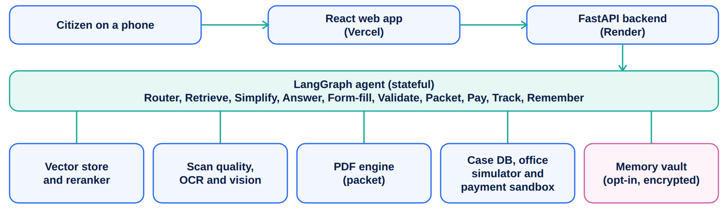
Pipelines: offline ingestion (extraction, cleaning, chunking with source, URL, date and language metadata, embeddings, vector store) and an online agent loop in which an intent router sends questions to retrieval, re-ranking, a plain-language rewrite and a cited answer (or a refusal), and applications to a form subgraph with scan check, extraction, validation, confirmation, packet, payment and case creation.
5. Related work and positioning
The government already runs Nagorik Sheba Bangladesh, myGov and the ekSheba centres, announced the Sathi virtual assistant, and official portals offer online forms and appointments. ESBC-AI complements them with capabilities that public descriptions of those services do not highlight: the source and date on every claim, a refusal when unsure, plain-language explanation, cross-document checks with a correction pathway, and scan-to-packet preparation. Every source is dated, the newest official source wins when sources conflict, and the biometric visit stays physical.
6. AI approach and methodology
Component | Method | How it is evaluated
Retrieval | Multilingual embeddings (BGE-M3 or multilingual-e5), hybrid BM25 and dense search, cross-encoder re-ranking; each chunk carries source, page, URL and date. | Top-5 hit rate
Grounded generation | Gemini LLM with a citation-constrained prompt that answers only from retrieved passages. | Faithfulness (RAGAS), citation correctness
Hallucination control | A confidence gate on the re-ranker score plus a groundedness check; below the threshold the agent says “I’m not sure” and points to the official office. | Refusal accuracy on out-of-scope questions
Plain-language rewriting | Formal Bangla and English rewritten in everyday words, always shown beside the original wording and its source. | User clarity rating
Document intelligence | OpenCV quality checks (blur, glare, crop), Tesseract (Bangla and English) with a vision-LLM fallback, Pydantic structured extraction with per-field confidence. | Field-level accuracy on synthetic documents
Validation | Rule-based and LLM-assisted checks of names, dates and relationships; the correction type is identified from official rules. | Injected-error detection rate
Orchestration | LangGraph state graph with tools, checkpoints and human confirmation before anything is generated; opt-in Memory through a LangGraph store. | Task completion, visits per application
7. Technology stack
Frontend: React, mobile-first web app with camera upload. Backend: FastAPI, Pydantic, case database, PDF generation (ReportLab or WeasyPrint). AI and ML: LangGraph, LangChain, Gemini, Chroma, OpenCV, Tesseract. Deployment: Vercel (frontend), Render (backend), Docker. Engineering: Git and GitHub, pytest, RAGAS, Langfuse or LangSmith tracing.
8. Plan, 12 to 23 October 2026
Dates | Output
12 to 13 Oct | Repository, knowledge base, ingestion, embeddings, evaluation set v1
14 to 15 Oct | LangGraph agent, retrieval and re-ranking, citations, refusal gate, FastAPI skeleton; live skeleton deployed on 16 Oct
16 to 18 Oct | Death Certificate form flow, synthetic documents, OCR pipeline
19 to 20 Oct | Extraction, validation, packet PDF, Memory, case tracker, API tests; scope freeze on 20 Oct
21 to 23 Oct | React UI and deployment (21); final evaluation, README, final report and demo video (22); buffer and submission (23)
9. Risks and mitigation
Risk | Mitigation
Bangla OCR accuracy on phone photos | Scan guide and quality check, vision fallback, per-field confidence, manual correction
Outdated or conflicting official sources | Dated sources, newest official source wins, conflicts flagged, refusal when unsure
Free-tier hosting limits | Warm-up ping, vector index built at startup from committed documents, small demo data
Scope too large for 12 days | Priority tiers with a cut line: Q&A first, then the Death Certificate flow, then optional features
10. Deliverables and ethics
Deliverables: code repository with frontend, backend and AI components and meaningful commits; deployed application at a public URL; README with setup instructions, description of the AI models and methodology, usage instructions and screenshots; final report (3 to 5 pages); a 3 to 4 minute demo video. Ethics: synthetic documents only in the demo, opt-in and deletable Memory, no legal advice, and a clear statement that it is not an official service.

