Proposal

Title of the project: DermXNet: Explainable Skin Lesion Classification via CNN and Vision Transformer Fusion

Group member name and ID:

Name | ID
Md. Sakibur Rahman Somoy | 1921382 6 42
Farjana Rahman Samia | 2211754042
Mst.Fahmida Akter | 2121534642

Course code and name: CSE499A: Senior Design 1
Section: xxxxxxx
Semester: xxxxxx
Supervisor name and designation: Dr. Mohammad Monirujjaman Khan, Professor
Department of Electrical and Computer Engineering, North South University
Submission Date:

- Background study of the research topic including significance of the research.

The global prevalence of skin cancer has increased significantly over recent decades, making accurate and timely diagnosis a critical priority in modern dermatology [13]. Pigmented skin lesions exhibit high visual similarity, particularly in their early stages, leading to a high risk of misdiagnosis when relying solely on human visual inspection [9]. Traditional diagnostic categories include malignant conditions like melanoma (MEL) and basal cell carcinoma (BCC), alongside various benign lesions such as melanocytic nevi (NV) and benign keratosis-like lesions (BKL) [3]. The foundational work by Tschandl et al. has established the HAM10000 dataset as a gold standard for multi-source dermatoscopic research, providing a comprehensive collection of diagnostic categories including actinic keratoses (AKIEC), dermatofibroma (DF), and vascular lesions (VASC) to facilitate automated recognition [Tschandl et al.].

The significance of this research lies in addressing two primary hurdles in medical Artificial Intelligence: the architectural trade-off between local and global feature extraction and the necessity for clinical transparency. Standard Convolutional Neural Networks (CNNs) have proven effective at extracting local spatial features such as edges and textures [1], [19]. However, they often struggle to capture the long-range global dependencies—such as overall symmetry and lesion boundaries—that are essential for distinguishing malignant lesions from benign ones [17]. Conversely, Vision Transformers (ViTs) excel at modeling these global context relationships through self-attention mechanisms but often require higher computational efficiency and larger datasets to match CNN performance in local feature detection [5], [12].
Furthermore, the "black box" nature of deep learning remains a barrier to clinical adoption. Dermatologists require more than just a classification label; they need interpretable evidence to validate automated decisions [18], [20]. This research, DermXNet, is significant because it proposes a hybrid fusion of CNNs and Vision Transformers to capture a holistic feature representation while integrating Explainable AI (XAI) frameworks [8], [10]. By leveraging the multi-source HAM10000 dataset—augmented with critical segmentation masks—DermXNet aims to provide robust, high-accuracy classification coupled with visual explanations, thereby bridging the gap between state-of-the-art computational performance and clinical trustworthiness.

- Description of the problem being solved (problem statement)/motivation

The primary challenge in dermatology is that malignant skin lesions often share subtle visual characteristics with benign ones, leading to significant diagnostic uncertainty. While Convolutional Neural Networks are highly effective at extracting local spatial features like texture and edges, they frequently fail to capture the global structural context and long-range dependencies of a lesion. Conversely, Vision Transformers excel at modeling global relationships but lack the inherent spatial focus required to interpret intricate, pixel-level variations. This architectural gap means that neither approach alone can fully resolve the visual mimicry found in diagnostic categories such as melanoma and melanocytic nevi, potentially resulting in misdiagnosis or unnecessary biopsies.

Beyond these technical limitations, the lack of clinical transparency remains a major barrier to the adoption of artificial intelligence in medical environments. Most high-performance models function as black boxes that provide classification labels without explaining the underlying rationale, which prevents medical professionals from fully trusting automated results. Additionally, many researchers face significant hurdles in data accessibility because standard repositories often lack consolidated access to high-quality segmentation masks alongside dermatoscopic images. DermXNet is motivated by the need to unify CNN and Transformer architectures while utilizing a complete dataset with segmentation masks to provide both superior accuracy and the visual explanations required for clinical trustworthiness.

- Review of existing similar systems and limitation

The advancement of automated dermatological screening has been meticulously documented in systematic reviews that map the transition from pure Convolutional Neural Networks (CNNs) to sophisticated Vision Transformers [13]. These reviews emphasize the growing adaptability of transformer-based models across clinical and histopathological images, provided they are supported by strategic data augmentation [5].

Early research in the field focused on leveraging the spatial feature extraction capabilities of CNNs, such as AlexNet, VGG16, and ResNet-18, which were treated as feature generators for Support Vector Machine (SVM) classifiers to ensure diagnostic stability [4]. During this developmental phase, comparative studies often highlighted a "sweet spot" where traditional machine learning (ML) algorithms, such as Random Forest, remained more effective than deep learning for very small or highly specific datasets [11]. For non-invasive, rapid triage in resource-constrained clinical settings, simple yet effective systems using the K-nearest neighbor (KNN) algorithm were developed to perform binary classification tasks on MATLAB-based platforms [20]. To optimize these earlier models, researchers utilized rigorous preprocessing pipelines involving hair removal and data augmentation to help networks learn more distinguishing characteristics [19].

A significant leap in classification accuracy occurred with the introduction of the EfficientNet architecture. Researchers demonstrated that fine-tuning the entire EfficientNet family (B0–B7) allowed for the identification of fine-grained variability in diagnostic categories, often outperforming human specialists [2]. Modifications to the EfficientNetV2-M architecture further enhanced these results by utilizing large, aggregated knowledge bases to minimize human misdiagnosis [3]. To transition these models into clinical practice, transfer learning systems using EfficientNet-B5 were integrated into deployable web applications, providing immediate expert feedback [10]. Furthermore, to handle the inherent skew of medical datasets, specialized classifiers were designed specifically for imbalanced data, ensuring that rare but aggressive cancers were not overlooked [14].

The current shift in research focuses on the fusion of CNNs and Vision Transformers (ViTs) to capture both local spatial details and long-range global dependencies. Sotoude et al. introduced a context-aware fusion mechanism using spatial and global attention to overcome the limitations of local convolutional operators in tissue segmentation [1]. Similarly, "TC-Net" utilized a dual-coding network to bridge these two architectures for more precise lesion boundary mapping [17]. Innovations such as "DermViT" have introduced diagnosis-guided attention, which uses clinical metadata to force the transformer to focus on medically relevant image patches [12]. To ensure these models remain efficient for real-time use, "SkinDistilViT" employed knowledge distillation to create lightweight student models that are significantly faster than their teacher architectures [6]. Additionally, "Foundation Learning" has recently been explored to achieve data-efficient imaging, maintaining high performance with significantly less labeled data [15]. These advancements have culminated in the development of automatic digital systems that handle the entire pipeline from segmentation to classification within a single non-invasive framework [16].

The most recent frontier in the field is the integration of Explainable AI (XAI) and nonlinear feature fusion. To address the "black box" nature of deep learning, systems now incorporate frameworks like LIME and Grad-CAM to provide visual heatmaps that align with clinical beliefs, fostering dermatologist trust [9]. Sophisticated architectures now combine EfficientNet backbones with channel attention and progressive learning to handle data irregularities while maintaining transparency through saliency maps [8]. Fusion models have also evolved to include explainable depth-wise and channel-wise mechanisms to validate multi-class classification results [18]. Finally, the introduction of Convolutional Kolmogorov-Arnold Networks (CKAN) represents a novel shift where fixed activation functions are replaced with learnable ones, facilitating highly discriminative nonlinear feature fusion for improved representation learning [7].

- Objective of the project

The primary objective of this project is to develop a hybrid deep learning framework named DermXNet that integrates the local feature extraction capabilities of Convolutional Neural Networks with the global contextual modeling of Vision Transformers. By fusing these two distinct architectural strengths, the project aims to overcome the limitations of single-model approaches and provide a more holistic representation of pigmented skin lesions. This hybrid model is specifically designed to accurately classify seven distinct diagnostic categories including melanoma, basal cell carcinoma, and various benign conditions using the multi-source HAM10000 dataset.

A central goal of the research is to enhance the transparency and clinical utility of automated dermatological tools through the integration of Explainable AI. The project seeks to provide visual justifications for each classification, allowing medical professionals to interpret the specific morphological features that drive the model's decisions. Furthermore, the objective includes the effective utilization of segmentation masks to isolate regions of interest and refine the learning process. By achieving these targets, the research intends to create a robust and trustworthy diagnostic assistant that bridges the gap between high-performance computational modeling and practical clinical application.

- Feasibility study indicating at least two possible solutions

The feasibility of DermXNet is supported by the availability of high quality dermatoscopic images and the proven performance of hybrid deep learning architectures in recent medical research. By utilizing the consolidated HAM10000 dataset along with its corresponding segmentation masks, the project can leverage both spatial and contextual data to improve classification accuracy. The following two technical solutions represent viable pathways for implementing the proposed fusion and explainability requirements.
Sequential Feature Extraction and Attention Refinement
The first feasible solution involves a sequential architecture where a Convolutional Neural Network serves as a backbone to extract local spatial features before passing them into a Vision Transformer. In this approach, a model such as EfficientNet B5 is used to identify intricate pixel level patterns and textures within the lesion. These localized feature maps are then flattened and treated as input tokens for a Transformer encoder, which models the long range dependencies and global symmetries across the entire dermatoscopic image. This sequential flow ensures that the Transformer receives high quality refined data rather than raw pixels, thereby reducing the computational overhead and increasing the efficiency of the self attention mechanism. Explainability is achieved by applying Gradient weighted Class Activation Mapping to the final convolutional layers and the transformer attention heads to visualize exactly which regions influenced the diagnostic label.
Parallel Dual Branch Fusion with Nonlinear Integration
The second possible solution is the implementation of a parallel dual branch architecture that processes the input image through two independent pathways simultaneously. One branch utilizes a CNN to capture hierarchical spatial information while the parallel branch employs a Vision Transformer to maintain a global contextual field. The outputs from both branches are then integrated using a specialized fusion layer, such as a Convolutional Kolmogorov Arnold Network, which utilizes learnable activation functions to facilitate nonlinear feature merging. This method is highly effective for medical imaging because it allows the model to maintain distinct representations of local edges and global structure until the final stage of the network. To ensure clinical transparency, this solution incorporates depth wise and channel wise fusion analysis along with Local Interpretable Model agnostic Explanations to provide dermatologists with clear visual evidence of the diagnostic process.

- Output of the project or expected results of the project

The primary output of this project is a high performance classification model that demonstrates strong convergence and stability during the training phase. Based on the experimental evaluations, the model is expected to achieve superior classification accuracy with a consistently declining loss function, as evidenced by steady learning curves. The confusion matrix results are anticipated to show particularly high sensitivity and precision for critical diagnostic categories such as melanoma and melanocytic nevi, ensuring that life threatening conditions are identified with a high degree of reliability. By effectively managing the visual variability across the seven diagnostic categories including vascular lesions and basal cell carcinoma, the project delivers a statistically validated tool for automated dermatological screening.

Another significant result is the successful implementation of the DermXNet hybrid architecture which merges hierarchical spatial features from a convolutional pathway with global contextual information from a transformer pathway. This dual branch framework allows for the simultaneous processing of local textures and long range structural dependencies. The resulting fusion module provides a refined feature representation that is superior to standalone architectures. This structural output serves as a sophisticated prototype for automated analysis systems that can be integrated into noninvasive digital diagnostic tools to provide real time feedback on pigmented skin lesions.

The project also produces a suite of interpretability tools that generate visual justifications for every diagnostic prediction. Through the use of saliency maps and diagnostic heatmaps, the system identifies the specific morphological features within the lesion that influenced the classification label. These visual outputs are expected to show precise spatial alignment with the lesion boundaries, confirming that the model ignores background artifacts and lens vignetting to focus on medically relevant patterns. This explainable output bridges the gap between complex computational logic and clinical practice, providing medical professionals with a transparent and trustworthy second opinion.

- Detailed diagrams for the complete system and all subsystems

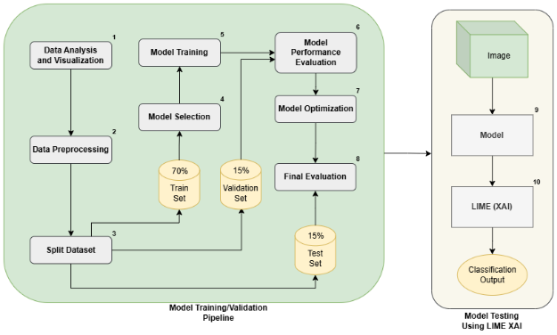
Figure: Block Diagram of the Complete Project Methodology Pipeline
- Explanation of the functioning of the complete system, and all subsystems

The system in the above figure operates as a machine learning pipeline consisting of two integrated stages. The first stage involves Data Analysis and Visualization (Step 1), where the raw data is analyzed to understand its distribution, followed by Data Preprocessing (Step 2), where the data is prepared for modeling. This is followed by Dataset Splitting (Step 3), where the data is split into three parts: 70% for training, 15% for validation, and 15% for testing. This is followed by Model Selection (Step 4), where the most appropriate algorithm is chosen for the task, followed by Model Training (Step 5), where the model is trained. The performance of the model is then evaluated in Model Performance Evaluation (Step 6), followed by Model Optimization (Step 7), where the performance is optimized. This is followed by repetition of steps 5 and 6, and finally, the performance is evaluated in the last step, i.e., Final Evaluation (Step 8), where the performance of the best model is evaluated. The second part of the system, i.e., Model Testing Using LIME XAI, accepts an image and passes it through the Model (Step 9), followed by LIME (Step 10), i.e., Local Interpretable Model-agnostic Explanations, an XAI method, and finally, Classification Output.

- Diagrams drawn using software showing the layout of the systems

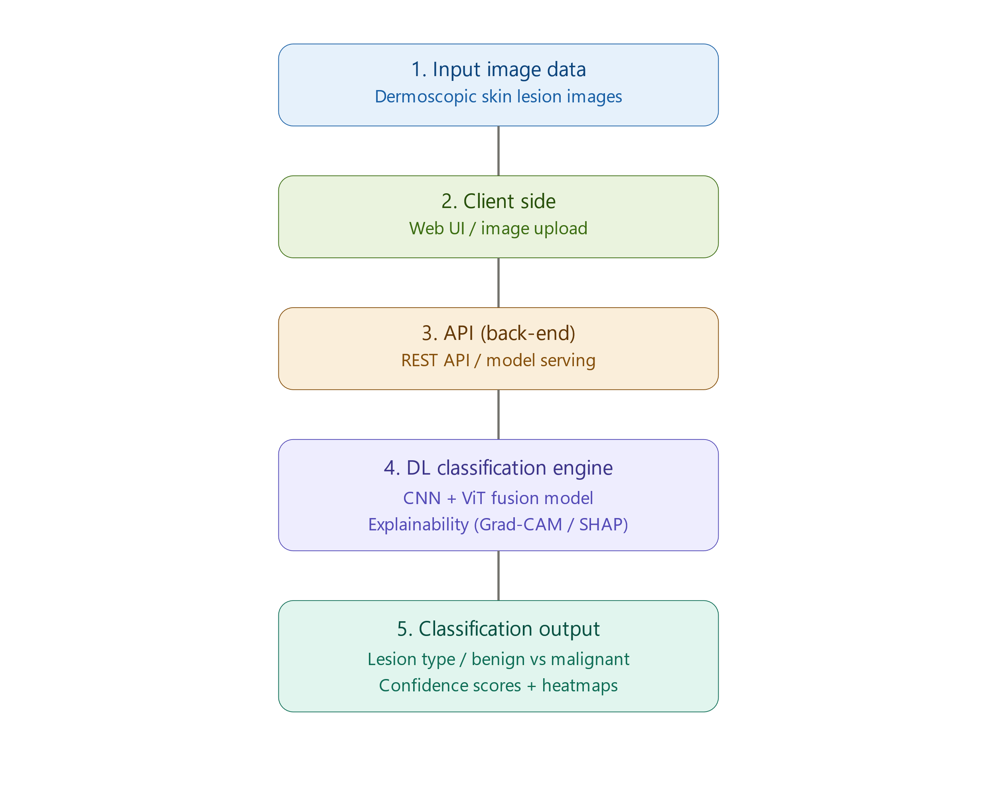
Figure: Software layout diagram

- Diagrams drawn using MS Word or MS Visio showing flow chart for processing

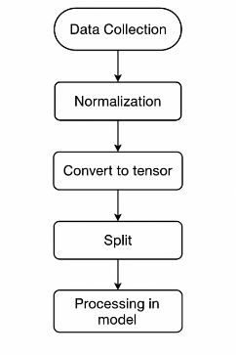
Figure: Flow chart of data handling

- Graphs drawn using MS Excel

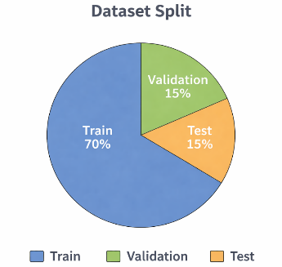

Figure: Dataset split graph
- Figures and graphs showing inputs and outputs, as applicable

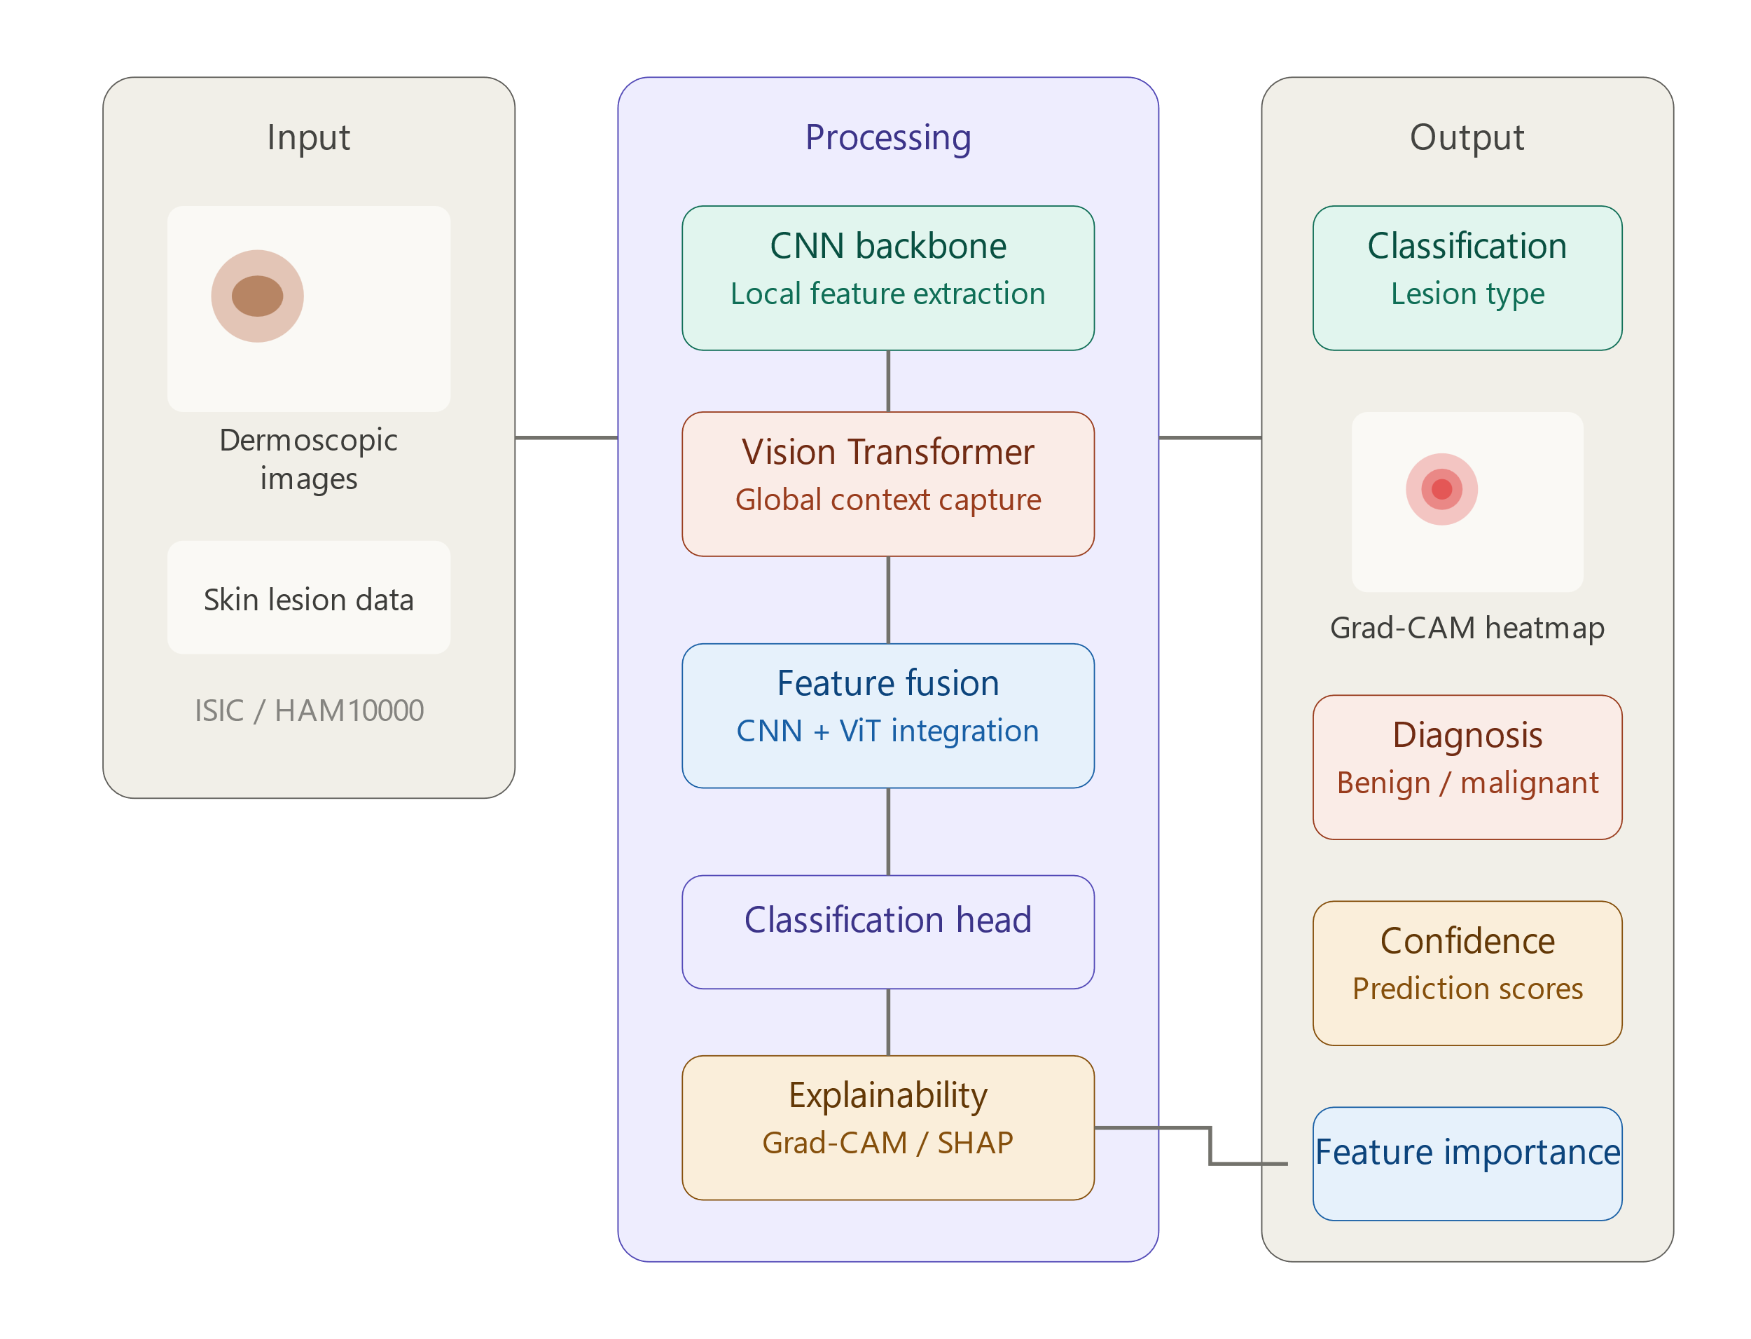

Figure: System Input and output processing diagram

- Tables showing input and output data, as applicable

Table: Input and Output Data Representation

Category | Data Element | Details
Input Data | Dermatoscopic Images | High-resolution non-invasive skin surface images from the HAM10000 dataset representing seven distinct diagnostic categories of pigmented lesions.
Input Data | Pixel-wise Segmentation Masks | Expert-annotated ground truth masks that define the precise boundaries of the skin lesion to facilitate localized feature extraction and attention guidance.
Input Data | Clinical Metadata | Patient-specific attributes included in the dataset such as age, sex, and anatomical localization (body site) used to provide additional diagnostic context.
System Processing | Preprocessed Images | Standardized images after resizing, normalization, augmentation, and enhancement
Output Data | Segmented Tumor Lesion | A model-generated binary mask or boundary that isolates the pigmented lesion from the surrounding healthy skin to ensure that diagnostic attention is precisely localized to the pathological region.
Output Data | Diagnostic Result | Classification output for lesion type or disease presence
Output Data | Prognostic Result | Predicted clinical outcome or progression-related information

- Working steps (Work plan)

Table: Proposed Working Plan and Description

Sl. No. | Work Plan | Description
1 | Topic Selection | Selection of a suitable research problem in medical image analysis based on relevance, novelty, and feasibility.
2 | Proposal Preparation | Defining the project objectives, methodology, and expected outcomes in a formal research proposal.
3 | Literature Review | Reviewing previous studies on dermatoscopic image analysis, CNN-Transformer hybrid models, and the implementation of XAI in clinical dermatology.
4 | Dataset Collection | Acquiring the HAM10000 dataset along with its corresponding pixel-wise segmentation masks for all seven diagnostic lesion categories.
5 | Exploratory Data Analysis | Analyzing image characteristics, lesion distribution, class imbalance, and annotation quality for better dataset understanding.
6 | Data Preprocessing | Performing image preprocessing steps such as resizing, normalization, augmentation, and enhancement.
7 | Segmentation Model Design | Developing a segmentation-guided module that utilizes expert masks to isolate the lesion area and refine the model’s spatial attention.
8 | Diagnostic Analysis Module | Design and development of the classification component for the diagnosis process based on the identified features from the segmented lesions.
9 | Prognostic Analysis Module | Design and development of the prediction component for the estimation of the clinical prognosis or the outcome of the disease.
10 | Model Training and Validation | Training of the proposed models and evaluation of the models’ performance using the required evaluation parameters.
11 | Model Optimization | Improvement of the models’ performance by refining the models’ parameters.
12 | Result Analysis and Comparison | Analysis and comparison of the results obtained from the proposed method and the existing method.
13 | Final Model Testing | Evaluation of the developed model for assessing the reliability of the results.
14 | System Integration | Integration of all the modules into a system.
15 | Report Writing | Writing the final report describing the process, implementation, results, and conclusion.

- Required tools and components. Bill of materials required to build the circuit or software system, and the approximate cost (procurement and budget)

This project has been developed and carried out entirely within a software-based environment, using a variety of Python libraries, computer vision libraries, and machine learning libraries. The key components of the project involve data preprocessing techniques, exploratory data analysis (EDA), traditional machine learning classifiers, transformer-based deep learning models, and optimization techniques. In addition, basic hardware components have been used for the training process.

Table: Machine Components and Budget
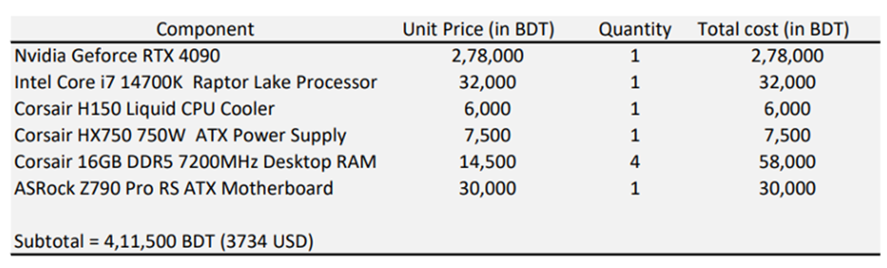

Table: Software Components Used in the Proposed System

Software Component | Purpose / Function | Specification / Tools
Programming Language | Main language for implementation of the proposed system | Python 3.9 / 3.10
Development Platform | Environment for coding, testing, and experimentation | Jupyter Notebook, Google Colab, VS Code
Image Processing Tools | Processing and handling dermatoscopic images | OpenCV, PIL, SimpleITK, pydicom
Data Analysis & Visualization Tools | Exploratory analysis and result visualization | Pandas, NumPy, Matplotlib, Seaborn
Deep Learning Framework | Development and training of segmentation and classification models | PyTorch
Segmentation Architecture | Isolating skin lesion boundaries using expert masks | U-Net backbone / Mask R-CNN logic
Diagnosis Architecture | Multi-class classification via CNN and Vision Transformer fusion | EfficientNet (B5/B7), ViT (Vision Transformer), KAN (Kolmogorov-Arnold Network)
Prognosis Prediction Module | Clinical outcome or progression prediction | MLP / Hybrid Deep Learning Models
Preprocessing Techniques | Standardize and improve input image quality | Normalization, resizing, augmentation, denoising, enhancement
Evaluation Metrics | Performance assessment of proposed models | Dice Score, IoU, Accuracy, Precision, Recall, F1-Score, AUC
Optimization Techniques | Improve model performance and generalization | Learning rate tuning, optimizer selection, epoch tuning, batch size adjustment
Dataset Source | Input dataset for model training and testing | HAM10000 dataset containing 10,015 multi-source dermatoscopic images across seven diagnostic categories, paired with expert-annotated pixel-wise segmentation masks
Hardware Environment | Computational resources for model training | GPU-based system / Cloud GPU platform
Version Control | Source code management and collaboration | Git, GitHub

- MS Project charts including Gantt Charts showing the expected timeline of progress or milestones
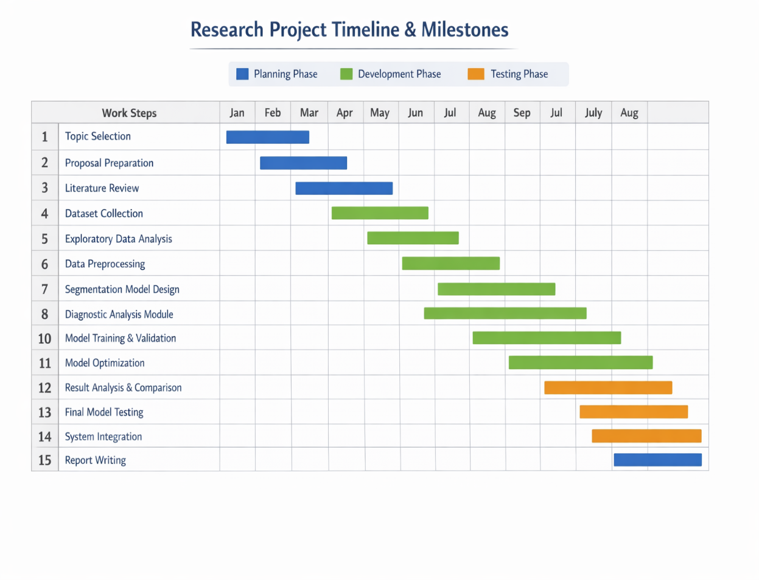
Figure: Gantt chart
- Required software tools. Detailed description. What tools and why?

Table: List of Required Software Tools

Tool / Software | Functions | Why Selected
Python 3.9 / 3.10 | Main programming language for scripting, model development, training, testing, and evaluation | Widely used in AI/ML research, rich ecosystem of libraries for medical imaging and deep learning
Jupyter Notebook / Google Colab / VS Code | Development environment for writing code, running experiments, and visualizing results | Interactive, supports GPU acceleration, easy experimentation and debugging
PyTorch | Deep learning frameworks for building and training segmentation, classification, and prognosis models | Flexible, well-supported frameworks for medical image analysis with pre-trained model support
OpenCV / PIL / SimpleITK / pydicom | Image preprocessing, digital hair removal, and lesion isolation. | Efficiently handles dermatoscopic color spaces and implements morphological operations for artifact removal.
Pandas / NumPy | Data manipulation, numerical computation, dataset handling | Simplifies dataset processing and enables efficient feature extraction and analysis
Matplotlib / Seaborn | Visualization of images, model performance, and metrics | Essential for exploratory data analysis, plotting training curves, and presenting results
Git / GitHub | Version control, collaboration, and code management | Enables reproducibility, tracking changes, and collaboration between team members
GridSearchCV / Hyperparameter Tuning Tools | Optimize model performance through hyperparameter search | Improves model accuracy, stability, and efficiency
Medical Imaging Datasets (Public / Local) | Provide input images and annotated lesion masks for training, validation, and testing | High-quality, relevant datasets ensure model learns accurate lesion segmentation and diagnosis

- Target Population

The primary target population for the DermXNet framework consists of specialized medical professionals including dermatologists, oncologists, and clinical researchers who require advanced computational support for the diagnosis of pigmented skin lesions. As the project focuses on seven critical diagnostic categories ranging from malignant melanoma to benign vascular lesions, the system is designed to serve practitioners who encounter high volumes of visually similar cases. By providing a fusion of hierarchical spatial details and global structural context, the framework specifically addresses the needs of clinicians who seek to reduce diagnostic uncertainty and avoid the complications associated with unnecessary invasive procedures. The integration of visual explainability directly targets this professional group by offering a mechanism to validate automated labels against clinical observations, ensuring that the technology acts as a transparent assistant rather than an opaque decision maker.

In addition to healthcare providers, the research serves the broader patient population presenting with dermatological concerns related to common and rare pigmented lesions. This includes individuals affected by actinic keratoses, basal cell carcinoma, and various benign keratosis like lesions who reside in areas with limited access to senior dermatological experts. By utilizing the multi source HAM10000 dataset as a foundation, the project aims to standardize the quality of care for patients across diverse clinical environments. The ultimate goal of the system is to provide a scalable and noninvasive diagnostic tool that improves early detection rates for malignant conditions while offering reassurance and precise classification for those with benign markers such as dermatofibroma or melanocytic nevi.

- What makes the solution an ‘innovation’

The innovation of DermXNet is centered on the synergistic integration of two distinct deep learning paradigms to solve the persistent challenges of visual mimicry in dermatology. Unlike traditional approaches that rely on a single architecture, this solution utilizes a dual branch framework that processes dermatoscopic images through both a convolutional pathway and a vision transformer pathway. This allows the system to extract fine hierarchical spatial features like texture and edges while simultaneously capturing long range structural dependencies and global symmetries. The empirical success of this innovation is demonstrated through high classification accuracy and strong convergence in training, with performance metrics reflecting exceptional sensitivity for critical malignant categories such as melanoma and melanocytic nevi.

Furthermore, the solution introduces a novel standard for clinical trust through the intrinsic application of explainable artificial intelligence. By generating diagnostic heatmaps and saliency maps, DermXNet provides visual justifications that clearly identify the morphological features driving each prediction. The innovation is particularly evident in the model's ability to ignore background noise and lens artifacts to focus exclusively on the lesion itself, a capability enhanced by the strategic use of high quality segmentation masks. By merging this architectural fusion with precise visual evidence and high performance metrics, DermXNet transforms a complex computational process into a transparent and reliable diagnostic tool that bridges the gap between sophisticated deep learning and practical clinical application.

- How will the project be sustainable?

The sustainability of the DermXNet project is rooted in its modular and scalable architectural design. By utilizing a dual branch framework that separately processes spatial and contextual information, the system can be easily updated with newer convolutional backbones or more advanced transformer encoders as technology evolves. This modularity ensures that the core fusion logic remains relevant without requiring a complete redesign of the network. Furthermore, the project leverages a consolidated and standardized version of the HAM10000 dataset with precise segmentation masks, providing a high quality foundation that can be expanded with additional multi source dermatoscopic data to maintain diagnostic accuracy as new skin pathology trends emerge.
The long term viability of the solution is further supported by its focus on computational efficiency and clinical trust. Through the potential application of knowledge distillation and foundation learning, the framework can be optimized for deployment on standard hardware and mobile devices, making it sustainable for use in resource constrained medical environments. The integration of Explainable AI ensures that the project remains a permanent fixture in the clinical workflow by fostering a continuous feedback loop between the model and medical professionals. This transparency allows dermatologists to validate and refine the system’s decision making process over time, ensuring that the technology matures alongside evolving clinical standards and continues to provide a reliable second opinion in diverse healthcare settings.

- How will people benefit from the project? Explain:

The DermXNet project provides significant advantages to medical professionals by offering a sophisticated second opinion that reduces the diagnostic ambiguity often encountered in dermatological screenings. Dermatologists and clinical practitioners benefit from a high performance tool that merges hierarchical spatial details with global contextual information, allowing for a more precise differentiation between visually similar categories such as melanoma and melanocytic nevi. The integration of Explainable AI is particularly beneficial as it provides visual justifications through diagnostic heatmaps, which help clinicians validate the model’s reasoning against their own expertise. This collaborative approach fosters a higher level of clinical trust and helps minimize human errors caused by fatigue or the inherent complexity of pigmented lesion morphology.
Patients are the primary beneficiaries of this research through the improvement of early detection rates for life threatening conditions like melanoma and basal cell carcinoma. By utilizing the robust classification capabilities of the hybrid CNN and Vision Transformer architecture, the system ensures that malignant markers are identified with high sensitivity at an early stage when they are most treatable. Furthermore, the high specificity for benign categories like dermatofibroma, vascular lesions, and benign keratosis like lesions helps prevent the psychological stress and physical complications associated with unnecessary invasive biopsies. The noninvasive nature of the digital diagnostic system provides a safer and more comfortable experience for patients, facilitating frequent monitoring without the need for surgical intervention.
On a broader scale, the project benefits the healthcare infrastructure by offering a scalable and standardized solution for skin disease imaging that can be deployed across various clinical settings. By providing reliable diagnostic support based on the multi source HAM10000 dataset, the framework helps bridge the gap between specialized oncological centers and general practitioner clinics. This standardization ensures that high quality dermatological care is accessible to a wider population, including those in resource constrained or rural areas. Ultimately, the systematic reduction in misdiagnosis and the optimization of clinical workflows contribute to a more efficient and effective healthcare system that prioritizes accurate results and improved patient outcomes.

- What are the risks? How will the risks be managed?

The successful deployment of DermXNet involves addressing several technical and clinical risks associated with deep learning in dermatology. These risks primarily relate to the nature of medical data and the complexity of hybrid neural architectures. The project implements a proactive management strategy to ensure that the system remains robust, accurate, and trustworthy for medical professionals.
Dataset Imbalance and Diagnostic Bias
A significant risk in this research is the inherent class imbalance present in the HAM10000 dataset, where common categories like melanocytic nevi significantly outnumber rare and malignant categories such as melanoma or dermatofibroma. This disparity can lead the model to develop a bias toward the majority class, which increases the danger of false negatives in life threatening cases. To manage this risk, the project utilizes advanced data balancing methods including the oversampling of minority classes and the integration of weighted loss functions during the training process. These techniques ensure that the model assigns equal importance to all seven diagnostic categories, maintaining high sensitivity for rare pathologies and preventing the system from ignoring the subtle markers of aggressive skin cancers.
Computational Complexity and Clinical Interpretability
Another primary risk involves the high computational overhead and "black box" nature of fusing Convolutional Neural Networks with Vision Transformers. The dual branch architecture requires substantial memory and processing power, which could lead to slow performance in real time clinical settings. This is managed by adopting a modular design that allows for the use of efficient backbones and the potential application of knowledge distillation to optimize the model for standard hardware. Additionally, the risk of clinicians distrusting automated results is mitigated through the inclusion of Explainable AI. By generating saliency maps and diagnostic heatmaps, the system provides visual proof that its attention is focused on the lesion rather than background artifacts or skin hair. This transparency allows dermatologists to verify model decisions, ensuring that the technology serves as a reliable and interpretable diagnostic aid.

- Impact on Environment, Social, Economic, Political, Legal, Technology, Health and Safety

The DermXNet project is designed to have a multifaceted impact across various domains of society and clinical practice. By integrating advanced deep learning with explainable frameworks, the project addresses critical issues ranging from diagnostic efficiency to patient safety.
- Environmental Impact
  - Reducing the consumption of medical supplies and chemical reagents associated with traditional physical biopsies through the implementation of a non-invasive digital diagnostic system.
  - Supporting the transition toward sustainable, paperless medical records and digital-first clinical workflows, which minimizes the physical waste generated in dermatological departments.
- Social Impact
  - Increasing diagnostic trust and acceptance of artificial intelligence among medical professionals by providing interpretable visual evidence that supports clinical decision-making.
  - Promoting equitable healthcare by offering high-quality dermatological screening tools to underserved and rural populations who lack direct access to specialized oncology centers.
- Economic Impact
  - Lowering the financial burden on healthcare systems by significantly reducing the number of unnecessary and expensive invasive procedures for benign lesions such as melanocytic nevi and vascular lesions.
  - Improving the operational efficiency of clinics, allowing dermatologists to focus their time and resources on urgent malignant cases through automated triage.
- Political Impact
  - Assisting in the standardization of dermatological care and supporting public health policies aimed at reducing the mortality rates of skin cancer through early detection initiatives.
  - Providing a robust framework that supports national healthcare infrastructure by offering a reliable and scalable second-opinion tool for standardized screening.
- Legal Impact
  - Enhancing the transparency of automated medical decisions, which helps address the legal and ethical challenges associated with the "black box" nature of traditional deep learning models.
  - Ensuring that diagnostic decisions are traceable and justifiable, providing a defensible record for clinical outcomes and adhering to medical data safety standards.
- Technology Impact
  - Advancing the state of the art in medical imaging by successfully fusing the hierarchical spatial precision of Convolutional Neural Networks with the global contextual awareness of Vision Transformers.
  - Pioneering the use of sophisticated fusion mechanisms, such as Kolmogorov-Arnold Networks and foundation learning, to solve complex classification tasks in high-stakes medical environments.
- Health and Safety Impact
  - Directly improving patient outcomes by providing high-sensitivity identification of aggressive malignancies like melanoma and basal cell carcinoma at their most treatable stages.
  - Reducing the physical risks and patient anxiety associated with surgical interventions by providing a safe, non-invasive diagnostic pathway for benign conditions.

- Individual responsibilities for this project

Members | Name | ID | Responsibilities
1 | Md. Sakibur Rahman Somoy | 1921382642 | Project Proposal Writing, Dataset EDA, Training Model, Train Segmentation models, Model Optimization, Deployment.
2 | Farjana Rahman Samia | 2211754042 | Literature Review, Data Acquisition, Model Validation, Train Traditional ML Models, Model Evaluation, Model Testing. Deployment.
3 | Mst.Fahmida Akter | 2121534642 | Literature Review, Training Model, Model Evaluation and Benchmarking, Model Testing, Documentation.

- Limitations of the work.

One significant limitation of this research is the inherent class imbalance found in the primary dataset where common categories like melanocytic nevi vastly outnumber rare conditions like dermatofibroma and vascular lesions. While balancing techniques and weighted loss functions are employed to mitigate this issue, the disparity in sample sizes can still affect the model’s ability to generalize across all diagnostic categories with equal confidence. Furthermore, dermatoscopic images frequently contain visual artifacts such as dense hair and lens vignetting that can obscure critical pathological markers. Although segmentation masks are utilized to focus the model's attention on the lesion, any imperfections in these original expert annotations could potentially influence the accuracy of the resulting explainable heatmaps.
The computational demands of the hybrid DermXNet architecture also present a challenge for real time deployment in diverse clinical settings. The simultaneous processing of local spatial features and global contextual dependencies requires significant memory and graphical processing resources which may not be available on standard mobile or edge devices. Additionally, the model’s high performance is largely tied to the specific distributions and lighting conditions found in the multi source HAM10000 dataset. Its robustness against images captured via different camera sensors or from varying ethnic skin tones remains a subject for further investigation to ensure broad clinical generalizability. Finally, the system's reliance on fixed diagnostic categories means it may struggle to classify extremely rare skin diseases that were not included in the original training distribution.

Bibliography

- D. Sotoude, M. Hoseinkhani, and A. A. Tehranizadeh, “Context-aware fusion of transformers and CNNs for medical image segmentation,” Informatics in Medicine Unlocked, vol. 43, p. 101396, Jan. 2023, doi: 10.1016/j.imu.2023.101396.
- K. Ali, Z. A. Shaikh, A. A. Khan, and A. A. Laghari, “Multiclass skin cancer classification using EfficientNets – a first step towards preventing skin cancer,” Neuroscience Informatics, vol. 2, no. 4, p. 100034, Dec. 2021, doi: 10.1016/j.neuri.2021.100034.
- V. Venugopal, N. I. Raj, M. K. Nath, and N. Stephen, “A deep neural network using modified EfficientNet for skin cancer detection in dermoscopic images,” Decision Analytics Journal, vol. 8, p. 100278, Jun. 2023, doi: 10.1016/j.dajour.2023.100278.
- Mahbod et al., “SKIN LESION CLASSIFICATION USING HYBRID DEEP NEURAL NETWORKS,” journal-article, Apr. 2019. [Online]. Available: https://arxiv.org/abs/1702.08434v2
- Adebiyi, N. Abdalnabi, E. J. Simoes, M. Becevic, E. H. Smith, and P. Rao, “Transformers in Skin Lesion Classification and Diagnosis: A Systematic review,” medRxiv, Sep. 2024, doi: 10.1101/2024.09.19.24314004.
- V.-C. Lungu-Stan, D.-C. Cercel, and F. Pop, “Skin DiSTILVIT: Lightweight Vision Transformer for Skin Lesion Classification,” available: ARXIV:2308.08669. 2023.
- S. Agarwal Mehta and A. Kumar Mahto, S. Agarwal and A. K. Mahto, “Skin Cancer Classification: Hybrid CNN-Transformer Models with KAN-Based Fusion,” arXiv, Aug. 17, 2025. doi: 10.48550/arxiv.2508.12484. 2025. [Online]. Available: https://.
- Md. M. Haque 1* et al., “A Deep Learning Approach for Automated Skin Lesion Diagnosis with Explainable AI,” arXiv, Jan. 2026, [Online]. Available: https://arxiv.org/abs/2601.00964v1
- N. Nigar, M. Umar, M. K. Shahzad, S. Islam, and D. Abalo, “A deep learning approach based on explainable artificial intelligence for skin lesion classification,” IEEE Access, vol. 10, pp. 113715–113725, Jan. 2022, doi: 10.1109/access.2022.3217217.
- D. Turuta, R. Robu, and I. Filip, “A Transfer Learning System for Skin Disease Classification Using EfficientNet-B5 with Grad-CAM Explainability,” Applied Sciences, vol. 16, no. 6, p. 3083, Mar. 2026, doi: 10.3390/app16063083.
- S. Bechelli and J. Delhommelle, “Machine Learning and Deep Learning Algorithms for Skin Cancer Classification from Dermoscopic Images,” Bioengineering, vol. 9, no. 3, p. 97, Feb. 2022, doi: 10.3390/bioengineering9030097.
- X. Zhang et al., “DERMVIT: Diagnosis-Guided vision Transformer for robust and efficient skin lesion classification,” Bioengineering, vol. 12, no. 4, p. 421, Apr. 2025, doi: 10.3390/bioengineering12040421.
- “Machine Learning and Deep Learning Methods for skin Lesion Classification and Diagnosis: A Systematic review,” 2021. [Online]. Available: https://doi.org/10.3390/diagnostics11081390
- T. M. Alam et al., “An efficient Deep Learning-Based skin cancer classifier for an imbalanced dataset,” Diagnostics, vol. 12, no. 9, p. 2115, Aug. 2022, doi: 10.3390/diagnostics12092115.
- M. Nasir et al., “Transformer-Based Foundation Learning for Robust and Data-Efficient skin Disease Imaging,” journal-article, Feb. 2026. [Online]. Available: https://doi.org/10.3390/diagnostics16030440
- G. M. S. Himel, Md. M. Islam, Kh. A. Al-Aff, S. I. Karim, and Md. K. U. Sikder, “Skin cancer segmentation and classification using Vision Transformer for automatic analysis in Dermatoscopy-Based noninvasive digital system,” International Journal of Biomedical Imaging, vol. 2024, pp. 1–18, Feb. 2024, doi: 10.1155/2024/3022192.
- Y. Dong, L. Wang, and Y. Li, “TC-Net: Dual coding network of Transformer and CNN for skin lesion segmentation,” PLoS ONE, vol. 17, no. 11, p. e0277578, Nov. 2022, doi: 10.1371/journal.pone.0277578.
- H. AbuAlkebash, R. a. A. Saleh, and H. M. Ertunç, “Explainable depth-wise and channel-wise fusion models for multi-class skin lesion classification,” Jan. 2026. [Online]. Available: https://doi.org/10.1371/journal.pone.0340901
- Shetty, R. Fernandes, A. P. Rodrigues, R. Chengoden, S. Bhattacharya, and K. Lakshmanna, “Skin lesion classification of dermoscopic images using machine learning and convolutional neural network,” Scientific Reports, vol. 12, no. 1, p. 18134, Oct. 2022, doi: 10.1038/s41598-022-22644-9.
- M. Q. Hatem, “Skin lesion classification system using a K-nearest neighbor algorithm,” Visual Computing for Industry Biomedicine and Art, vol. 5, no. 1, p. 7, Mar. 2022, doi: 10.1186/s42492-022-00103-6.

