INSTITUTE OF INFORMATION TECHNOLOGY
UNIVERSITY OF DHAKA

CodeLens
An Enhanced Code Visualization and Quality Analysis System

Technical Report
SE - 801 - Software Project Lab III

Supervised by:
Dr. Naushin Nower
Professor
Institute of Information Technology
University of Dhaka

Submitted by:
Farjana Sarker Naima (BSSE-1449)
Institute of Information Technology
University of Dhaka

Submitted to:
SPL-3 Program Committee

Submission Date: October 2026

Letter of Transmittal
October 2026
BSSE 4th Year Exam Committee
Institute of Information Technology
University of Dhaka
Subject: Technical Report Submission – CodeLens: An Enhanced Code Visualization and Quality Analysis System.
Sir,
I am submitting the technical report for my Software Project Lab 3, “CodeLens: An Enhanced Code Visualization and Quality Analysis System.”
This report covers the project’s technical details, including requirements, design, applied methodology, user interface, implementation setup and the test plan. While I have tried to do my best, I welcome your feedback for improvement.
Thank you for your consideration.
Sincerely,
Farjana Sarker Naima
BSSE-1449
Institute of Information Technology
University of Dhaka
-----------------------------
Supervisor’s Signature

Acknowledgement
I would like to express my sincere gratitude to the Institute of Information Technology, University of Dhaka, for the opportunity to work on the “CodeLens” project. This journey has been both rewarding and enlightening. A special thanks to my supervisor, Dr. Naushin Nower, Professor at the Institute of Information Technology, whose guidance and encouragement were invaluable throughout the project. Her insights helped shape the project’s direction and fueled my commitment to excellence. I also appreciate my classmates’ camaraderie and valuable feedback, which added depth to this experience and helped refine the project.

Abstract
As software systems grow, developers find it increasingly hard to understand structural relationships between modules, locate risky or poorly maintained code, and judge the effect of a change before making it. Existing tools usually support a single language, offer a flat visualization, or separate structural analysis from actionable quality insight.
CodeLens is a web-based system that accepts source code as a single file, a ZIP archive or a folder, parses it with Tree-sitter across multiple languages, and stores the result as a per-session graph in Neo4j. The codebase is visualized as an interactive four-tier graph (module, file, function, chunk) built with Vue Flow. On top of this graph the system provides architecture-pattern and GoF design-pattern detection, layer-violation analysis, three levels of code-smell detection with root-cause ranking, change-impact analysis, dependency-risk scoring, dead-code detection, a metrics dashboard, Git-history tracking and sandboxed dynamic backward slicing. An LLM is used only on explicit request to turn the static smell analysis into a prioritized refactor plan, and a deterministic static fallback is returned whenever the LLM is unavailable. Every user works in an isolated, time-bound session.

Table of Contents

1. Introduction
As codebases grow in size and complexity, developers and technical teams struggle to understand how the parts of a system relate to each other, which parts are risky or poorly maintained, and what a change will affect. Reading code file by file does not scale, and most available tools either support a single language, provide only a flat dependency picture, or report metrics without explaining what to do about them.
CodeLens is developed to close this gap. It ingests source code in multiple languages, analyzes its structure and quality, visualizes it at different levels of abstraction, and provides AI-assisted recommendations for improvement, while keeping each user’s data isolated in a secure, time-bound session.

1.1 Motivation
Developers, reviewers, architects and tech leads repeatedly face the same questions when they inherit or review a project:
- What are the main modules, and how do they depend on each other?
- Which functions are risky to change because many other functions call them?
- Is the intended architecture (for example Controller → Service → Repository → Model) actually respected?
- Where are the code smells, which of them are root causes, and in what order should they be fixed?
- Which design patterns are really present in the code?
Answering these manually is slow and inconsistent, and a single-language or metrics-only tool cannot answer them together. CodeLens combines structural parsing, graph visualization, quality analysis and optional AI reasoning in one platform so that these questions can be answered from a single upload.

1.2 Scope
The scope of CodeLens includes:
- A web-based system for analyzing source code uploaded as a single file (up to 2 MB), a ZIP archive or a folder (up to 50 MB and 1000 source files in total).
- Parsing and metric extraction with Tree-sitter for Python, JavaScript/JSX, TypeScript/TSX, Java, Go, Rust, C, C++ and C#.
- Four-tier interactive graph visualization: module, file, function and chunk (for very large “god” files).
- Architecture-pattern detection (MVC/MVP, Layered, Clean, Hexagonal, Repository) and rule-based GoF design-pattern detection.
- Layer-violation analysis, code-smell analysis (function, module and architecture level) with root-cause ranking, and an on-demand AI refactor plan.
- Change-impact analysis, dependency-risk scoring, dead-code detection, a metrics dashboard and Git-history tracking (last 30 commits).
- Sandboxed dynamic execution and backward slicing of Python functions.
- Session-based data isolation with automatic expiry and an administrator view of active sessions.
The following are out of scope: analysis of third-party library internals, real-time collaborative editing, and automatic application of refactorings (the system only recommends changes).

1.3 Project Timeline
The estimated project timeline is shown below. Prerequisite study, requirements analysis, system design, and development and testing are complete; deployment and final report writing remain.
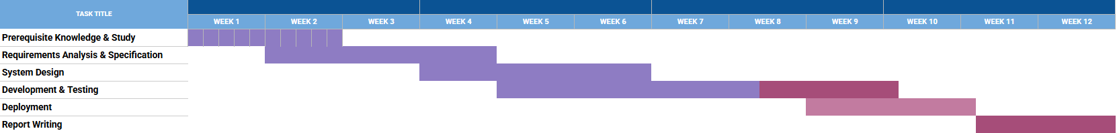
Figure 1: Project Timeline

1.4 Purpose of Document
The purposes of this document are:
- Identify and analyze the requirements
- Present the system models and architecture
- Describe the applied methodology
- Document the user interface and the setup procedure
- Design the test plan
- Improve understanding and reduce development effort

2. Project Description
Modern projects routinely mix several languages and span hundreds of files. Understanding such a project requires seeing it at more than one level: first the modules and how they depend on each other, then the files inside a module, then the functions inside a file. Without this, risky code and structural problems stay hidden until a change breaks something.
CodeLens addresses this by turning an uploaded codebase into a graph, letting the user drill down through four tiers, and layering quality analyses on top of that graph. The system aims to detect problems and explain them, but never to modify the user’s code.

2.1 Quality Function Deployment
Quality Function Deployment (QFD) translates user needs into specific technical requirements. For CodeLens, the requirements are classified as follows (the full list, FR-1 to FR-13, is given in the SRS).

2.1.1 Normal Requirements
- Code Upload & Ingestion: The system shall accept a single source file, a ZIP archive or a folder, reject files over 2 MB and uploads over 50 MB / 1000 files, sanitize ZIP entries against path traversal (zip-slip) and skip directories such as node_modules, venv, dist and build.
- Multi-Language Parsing & Metrics: The system shall parse the supported languages with Tree-sitter and extract, per function, the name, parameters, line range, cyclomatic complexity, fan-in and fan-out, and build a same-project call graph.
- Multi-Tier Graph Visualization: The system shall render module, file, function and chunk graphs with click-to-drill-down, breadcrumb navigation, a MiniMap and zoom controls.
- Search: The system shall provide full-text search over function, file and module names and focus the selected node in the graph.

2.1.2 Expected Requirements
- Architecture Pattern & Layer Analysis: The system shall detect architecture patterns with confidence scores and evidence, and report layer violations with source, target, severity and explanation.
- Code Smell Analysis: The system shall detect function-, module- and architecture-level smells and rank root causes using a smell dependency graph.
- Change Impact & Risk: The system shall compute the transitive callers of a function (with hop depth) and classify functions by fan-in into High (≥10), Medium (3–9), Low (1–2) or None (0) risk.
- Dead Code & Metrics: The system shall flag unreachable functions and unused imports and compute LOC, complexity, Halstead metrics and a Maintainability Index.
- Session Management: The system shall isolate every user’s data in a session identified by an X-Session-ID header and expire sessions after 3 hours of inactivity.
- Performance & Reliability: The system shall parse 100 files in under 2 seconds, render the Tier-1 graph in under 5 seconds, answer searches in under a second, and fall back to an in-memory cache if Neo4j fails.

2.1.3 Exciting Requirements
- AI Refactor Plan: On explicit user request, the system shall call an LLM with a structured smell summary and return an executive summary, a root cause and prioritized refactor steps, falling back to a static plan when the LLM is unavailable.
- GoF Design-Pattern Detection: The system shall detect the 23 GoF patterns from the structural shape of the code, without relying on naming heuristics.
- Git History & Evolution: The system shall extract the last 30 commits and show churn and estimated quality metrics per commit.
- Dynamic Slicing: The system shall run a Python function in an isolated Docker sandbox and compute a backward slice of the executed statements.

2.2 Usage Scenario
CodeLens is a web application used by developers, code reviewers, software architects and QA/tech leads. A typical session proceeds as follows.
Session start. When the application loads, the frontend creates a session (or restores one from sessionStorage). From then on every API request carries the session ID in the X-Session-ID header.
Upload. The user selects a file, a ZIP archive or a folder. The frontend validates the selection and shows upload progress with stage labels. The backend sanitizes and extracts the files, filters ignored directories, parses each file, classifies large files, chunks god files, resolves imports, computes layer violations and stores the resulting graph in Neo4j under the session ID.
Exploration. The Tier-1 module graph is shown. Clicking a module opens its file graph (Tier-2), clicking a file opens its function graph (Tier-3), and clicking a function expands its direct callers and callees. For god files the chunk graph (Tier-4) is shown. The user can search for any entity and jump to it.
Analysis. From the sidebar the user can open the metrics dashboard, dependency-risk ranking, dead-code report, architecture and GoF pattern panels, layer-violation analysis, Git history and smell analysis. Hovering over or selecting a function shows the change-impact overlay. In the smell panel the user may request an AI refactor plan.
Session end. When the tab is closed, a beacon deletes the session’s data from Neo4j, the cache and the disk. Otherwise a background task removes sessions that have been idle for more than 3 hours.

3. Scenario Based Modeling
Scenario-based modeling describes how the system behaves in real usage situations. It helps to identify missing requirements and to confirm that the design supports every user goal. This chapter presents the use case diagram, the activity diagrams and the sequence diagrams of CodeLens.

3.1 Use Case Diagram
Primary actors: Developer / Code Reviewer, Software Architect, QA / Tech Lead, System Administrator. Secondary actors: Neo4j database and the LLM provider (Groq).
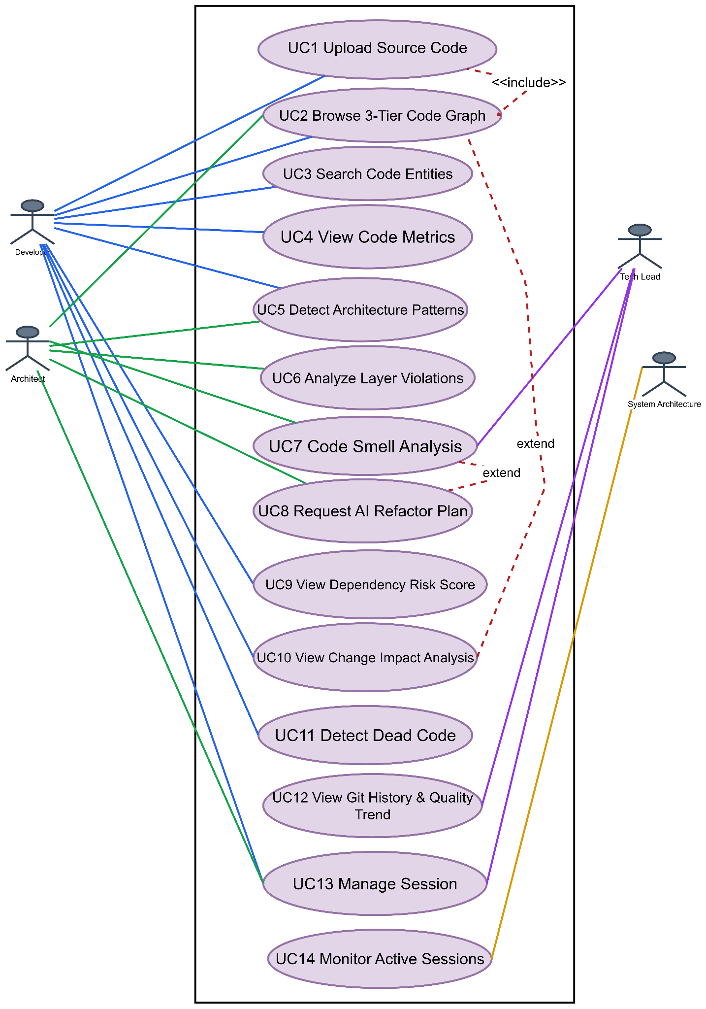
Figure 2: Use Case Diagram of CodeLens
The use cases shown in the diagram are described in Table 1.
ID | Use Case | Actor | Description
UC1 | Upload Source Code | Developer | POST /upload; the backend extracts, filters, parses, builds graphs and stores them in Neo4j. Invalid type, oversized upload or zip-slip path is rejected with an error.
UC2 | Browse Multi-Tier Code Graph | Developer / Architect | Module → File → Function drill-down through /graph/tier1, /graph/tier2, /graph/tier3 and /expand; breadcrumb and “Back” navigation.
UC3 | Search Code Entities | Developer | Search over functions, files and modules; selecting a result loads the relevant tier and focuses the node.
UC5 | Detect Architecture Patterns | Architect | GET /api/patterns/{session_id}; confidence-scored patterns with evidence. GoF patterns are served by /api/gof-patterns/{session_id}.
UC6 | Analyze Layer Violations | Architect | GET /layer-violations; requires a folder or ZIP upload. Violations are listed by severity.
UC7 | Run Code Smell Analysis | Architect / Tech Lead | GET /smell-analysis; smell rules, smell dependency graph and root-cause ranking.
UC8 | Request AI Refactor Plan (extends UC7) | Architect | POST /llm-refactor-reason; the LLM returns a prioritized plan, or a static fallback plan on failure.
UC9 | View Dependency Risk Score | Developer | GET /risk-score; functions ranked by fan-in.
UC10 | Run Change Impact Analysis (extends UC2) | Developer | GET /impact-analysis/{function}; BFS over the reverse call graph with hop depth.
UC11 | Detect Dead Code | Developer | GET /dead-code; zero fan-in functions and unused imports.
UC12 | View Git History & Quality Trend | Developer / Tech Lead | GET /git-history; last 30 commits, requires a .git directory in the upload.
UC13 | Manage Session | Any user | POST /start-session, DELETE /end-session, 3-hour auto-expiry.
UC14 | Monitor Active Sessions | Administrator | GET /admin/sessions.
Table 1: Use Case Descriptions

3.2 Activity Diagrams
Activity diagrams capture the dynamic behavior of the system as a flow of activities.

3.2.1 Level-1: System Operational Activity Diagram
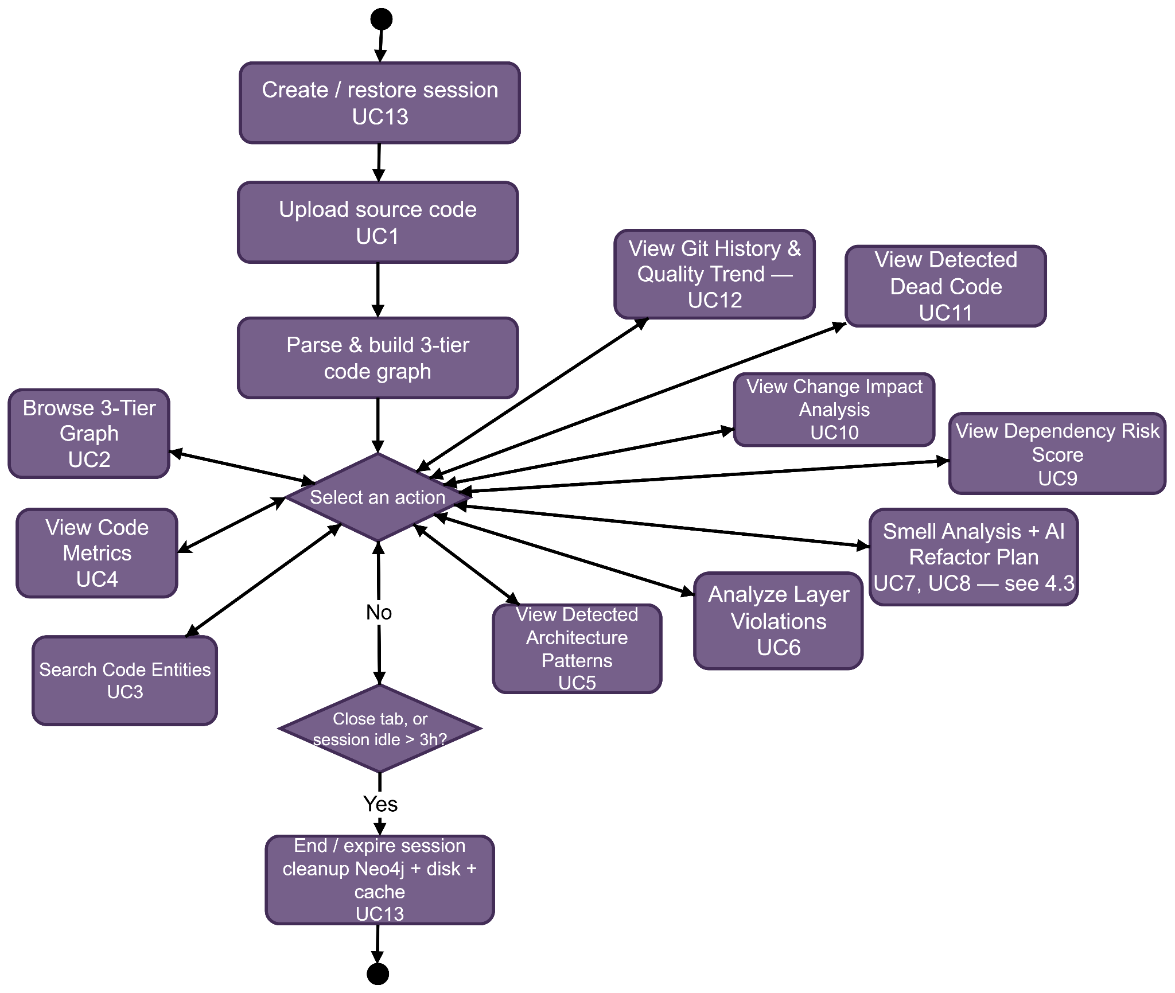
Figure 3: Level-1 Activity Diagram
The process begins with “Create/Restore Session” (UC13), which gives the user an isolated environment. The user then uploads source code (UC1), and the system parses it and builds the multi-tier code graph. From the central “Select an action” decision node the user can browse the graph, search, detect architecture patterns, analyze layer violations, run smell analysis with the AI refactor plan, view risk scores, run change-impact analysis, detect dead code or view Git history. The loop ends when the session is idle for more than 3 hours or the tab is closed, which triggers cleanup of the data in Neo4j, the cache and temporary disk storage.

3.2.2 Level-2: Smell-Detection Activity Diagram
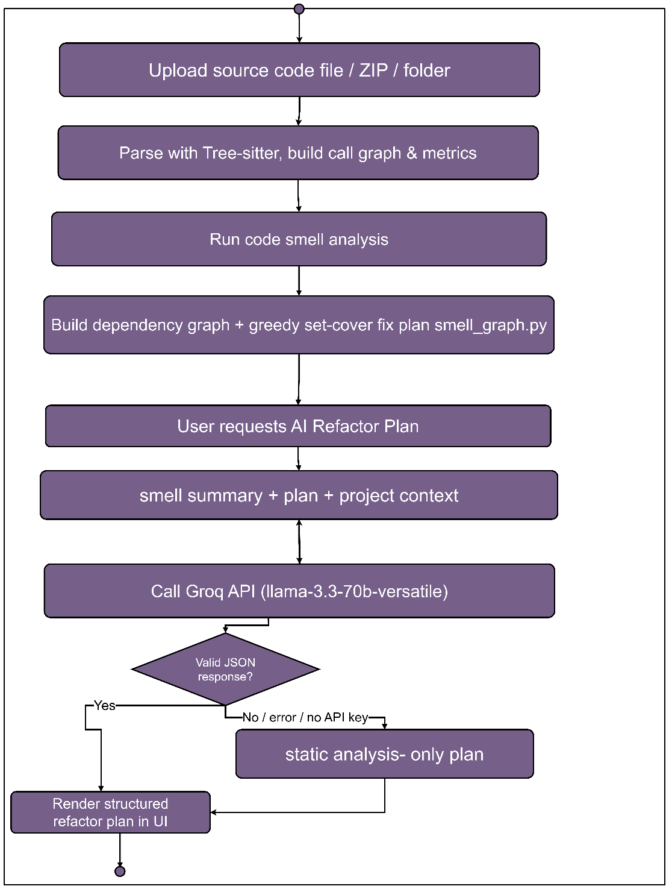
Figure 4: Smell-Detection Activity Diagram
This diagram details the logic of the smell analysis: parsing, smell detection, construction of the smell dependency graph, root-cause ranking and the optional AI-assisted refactor plan.

3.3 Sequence Diagrams

3.3.1 Upload and Initial Analysis (UC1)
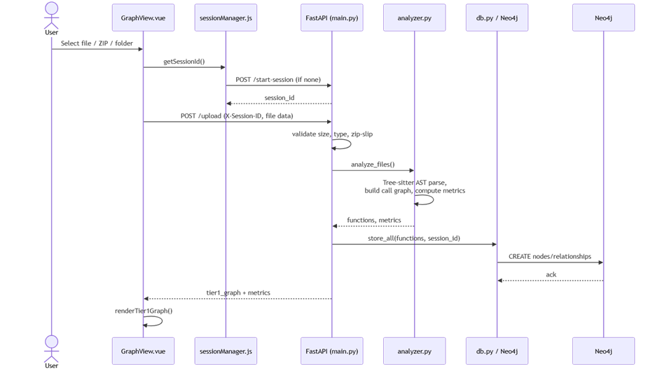
Figure 5: Sequence Diagram – Upload & Initial Analysis (UC1)
The user uploads a file through the GraphView component, which verifies the session before sending the data to FastAPI. The backend parses the files, extracts metrics, stores the structural data in Neo4j and returns the data needed to render the Tier-1 graph.

3.3.2 Drill-Down Navigation (UC2)
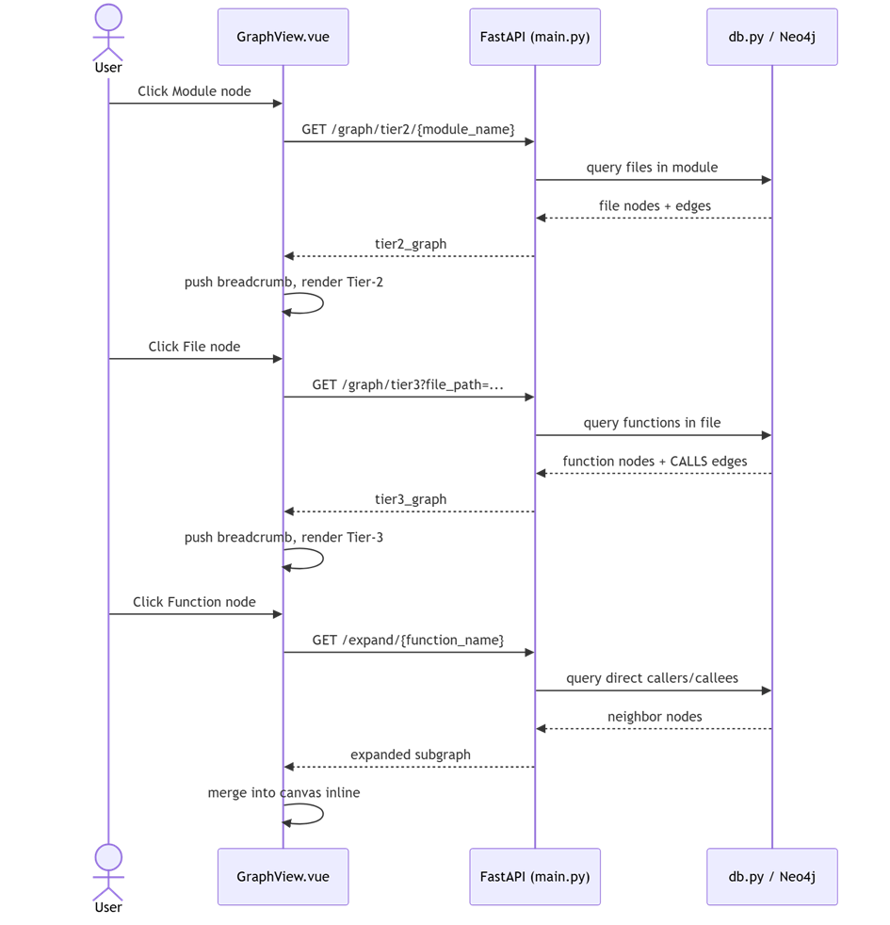
Figure 6: Sequence Diagram – Drill-Down Navigation (UC2)
When the user clicks a module or file node, the frontend requests the corresponding tier from the backend, which queries Neo4j. The frontend then pushes a breadcrumb entry and renders the requested tier.

3.3.3 Change Impact Analysis (UC10)
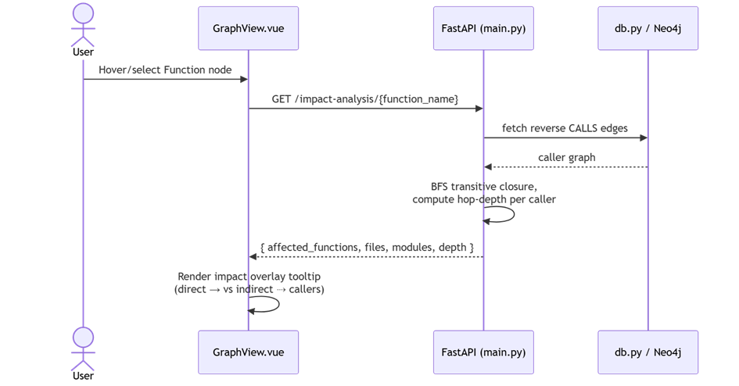
Figure 7: Sequence Diagram – Change Impact Analysis (UC10)
On selecting a function, the backend retrieves the reverse call graph from Neo4j and performs a breadth-first traversal to compute hop depths. The frontend renders an overlay showing the ripple effect of a potential change.

3.3.4 Code Smell Analysis and AI Refactor Plan (UC7, UC8)
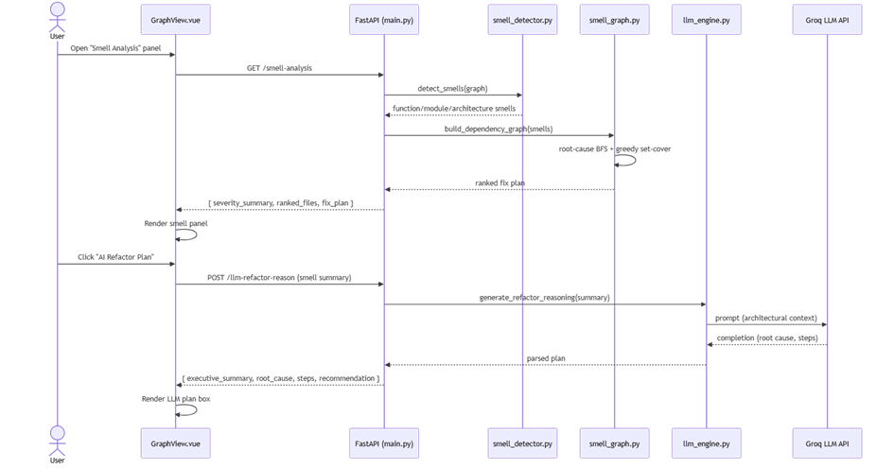
Figure 8: Sequence Diagram – Smell Analysis + AI Refactor Plan (UC7, UC8)
Smell analysis runs in two stages. The general analysis runs the smell detector and the smell-graph builder. Only when the user asks, the LLM engine sends the structured smell summary to the LLM and returns a refactor plan to the interface.

3.3.5 Session Lifecycle (UC13)
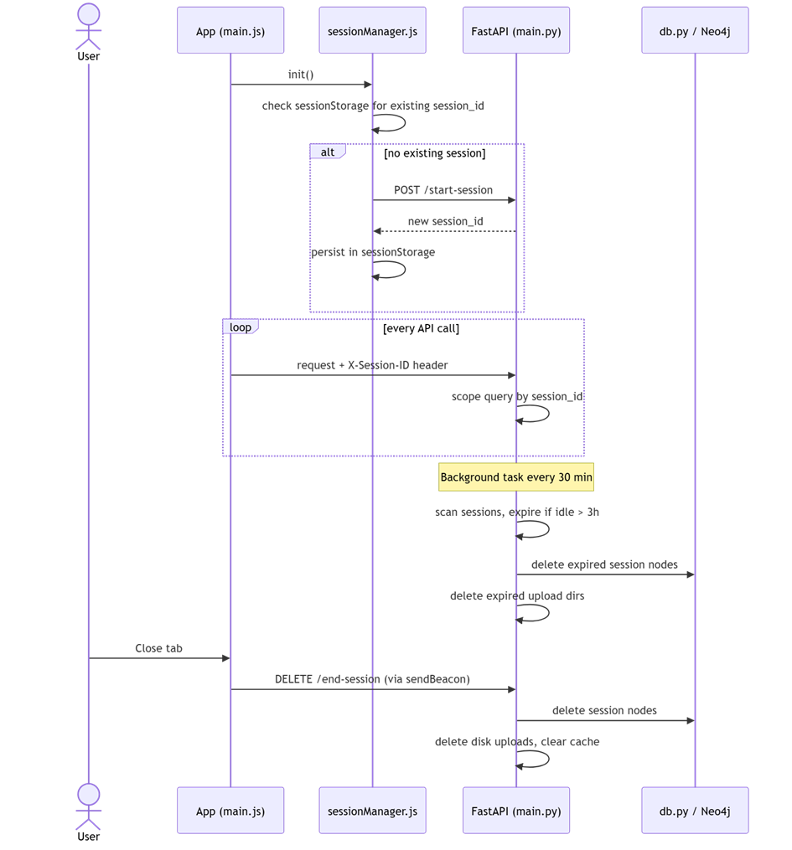
Figure 9: Sequence Diagram – Session Lifecycle (UC13)
A session ID is created on application load and attached to every request for data isolation. Cleanup is triggered either by tab closure (sendBeacon → DELETE /end-session) or by the background task that removes idle sessions.

4. Data-Based Modeling
Data-based modeling describes how data is organized and stored. CodeLens does not use a relational database. Because the central data structure is a code graph (modules containing files, files containing functions, functions calling functions), the system stores it as a property graph in Neo4j. Every node carries a session_id property so that the data of different users in the shared database stays isolated.
Parsed results are also kept in an in-memory cache. If Neo4j is unreachable, the system falls back to this cache so that the core features keep working.
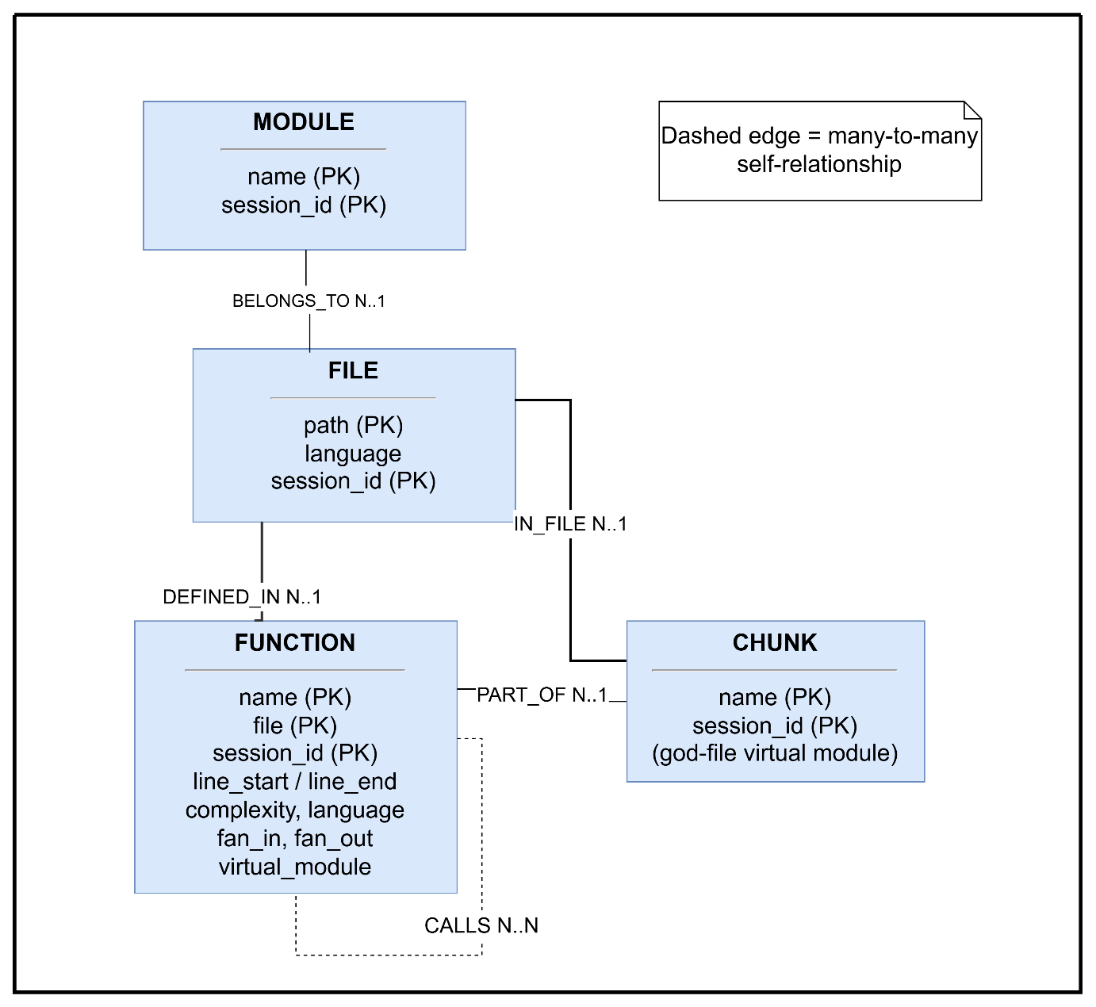
Figure 10: Entity-Relationship Diagram of CodeLens

4.1 Graph Schema of CodeLens
The main node labels and relationships stored in Neo4j are summarized in Tables 2 and 3.
Node Label | Description
Module | A top-level directory/package of the uploaded project (Tier-1 node).
File | A source file inside a module, with line count and file-size classification (normal, data file, large normal, god file).
Chunk / VirtualModule | A virtual module created when a god file is split by class, complexity or line range. It sits between File and Function.
Function | A function or method with name, parameters, line range, cyclomatic complexity, fan-in, fan-out and dead-code flags.
Class | A class, interface, struct, trait or abstract class. Used by the GoF pattern engine. Uniquely keyed by (name, file, session_id).
Statement | A statement of a Python function, created on demand for dynamic slicing.
Run | One sandboxed execution of a function with its inputs and status.
Table 2: Node Labels
Relationship | Description
DEFINED_IN / IN_FILE | Function → File (and Chunk) in which it is defined.
BELONGS_TO / PART_OF | File → Module, Chunk → File containment.
CALLS | Function → Function. Many-to-many self-relationship carrying call frequency and line.
INHERITS_FROM / IMPLEMENTS | Class → Class inheritance and interface implementation.
METHOD_OF / HAS_FIELD | Function → Class and Class → field type relationships.
HAS_STATEMENT / CONTROL_DEP | Function → Statement, and control dependence between statements.
EXECUTED | Run → Statement, recording which statements were executed and in which order.
Table 3: Relationships
Git commit and smell results are computed on request from the stored graph and the uploaded repository and are returned to the client; they are not part of the permanent graph.

5. Class-Based Modeling
Class-based modeling identifies the classes (or class-like modules) that carry the system’s responsibilities and shows how they collaborate. The nouns of the usage scenario were filtered into analysis classes using general classification (external entities, things, events, roles, places, structures) and the selection criteria (retained information, needed services, multiple attributes, common operations, essential requirements).

5.1 Analysis Classes
- SessionManager
- UploadHandler
- UniversalParser
- GraphBuilder
- MetricsCalculator
- SmellDetector
- SmellGraph
- PatternDetector
- GoFRuleEngine
- LLMEngine
- DynamicAnalyzer
- GraphRepository (Neo4j access)

5.2 Class Cards
SessionManager
Attribute | Method
- session_id  - created_at  - last_active  - upload_dir | + startSession()  + endSession()  + touch()  + cleanupExpired()  + listSessions()
Responsibilities | Collaborators
Create and track isolated sessions  Expire sessions after 3 hours and remove their data | GraphRepository

UploadHandler
Attribute | Method
- uploadType (file/zip/folder)  - sizeLimit, fileLimit  - ignoredDirs | + validateUpload()  + extractZipSafely()  + walkFolder()  + filterIgnoredPaths()
Responsibilities | Collaborators
Validate size, count and depth limits  Prevent zip-slip path traversal  Hand clean files to the parser | SessionManager, UniversalParser

UniversalParser
Attribute | Method
- language  - syntaxTree  - functions  - classes | + parseFile()  + extractFunctions()  + extractClasses()  + extractCalls()  + classifyFile()  + chunkGodFile()
Responsibilities | Collaborators
Parse nine languages with Tree-sitter  Extract functions, classes, calls and complexity  Classify large files and split god files into chunks | UploadHandler, MetricsCalculator

GraphBuilder
Attribute | Method
- functions  - fanIn / fanOut  - layerViolations | + buildCallGraph()  + buildTierGraph()  + resolveImports()  + computeLayerViolations()
Responsibilities | Collaborators
Build call graphs from parsed functions  Produce Tier-1 to Tier-4 graph data  Compute layer violations | UniversalParser, GraphRepository

MetricsCalculator
Attribute | Method
- loc  - cyclomaticComplexity  - halstead  - maintainabilityIndex | + computeMetrics()  + riskScore()  + detectDeadCode()  + impactAnalysis()
Responsibilities | Collaborators
Compute LOC, complexity, Halstead and Maintainability Index  Classify dependency risk  Detect dead code and compute change impact by BFS | GraphRepository

SmellDetector
Attribute | Method
- thresholds  - smells  - severityWeights | + detectFunctionSmells()  + detectModuleSmells()  + detectArchitectureSmells()
Responsibilities | Collaborators
Apply smell rules at function, module and architecture level  Assign severity | MetricsCalculator, SmellGraph

SmellGraph
Attribute | Method
- smellNodes  - dependencies  - rootCauseScores | + buildGraph()  + rankRootCauses()  + minimalFixPlan()
Responsibilities | Collaborators
Build the smell dependency graph  Rank root causes (BFS) and order fixes (greedy set cover) | SmellDetector, LLMEngine

PatternDetector / GoFRuleEngine
Attribute | Method
- patternSpecs (YAML)  - sessionGraphView  - confidenceWeights | + detectArchitecturePatterns()  + loadSpecs()  + evaluate()  + confidence()
Responsibilities | Collaborators
Detect MVC, Layered, Clean, Hexagonal and Repository patterns  Evaluate 23 GoF pattern specs over the class graph with confidence scores | GraphRepository

LLMEngine
Attribute | Method
- model  - temperature  - apiKey  - systemPrompt | + getRefactorPlan()  + getCodePreview()  + fallbackPlan()
Responsibilities | Collaborators
Send only structured smell data to the LLM  Parse the JSON plan  Return a static fallback plan on any failure | SmellGraph

DynamicAnalyzer
Attribute | Method
- functionId  - inputs  - runId  - statements | + getParams()  + runInSandbox()  + computeBackwardSlice()
Responsibilities | Collaborators
Run a Python function in a network-less Docker sandbox  Record executed statements  Compute the backward slice | GraphRepository

5.3 Class Responsibility and Collaboration
The collaboration between the classes follows the processing pipeline. UploadHandler passes validated files to UniversalParser; the parsed functions and classes are used by GraphBuilder and MetricsCalculator and persisted through GraphRepository. SmellDetector consumes the metrics, SmellGraph ranks the detected smells, and LLMEngine enriches the ranked result on request. PatternDetector and GoFRuleEngine read the stored class graph, and DynamicAnalyzer reads and writes statement and run data. SessionManager scopes every one of these operations to a session.

6. Architectural Design
Architectural design defines the high-level structure of the system: its major components, their responsibilities and their interactions.

6.1 Architectural Context
- Superordinate systems: none.
- Subordinate systems: Neo4j (graph database, via the Bolt protocol), the Groq LLM API (HTTPS), the Tree-sitter parsing runtime, Docker (sandbox for dynamic analysis) and the local git executable (history extraction).
- Peer systems: none.
- Actors: Developer / Code Reviewer, Software Architect, QA / Tech Lead and System Administrator.

6.2 Top-Level Components
Component | Responsibility
Frontend (Vue 3 SPA) | Upload, graph canvas (Vue Flow with Dagre layout), search, analysis panels, session handling.
API layer (FastAPI) | REST endpoints, session validation through X-Session-ID, request orchestration.
Analyzer package | Parsing, metrics, file classification, god-file chunking, import resolution, layer rules, graph building.
Quality engines | Smell detector, smell graph, architecture pattern detector, GoF rule engine, service-call detector.
AI engine | Prompt construction, LLM call and static fallback.
Dynamic analysis | Statement extraction, parameter extraction, Docker sandbox and backward slicer.
Persistence | Neo4j graph store plus in-memory cache and per-session upload directory.
Table 4: Top-Level Components

6.3 Client–Server Architecture
CodeLens uses a client–server architecture. The Vue single-page application runs in the browser and communicates with the FastAPI server over HTTPS/JSON. Each request carries an X-Session-ID header. The server parses and analyzes, reads and writes Neo4j, and optionally calls the Groq API. Results are returned as JSON and rendered by the client.
Analysis phase: the client uploads code → the server validates, extracts and parses it → the graph is stored in Neo4j → the client requests tiers and analyses on demand → the server computes them from the stored graph and returns JSON.
Session phase: the client creates a session on load → all data is scoped by the session ID → a tab-close beacon or the 3-hour timeout triggers cleanup.

6.4 REST API Summary
Method | Endpoint | Purpose
GET | /health | Health check and active session count
POST / DELETE | /start-session, /end-session | Create and clean up a session
GET | /sessions/info, /admin/sessions | Session metadata; list of active sessions
POST | /upload | Upload and analyze file / ZIP / folder
GET | /graph/tier1, /graph/tier2/{module}, /graph/tier3, /graph/chunk, /graph/files | Graph tiers and flat file graph
GET | /expand/{function} | Direct callers and callees
GET | /risk-score, /impact-analysis/{function}, /dead-code | Risk ranking, change impact, dead code
GET | /layer-violations, /metrics, /git-history | Layer rules, metrics dashboard, commit history
GET | /smell-analysis | Smell detection and fix plan
POST | /llm-refactor-reason | AI refactor plan
GET | /api/patterns/{session_id}, /api/gof-patterns/{session_id} | Architecture and GoF pattern detection
POST | /dynamic/functions/{id}/params, /dynamic/functions/{id}/run, /dynamic/runs/{run}/slice | Dynamic analysis: parameters, sandboxed run, backward slice
Table 5: REST API Endpoints

6.5 Deployment
The frontend is built with Vite and served as static files or by the Vite dev server (port 3000/5173). The backend runs as a FastAPI application under Uvicorn (port 8000). Neo4j is accessed over Bolt and may be a local instance or a Neo4j Aura cloud instance. Docker must be available on the backend host only if dynamic analysis is used.

7. Applied Methodology
This chapter explains how CodeLens ingests code, builds the graph, performs its analyses and presents the results, following the Input, Processing and Output structure.

7.1 Workflow
- Input module: accepts the upload, validates and sanitizes it, and prepares the files.
- Processing module: parses the code, classifies files, builds the graph and runs the quality analyses.
- Output module: returns graphs, metrics and reports as JSON and renders them in the interface.

7.2 Input

7.2.1 Upload Handling
The user can upload a single file, a ZIP archive or a folder chosen with the folder picker. The backend enforces a 2 MB limit per source file, 50 MB per upload, at most 1000 source files and a maximum directory depth of 50. ZIP entries are checked so that no entry can escape the target directory (zip-slip), and directories such as node_modules, venv, dist and build are skipped. The .git directory is skipped for parsing but kept so that history can be extracted.

7.2.2 Session Handling
A UUID session is created on load and stored in sessionStorage. Each upload, graph and analysis is stored and queried under this ID, which isolates users from each other.

7.3 Processing

7.3.1 Parsing and Metrics
Files are parsed with Tree-sitter using a language mapped from the file extension (.py, .js/.jsx, .ts/.tsx, .java, .go, .rs, .c, .cpp, .cs). For each function the system records name, parameters, line range, cyclomatic complexity, fan-in and fan-out. Only calls to functions defined in the same project are kept in the call graph; external and standard-library calls are excluded. The module also computes LOC, Halstead metrics and the Maintainability Index.

7.3.2 File Classification and God-File Chunking
A file with at most 10,000 lines is “normal”. Above that, it is classified by function count: fewer than 3 functions is a “data file”, 3 to 100 is “large normal”, and more than 100 is a “god file”. Generated-file suffixes such as .pb.go are always god files unless they exceed 100,000 lines. A god file is split into virtual modules by class, then by complexity, and finally by line range. Chunking is read-only and does not change function identity.

7.3.3 Graph Construction and Storage
The parsed functions, files, modules and classes are written to Neo4j under the session ID. Tier-1 to Tier-4 graph views are produced by Cypher queries, and the frontend lays them out with Dagre.

7.3.4 Architecture and Layer Analysis
Architecture patterns (MVC/MVP, Layered, Clean, Hexagonal, Repository) are detected with rule-based detectors that use the project’s structure and naming, and each result has a confidence score and evidence. Layer analysis validates that calls flow Controller → Service → Repository → Model and reports violations with severity.

7.3.5 GoF Design-Pattern Detection
The GoF engine is purely structural and deterministic. Class, field, inheritance and call data are loaded into an in-memory SessionGraphView once per session. Each of the 23 patterns is described by a YAML specification that lists the required structural predicates and confidence weights; the rule engine evaluates every specification against the view and reports patterns whose confidence reaches the specification’s minimum. Language-specific keywords (ABC, interface, trait) are first normalized into five canonical kinds so that one specification works for all languages, and no pattern- or file-name keyword is needed.

7.3.6 Code Smell Analysis
Smells are detected with configurable thresholds at three levels.
Level | Smells and key thresholds
Function | Long Method (over 50 lines or complexity over 10), Too Many Parameters (over 5), Dead Code, Feature Envy (fan-out/fan-in ratio ≥ 3), Deep Nesting (depth ≥ 4), Switch Smell, Magic Numbers.
Module | God Module (over 20 functions and average complexity ≥ 7), God Class, Large Module (over 400 LOC), Lazy Class, Duplicate Code, Data Clumps, Shotgun Surgery.
Architecture | Circular Dependency, Long Call Chain (depth ≥ 7), Inappropriate Intimacy, Divergent Change.
Table 6: Smell Levels and Thresholds
The detected smells are connected into a smell dependency graph. Root causes are ranked by the number of downstream smells they explain (BFS), and a minimal fix plan is derived with a greedy set-cover ordering.

7.3.7 Change Impact, Risk, Dead Code and Git History
- Change impact: a BFS over the reverse call graph returns all transitive callers with hop depth and the affected files and modules.
- Risk score: High (≥10 callers), Medium (3–9), Low (1–2), None (0); the top 50 are listed.
- Dead code: functions with zero fan-in that are not entry points are flagged with High (private) or Medium (public) confidence; unused imports are listed per file.
- Git history: git log and git show provide the last 30 commits with hash, message, author, date, churn and estimated metrics per commit.

7.3.8 Dynamic Analysis
For a plain Python function, the user supplies inputs, and the function is executed in an isolated Docker container with no network, a read-only mount of the session’s source, and CPU, memory and process limits. The executed statements are recorded, and a backward slice is computed over the control and data dependencies. Class methods are not yet supported.

7.4 Output
Every analysis returns structured JSON that the frontend renders as graph nodes with color-coded risk, panels with severity chips, ranked lists and an impact overlay. The AI plan is shown in a dedicated plan box.

7.5 AI Engineering Design

7.5.1 Purpose
Static analysis decides what is wrong. The AI layer is invoked only on explicit request and explains why the smells occurred and how to fix them. It never runs automatically and never replaces the static analysis.

7.5.2 Model and Configuration
Setting | Value
Provider | Groq Chat Completions API
Model | Configured by the GROQ_MODEL environment variable (the default in llm_engine.py is openai/gpt-oss-120b)
Temperature | 0.20, favoring deterministic, structured output
Response format | Forced JSON object
Credentials | GROQ_API_KEY from Backend/.env
Table 7: Model and Configuration

7.5.3 Prompt Design
The model never receives source code. Its input is limited to the smell summary, the top steps of the static minimal-fix plan and project scale context. The system prompt requires a single primary root cause, structural (not stylistic) refactors with GoF or Fowler names, justification of the ordering and strictly valid compact JSON. The output contains an executive summary, root causes, a prioritized refactor plan (priority, pattern, target, effort, risk) and a long-term recommendation.
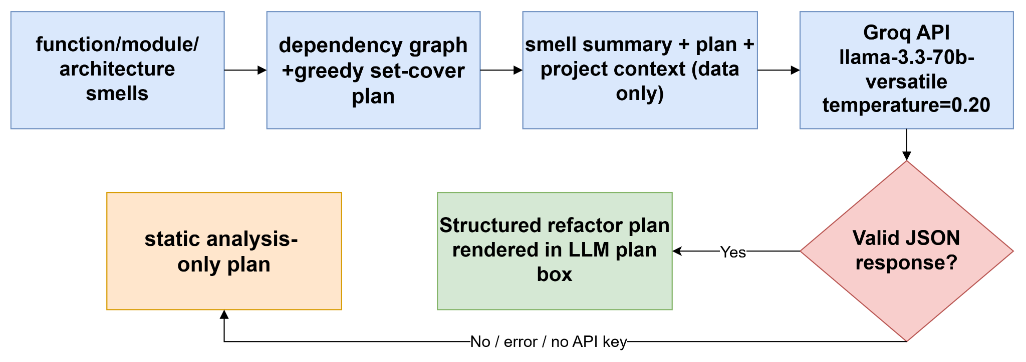
Figure 11: AI Engineering Pipeline Design

7.5.4 Reliability
If the API key is missing, the package is not installed, the call fails or the response is not valid JSON, a deterministic fallback plan derived from the static analysis is returned and marked with _source: static_analysis_fallback, so the Smell Analysis panel always shows a plan.

7.6 Technology Stack
Layer | Technology
Frontend | Vue 3, Vite, Vue Flow (with MiniMap and Controls), Dagre, Axios
Backend | Python, FastAPI, Uvicorn, python-multipart, PyYAML
Parsing | Tree-sitter with language grammars
Database | Neo4j (Bolt driver) with in-memory cache fallback
AI | Groq API
Sandbox | Docker
Testing | pytest
Table 8: Technology Stack

8. User Manual and User Interface
CodeLens provides a single-page interface with a resizable left sidebar and a main graph canvas. The sidebar contains the upload control, status, search, legend and the analysis panels. The canvas shows the Vue Flow graph with a MiniMap and zoom controls.

8.1 Uploading Code
When the application opens, the left sidebar shows a short “Get Started” guide (Upload, Analyze, Explore), the upload area and a legend of node types. The user either drops or browses for a single file or ZIP archive (.py, .js, .ts, .java, .go, .rs, .zip), or clicks “Upload Folder” to select a whole directory. Until something is uploaded, the canvas shows “No graph loaded”. If the upload is invalid, oversized or contains an unsafe path, an error message is displayed and nothing is analyzed.
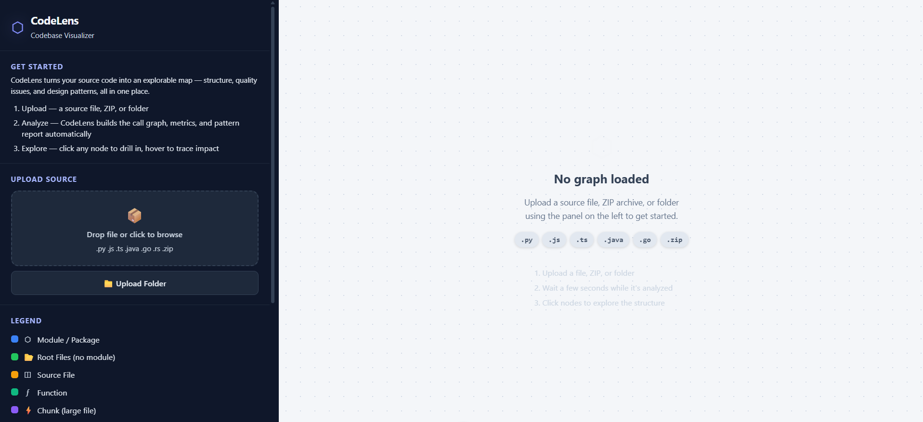
Figure 12: CodeLens Main Interface (Upload Panel and Legend)
The legend explains the node colors used in the graph views: blue for Module/Package, green for Root Files (files without a module) and for Functions, orange for Source File, and purple for Chunk (large file).

8.2 Browsing the Multi-Tier Graph
After analysis, the Tier-1 graph shows the project’s modules and the dependencies between them. Files that do not belong to any module are grouped in a “Root Files” node.
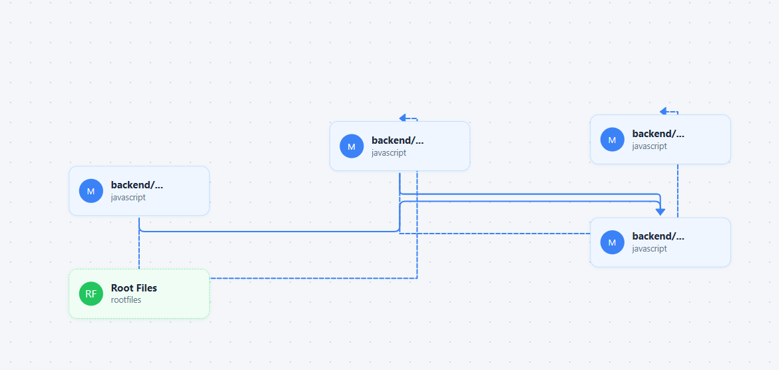
Figure 13: Tier-1 Module Graph
Clicking a module (or Root Files) opens the Tier-2 graph of the files it contains.
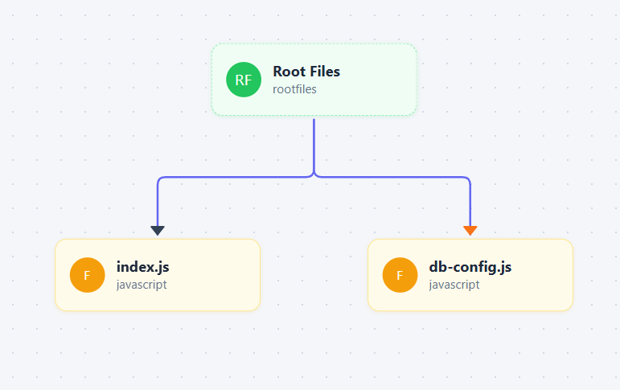
Figure 14: Tier-2 File Graph
Clicking a file opens the Tier-3 function graph. Each function node shows its name and the class it belongs to, and carries a small play button that starts dynamic analysis (Section 8.5). Functions that are not called from anywhere (for example parse_file here) are drawn faded, which marks them as dead-code candidates. Clicking a function expands its direct callers and callees. The breadcrumb shows the current path and “← Back” returns to the previous tier. Hovering over a function shows its change-impact overlay (Figure 16).
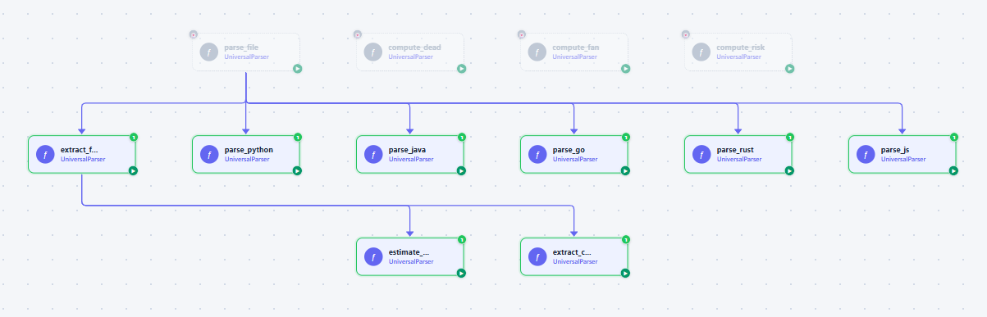
Figure 15: Tier-3 Function Graph
When the user hovers over or selects a function, the change-impact overlay appears at the top right of the canvas. It shows the function name, a summary such as “Changing this affects 2 function(s) across 1 file(s)”, and the list of affected callers with their files. The affected call paths are highlighted in orange on the graph and all unrelated nodes are faded. In the example, changing g3 affects slice_demo and slice_demo_extra.
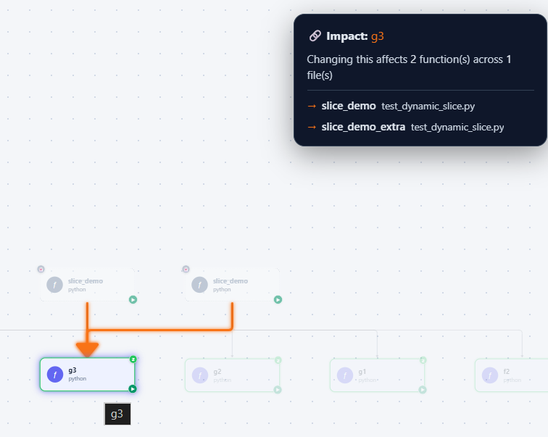
Figure 16: Change Impact Overlay

8.3 Searching
Type a function, file or module name in the search box. As soon as the user starts typing, a suggestion list opens under the search box. Each result shows an icon for its entity type (ƒ for a function), its name, its file path and a colored risk badge (for example a green “L” for low risk). Selecting a result loads the relevant tier and focuses the node.
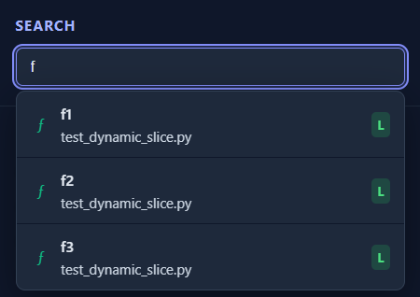
Figure 17: Search Suggestions

8.4 Analysis Panels
The analysis results are grouped into three tabs at the top of the sidebar: Overview, Quality and Architecture.

8.4.1 Code Metrics (Overview tab)
The metrics panel gives a quick health check of the project: lines of code, significant lines, number of files and functions, number of call edges, average and maximum cyclomatic complexity, decision points, cognitive complexity, average and maximum parameter count, Halstead volume and difficulty, the Maintainability Index with a verbal rating (for example “Hard to Maintain”), call-chain depth, circular dependencies and orphan nodes. Values that indicate a problem are highlighted in red or yellow.
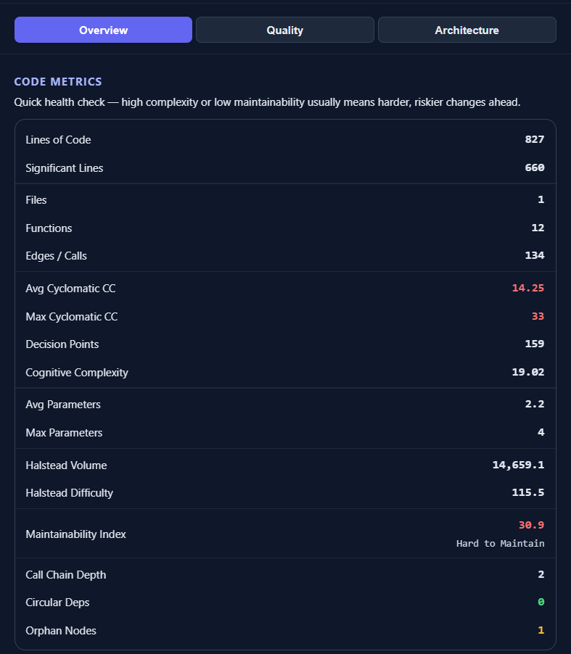
Figure 18: Code Metrics Panel

8.4.2 Code Smell Analysis (Quality tab)
The smell panel shows the number of Critical, High and Medium smells, a technical-debt score and an estimated development effort in days. It lists the top root smells with their counts and the ranked files with their score and smell count. The sub-tabs Files, ROI Plan, By Layer and Fix Tree present the result from different views. The “Generate AI Refactor Plan” button requests the LLM-based plan described in Section 7.5; if the LLM is unavailable, the static fallback plan is shown.
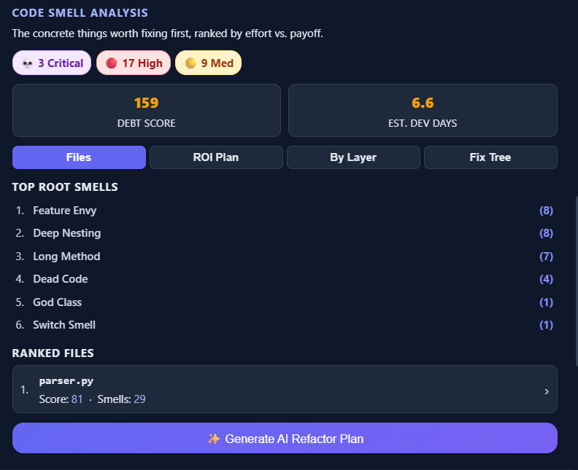
Figure 19: Code Smell Analysis Panel

8.4.3 Dependency Risk (Quality tab)
The risk panel counts functions by High, Medium and Low risk and lists the most depended-on functions with the message “Changing this will affect N caller(s)”. A colored dot and a caller-count badge show the risk level of each function.
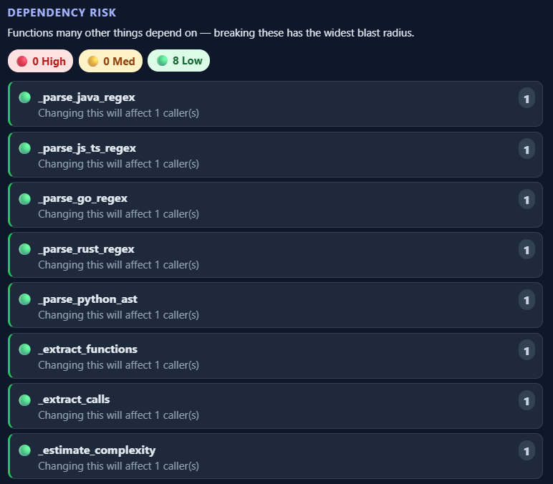
Figure 20: Dependency Risk Panel

8.4.4 Dead Code (Quality tab)
The dead-code panel shows the number of unreachable private and public functions and of unused imports. Unreachable functions are listed with their file, line number and confidence (for example “med” for public functions), and unused imports are listed per file. A note reminds the user that this is static analysis only, so dynamic calls, reflection and external callers cannot be detected.
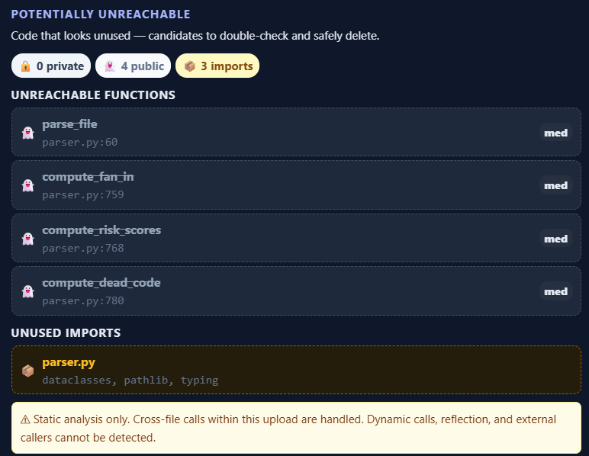
Figure 21: Dead Code Panel

8.4.5 Architecture Patterns (Architecture tab)
This panel lists the architecture patterns found in the project with a confidence percentage, the evidence for each pattern (for example the detected layers) and the components assigned to each layer. In the example, a Layered/N-Tier architecture is detected with 95% confidence.
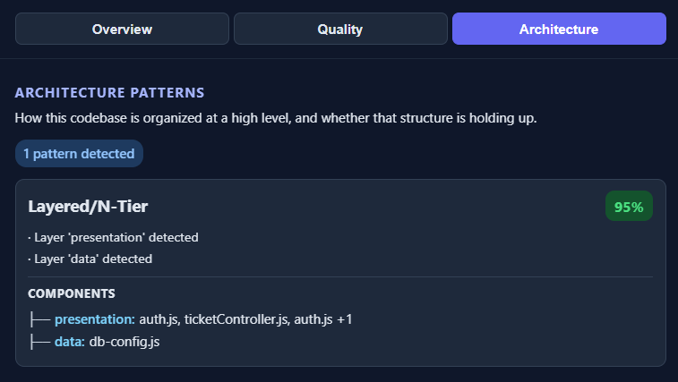
Figure 22: Architecture Pattern Detection

8.4.6 GoF Design Patterns (Architecture tab)
The GoF panel lists each detected design pattern with its category (for example Structural), its confidence tier, a plain-language description of what the pattern does and the number of occurrences. Each occurrence shows its own confidence.
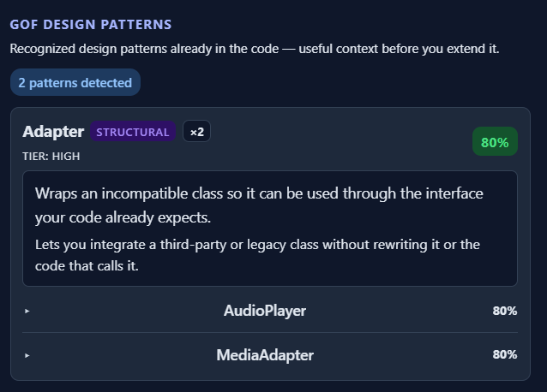
Figure 23: GoF Design Pattern Detection
Expanding an occurrence shows the technical details and raw evidence behind the detection and the role each class plays in the pattern. In the example, MediaAdapter is reported as the Adapter because it implements MediaPlayer and delegates to the unrelated field advancedPlayer of type AdvancedMediaPlayer.
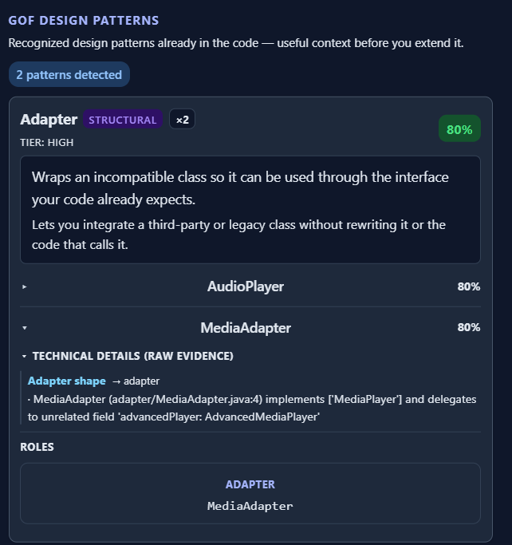
Figure 24: GoF Pattern Evidence and Roles

8.4.7 Layer Analysis (Architecture tab)
The layer-analysis panel reports violations of the intended layer boundaries with a severity, a plain-language explanation and the files involved. In the example, one warning reports same-layer coupling between AudioPlayer.java and MediaAdapter. This panel needs a folder or ZIP upload.
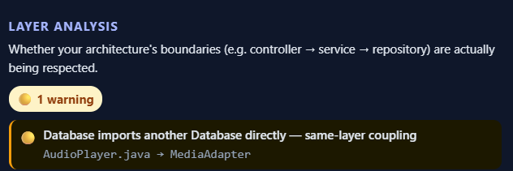
Figure 25: Layer Analysis Panel

8.4.8 Git History
If the uploaded project contains a .git directory, the Git History panel shows the current branch, the number of commits, the overall Maintainability Index, cyclomatic and cognitive complexity, and a table of the recent commits. Each row shows the short hash, the message, the date, the churn, the number of changed files, and the estimated lines of code, function count, Maintainability Index and change in lines of code for that commit. The panel helps to see whether quality is improving or getting worse over time.
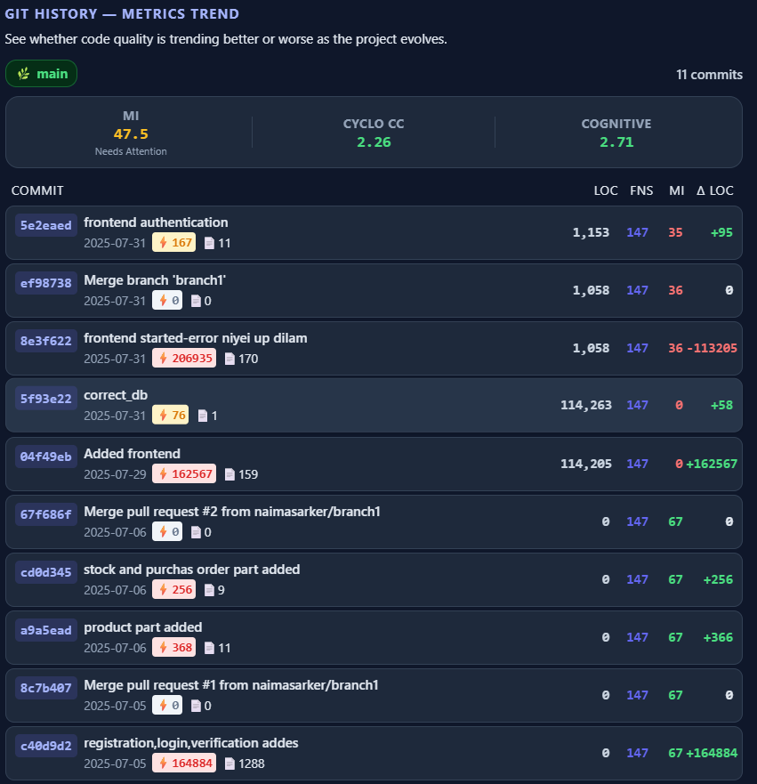
Figure 26: Git History and Metrics Trend

8.5 Dynamic Slice
Clicking the play button on a Python function node opens the “Run Dynamic Slice” dialog. The dialog shows an input field for every parameter of the function. After the user enters the values and presses Run, the function is executed in the Docker sandbox and the dialog reports how many statements were executed. The executed statements are then listed, and clicking a variable next to a statement computes the backward slice for that variable.
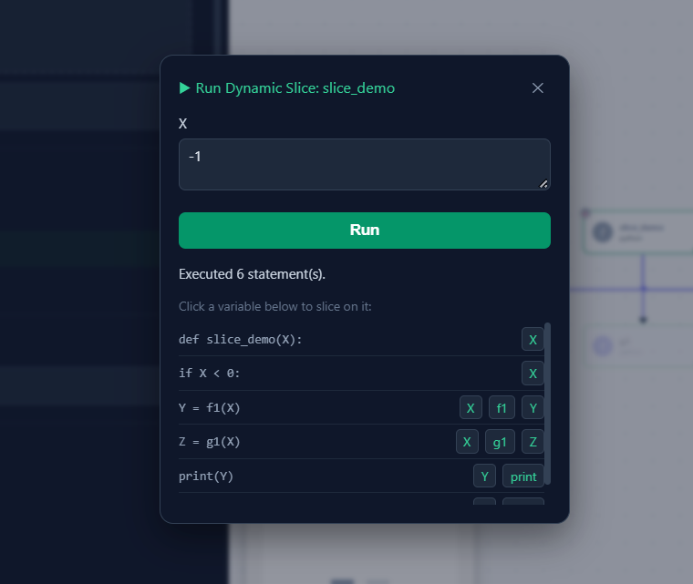
Figure 27: Run Dynamic Slice Dialog

8.6 Session Behavior
Your data belongs to your session only. It is deleted when you close the tab, and automatically after 3 hours of inactivity.

8.7 Installation and Setup
This section explains how to install and run CodeLens on a local machine. The backend and frontend are installed separately.

8.7.1 Prerequisites
Software | Version | Purpose
Python | 3.12 or later | Runs the FastAPI backend and the analyzers.
Node.js and npm | Node 20.19+ or 22.12+ | Builds and runs the Vue frontend (required by Vite).
Neo4j | 5.x (local, Docker or Neo4j Aura) | Stores the per-session code graph.
Git | Any recent version | Needed on the backend host for Git-history extraction.
Docker Desktop | Any recent version | Optional; only needed for dynamic analysis (sandbox).
Groq API key | – | Optional; only needed for the AI refactor plan.
Table 9: Installation Prerequisites

8.7.2 Get the Source Code
- Clone the project repository (or copy the project folder) to the local machine.
- Check that the folder contains the two directories Backend and Frontend.

8.7.3 Install and Configure the Backend
- Open a terminal in the Backend folder.
- Create a virtual environment: python -m venv venv
- Activate it (Windows: venv\Scripts\activate; Linux/macOS: source venv/bin/activate).
- Install the dependencies: pip install -r requirements.txt
- Install Neo4j (a local installation, a Docker container, or a free Neo4j Aura instance) and note its connection URI, user name and password.
- Create a file named .env in the Backend folder and set the variables listed in Table 10.
- Start the backend: python -m uvicorn main:app --reload --host 0.0.0.0 --port 8000
Variable | Example / default | Meaning
NEO4J_URI | bolt://localhost:7687 (default) | Neo4j Bolt address. Use the neo4j+s:// address for Aura.
NEO4J_USER | neo4j (default) | Neo4j user name.
NEO4J_PASSWORD | your password | Neo4j password.
GROQ_API_KEY | your key (optional) | Enables the AI refactor plan. If missing, the static fallback plan is used.
GROQ_MODEL | optional | Overrides the default LLM model name.
Table 10: Backend Environment Variables

8.7.4 Install and Configure the Frontend
- Open a second terminal in the Frontend folder.
- Install the packages: npm install
- If the backend does not run at http://localhost:8000, create a .env file in the Frontend folder with VITE_API_URL set to the backend address.
- Start the development server: npm run dev
- Open the address printed by Vite (normally http://localhost:5173) in the browser.
For a production build, run npm run build; the static files are created in the dist folder.

8.7.5 Dynamic-Analysis Sandbox (Optional)
Dynamic analysis needs Docker to be installed and running on the backend host. No manual image build is needed: on the first dynamic run the backend builds a small python:3.12-slim based sandbox image automatically and rebuilds it if its files change. If Docker is not running, only the dynamic-slice feature is unavailable; all other features keep working.

8.7.6 Verify the Installation
- Open http://localhost:8000/health in the browser. The response should show status “ok” and the number of active sessions.
- Open the frontend; the “No graph loaded” screen should appear without errors.
- Upload a small sample project; the Tier-1 graph and the sidebar panels should appear.

8.7.7 Common Problems
Problem | Likely cause and fix
Frontend cannot reach the backend | The backend is not running or VITE_API_URL points to the wrong address. Start the backend and check the address.
Graph is empty or analyses fail | Neo4j is not reachable or the credentials in .env are wrong. Check NEO4J_URI, NEO4J_USER and NEO4J_PASSWORD.
AI Refactor Plan shows the fallback plan | GROQ_API_KEY is missing or invalid. Set a valid key and restart the backend.
Dynamic slice does not run | Docker is not running. Start Docker Desktop and try again.
Git History panel is empty | The uploaded ZIP or folder has no .git directory.
Table 11: Common Installation Problems

8.8 Using CodeLens Locally
After both servers are running: open the frontend, upload a source file, ZIP or folder, browse the graph, and open the Overview, Quality and Architecture tabs for the analyses.

9. Preliminary Test Plan
This chapter gives the high-level testing goals and a set of preliminary test cases for CodeLens.

9.1 High-Level Description of Testing Goals
- To demonstrate that the system satisfies the specified requirements (FR-1 to FR-13).
- To verify that upload validation and security controls work: zip-slip rejection, size and count limits, ignored directories.
- To verify that multi-language parsing produces correct function inventories, call graphs and complexity metrics.
- To verify that the multi-tier drill-down stays consistent, with correct breadcrumbs and scoping.
- To validate architecture-pattern, GoF-pattern, layer-violation, smell, dead-code and risk analyses against representative code fixtures.
- To verify that the AI refactor plan falls back to the static plan when the LLM is unavailable.
- To verify session isolation, expiry and cleanup.
- To verify that the performance targets of the non-functional requirements are met.

9.2 Test Approach
Level | Technique | Notes
Unit | pytest | Analyzer, normalization, predicates, rule engine and singleton-idiom tests against small fixtures.
Integration | FastAPI TestClient | Upload → parse → store → query round-trips, GoF and dynamic-slice endpoints.
System | Manual, browser-driven | Full upload-to-analysis walkthroughs.
Security | Manual + targeted tests | Zip-slip payloads, oversized uploads, symlink entries.
Performance | Manual timing | Tier response time, search latency, god-file chunking time.
Table 12: Test Levels and Types
The repository already contains pytest suites under Backend/tests (for example test_rule_engine.py, test_predicates.py, test_normalization.py, test_gof_endpoint.py, test_dynamic_slice_endpoint.py and per-phase GoF fixture tests with fixtures for the 23 patterns in several languages). The test cases below extend this suite with feature-level scenarios.

9.3 Feature-Level Test Cases
Test Case ID | T1
Title | System Health Check
Test Steps | 1. Start the backend.  2. Send GET /health.
Expected Outcome | The response is successful and shows the active session count.  No server error occurs.

Test Case ID | T2
Title | Session Creation and Isolation
Test Steps | 1. Create two sessions with POST /start-session.  2. Upload a project in session A.  3. Request the graph in session B.
Expected Outcome | Session B does not see session A’s data.

Test Case ID | T3
Title | Zip-Slip Rejection (FR-1.3)
Test Steps | 1. Upload a ZIP containing an entry with a ../../ path.
Expected Outcome | The upload is rejected with an error.  No file is written outside the target directory.

Test Case ID | T4
Title | Size and Count Limits (FR-1.2)
Test Steps | 1. Upload a single file larger than 2 MB.  2. Upload a folder larger than 50 MB or with more than 1000 files.
Expected Outcome | Both uploads are rejected with a size/count error.

Test Case ID | T5
Title | Multi-Language Parsing (FR-2)
Test Steps | 1. Upload a project with Python, JavaScript, Java and Go files.  2. Open the function graph.
Expected Outcome | Functions, parameters, complexity, fan-in and fan-out are extracted for each language.  External calls are not in the call graph.

Test Case ID | T6
Title | God-File Chunking (FR-2.4)
Test Steps | 1. Upload a file with more than 10,000 lines and more than 100 functions.  2. Open its Tier-3 view.
Expected Outcome | The file is classified as a god file and the chunk-level graph is returned.

Test Case ID | T7
Title | Drill-Down Navigation (UC2)
Test Steps | 1. Click a module, then a file, then a function.  2. Press “← Back”.
Expected Outcome | Correct Tier-2/Tier-3 graphs and expansion are returned.  The breadcrumb reflects the path and Back restores the previous tier.

Test Case ID | T8
Title | Search (UC3)
Test Steps | 1. Search for part of a function name.
Expected Outcome | Results show entity type, file path and risk badge; selecting one focuses the node.

Test Case ID | T9
Title | Change Impact Analysis (UC10)
Test Steps | 1. Request impact analysis for a function with 3 transitive callers.
Expected Outcome | All 3 callers are returned with the correct hop depth.

Test Case ID | T10
Title | Risk Scoring (UC9)
Test Steps | 1. Open the risk panel for a project with functions of varying fan-in.
Expected Outcome | Functions are classified as High, Medium, Low or None by the defined fan-in bands.

Test Case ID | T11
Title | Dead Code Detection (UC11)
Test Steps | 1. Upload code with an uncalled private function and an unused import.
Expected Outcome | The function is flagged with High confidence and the unused import is listed.

Test Case ID | T12
Title | Layer Violation Analysis (UC6)
Test Steps | 1. Upload a layered project in which a controller calls a repository directly.
Expected Outcome | A violation is reported with source, target, severity and explanation.

Test Case ID | T13
Title | GoF Pattern Detection (UC5)
Test Steps | 1. Upload the Strategy and Singleton fixtures.  2. Call /api/gof-patterns/{session_id}.
Expected Outcome | The patterns are reported with confidence scores; the single-implementer negative fixture is not reported as Strategy.

Test Case ID | T14
Title | Code Smell Analysis (UC7)
Test Steps | 1. Upload code with a long method and a circular dependency.  2. Open the smell panel.
Expected Outcome | Both smells are reported with severity, and root-cause ranking is shown.

Test Case ID | T15
Title | AI Refactor Plan Fallback (UC8)
Test Steps | 1. Unset GROQ_API_KEY.  2. Request the AI Refactor Plan.
Expected Outcome | The response has _source: static_analysis_fallback and the UI still shows a complete plan.

Test Case ID | T16
Title | Git History (UC12)
Test Steps | 1. Upload a ZIP containing a .git directory.
Expected Outcome | The last 30 commits are shown, paginated, with churn and metrics.

Test Case ID | T17
Title | Dynamic Slicing
Test Steps | 1. Choose a plain Python function and supply inputs.  2. Run it, then request a slice.
Expected Outcome | The run completes in the sandbox and the slice contains only statements affecting the chosen output.

Test Case ID | T18
Title | Session Expiry (UC13)
Test Steps | 1. Leave a session idle beyond the 3-hour window.
Expected Outcome | The cleanup task removes its Neo4j nodes, cache and uploads.

Test Case ID | T19
Title | Admin Session Monitoring (UC14)
Test Steps | 1. Call GET /admin/sessions.
Expected Outcome | Metadata of every active session is returned.

Test Case ID | T20
Title | Neo4j Failure Fallback
Test Steps | 1. Simulate a Neo4j outage.  2. Request a graph.
Expected Outcome | The in-memory cache serves the request without a crash.

9.4 Endpoint Test Cases
Every REST endpoint of the backend (27 in total) has at least one test case in Table 13. I executed the cases against the running backend on 6 October 2026 with a script that calls the HTTP API, using sample projects taken from the project’s test fixtures (a layered JavaScript project, Strategy, Singleton, Builder and Adapter-style Python fixtures, the dynamic-slice example, a generated 100-file project, a generated large file and a small Git repository). The last column shows the observed result.
All endpoints except /health, /start-session and /admin/sessions need a valid X-Session-ID header. Cases E28 and E29 check this rule for every session-scoped GET endpoint.
ID | Endpoint | Test scenario | Observed result | Status
E1 | GET /health | Request to the running backend. | 200, status “ok”, active session count returned. | Pass
E2 | POST /start-session | Create two sessions. | 200, a session ID and a 3-hour expiry returned; the two IDs are different. | Pass
E3 | DELETE /end-session | End a session; end without header; read info after ending. | 200 when ended; 400 “Missing X-Session-ID header”; 404 for the ended session. | Pass
E4 | GET /sessions/info | Valid session ID; unknown session ID. | 200 with metadata; 404 “Session not found”. | Pass
E5 | GET /admin/sessions | Create two sessions and list all. | 200, both sessions are listed. | Pass
E6 | POST /upload | (a) valid file, (b) valid ZIP, (c) ZIP with a ../../ entry, (d) 3 MB file, (e) no file, (f) .txt file, (g) large file with 120 functions. | (a),(b),(g) 200 and graph created; (c) 200, the unsafe entry was skipped, the safe file was analyzed and nothing was written outside the session folder; (d) 400 “No supported source files found”; (e) 400 “No file(s) provided”; (f) 400 “Unsupported file type”. | Pass
E7 | GET /graph/tier1 | Request after uploading the mixed project. | 200, 19 module nodes returned. | Pass
E8 | GET /graph/tier2/{module_name} | Request for module builder_python. | 200, file car.py with its function count. | Pass
E9 | GET /graph/tier3 | Request for strategy_python/payment.py. | 200, 7 function nodes and 5 call edges with complexity, fan-in, fan-out and risk level. | Pass
E10 | GET /graph/chunk | Request for a chunk of a large file (Group 1). | 200, the 50 functions of that chunk. For an unknown chunk the endpoint returns 200 with an empty graph. | Pass
E11 | GET /graph/files | Request after upload. | 200, 18 file nodes. | Pass
E12 | GET /expand/{function_name} | Expand function pay. | 200, callees charge and send with edges. | Pass
E13 | GET /service-graph | Request for a single-service upload. | 200, empty services and connections (no multi-service structure). | Pass
E14 | GET /risk-score | Request after upload. | 200 with function list, summary and total. | Pass
E15 | GET /search?q= | Search “pay”. | 200, matching functions with file, node id, line and risk level. | Pass
E16 | GET /impact-analysis/{function_name} | Function pay; unknown function. | 200, caller process at depth 1 with affected files; 404 “Function not found”. | Pass
E17 | GET /dead-code | Request for the mixed project. | 200, unreachable functions with confidence and suggestion. | Pass
E18 | GET /layer-violations | Layered JS project. | 200, one high-severity violation in legacy_mixed/adapters (database layer imports a service-layer use case). | Pass
E19 | GET /metrics | Request after upload. | 200, LOC 229, 18 files, 38 functions, complexity, Halstead and orphan nodes. | Pass
E20 | GET /git-history | Upload without .git; ZIP with a 2-commit repository. | 200 “available: false” with a message; 200 with 2 commits, branch, churn and metrics. | Pass
E21 | GET /smell-analysis | Request for the mixed project. | 200, 17 smells with summary, root-cause graph, fix plan, debt score and estimated days. | Pass
E22 | POST /llm-refactor-reason | Send the smell result with the configured API key. | 200 with an LLM plan and executive summary. I tested the fallback separately by calling the LLM engine in its own process: with no key and with an invalid key (HTTP 401 from the provider) it returned a complete plan with _source = static_analysis_fallback and the reason in _error. | Pass
E23 | GET /api/patterns/{session_id} | Mixed project. | 200, 5 architecture patterns with confidence and evidence (for example MVC at 100%). | Pass
E24 | GET /api/gof-patterns/{session_id} | Strategy, Builder and Singleton fixtures. | 200, Strategy, Builder and Singleton detected. | Pass
E25 | POST /dynamic/functions/{id}/params | Function f; malformed ID. | 200 with parameter X; 400 “malformed function_node_id”. | Pass
E26 | POST /dynamic/functions/{id}/run | Run f with X = -1 (Docker running). | 200, status “ok”, executed statements S1, S2, S3, S4, S10, S11 in this order, as specified. An earlier run with Docker stopped returned status “sandbox_unavailable” without an error, so the failure is handled gracefully. | Pass
E27 | POST /dynamic/runs/{run_id}/slice | Slice on variable Y at statement S10; slice without the variable name. | 200, slice = S1, S2, S3, S10 (statement S4, Z = g1(X), is correctly excluded); 400 “statement_node_id and variable_name are required”. | Pass
E28 | All session-scoped GET endpoints (16 paths) and POST /upload, /llm-refactor-reason, /dynamic/.../run | Call without X-Session-ID. | 401 for every endpoint. | Pass
E29 | All session-scoped GET endpoints (16 paths) | Call with an unknown session ID. | 404 for every endpoint. | Pass
Table 13: Endpoint Test Cases and Observed Results

9.5 Test Execution Results
The results of the execution on 6 October 2026 are summarized below. Environment: Windows 11, backend with Uvicorn on port 8000, frontend with Vite on port 5173, Neo4j reached over the network, Docker Desktop running (28.0.4).
- Automated pytest suite (Backend/tests): 101 passed, 1 skipped, 0 failed in the first run (about 13 minutes, because several tests use Neo4j). The skipped test was the Docker-based dynamic-slice acceptance test; after Docker was started it was run again and passed.
- Endpoint tests: 29 cases; all 29 passed.
- Session isolation (T2): a session with an 18-file project and a session with a single file saw only their own data.
- Security: a ZIP containing a ../../ entry did not write any file outside the session folder.
- Performance (NFR): Parsing and analyzing 100 files took 1.8 seconds, which meets the 2-second target. Over 15 repeated requests the search endpoint answered in about 4 ms (median; maximum 14 ms) for both an 18-file and a 100-file project, which meets the sub-second target. The Tier-1 graph was returned in about 0.36 seconds (median; maximum about 1 second), which meets the 5-second target. A complete upload including storing the graph in Neo4j took about 12 seconds for 18 files and about 44 seconds for 100 files, so storage in Neo4j, not parsing, dominates the upload time. These timings were measured against http://127.0.0.1; on Windows the name localhost adds a fixed delay to every request.
- AI refactor plan (UI): I generated the plan from the Smell Analysis panel with a valid Groq key, and the plan was correct and complete.
- Acceptance tests: all 13 acceptance criteria (A1–A13) were executed and passed.

9.6 Acceptance Testing
Acceptance testing checks whether the finished system meets the needs of its users. It is carried out by the supervisor or by representative users (a developer, an architect and a tech lead) on the deployed system with real projects, without knowledge of the internal implementation. The system is accepted if all acceptance criteria in Table 14 are met.

9.6.1 Acceptance Environment and Data
- The system is installed as described in Section 8.7 on a clean machine.
- Three sample projects are used: a small single-language project, a multi-module project with a layered structure and a .git directory, and a project containing a very large (god) file.
- A valid and an invalid GROQ_API_KEY are available for the AI scenario.

9.6.2 Acceptance Criteria
ID | Requirement | Acceptance scenario and criterion | Result
A1 | FR-1 Upload | The user uploads a file, a ZIP and a folder; each is analyzed and the graph appears. An unsafe or oversized upload is rejected with a clear message. | Pass
A2 | FR-2 Parsing | Functions and call relationships of each supported language in the sample projects are shown correctly. | Pass
A3 | FR-3 Graph | The user can reach Tier-1, Tier-2, Tier-3 and the chunk view and return with Back without confusion. | Pass
A4 | FR-4 Search | A known function is found by a partial name within one second and is focused on selection. | Pass
A5 | FR-5/6 Architecture | The expected architecture pattern and the planted layer violation are reported with an understandable explanation. | Pass
A6 | FR-7 Smells and AI | Planted smells are reported; the AI plan is shown with a valid key, and a plan is still shown with an invalid key. | Pass
A7 | FR-8/9/10 Impact, risk, dead code | The impact overlay, risk list and dead-code list agree with the known call structure of the sample project. | Pass
A8 | FR-11 Metrics | The metrics dashboard shows plausible values and a Maintainability Index rating. | Pass
A9 | FR-12 Git history | The commit table of the sample repository is shown, paginated, with trend values. | Pass
A10 | FR-13 Sessions | Two users working at the same time do not see each other’s data; data is removed after the tab is closed. | Pass
A11 | Dynamic slice | A sample Python function is run and a slice on a chosen variable contains only relevant statements. | Pass
A12 | Performance | Parsing 100 files takes under 2 seconds and the Tier-1 graph is shown within 5 seconds. | Pass
A13 | Usability | A first-time user completes upload, drill-down and reading of one analysis panel without help. | Pass
Table 14: Acceptance Criteria

9.6.3 Acceptance Decision
The system is accepted when all criteria A1 to A13 pass and no Critical or High severity defect is open. Failed criteria are recorded as defects, fixed, and the affected criteria are executed again. In the execution described in Section 9.5, all criteria A1 to A13 passed, no Critical or High severity defect is open, and the system is therefore accepted.

9.7 Entry and Exit Criteria
- Entry: the feature’s endpoints are implemented and reachable, and test fixtures are prepared for each language.
- Exit: all feature, endpoint and acceptance test cases pass, no Critical or High severity defects are open, and the performance targets are met on the reference environment.

10. Conclusion
In this report I have presented the technical specification and design of CodeLens, a web-based system for visualizing and assessing the quality of source code. The requirements were derived from a bounded problem statement and translated into use case, activity, sequence, data and class models, an architectural design and a detailed description of the applied methodology.
The distinguishing contribution of CodeLens is the combination of capabilities that are normally spread across separate tools: language-agnostic parsing with Tree-sitter, a four-tier interactive visualization that keeps even very large “god” files navigable, structural detection of architecture and GoF patterns, and a quality layer that ranks code smells by root cause and turns that ranking into a prioritized plan. The AI layer is an enhancement and not a dependency: when the LLM is unavailable, a deterministic static plan is returned, so the core value of the system is preserved.
Known limitations remain. Third-party library internals are not analyzed, refactorings are recommended but never applied, Git tracking covers only the last 30 commits, and dynamic slicing supports plain Python functions only. Future work includes wider language and dynamic-analysis coverage, CI/CD integration for automatic per-commit quality tracking, and an empirical evaluation of the generated refactor plans with practicing developers.
The test plan has been prepared and part of it is already covered by the automated pytest suite; deployment and the final evaluation remain. I am confident that this report gives a clear technical overview of the system and of the approach taken to build it.

References
[1] ISO/IEC/IEEE 29148:2018, Systems and Software Engineering — Life Cycle Processes — Requirements Engineering, International Organization for Standardization, Geneva, Switzerland, 2018.
[2] M. Fowler, Refactoring: Improving the Design of Existing Code, 2nd ed. Boston, MA, USA: Addison-Wesley, 2018.
[3] E. Gamma, R. Helm, R. Johnson, and J. Vlissides, Design Patterns: Elements of Reusable Object-Oriented Software. Reading, MA, USA: Addison-Wesley, 1994.
[4] R. C. Martin, Clean Architecture: A Craftsman’s Guide to Software Structure and Design. Boston, MA, USA: Prentice Hall, 2017.
[5] A. Cockburn, “Hexagonal Architecture,” 2005. [Online]. Available: https://alistair.cockburn.us/hexagonal-architecture/ [Accessed: 02-Aug-2026].
[6] T. J. McCabe, “A complexity measure,” IEEE Transactions on Software Engineering, vol. SE-2, no. 4, pp. 308–320, Dec. 1976.

