Software Requirements Specification (SRS)

CodeFlow — Code Base Visualisation & Architectural Analysis Platform
Version: 1.0
Date: June 22, 2026
Prepared from: Actual implementation in /Backend (FastAPI + Neo4j) and /Frontend (Vue 3 + Vue Flow)
Diagrams in this document use **Mermaid** syntax. They render automatically on GitHub, GitLab, Notion, and in VS Code with the "Markdown Preview Mermaid Support" extension. To convert this file to Word/PDF with diagrams rendered as images, use Pandoc with a Mermaid filter, or open the rendered preview and "Print to PDF/Word".

1. Introduction

1.1 Purpose
This document specifies the software requirements for CodeFlow, a web-based platform that ingests a developer's source code (single file, ZIP archive, or full folder) and produces an interactive, multi-tier visual map of the codebase together with automated architectural, quality, and risk analysis. The SRS is derived from the actual implemented system (not just the design plan) so that it reflects working, verifiable behavior.

1.2 Scope
CodeFlow allows a user to:
- Upload source code (Python, JavaScript, TypeScript, Java, Go, Rust, C, C++, C#).
- Visualize the codebase as a drill-down graph: Module → File → Function → Chunk.
- Search for any function/file/module across the uploaded project.
- Detect software architecture patterns (MVC, Layered, Clean, Hexagonal, Repository, GoF patterns).
- Detect layered-architecture rule violations.
- Detect code smells (function, module, and architecture level) and obtain an AI-generated refactor plan.
- Compute dependency risk scores and change-impact (reverse call graph) analysis for any function.
- Detect dead/unreachable code and unused imports.
- View aggregated code metrics (LOC, cyclomatic/cognitive complexity, Halstead metrics, Maintainability Index).
- View Git commit history with estimated quality metrics per commit (if .git is included in the upload).
- Operate within an isolated, auto-expiring user session backed by a Neo4j graph database.
Out of scope: code editing/modification, real-time collaborative editing, CI/CD integration, and IDE plugin delivery.

1.3 Definitions, Acronyms and Abbreviations
Term | Meaning
AST | Abstract Syntax Tree
CC | Cyclomatic Complexity
MI | Maintainability Index
Fan-in / Fan-out | Number of callers / callees of a function
God File/Module | A file/module with disproportionately high function count or complexity
Tier 1/2/3 | Module-level / File-level / Function-level graph view
DFD | Data Flow Diagram
ERD | Entity Relationship Diagram
LLM | Large Language Model (Groq `llama-3.3-70b-versatile`)

1.4 References
- Backend source: Backend/main.py, analyzer.py, pattern_detector.py, smell_detector.py, smell_graph.py, db.py, llm_engine.py
- Frontend source: Frontend/src/components/GraphView.vue, FunctionNode.vue, BottomBackEdge.vue, Frontend/src/services/sessionManager.js
- Project planning docs: CONTEXT.md, .instructions.md, PHASES.md

1.5 Overview
Section 2 describes the product context and actors. Section 3 shows system architecture. Section 4 gives the use-case model. Section 5 lists detailed functional requirements per feature. Sections 6–8 provide DFDs, the ER/graph data model, and sequence diagrams. Sections 9–11 cover interfaces, non-functional requirements, and constraints.

2. Overall Description

2.1 Product Perspective
CodeFlow is a standalone, self-contained web application with a decoupled frontend (Vue 3 SPA) and backend (FastAPI REST API), backed by a Neo4j graph database for persisted code-graph storage and an external LLM API (Groq) for AI-assisted refactor reasoning.

2.2 Product Functions (Summary)
# | Feature | Description
F1 | Code Upload & Ingestion | Accepts file / ZIP / folder, validates and parses source
F2 | Multi-language Parsing | Tree-sitter based AST parsing across 6+ languages
F3 | 3-Tier Graph Visualization | Module → File → Function drill-down with Vue Flow
F4 | Search | Full text search across functions/files/modules
F5 | Architecture Pattern Detection | MVC, Layered, Clean, Hexagonal, Repository, GoF patterns
F6 | Layer Violation Analysis | Detects illegal cross-layer calls
F7 | Code Smell Analysis | Static smell detection + LLM refactor plan
F8 | Change Impact Analysis | Reverse call graph for a selected function
F9 | Dependency Risk Scoring | Fan-in based risk ranking
F10 | Dead Code Detection | Unreachable functions & unused imports
F11 | Code Metrics Dashboard | LOC, complexity, Halstead, Maintainability Index
F12 | Git History & Evolution | Per-commit quality trend (if `.git` present)
F13 | Session Management | Isolated, auto-expiring per-user sessions

2.3 User Classes and Characteristics
User Class | Description
**Developer / Code Reviewer** | Uploads a project to understand structure, locate risky/dead code, and review architecture before refactoring
**Software Architect** | Uses pattern detection and layer-violation analysis to audit architectural compliance
**QA / Tech Lead** | Uses code smell, metrics, and Git history panels to track quality trends over time
**System Administrator** | Monitors active sessions via `/admin/sessions`, ensures cleanup and resource limits

2.4 Operating Environment
- Frontend: Modern browsers (Chrome, Edge, Firefox) — Vue 3 SPA served via Vite.
- Backend: Python 3.x, FastAPI + Uvicorn, runs on any OS with network access to Neo4j Aura (cloud) and Groq API.
- Database: Neo4j (cloud-hosted, v6.1.0), with in-memory cache fallback if unreachable.

2.5 Design and Implementation Constraints
- Parsing is AST-based (Tree-sitter); dynamic/reflective calls are not tracked.
- Maximum upload: 50 MB total, 1000 files, 2 MB per source file.
- Git history limited to the last 30 commits for performance.
- Session data isolated by session_id; not designed for real-time multi-user collaboration on the same project.

2.6 Assumptions and Dependencies
- Internet connectivity is required for Neo4j Aura and Groq LLM calls.
- Uploaded code is trusted enough to parse (no code execution occurs server-side).
- If Neo4j is temporarily unavailable, the system falls back to an in-memory cache for the current session only.

3. System Architecture
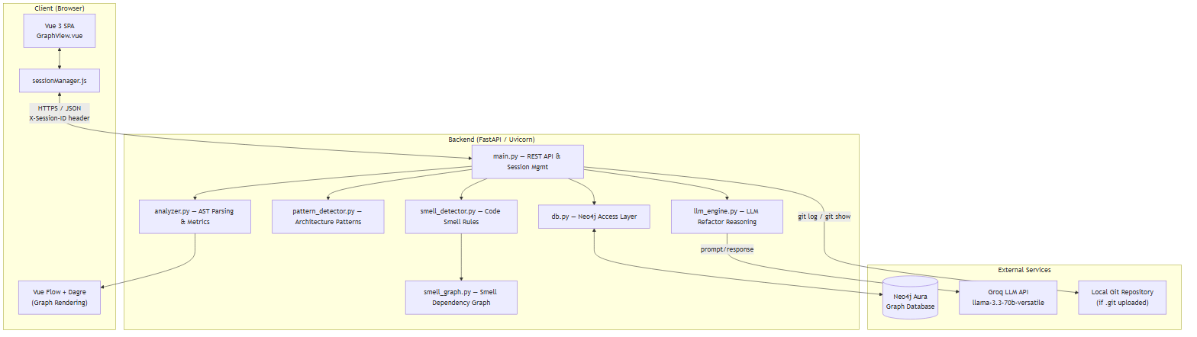

4. Use Case Model

4.1 Use Case Diagram
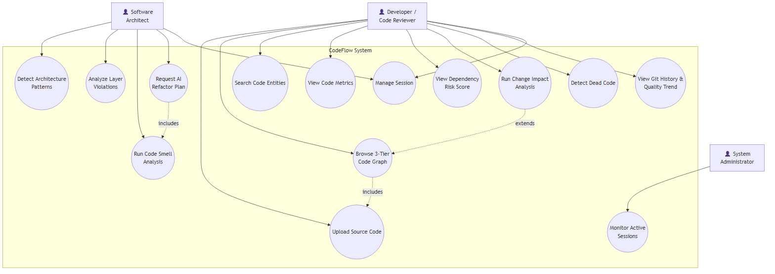

4.2 Use Case Descriptions
UC1 — Upload Source Code
- Actor: Developer
- Precondition: Active session exists (auto-created on app load).
- Flow: User selects a single file, a ZIP, or a folder → frontend validates extension/size → POST /upload → backend extracts (if ZIP), filters ignored directories, parses with Tree-sitter, builds graphs, stores in Neo4j, returns Tier-1 graph + metrics.
- Postcondition: Session now holds the parsed project graph; Tier-1 view is rendered.
- Alternate flow: Invalid file type / oversized upload / zip-slip path → reject with error message.
UC2 — Browse 3-Tier Code Graph
- Actor: Developer / Architect
- Flow: User clicks a Module node → GET /graph/tier2/{module_name} → file-level graph rendered. User clicks a File node → GET /graph/tier3?file_path=... → function-level graph rendered. User clicks a Function node → GET /expand/{function_name} → inline callers/callees shown.
- Postcondition: Breadcrumb trail updated; user can navigate back via "← Back".
UC3 — Search Code Entities
- Actor: Developer
- Flow: User types a query in the search box → client-side/REST search returns matching functions/files/modules with risk badge → clicking a result focuses/centers that node in the graph (loading the relevant tier if not visible).
UC5 — Detect Architecture Patterns
- Actor: Architect
- Flow: GET /api/patterns/{session_id} → pattern_detector.py runs rule-based detectors (MVC/MVP, Layered, Clean, Hexagonal, Repository, GoF) against the parsed graph → confidence-scored results with evidence and violations rendered in the Architecture Patterns panel.
UC6 — Analyze Layer Violations
- Actor: Architect
- Precondition: Folder/ZIP upload (multi-file structure required).
- Flow: GET /layer-violations → backend checks Controller→Service→Repository→Model call ordering → violations grouped by module/severity → displayed in Layer Analysis panel.
UC7 — Run Code Smell Analysis
- Actor: Architect / Tech Lead
- Flow: GET /smell-analysis → smell_detector.py evaluates function/module/architecture-level smell rules → smell_graph.py builds a smell dependency graph and root-cause ranking → results (severity chips, ranked files, expandable detail) shown in Smell Analysis panel.
UC8 — Request AI Refactor Plan (extends UC7)
- Actor: Architect
- Flow: User clicks "AI Refactor Plan" → POST /llm-refactor-reason with smell summary → llm_engine.py prompts Groq LLM → response parsed into executive summary, root cause, prioritized steps (pattern, target, effort, risk), and long-term recommendation → rendered in LLM plan box.
UC9 — View Dependency Risk Score
- Actor: Developer
- Flow: GET /risk-score → functions ranked by fan-in into High/Medium/Low/None risk buckets → top functions shown with "Changing this will affect N caller(s)" warning.
UC10 — Run Change Impact Analysis (extends UC2)
- Actor: Developer
- Flow: User hovers/selects a function node → GET /impact-analysis/{function_name} → backend performs BFS over the reverse call graph → affected functions/files/modules with hop-depth returned → impact overlay tooltip rendered on canvas.
UC11 — Detect Dead Code
- Actor: Developer
- Flow: GET /dead-code → backend flags functions with fan-in = 0 that are not recognized entry points, classified by confidence (high for private, medium for public); unused imports listed per file.
UC12 — View Git History & Quality Trend
- Actor: Developer / Tech Lead
- Precondition: Uploaded ZIP/folder contains a .git directory.
- Flow: GET /git-history → backend runs git log/git show (last 30 commits), estimates LOC/function count/MI per commit → paginated commit table with churn and net delta rendered.
UC13 — Manage Session
- Actor: Any user
- Flow: On app load, frontend calls POST /start-session (or restores ID from sessionStorage); all subsequent requests carry X-Session-ID; on tab close, sendBeacon triggers DELETE /end-session; backend also auto-expires sessions after 3 hours via a background cleanup task.
UC14 — Monitor Active Sessions
- Actor: Administrator
- Flow: GET /admin/sessions → returns list of all active sessions with metadata for operational monitoring.

5. Functional Requirements (System Features)

5.1 FR-1: Code Upload & Ingestion
- FR-1.1: System shall accept a single source file, a ZIP archive, or a directory (via folder picker).
- FR-1.2: System shall reject files exceeding 2 MB (single file) or uploads exceeding 50 MB / 1000 files in total.
- FR-1.3: System shall sanitize ZIP entries to prevent path traversal ("zip-slip") and skip directories such as node_modules, .git (except for history extraction), venv, dist, build.
- FR-1.4: System shall display upload progress with stage labels.

5.2 FR-2: Multi-Language Parsing & Metrics
- FR-2.1: System shall parse Python, JavaScript, TypeScript, Java, Go, Rust, C, C++, and C# using Tree-sitter.
- FR-2.2: System shall extract, per function: name, parameters, line range, cyclomatic complexity, fan-in, fan-out.
- FR-2.3: System shall build an internal call graph using only same-project function calls (external/stdlib calls excluded).
- FR-2.4: System shall classify "god files" and chunk them into virtual modules using class-based, complexity-based, or line-range strategies.

5.3 FR-3: 3-Tier Graph Visualization
- FR-3.1: System shall render Tier-1 (module), Tier-2 (file), Tier-3 (function), and Tier-4 (chunk) graphs using Vue Flow with Dagre auto-layout.
- FR-3.2: System shall support click-to-drill-down and a breadcrumb/back-navigation stack.
- FR-3.3: System shall provide a MiniMap and pan/zoom Controls.
- FR-3.4: System shall visually distinguish node types (Module, File, Function, Chunk, Root/orphan file) and risk levels by color/icon.

5.4 FR-4: Search
- FR-4.1: System shall support full-text search across function, file, and module names.
- FR-4.2: Search results shall display entity type, file path, and risk badge.
- FR-4.3: Selecting a result shall load the relevant tier (if not already visible) and focus the node.

5.5 FR-5: Architecture Pattern Detection
- FR-5.1: System shall detect MVC/MVP, Layered Architecture, Clean Architecture, Hexagonal Architecture, Repository Pattern, and common GoF design patterns (Singleton, Observer, Factory, Facade).
- FR-5.2: Each detected pattern shall include a confidence score, supporting evidence, and component-to-layer mapping.
- FR-5.3: System shall list architecture rule violations associated with detected patterns.

5.6 FR-6: Layer Violation Analysis
- FR-6.1: System shall validate that calls only flow Controller → Service → Repository → Model (utility layers callable from any layer).
- FR-6.2: Violations shall be reported with source file, target reference, severity (High/Medium), and explanation, grouped by module.
- FR-6.3: This feature requires folder/ZIP upload (not applicable to single-file upload).

5.7 FR-7: Code Smell Analysis & AI Refactor Plan
- FR-7.1: System shall detect function-level smells: Long Method, Too Many Parameters, Dead Code, Feature Envy, Deep Nesting, Switch Smell, Magic Numbers.
- FR-7.2: System shall detect module-level smells: God Module, God Class, Large Module, Lazy Class, Duplicate Code, Data Clumps, Shotgun Surgery.
- FR-7.3: System shall detect architecture-level smells: Circular Dependency, Long Call Chain, Inappropriate Intimacy, Divergent Change.
- FR-7.4: System shall build a smell dependency graph and compute root-cause ranking via BFS and a greedy set-cover fix-ordering algorithm.
- FR-7.5: On user request, system shall call an LLM (Groq llama-3.3-70b-versatile) to generate an executive summary, root cause, prioritized refactor steps (with effort/risk), and a long-term recommendation.

5.8 FR-8: Change Impact Analysis
- FR-8.1: For a selected function, system shall compute the full reverse call graph (all transitive callers) via BFS.
- FR-8.2: Results shall indicate hop-depth (direct vs. indirect caller) and aggregate affected files/modules.
- FR-8.3: System shall render an overlay showing the top affected functions with an option to view the full list.

5.9 FR-9: Dependency Risk Scoring
- FR-9.1: System shall classify every function into High (≥10 callers), Medium (3–9), Low (1–2), or None (0) risk based on fan-in.
- FR-9.2: System shall rank and display the top 50 highest-risk functions with a caller-count warning.

5.10 FR-10: Dead Code Detection
- FR-10.1: System shall flag functions with zero fan-in that are not recognized entry points (e.g., main, lifecycle hooks, test methods, web route handlers).
- FR-10.2: Flagged functions shall carry a confidence level: High (private, no callers) or Medium (public, no callers — may be used dynamically/externally).
- FR-10.3: System shall list unused imports per file.

5.11 FR-11: Code Metrics Dashboard
- FR-11.1: System shall compute and display LOC, SLOC, file/function counts, average/max cyclomatic complexity, cognitive complexity, decision points, Halstead volume/difficulty, and Maintainability Index (0–100, color-coded).
- FR-11.2: System shall report max call-chain depth, circular dependency count (with chains), and orphan node count.

5.12 FR-12: Git History & Evolution Tracking
- FR-12.1: If the upload contains a .git directory, system shall extract up to the last 30 commits via git log/git show.
- FR-12.2: For each commit, system shall report hash, message, author, date, insertions/deletions, churn, and net delta, plus estimated LOC/function count/MI at that point in history.
- FR-12.3: The commit table shall be paginated (10 rows per page, "load more").

5.13 FR-13: Session Management
- FR-13.1: System shall create a unique session (UUID) per user on first load and persist it in sessionStorage.
- FR-13.2: All API requests shall carry an X-Session-ID header; backend data (Neo4j nodes, disk uploads, in-memory cache) shall be isolated per session.
- FR-13.3: Sessions shall auto-expire after 3 hours of inactivity via a background cleanup task (every 30 minutes); explicit cleanup shall occur via sendBeacon on tab close.
- FR-13.4: An admin endpoint shall list all active sessions for monitoring.

6. Data Flow Diagrams

6.1 DFD — Level 0 (Context Diagram)
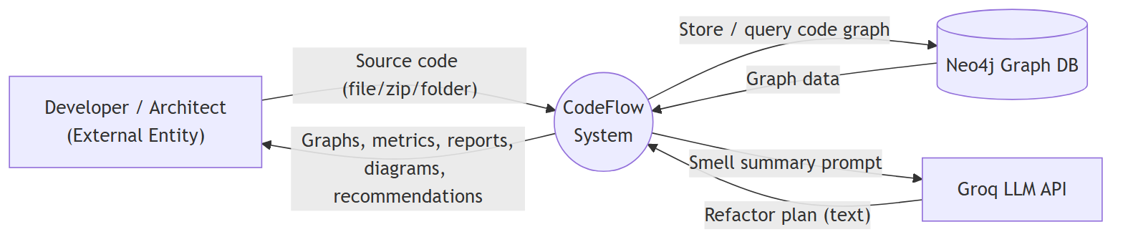

6.2 DFD — Level 1 (Major Processes)
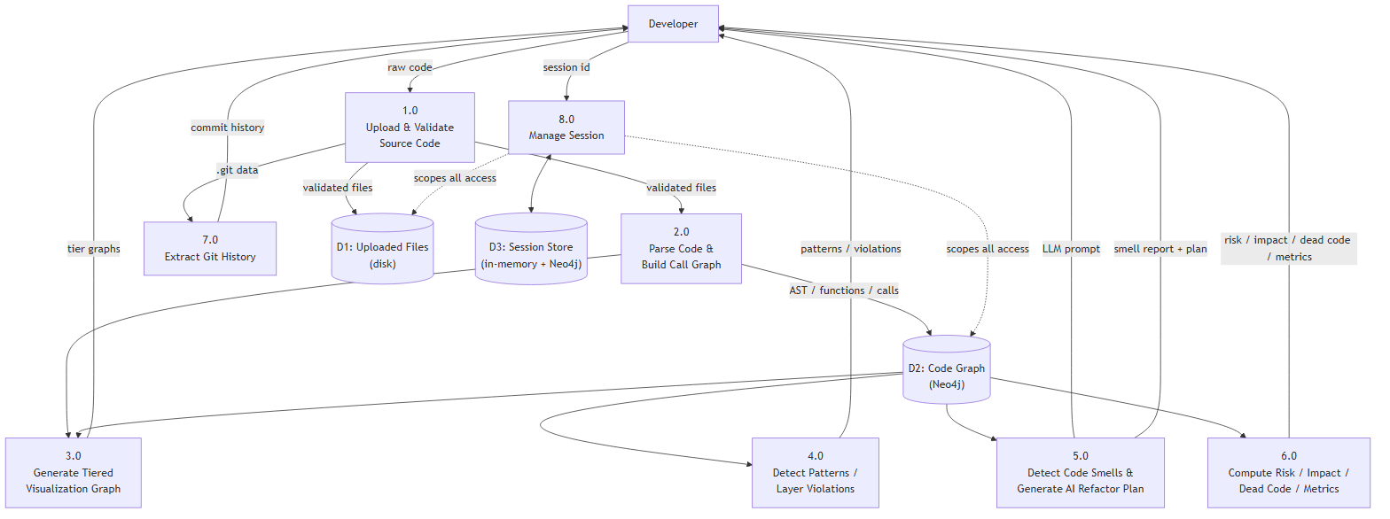

7. Data Model (ER Diagram)
CodeFlow's persistent store is a property graph (Neo4j) rather than a relational database. The diagram below is expressed in ER notation to show entities, attributes, and relationships.
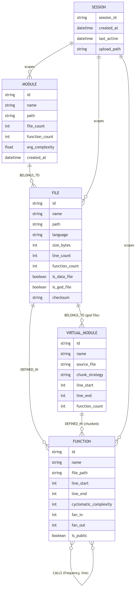
Notes:
- All nodes are tagged with session_id to isolate per-user data within the shared Neo4j instance.
- CALLS is a many-to-many self-relationship on FUNCTION, carrying frequency and line properties.
- VIRTUAL_MODULE exists only for "god files" that are split for readability; it sits between FILE and FUNCTION.

8. Sequence Diagrams

8.1 Sequence — Upload & Initial Analysis (UC1)
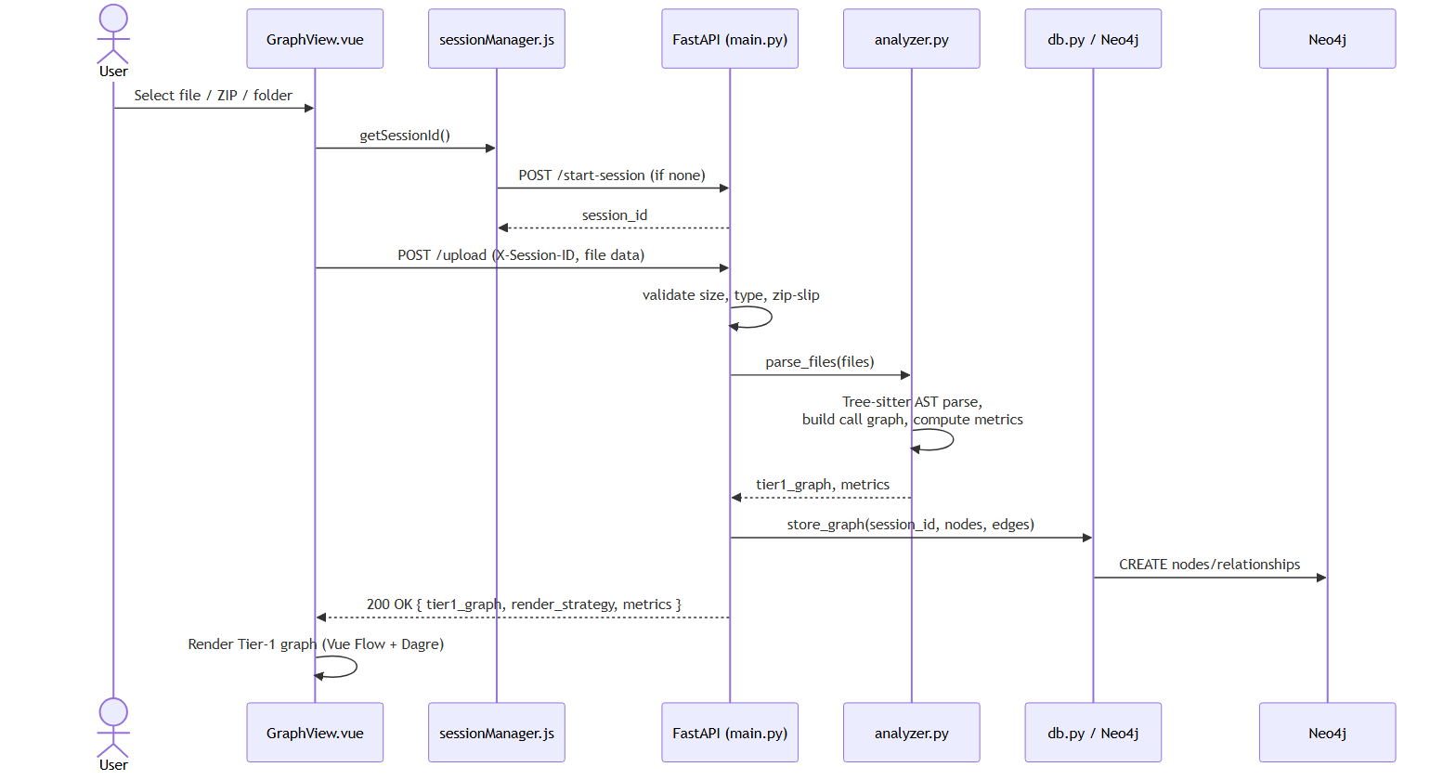

8.2 Sequence — Drill-Down Navigation (UC2)
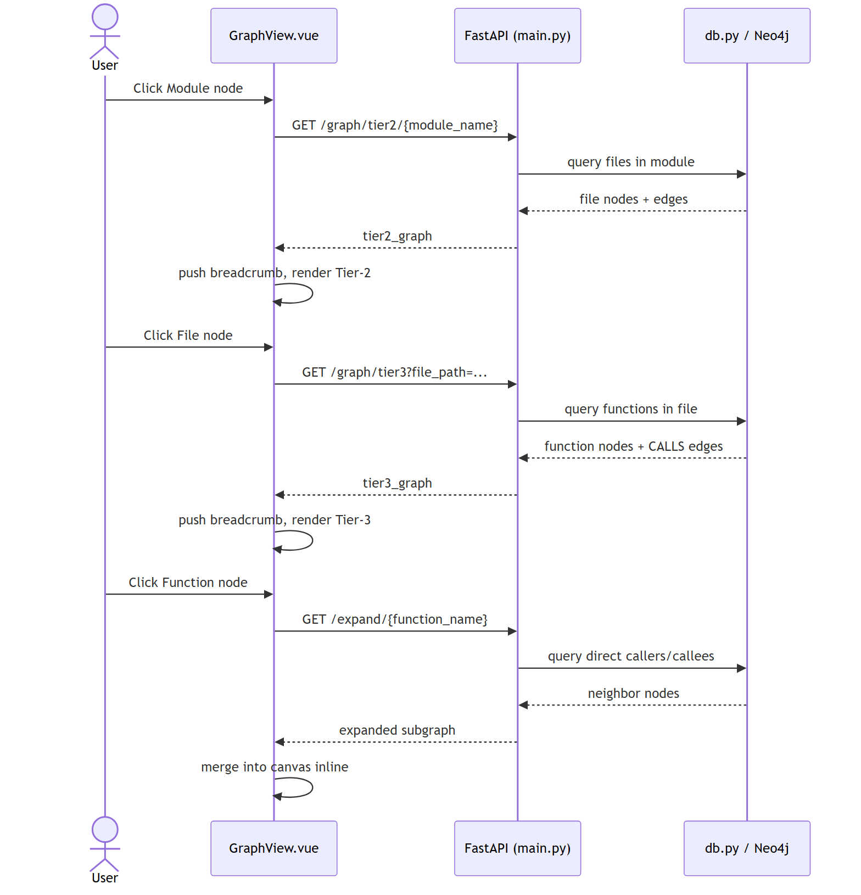

8.3 Sequence — Change Impact Analysis (UC10)
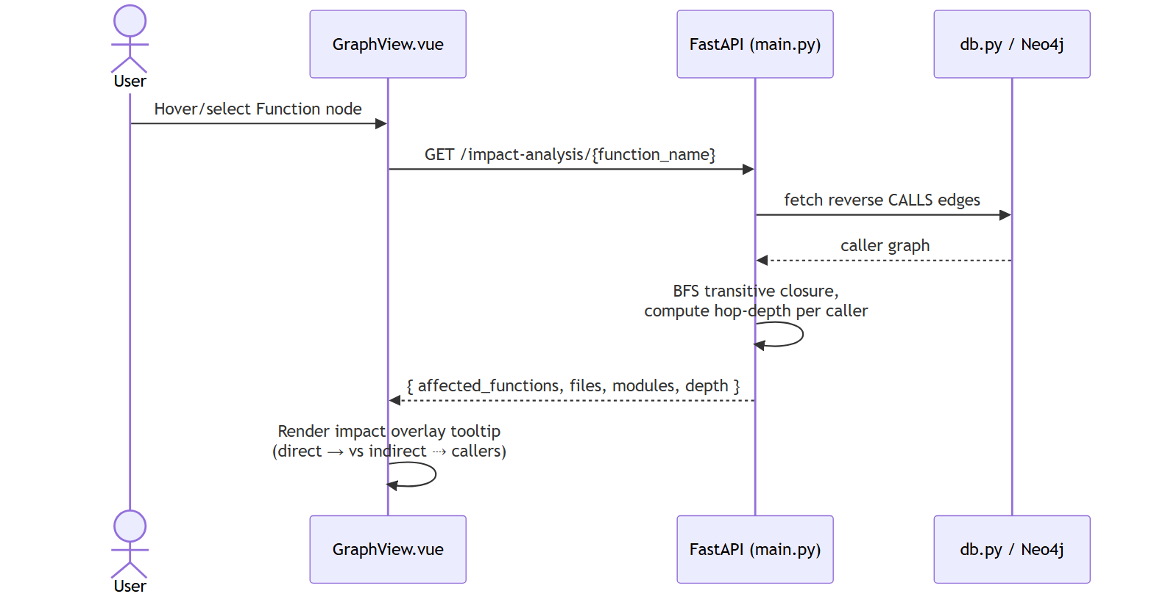

8.4 Sequence — Code Smell Analysis + AI Refactor Plan (UC7, UC8)
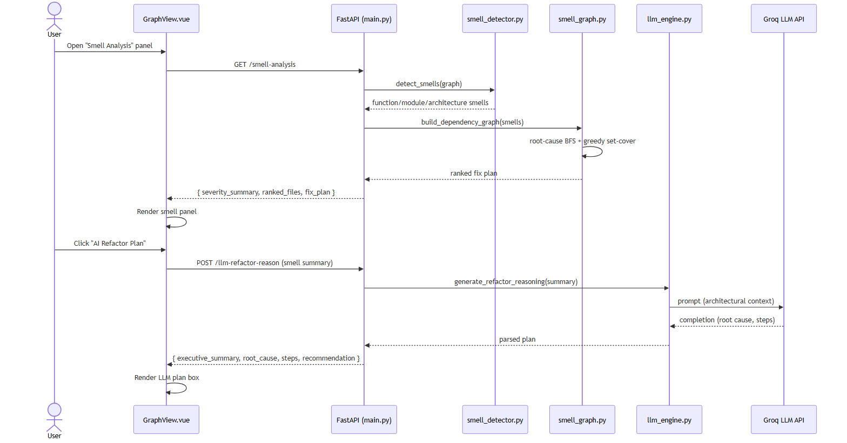

8.5 Sequence — Session Lifecycle (UC13)
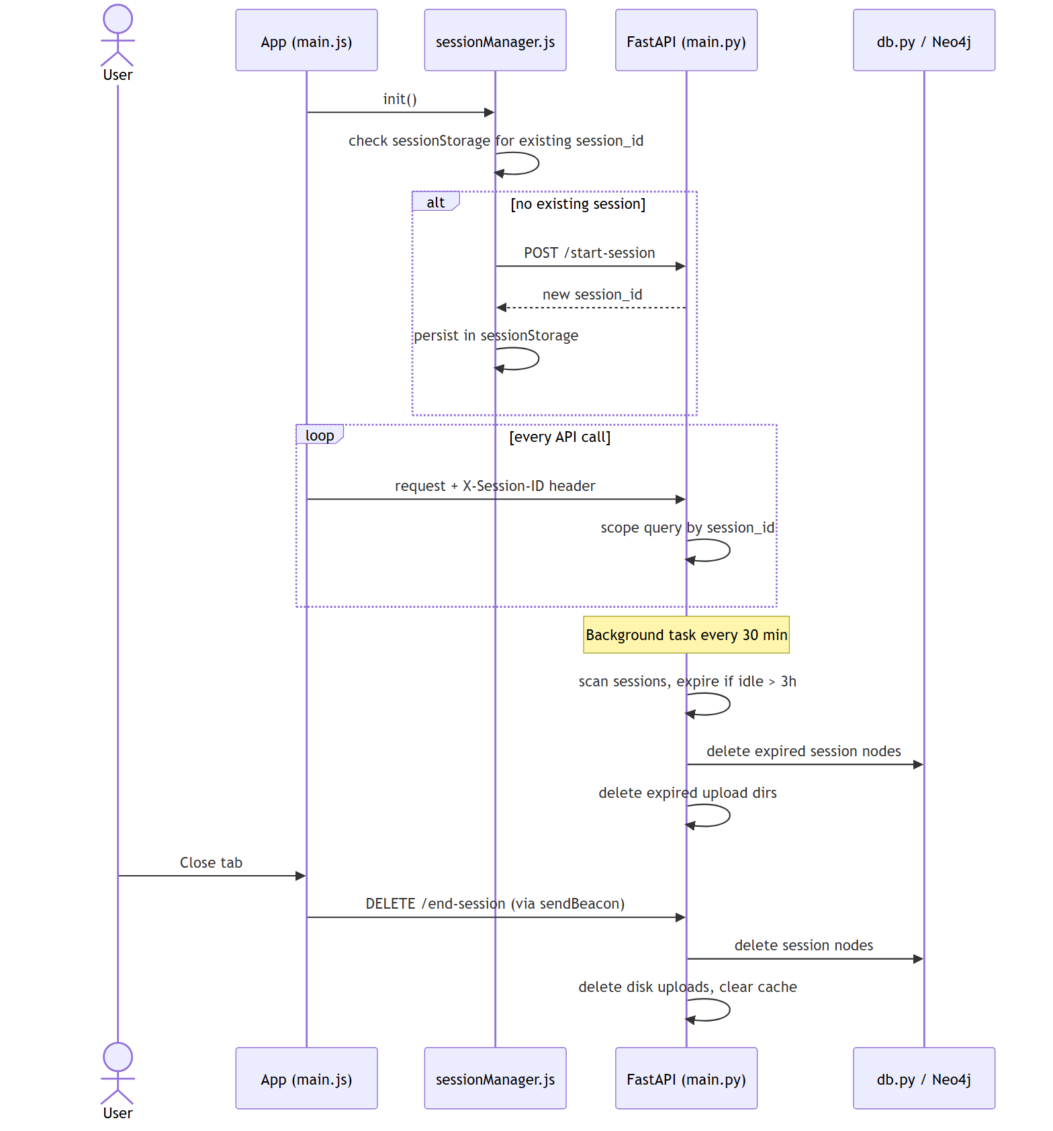

9. External Interface Requirements

9.1 User Interfaces
- Single-page application (Vue 3) with a resizable left sidebar (upload, status, search, legend, metrics, git history, smell analysis, risk, dead code, patterns, layer analysis panels) and a main canvas (Vue Flow graph with MiniMap and Controls).

9.2 Software Interfaces (REST API)
Method | Endpoint | Purpose
GET | `/health` | Health check + active session count
POST | `/start-session` | Create a new session
DELETE | `/end-session` | Clean up a session
GET | `/sessions/info` | Current session metadata
GET | `/admin/sessions` | List all active sessions
POST | `/upload` | Upload & analyze file/zip/folder
GET | `/graph/tier1` | Module-level graph
GET | `/graph/tier2/{module_name}` | File-level graph
GET | `/graph/tier3?file_path=` | Function-level graph
GET | `/graph/chunk?file_path=&chunk_name=` | Function graph for a chunked god file
GET | `/graph/files` | All-files flat graph
GET | `/expand/{function_name}` | Direct callers/callees of a function
GET | `/risk-score` | Dependency risk ranking
GET | `/impact-analysis/{function_name}` | Reverse call graph / change impact
GET | `/dead-code` | Unreachable functions & unused imports
GET | `/layer-violations` | Architectural layer rule violations
GET | `/metrics` | Aggregated code metrics
GET | `/git-history` | Commit history with quality estimation
GET | `/smell-analysis` | Code smell detection + fix plan
POST | `/llm-refactor-reason` | LLM-based architectural reasoning
GET | `/api/patterns/{session_id}` | Architecture pattern detection

9.3 Communication Interfaces
- Frontend ↔ Backend: HTTPS/JSON REST, X-Session-ID custom header for session scoping.
- Backend ↔ Neo4j: Bolt protocol (Neo4j driver) to Neo4j Aura cloud instance.
- Backend ↔ Groq: HTTPS REST call to Groq Chat Completions API.

10. Non-Functional Requirements
Category | Requirement
**Performance** | Parse 100 files in <2s; Tier-1 graph in <5s; Tier-2 in <1s; Tier-3 in <500ms; search over 1000+ functions in <1s; god-file chunking in <10s
**Security** | Zip-slip prevention, filename sanitization, symlink rejection, max file size/count enforcement, no server-side code execution, per-session data isolation
**Scalability** | Designed to support 500+ concurrent isolated sessions; in-memory + Neo4j dual caching
**Reliability** | Falls back to in-memory cache if Neo4j is unreachable; conservative (false-negative biased) dead-code detection to avoid false positives
**Maintainability** | Modular backend (`analyzer`, `pattern_detector`, `smell_detector`, `smell_graph`, `llm_engine`, `db` separated by responsibility)
**Usability** | Drill-down navigation with breadcrumbs, color-coded risk/severity indicators, in-app "How to Use" guidance
**Availability** | Session auto-cleanup every 30 minutes prevents resource leakage; sessions expire after 3 hours of inactivity

11. Other Constraints & Assumptions
- Dynamic/reflective function calls (e.g., calls via string lookup, eval, decorators that wrap call sites) are not tracked by the static AST-based analyzer — this is a known limitation acknowledged in the Dead Code and Risk Score panels.
- Layer Violation Analysis and Git History features require a folder/ZIP upload; they do not apply to single-file uploads.
- The AI Refactor Plan feature depends on third-party LLM availability (Groq); if the API is unavailable, the static smell report is still available without the AI-generated plan.
- Git History extraction assumes the uploaded archive/folder includes a valid .git directory with accessible commit objects.
End of Software Requirements Specification.

