Assignment2 – Amit Cohen 322330010

Question 1

Shutter speed- also known as exposure time, it is the time in which the shutter of the camera closes, which dictates the amount of light the camera takes in.

Camera field of view- the maximum area of an image that a camera can image.

Digitization bias- a phenomenon in path planning algorithms which uses grids, in which an almost empty cells are marked as occupied.

The difference between continuous and event-driven replanning is that continuous replanning computes all paths in advance, whereas event driven replanning only replans when there is a meaningful deviation from the original plan.

Question 2

1. I used my own mobile phone (Samsung s8) and took pictures of the chess board from the provided website. I took around 19 pictures (in two rounds, 11 from first position and 8 from other position to complete task 3) while moving the picture and keeping the camera static. Attached here are the pictures of my phone and chess board image.

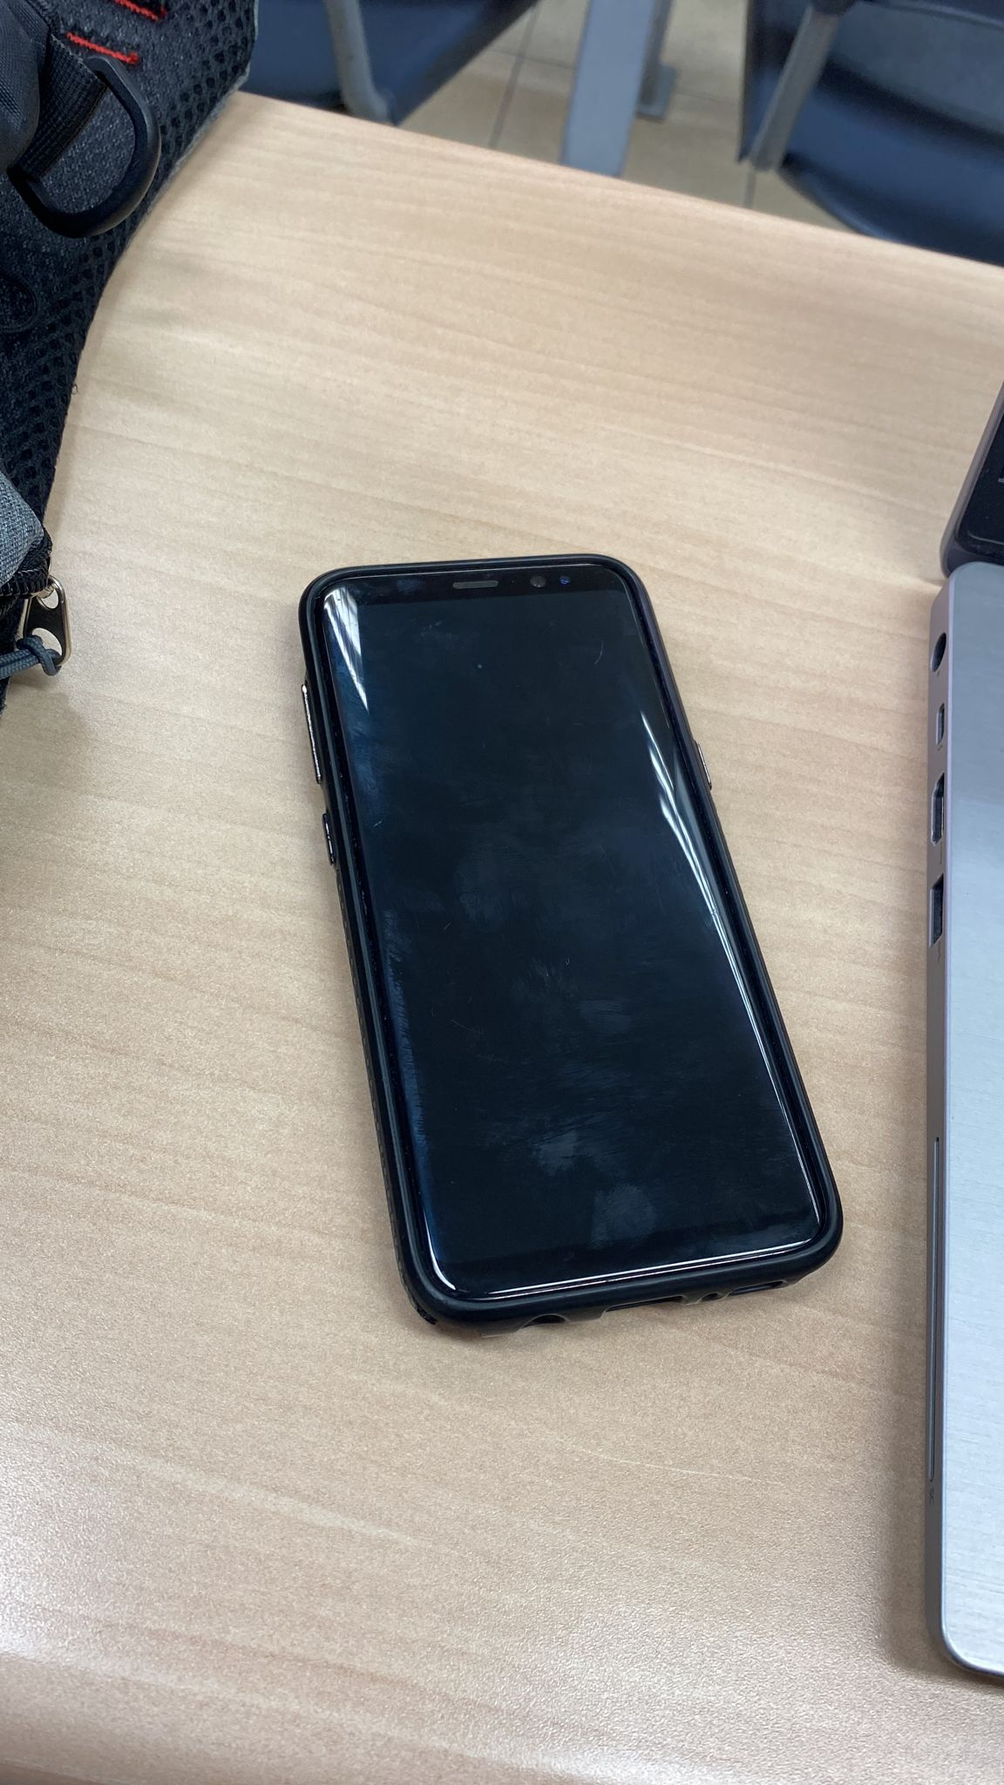 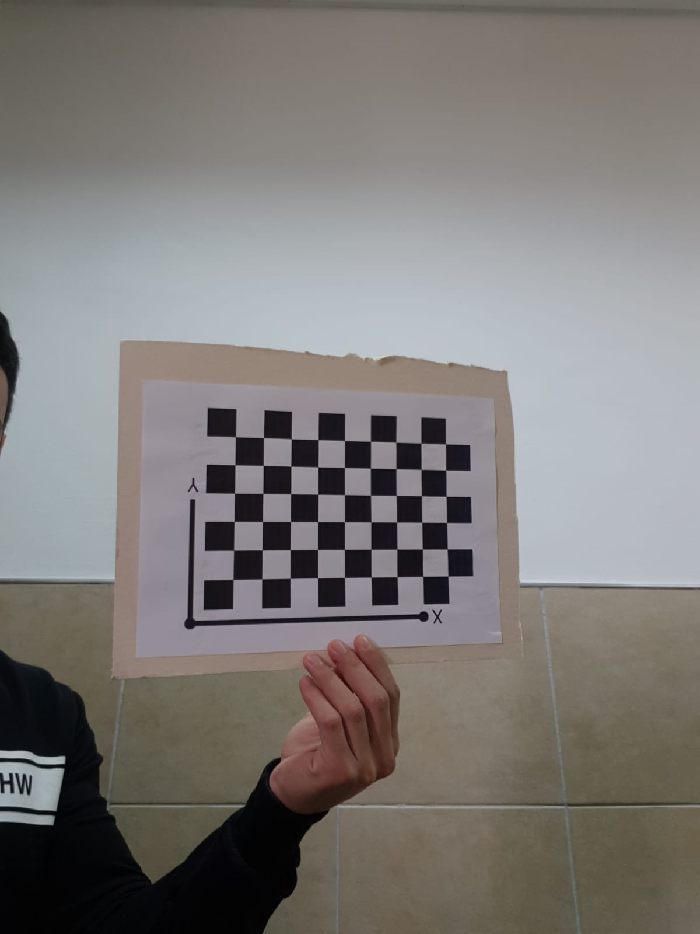

2. Attached here are all the relevant images including all parameters for 11 images.

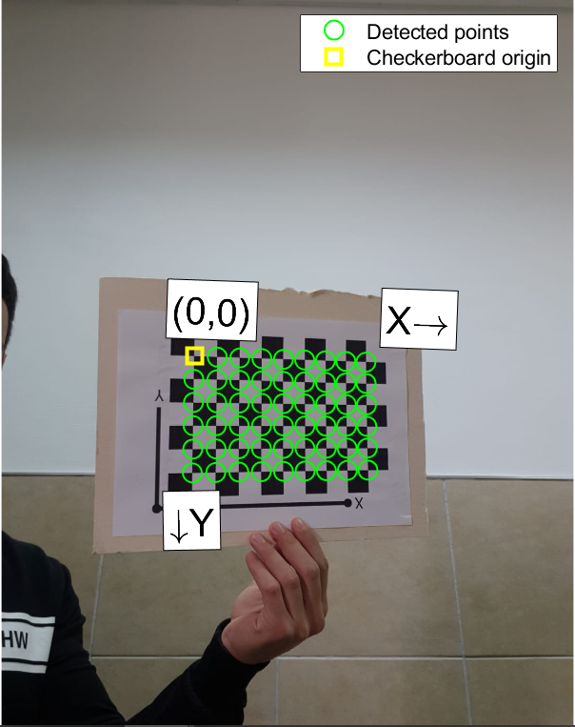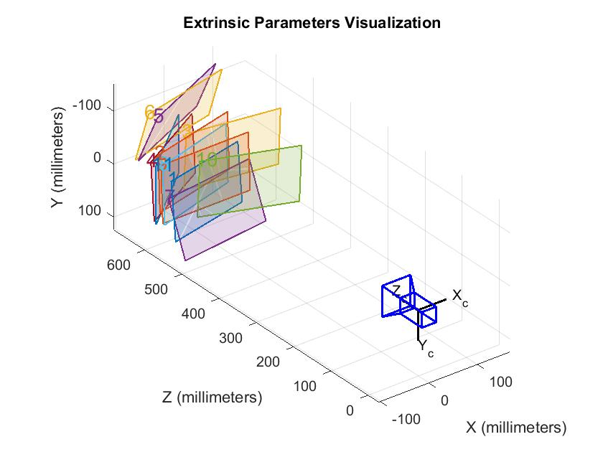

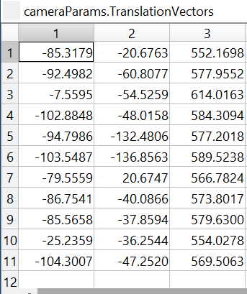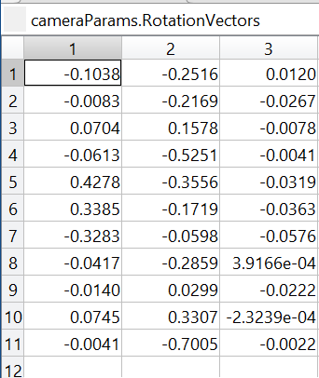

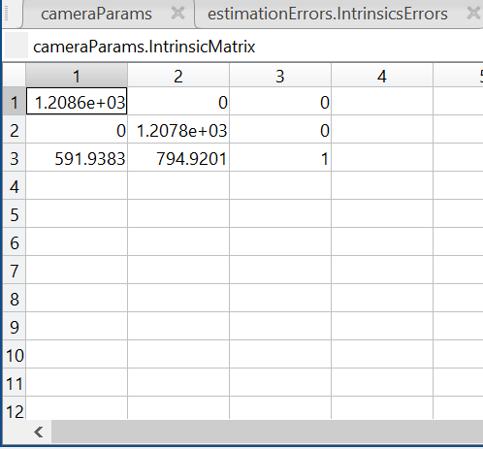

I used MATLAB camera calibration tool to generate all the images above. Below is an explanation for all the exported parameters above.

Parameters Explanation:

Based on lecture’s note with:

<https://ksimek.github.io/2013/08/13/intrinsic/>.

https://ksimek.github.io/2012/08/22/extrinsic/.

Intrinsic Matrix: This matrix includes five elements: focal length, axis skew and principal point offset. The format of the matrix is:

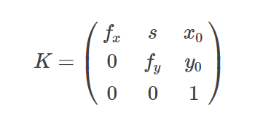

$Focal Length \left(f_{x},f_{y}\right):$ The focal length is the distance between the pinhole and the film (a.k.a. image plane).

$Principal point offset(x_{0},y_{0})$: The "principal point offset" is the location of the principal point relative to the film's origin.

$Axis skew\left(s\right):$ Axis skew causes shear distortion in the projected image.

Extrinsic Matrix:

The camera's extrinsic matrix describes the camera's location in the world, and what direction it's pointing.

All in all, I took 11 pictures and got 11 different extrinsic matrices (Rotation matrix is presented as a vector which could be transformed to 3x3 matrix). To make the extrinsic transformation, we will use the rotation matrix R with its corresponding T. The intrinsic parameters are the same because they are solely dependent on the camera.

3. This time I used 8 pictures; results are below:

As we can see, the extrinsic matrix is different, as expected. The focal length is the same in the intrinsic matrix, as expected. However, the camera changed its location, and therefore the principal point offset has changed.

Question3

1.

2.

I defined the size to be the volume of the bunny. I wrapped the bunny inside a box using the maximum differences of the x y and z values. Then, I made a product of these values and got: 0.002877 m^3.

3.

I segmented the point cloud using the z coordinates. Higher values of z denote higher parts of the bunny (ears).

Question 4

To solve this question, I will use the following claim: A star always finds the optimal solution when using admissible heuristic function. Admissible heuristic function is a heuristic function which always gives heuristic value which is less than or equal to the actual value.

1. The function h3 is admissible, therefore we are guaranteed to yield optimal result, therefore the path we will get is S, C, K, B, G
2. Functions h2 and h3 will yield optimal paths because they are admissible. The function h1 is not admissible, but still yields optimal path.

Question 5

Next node expanded would be D, its f value is 15, whereas: f(C)=24, f(E) = 17, f(F) = 20, f(G) = 16 and f(H) = 19.