**Assignment 1**

**Nitzan Levy - 322572488**

Question 1

Euler Angels & Quaternions – The Euler angles are three angles which describe the orientation of a rigid body with respect to a fixed coordinate system.  
Quaternion is the quotient of two directed lines in a three-dimensional space.

Sensor Fusion – Sensor fusion is the process of combining sensory data or derived from disparate sources.

Deliberative Paradigm – Deliberative paradigm is one of robotic paradigm. In deliberative paradigm the robot operates in a top-down fashion, heavy on planning, the robot senses the world plans the next action, all the sensing data tends to be gathered into one global world model.

Reactive Paradigm – Reactive paradigm is one of robotic paradigm. Reactive paradigm is sense-act based. The robot has multiple instances of sense-act coupling, these couplings are concurrent processes, called behaviors, which take the local sensing data and compute the best action to take independently of what the other processes are doing. The robot will do a combination of behaviors.

Question 2

Pure pursuit algorithm with large lookahead distances (L), less curvy of a path that can be followed. Small lookahead distances (L), curvier of a path that can be followed.

1. L:0.9 -> A sees deep into the future and so the algorithm is trying to reach in somewhat of a straight line, and therefore gets stuck in the wall.
2. L:0.6 -> B is the perfect one, it is not too large or too small and therefore fits perfectly into the path
3. L:0.3 -> C reaches the destination, but with big oscillations because he looks ahead a little bit less than it needs.

Question 3

a.

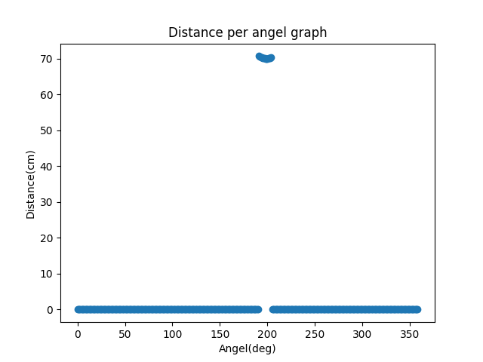

We can learn from the graph what the distance between the robot and the object and at which angle.

b.

D- 69.99 cm.  
D is the minimum point from our samples that they are not “noise” because he creates an angle of 90 with the object.   
“Noise” points are points with very small D values.

W- 17.18 cm.  
W was calculated by the cosine theorem. We create a triangle using 2 distances of the robot from the object, the first and the last, and the angle between them.  
The angle between them is the subtraction of their indexes in the csv file, and the distances are the data inside the indexes.

$θ-199°$. $θ$ 
 is the index of D, since the indexes in the csv file represents the angles on Xrcs

c.

P = (-66.18,-22.78)

Px calculated by Dcos($θ$) and Py calculate by DSin($θ$).  
D is the closest point on the face of the object facing.

d.

P = (Xw=-15.92,Yw=-12.82)

Xw and Yw calculate by the formula from the lecture to transfer Prcs to Pwcs.

Question 4

According to the given environment in figure 3, the 2 problems are:  
1. Local minima- The combination of the fields can cause the robot to be stuck at some points. The field add to zero, the repulsive fields from the wall cancel the attractive potential fields from the goal.  
2. The robot can get stuck in a cyclic behavior- the robot keeps returning to the local minimum.

To solve these problems:  
1. The local minimum is avoiding by adding a potential field comprising random values.  
2. Adding a dynamically updated potential field with repulsive forces from all previously visited locations.