**Assignment 2**

**Nitzan Levy – 322572488**

Question 1

1.

Shutter speed – it’s the speed at which the shutter of the camera closes.

Field of view – it’s the maximum area of a sample that a camera can image.

2. The difference between continuous and event-driven replanning is that continuous replanning is essentially imposing a hierarchical sense, plan, act cycle. Event-driven replan when there is some event, exception, or indication that the plan execution is not working.

Question 2

1. I used my own smart phone (iPhone 11) as a camera to take photos of the object. My object was A4 printed paper attached on canvas board.

My phone was static and I have moved the canvas board and took photos from 10 different angles.

My camera:

My object:

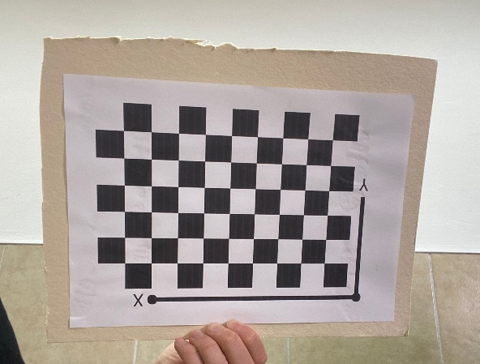

2.

Question 3

1. bunny045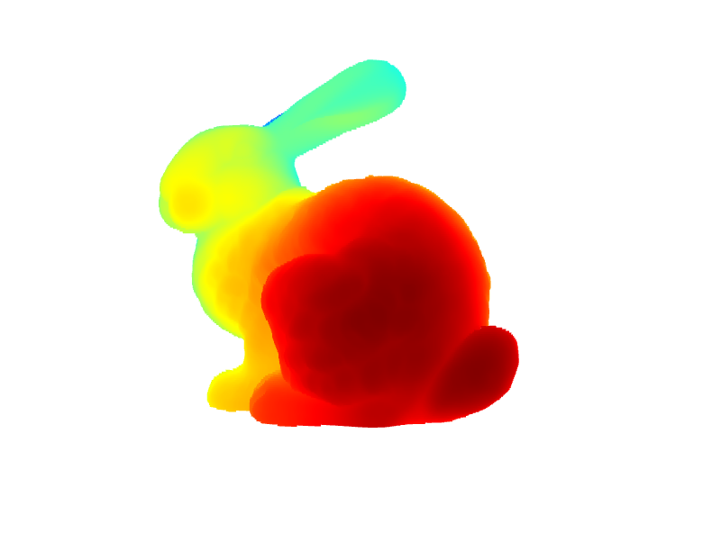
2. The bunny volume is 0.00323.

I calculated this volume by 4 scans. From 0, 90, 180 and 270 angles.  
I build dice around the bunny, I found the miny and maxy by bun000 and bun180 points, minx and maxx by bun090 and bun270, and minz and maxz using the four scans.

All this points represents the corners of the dice.  
After I found all this parameters I calculated the volume:  
(maxx-minx)*(maxy-miny)*(maxz-minz)=0.00323

1. I used the height to make the segmentation, meaning the z value, higher z values got closer to the ears and from a certain threshold I colored the points in red.

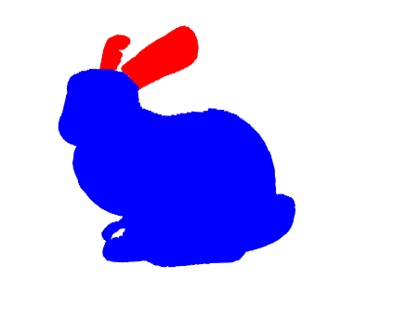

Question 4

1. The found path by A* search using h3 is SCKBG, this is the optimal path.
2. The 3 heuristic functions h1, h2 and h3 will generate an optimal path when using A*. h2 and h3 are admissible functions so it’s guaranteed to get an optimal solution, h1 not admissible but still generate an optimal path.

Question 5

The next node that will be expanded is D, because in A* we chose the next node by the calculation of the minimum value of f=h (hearustic function value) +g(actual value until now) of the neighbors.   
The calculation of f for node E is 17, for node F is 20, for node G is 16, for node H is 19, for node D is 15.  
So the next node that will be expanded is D.