Linux Ramp Up

Create bootable USB flash drive for Ubuntu (use ubuntu 18.04.1 as example)
- Download Rufus https://rufus.ie/
- Download the iso file for ubuntu 18.04.1 http://old-releases.ubuntu.com/releases/18.04.1/ ubuntu-18.04.1-desktop-amd64.iso
- Get a USB drive
- Use Rufus to create a bootable USB. Be careful that the selected USB drive will be formatted and all data on the USB drive will be destroyed. Make sure you select the correct device.




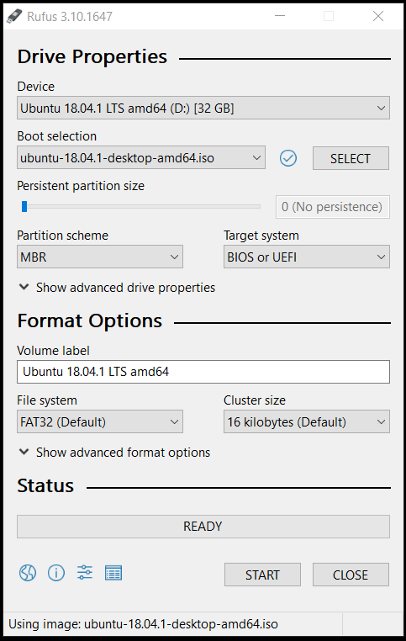
Device: select the USB device you want to use
Boot selection: click “SELECT” to select the iso file
Partition scheme: MBR (default) or GPT
Target system: BIOS or UEFI (default)
File system: FAT32(default) NTFS

You should see the following window. Click Yes.

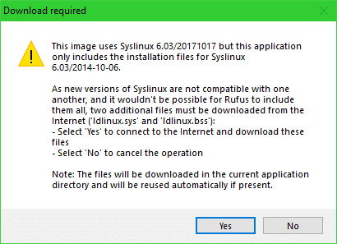

You should see the following window. Leave the default and click Yes.

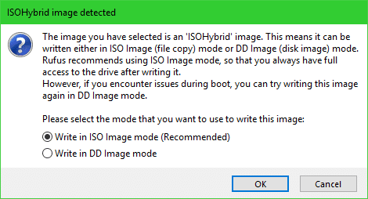

You should see a warning message. Click Yes.

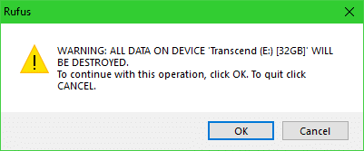

Reference: https://ubuntu.com/tutorials/tutorial-create-a-usb-stick-on-windows#1-overview
https://wiki.manjaro.org/index.php?title=Some_basics_of_MBR_v/s_GPT_and_BIOS_v/s_UEFI
https://www.howtogeek.com/235596/whats-the-difference-between-fat32-exfat-and-ntfs/

Install Ubuntu
- Get into BIOS to boot from USB device. Common keys to enter BIOS are F1, F2, F10, Del, Esc. Get ready to act quickly before the BIOS hands over control to OS. I would press Esc key repeatedly until I see the following screen.
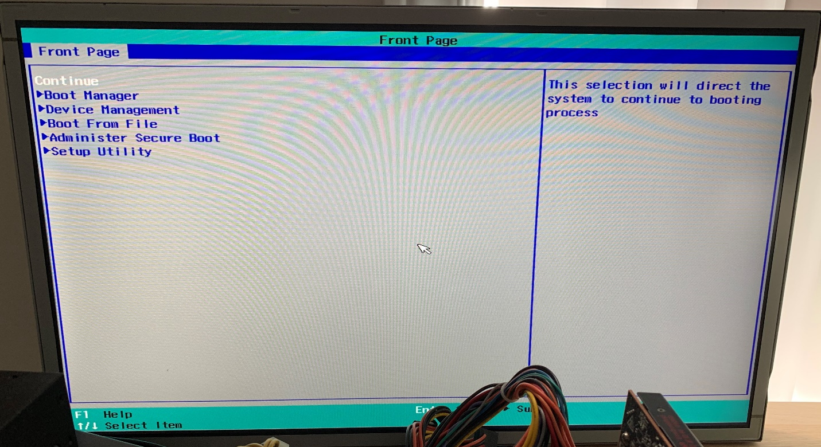
- Go to Boot Manager, find and select your bootable USB device
- If your USB device is not there, exit Boot Manager, go to Setup Utility->Boot->Boot type, change to UEFI Boot type, save and exit, reboot, go to Boot Manager again and select your bootable USB

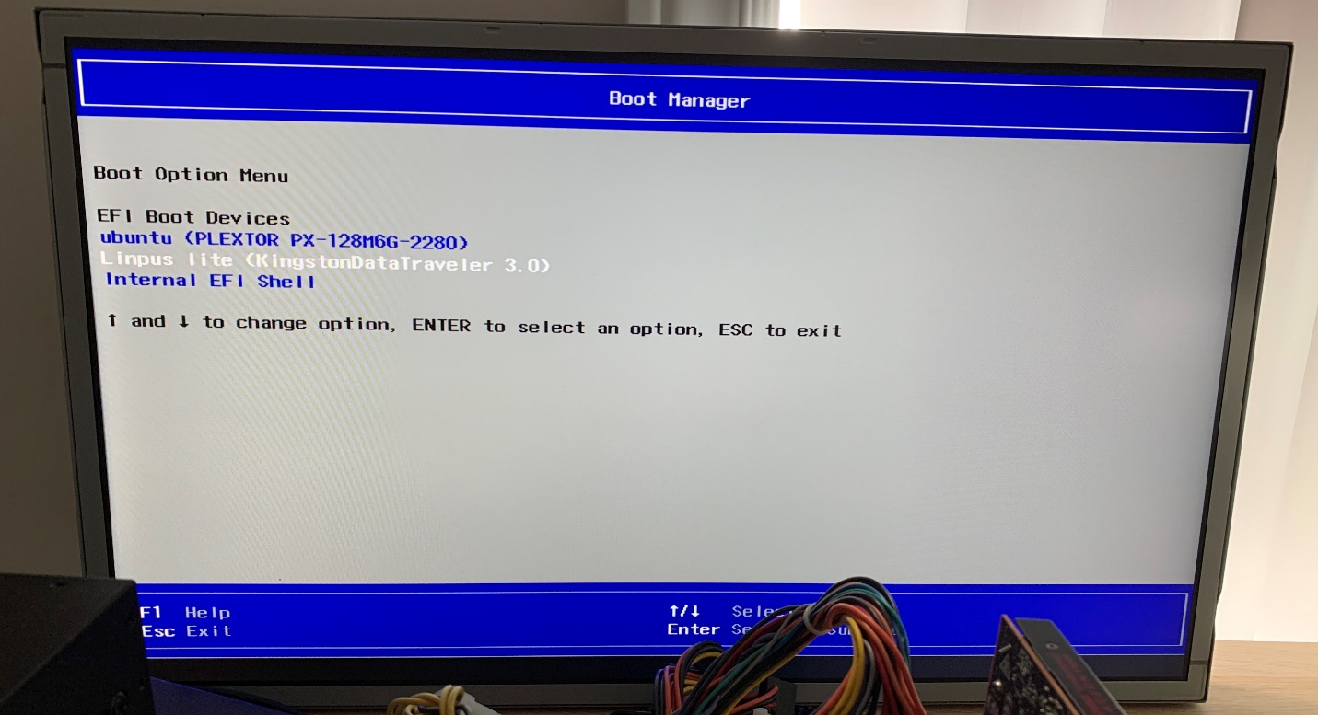

- You will then see the following screen. Select Install Ubuntu

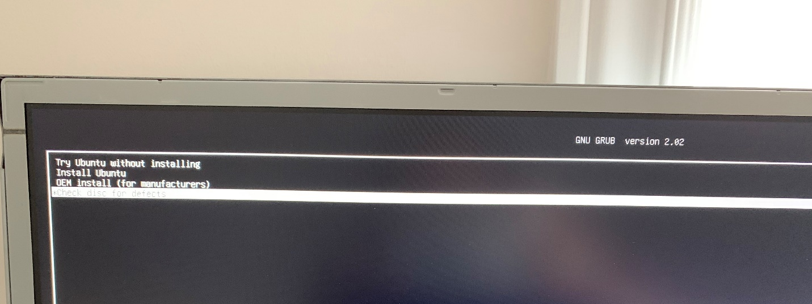
- You will enter Ubuntu installer. Follow the instructions to install Ubuntu

I normally select normal installation without any updates and 3rd party software.

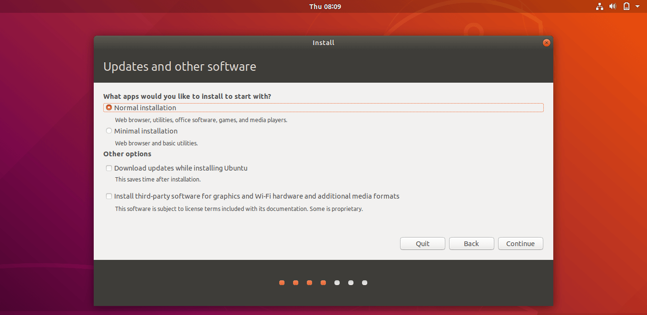

I normally select Erase disk and install ubuntu to do a clean install. You may want to have your own partition by selecting “something else”.

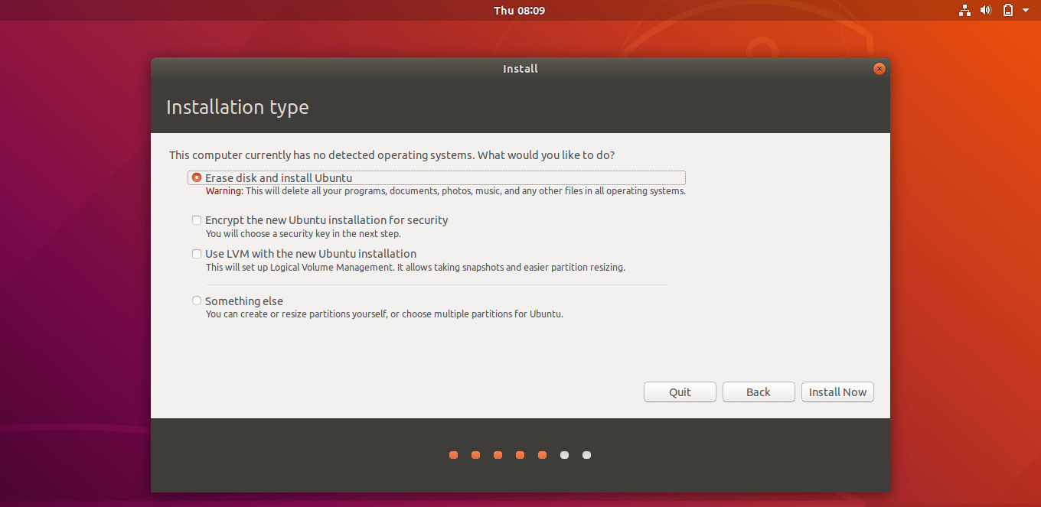

Once you click install now, it will ask you to confirm auto partitioning. Click Continue.

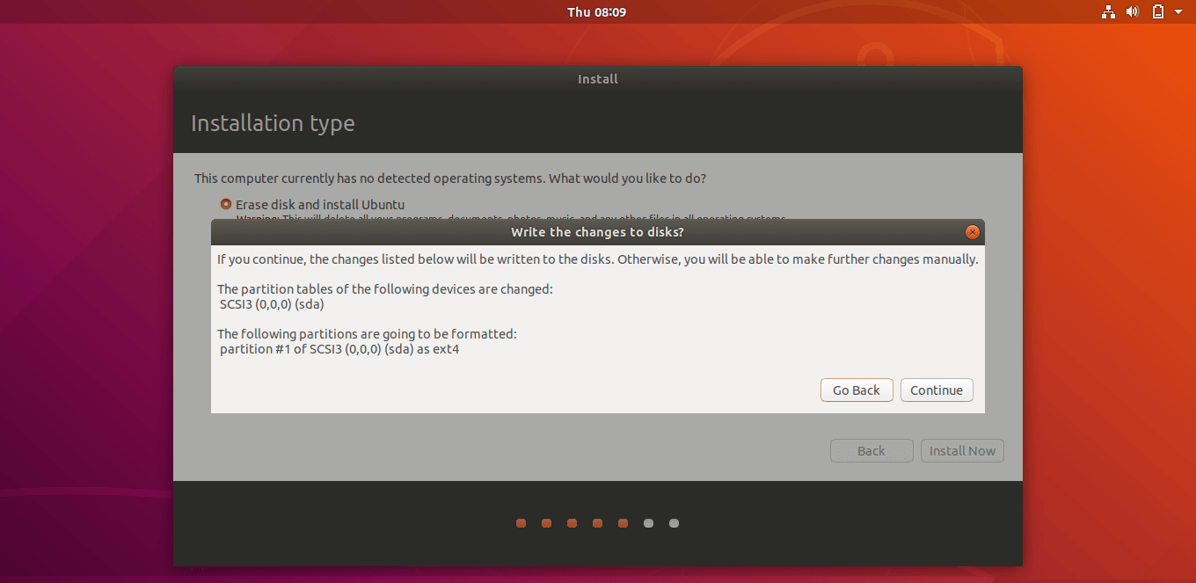

- Follow the instructions to finish the installation. Then restart the device.

References: https://linuxhint.com/rufus_bootable_usb_install_ubuntu_18-04_lts/

Preparation to build Linux kernel
  - After a clean install, update source list to provide the repository location to APT (advanced package tool) before downloading a package: run sudo gedit /etc/apt/source.list and uncomment all the deb and deb-src lines. Save the file.

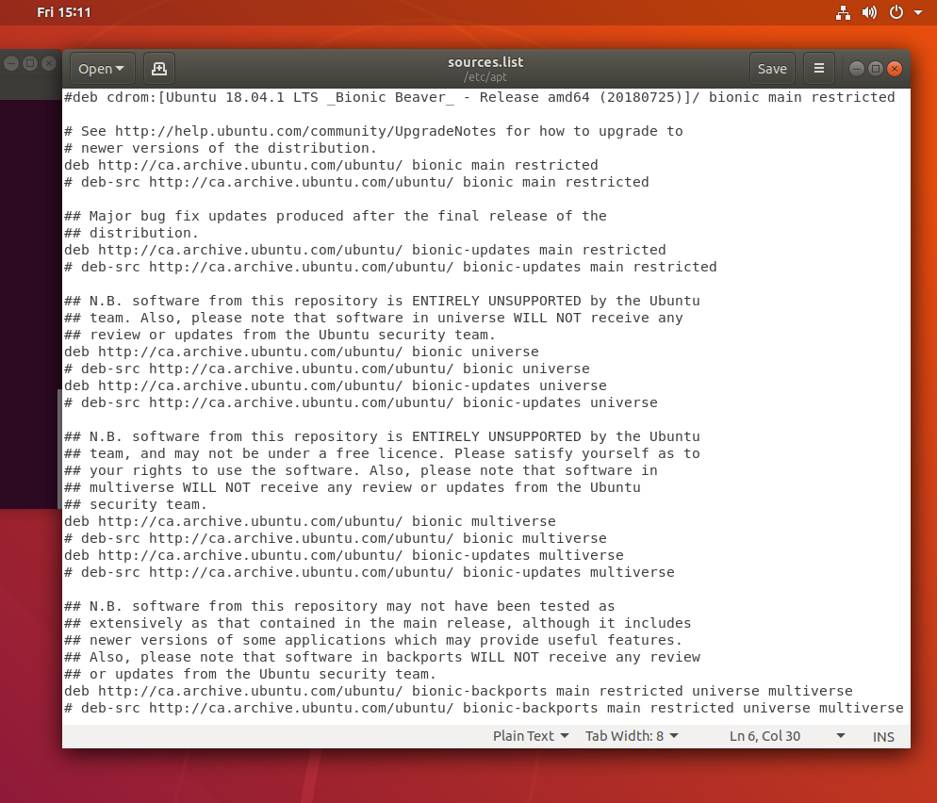
  - Update the repository: sudo apt-get update
  - Install build dependencies for linux: sudo apt-get build-dep linux
  - Install more packages for building linux: sudo apt-get install kernel-package kernel-wedge devscripts equivs fakeroot build-essential
  - Install git: sudo apt install git

Reference: https://techpiezo.com/linux/etc-apt-sources-list-sourceslist-file-in-ubuntu-distribution/

Build Linux kernel
- Linux kernel archives: https://www.kernel.org/
- Get Linux source code repo: git clone git://git.kernel.org/pub/scm/linux/kernel/git/stable/linux.git
- Go to the linux source code repo: cd linux
- Use the kernel version/tag/commit number you want: git checkout v4.19.124
- Make sure it is clean if you are not building the kernel for the 1st time: make clean
- Kernel configuration: make olddefconfig will update the .config file and sets every option to their default value without asking interactively.
- Build the kernel: fakeroot make-kpkg --initrd kernel_image kernel_headers -j8
- Kernel_header is only needed by user space programs. No need to build it most of the times.

Build and install amdgpu driver only
- If you only make source code changes within linux/drivers/gpu/drm/amd/amdgpu folder, you can only build amdgpu.ko and replace the old amdgpu.ko.
- Run make M=drivers/gpu/drm/amd/amdgpu -j4
- Replace the old amdgpu.ko: sudo cp -ar drivers/gpu/drm/amd/amdgpu/amdgpu.ko /lib/modules/4.19.8-768-amd+/kernel/drivers/gpu/drm/amd/amdgpu/amdgpu.ko
- Update initramfs (initial RAM filesystem, it is used to mount the root file system):
sudo update-initramfs -u -k 4.19.8-768-amd+
sudo update-initramfs -u -k all
- Restart the system
References: https://wiki.ubuntu.com/Initramfs

Install/uninstall kernel
- Install kernel:
sudo dpkg -i kernel_name
sudo reboot
- Uninstall kernel:
sudo apt remove --purge kernel_name
sudo update-grub
sudo reboot

Firmware
- Linux firmware: https://git.kernel.org/pub/scm/linux/kernel/git/firmware/linux-firmware.git/
- Get the Linux firmware repo: git clone git://git.kernel.org/pub/scm/linux/kernel/git/firmware/linux-firmware.git
- Checkout the version you want: git checkout 6314fa0cada1b052c973ef3f78c9689305554bd9
- backup old firmware to desktop: sudo cp -ar /lib/firmware/amdgpu /home/aes/Desktop
- Replace the old firmware: sudo cp -ar amdgpu/*.bin /lib/firmware/amdgpu
- Update initramfs: sudo update-initramfs -u -k all // will update firmware for all the installed kernels
- Check current firmware version:
cd /sys/kernel/debug/dri/0 // may need sudo privileges
cat amdgpu_firmware_info

Update grub
- You may need to update grub in the following cases:
- Multiple kernels are installed, you want the grub menu to always show in order to select between them
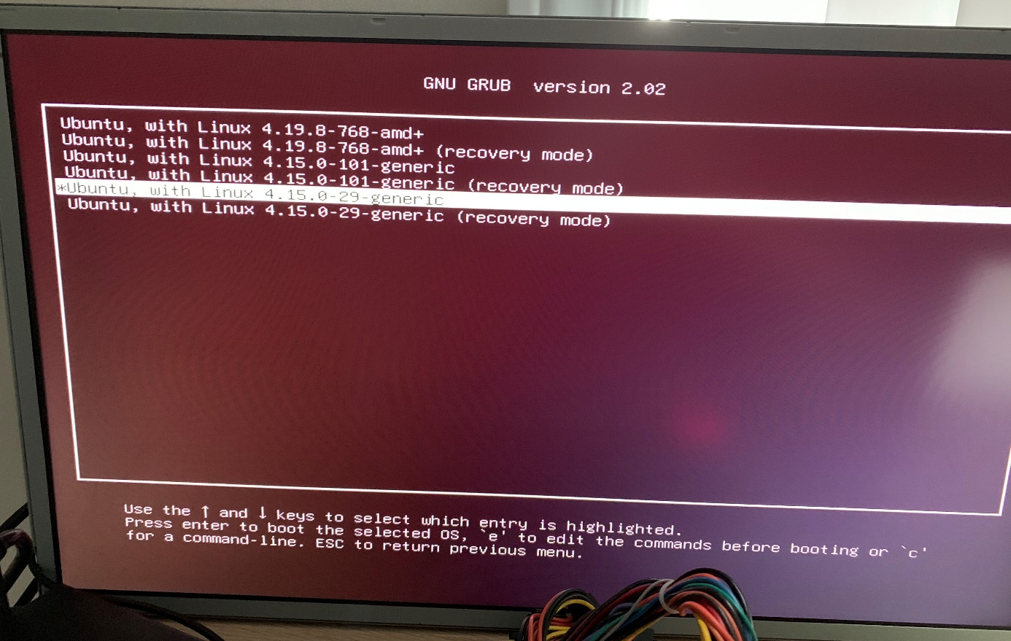
- Edit the boot command line, add kernel parameters
- Go to the /etc/default folder: cd /etc/default
- Edit the grub file: sudo gedit grub


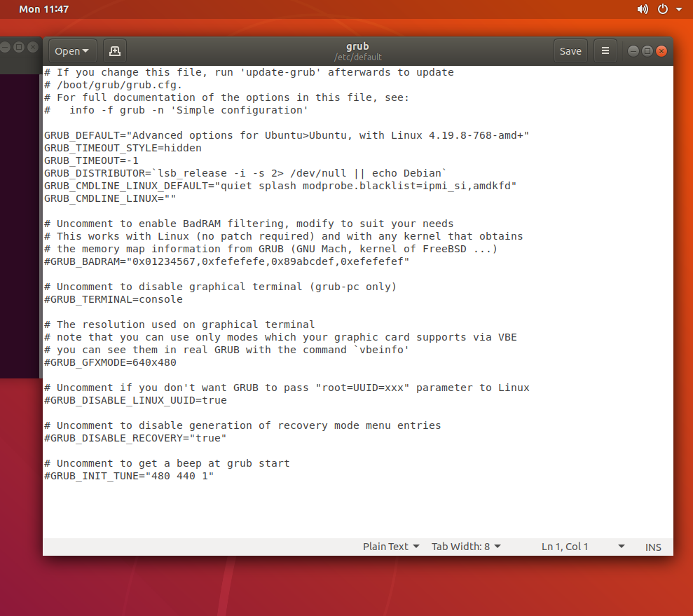
- GRUB_TIMEOUT_STYLE=menu // display the menu
- GRUB_TIMEOUT=-1 // boot the default entry after this many seconds unless a key is pressed, -1 will wait indefinitely
- GRUB_CMDLINE_LINUX_DEFAULT=”quiet splash” //show the splash screen and boot quietly, can add command line arguments such as nomodeset (don’t load amdgpu, use VESA driver instead), amdgpu.dc=0 (disable DC)
- GRUB_CMDLINE_LINUX=”” // options in GRUB_CMDLINE_LINUX_DEFAULT are always effective, options in GRUB_CMDLINE_LINUX are effective only during normal boot
- Update grub: sudo update-grub

- Can also update the kernel command line temporary (the command will only be used for one boot):


References: https://www.gnu.org/software/grub/manual/grub/html_node/Simple-configuration.html
https://wiki.ubuntu.com/Kernel/KernelBootParameters
https://dri.freedesktop.org/docs/drm/gpu/amdgpu.html

Useful commands
  - Open new terminal: Ctrl + Alt + T
  - Use tab to autocomplete commands, filenames or folder names
  - Ssh server: Apt install openssh-server
  - Dmesg: dmesg | grep -i amdgpu // show logs, -i is to ignore case, grep will search the keyword “amdgpu” in log
  - sudo apt-get install net-tools
ifconfig // check ip address
  - check if amdgpu is loaded correctly:
Dmesg | grep -i display // should have “[drm]: Display Core initialized”
sudo apt-get install mesa-utils
glxinfo // shows information about the OpenGL and GLX implementations
glxinfo | grep -i render // should have “opengl renderer string: <your graphic card model> (<graphic card family>, <DRM version>, <kernel version>, <LLVM version>)”, if it shows “LLVMPIPE” for opengl render string, driver is not loaded correctly and software render is being used instead of hardware render
  - Xorg.0.log location: ~/.local/share/xorg or /var/log/
  - Xrandr -q // list all available display output interfaces, current states and capabilities
Xrandr --output DisplayPort-3 --mode 1024x768 –rate 75 // change screen mode
Xrandr --output DisplayPort-3 –rotate left // rotate a display
  - List all installed kernels: dpkg -l | grep -i linux-image
  - List current kernel: uname -r
  - Show current OS version: lsb_release -a
  - Printk: add printk(KERN_ERR "hello world"); in kernel source code. Build and install the kernel and the message will be logged in dmesg. Use dmesg | grep -i "hello world" to search the kernel messages.

References: http://confluence.amd.com/pages/viewpage.action?spaceKey=EMBCAE&title=CAE+New+Hire+Guide
http://confluence.amd.com/display/EMBCAE/Linux+Cheat+Sheet

