**CCT COLLEGE DUBLIN**

**INTEGRATED ASSESSMENT**

**OBJECT ORIENTED CONTRUCTS & SYSTEM ANALYSIS AND DESIGN**

**ASSESSMENT REPORT**

**STUDENT NAMES: MATHEUS BARBOSA, FARLEY REIS.**

**STUDENT NUMBERS: 2019378, 2019334**

Summary

Our Netbeans Project is on this same compressed folder. 2

All the diagrams below can be found at our group github repository: 2

The Agile User Story can be found at our Trello repository: 2

Problem definition: 3

Requirements: 3

The Xtra-vision Kiosk must be able to provide the following services to the customer: 4

Four Use Case Diagrams: 5

In this first scenario, the customer is going to successfully log in the system, choose an available movie, proceed to check out and payment complete: 5

In this second scenario, the customer is going to successfully log in, is attempt to return a DVD, checks will be made and he'll successfully return it: 5

In this third scenario, the customer is not a customer yet and by the time he attempts to log in, he will have to create an account beforehand: 6

In this fourth and last scenario, the customer tries to access his account but for some reason he forgets his password. The database automatically blocks his transaction. The customer now has to update his info and choose a new password: 7

Sequence Diagram: 8

The next diagram represents the customer who wishes to Rent a DVD: 9

The next diagram represents the customer who wishes to Return a DVD: 9

Activity Diagram: 10

# Our Netbeans Project is on this same compressed folder.

All the diagrams below can be found at our group github repository: <https://github.com/farleyreis/Xtra-Vision>

The Agile User Story can be found at our Trello repository: <https://trello.com/b/HBJuixyZ/xtra-vision-user-story>

**XTRA-VISION**

Xtra-vision is a software system developed by Matheus Barbosa and Farley Reis, it’s inside video rental kiosks. The Kiosks will be placed in the lobby of shopping centers and grocery stores throughout Ireland.

# Problem definition:

Xtra-vision is planning to introduce to Ireland a new, technological, innovated way to rent movies. Before most people would have to go to a Video Rental Store, give them your personal information and be registered on that particular store.

Our service will provide the best service ever seem with the best prices, it’ll be handy and simple. Once the customer is registered in one of our Kiosks, he will be able to rent from every Kiosk in Ireland. Say you’re a customer who’s a resident in Galway and is on a trip in Dublin and you’re willing to watch a movie with your family, you’ll be able to rent in a Kiosk in Dublin.

The Kiosks will be standard and basically the same in all the places it is located.

# Requirements:

The software to be designed will have a magnetic stripe reader in order to receive customer payments by card, the screen will be the last generation of touchscreens in order to display maximum interaction with the user. The Kiosk will also have a place where the DVDs will be withdrew, and at this same place it’ll be put a barcode reader (to read the codes on the DVDs) in order for the Kiosk to say if the DVD being returned is the correct one or not.

The kiosk will serve one customer at a time, the customer will input the information necessary to log in or to be registered. The kiosk will communicate this information to the database in order to obtain verification.

If the database determines that the customer’s information is somehow invalid, the customer will be required to re-enter the information such as email and password before the transaction can proceed.

If the kiosk does not recognize the DVD by reading the barcode, instructions on how to send it to our office will pop up and also a contact number that the customer will be able to use to get in touch with us if necessary.

The Xtra-vision kiosk will provide the customer with a printed receipt for each successful renting and returning DVD, showing the date, time, which DVD was rented/returned, how many days it was in the customer possession, time that it was rented/returned, customer name and machine location.

## The Xtra-vision Kiosk must be able to provide the following services to the customer:

1. A customer will have no problem in signing up because it won’t be necessary to log in with a social media account. That means even if the customer does not have a social media account, he’ll be able to be registered with us.
2. The customer will be provided with the best service regarding prices and current movie releases.
3. The customer will have updates by email or text, regarding new movie releases available in our machines.
4. The customer will be able to check synopsis in order to know which movie is the best option for him.
5. Once the customer is registered and logged in, he’ll be able to rent from any of our Kiosks that can be found throughout Ireland.
6. The customer will be able to rent as many DVDs as he wants, and also choose returning dates. The system will provide the costs right away.
7. In the returning date, the barcode reader will check if the DVD being returned is the correct one, if so, it’ll check any overdues, complete the transaction or charge possible fees.
8. If the customer is a regular, the system will provide suggestions on what the kind of movies he likes the most.
9. If the customer has any complaint or suggestion, there’ll be a message box to get in touch with the support team.
10. Once this message is sent, the customer will have his reply from us inside 24-hour time.

# Four Use Case Diagrams:

## In this first scenario, the customer is going to successfully log in the system, choose an available movie, proceed to check out and payment complete:

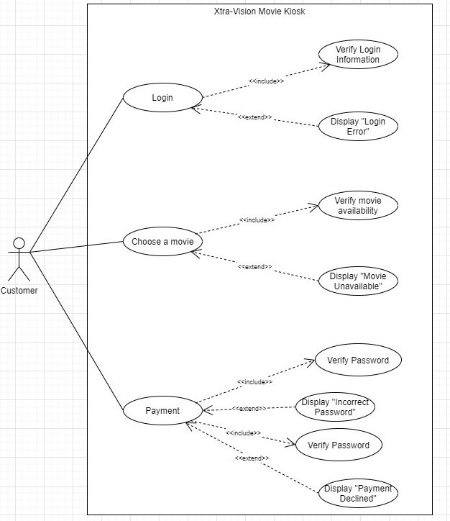

## In this second scenario, the customer is going to successfully log in, is attempt to return a DVD, checks will be made and he'll successfully return it:

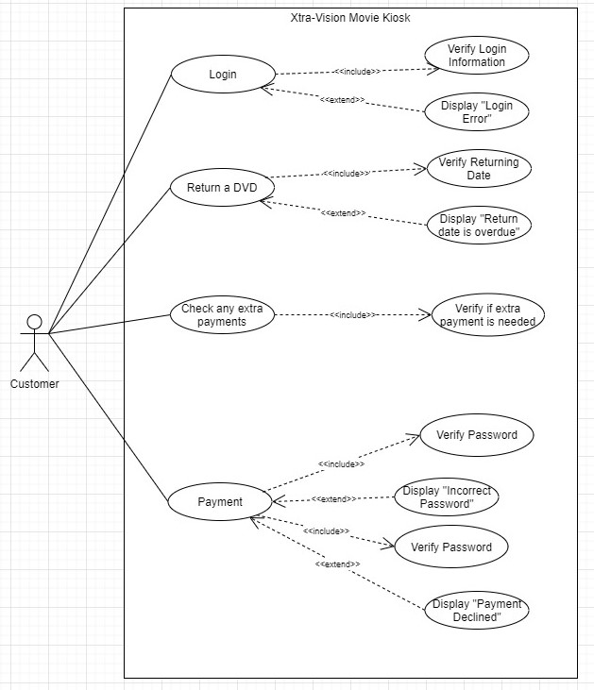

## In this third scenario, the customer is not a customer yet and by the time he attempts to log in, he will have to create an account beforehand:

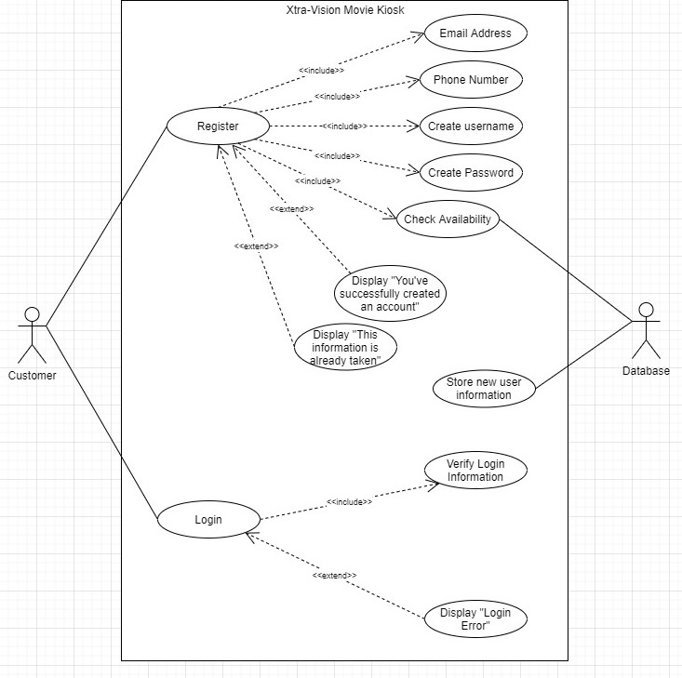

## In this fourth and last scenario, the customer tries to access his account but for some reason he forgets his password. The database automatically blocks his transaction. The customer now has to update his info and choose a new password:

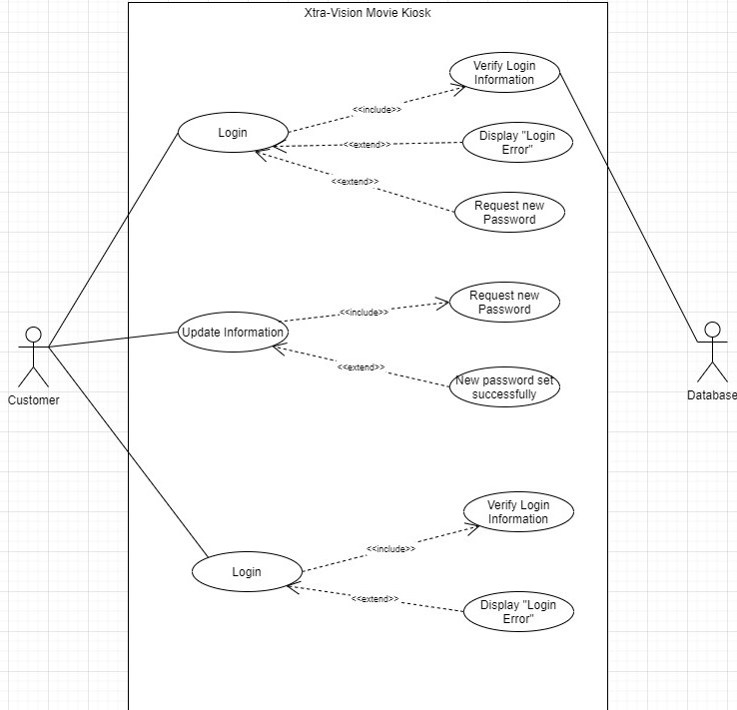

# Sequence Diagram:

The next diagram represents the customer who wishes to Rent a DVD: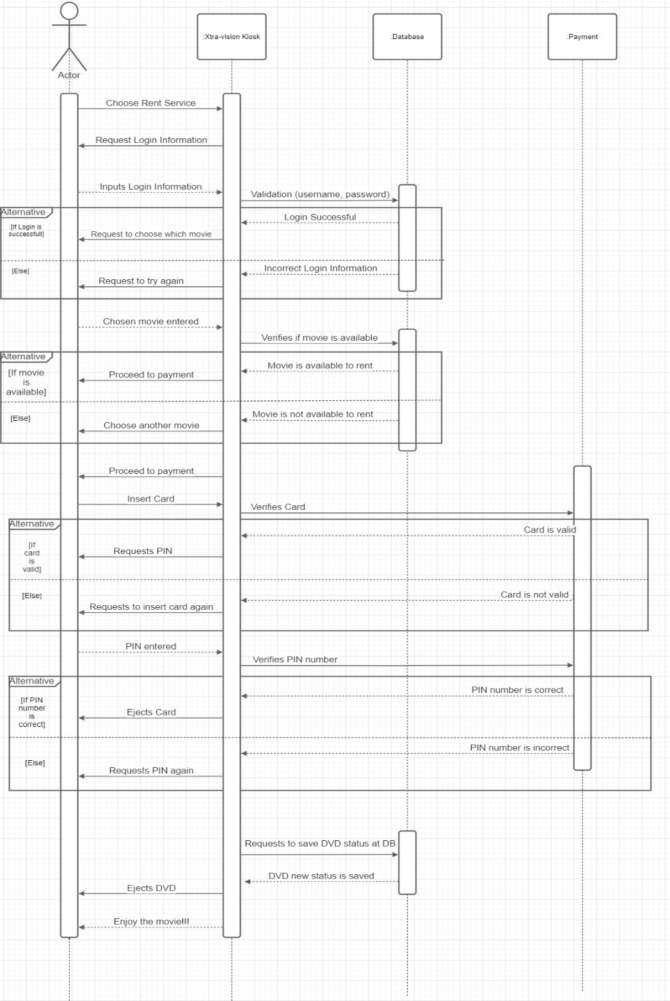

## The next diagram represents the customer who wishes to Return a DVD:

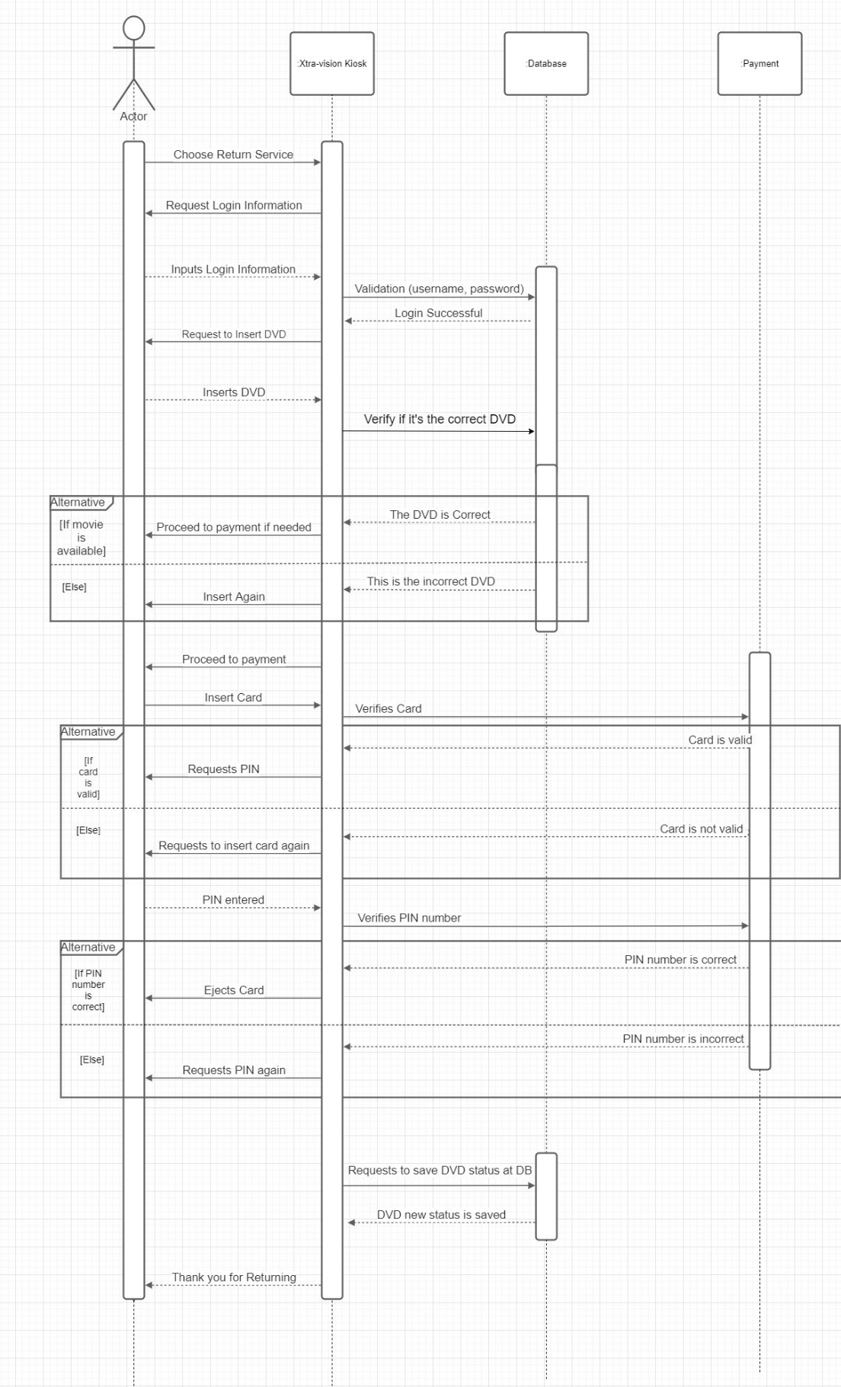

# Activity Diagram:

