# BIND – Name server

Bind is the most popular name server in linux.

## Install and configure DNS

BIND is a nameserver service responsible for performing domain-name-to-IP conversion on Linux-based DNS servers.

[root@servera ~] # yum install bind

The BIND package provides the named service. It reads the configuration from the /etc/named and /etc/named.conf files. Once this package is installed, you can start configuring DNS.

### **Configure the /etc/named.conf file**

First, add or edit the two values in the **options** field. One is the DNS server address, and the other is the **allow-query** to **any**.

[root@servera ~] # vim /etc/named.conf

listen-on port 53 { 127.0.0.1; 192.168.25.132; };

allow-query { localhost; any; };

Here are the values from the above file:

* **192.168.25.132** – DNS server address
* **any** – matches every IP address

### **Define the forward and reverse zones**

Define the forward and reverse zones in the /etc/named.conf or /etc/named.rfc1912.zones (you can define zones in either of those files). In this example, I am appending zone definition details to the /etc/named.rfc1912.zones file.

[root@servera ~] # vim /etc/named.rfc1912.zones

  zone "example.com" IN { type master;

file "example.forward.zone";

allow-update { none; };

};

zone "25.168.192.in-addr.arpa" IN {

type master;

file "example.reverse.zone";

allow-update { none; };

};

### **Create forward and reverse zone files**

You also need to create forward and reverse zone files in the /var/named directory.

**Note**: By default, the named.conf file includes the /var/named directory for checking zone files. Sample zone files named.localhost and named.loopback are created during the installation of the BIND package.

[root@servera ~] # vim /var/named/example.forward.zone

**Image**

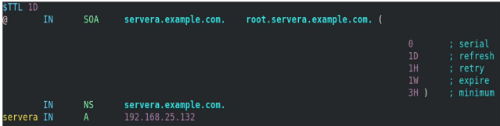

(Ashish Bharadwaj, CC BY-SA 4.0)

[root@servera ~] # vim /var/named/example.reverse.zone

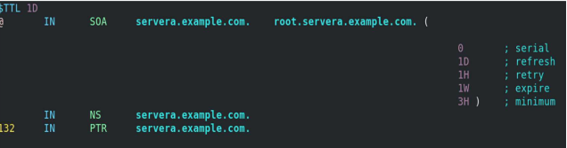

(Ashish Bharadwaj, CC BY-SA 4.0)

### **Add the nameserver IP to /etc/resolv.conf**

First, you must disable DNS processing by NetworkManager because it dynamically updates the /etc/resolv.conf file with DNS settings from its active connection profiles. To disable this and allow manual editing of /etc/resolv.conf, you must create a file (For example, 90-dns-none.conf), as root in the /etc/NetworkManager/conf.d/ directory that contains the following:

[main]

dns=none

Save the file and reload (restart) NetworkManager.

**#** systemctl reload NetworkManager

After you reload NetworkManager, it won't update /etc/resolv.conf. Now, you can manually add the nameserver's IP address to the /etc/resolv.conf file.

[root@servera ~] # vim /etc/resolv.conf

**#** Generated by NetworkManager

search localdomain example.com

nameserver 192.168.25.132

**[ Be prepared in case something goes wrong. Read**[***An introduction to DNS troubleshooting***](https://www.redhat.com/sysadmin/intro-dns-troubleshooting)**. ]**

### **Start/restart and enable the named service**

If the named service is not running or is disabled, then start and enable it. If it is already active (running) and you made all these configurations, you need to restart the service to make changes.

[root@servera ~] # systemctl status named.service

[root@servera ~] # systemctl start named.service

[root@servera ~] # systemctl enable named.service

[root@servera ~] # systemctl restart named.service

## **Verify the DNS name resolution**

You have installed the BIND package, configured named files, created lookup zones, and restarted the service to make configurations take effect. Now use the nslookup and dig commands to check whether DNS is working properly and verify whether you are getting the intended results.

* nslookup is a program to query internet domain name servers.
* dig is a tool for interrogating DNS servers. It performs DNS lookups and displays the answers that are returned from the nameserver.

### **Query with nslookup**

[root@servera ~] # nslookup servera.example.com

  Server: 192.168.25.132

Address: 192.168.25.132#53

Name: servera.example.com

Address: 192.168.25.132

[root@servera ~] # nslookup 192.168.25.132

132.25.168.192.in-addr.arpa name = servera.example.com.