# LVM



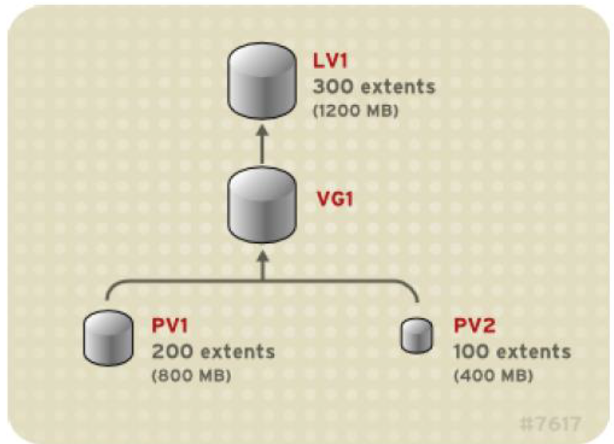

**typical usage of the LVM commandset**

Let's assume we have partitions/dev/hda4 and /dev/hda5.

**1 # pvcreate /dev/hda4 /dev/hda5**

Now we have created two physical volumes. Next, we will create a volume group. A volume group needs to have a name (we choose volume01).

**2 # vgcreate volume01 /dev/hda5 /dev/hda4**

This will create an array of physical extents, by default they are 4 Mb in size. Using these extents we can create one or more logical volumes, e.g:

**3 # lvcreate -L 100M volume01 -n newVol**

this creates a logical volume with a default name choosen by **lvcreate** and starts with the string lvol followed by a digit -- let's assume lvol0. The logical volume will be created using the volumegroup volume01. With -n we can set the name

**Note**: The maximum device size with LVM **is 8 Exabytes** on 64-bit CPUs.

Next, we can make a filesystem on the volumegroup, as usual, using **mkfs**, e.g. an xfs filesystem:

**4 # mkfs.xfs /dev/volgroup/newVol** # txfs or any other file system types

The resulting filesystem can be mounted as usual:

**5 # mount /dev/volgroup/newVol /mnt**

Modify fstab to prevent unwanted removal of drive

**6- /dev/volgroup/newVol /FTP_dir ext4 defaults 0 0**

# Operation

# **lvcreate -v -L 50MB new_vg**

The following command shows the output of the lvcreate command with the -v argument.

# lvmdiskscan

You can scan for block devices that may be used as physical volumes with the lvmdiskscan.

#pvs # pvscan # pvdisplay

use to display properties of LVM physical volumes. **pvdisplay** shows more details

## Adding Physical Volumes to a Volume Group

To add additional physical volumes to an existing volume group, use the vgextend command. The vgextend command increases a volume group's capacity by adding one or more free physical volumes.

The following command adds the physical volume /dev/sdf1 to the volume group vg1.

**# vgextend vg1 /dev/sdf1**

## Displaying Volume Groups

There are two commands you can use to display properties of LVM volume groups: vgs and vgdisplay.

**vgdisplay** shows more details.

## Extending Logical Volumes

To increase the size of a logical volume, use the **lvextend** command.

After extending the logical volume, you will need to increase the size of the associated file system to match.

In **2 way** we can extend the logical volume size:

The following command extends the logical volume /dev/myvg/homevol to 12 gigabytes.

**1** **# lvextend -L12G /dev/myvg/homevol**

The following command adds another gigabyte to the logical volume /dev/myvg/homevol.

**2 # lvextend -L+1G /dev/myvg/homevol**

Note: Use resize2fs to increase the size of the associated file system to match.

Procedure is as below :

1. Unmount /dev/VolGroup00/disk1_rootimg ( recommended unmounting, it means we can extend the file system without unmount)

**# umount** **/dev/VolGroup00/disk1_rootimg**

1. Run fsck on the unmounted file system.

**#e2fsck -f /dev/VolGroup00/disk1_rootimg**

1. Resize the file system with the **resize2fs /dev/device**command.

**#resize2fs -p /dev/VolGroup00/disk1_rootimg**

**It will extend file system to size of volume**

1. Mount the file system and partition. (if we do unmount we need to mount the drive)

**# mount** **/dev/VolGroup00/disk1_rootimg /mnt**

# Removing Volume Groups

To remove a volume group that contains no logical volumes, use the **vgremove** command.

**# vgremove vgr01**

# Renaming a Volume Group

Use the **vgrename** command to rename an existing volume group.

**# vgrename vg02 my_volume_group**

# Resizing Logical Volumes

The following command reduces the size of logical volume lvol1 in volume group vg00 by 3 logical extents.

**# lvreduce -l -3 vg00/lvol1**

**Note : it is dangerous to reduce the size of a volume. It may make your data loss**

# Renaming Logical Volumes

To rename an existing logical volume, use the **lvrename** command.

**# lvrename vg02 lvold lvnew**

# Removing Logical Volumes

To remove an inactive logical volume, use the **lvremove** command. If the logical volume is currently mounted, unmount the volume before removing it.

**# lvremove /dev/testvg/testlv**