# SOCKS proxy

Set up SOCKS5 SSH tunnel

You set up a SOCKS 5 tunnel in 2 essential steps. The first one is to build an SSH tunnel to a remote server.

Once that’s set up, you can configure your browser to connect to the local TCP port that the SSH client has exposed, which will then transport the data through the remote SSH server.

It boils down to a few key actions;

You open an SSH connection to a remote server. As you open that connection, your SSH client will also open a local TCP port, available only to your computer. In this example, I’ll use local TCP port :1337.

You configure your browser (Chrome/Firefox/…) to use that local proxy instead of directly going out on the internet.

The remote SSH server accepts your SSH connection and will act as the outgoing proxy_/vpn_ for that SOCKS5 connection.

To start such a connection, run the following command in your terminal.

$ ssh -D 1234 -c -N root@185.221.237.214

What that command does is;

1. -D 1337: open a SOCKS proxy on local port :1337. If that port is taken, try a different port number. If you want to open multiple SOCKS proxies to multiple endpoints, choose a different port for each one.
2. -C: compress data in the tunnel, save bandwidth
3. -N: do not execute remote commands, useful for just forwarding ports
4. root@185.221.237.214: the remote SSH server you have access to

Once you run that, ssh will stay in the foreground until you CTRL+C it to cancel it. If you prefer to keep it running in the background, add -f to fork it to a background command:

$ ssh -D 1234 -q -C -N -f root@185.221.237.214

Now you have an SSH tunnel between your computer and the remote host, in this example 185.221.237.214.

If we want to have our command connection and at the same time having socks connection write below command:

$ ssh -D 1234 root@185.221.237.214

# Use SOCKS proxy in Chrome/Firefox

Next up: tell your browser to use that proxy. This is something that should be done per application as it isn’t a system-wide proxy.

In Chrome, go to the chrome://settings/ screen and click through to **Advanced Settings**. Find the **Proxy Settings**.

In Firefox, go to **Preferences > Advanced > Network** and find the **Connection** settings. Change them as such:

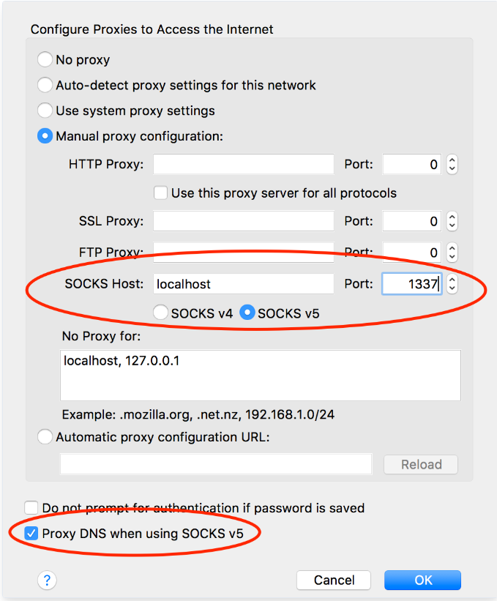

From now on, your browser will connect to localhost:1234, which is picked up by the SSH tunnel to the remote server, which then connects to your HTTP or HTTPs sites.