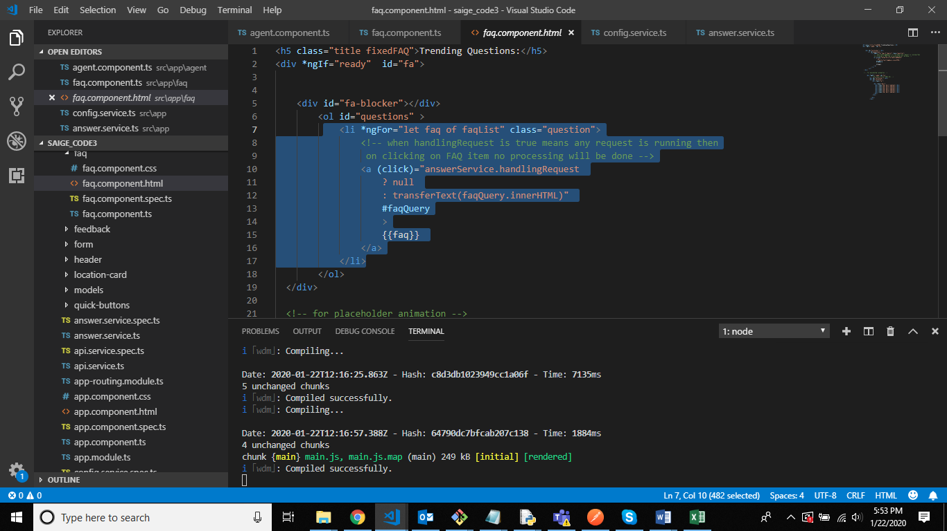

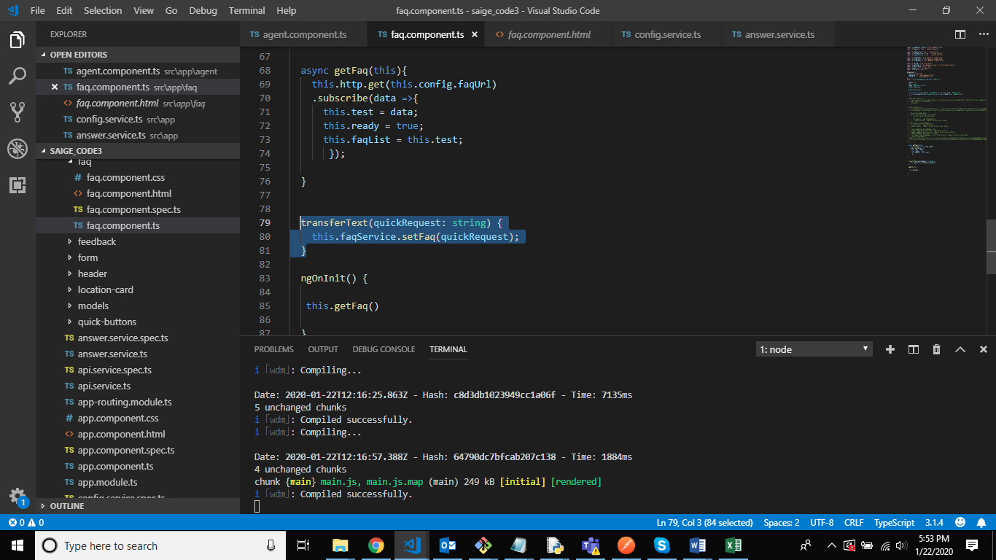 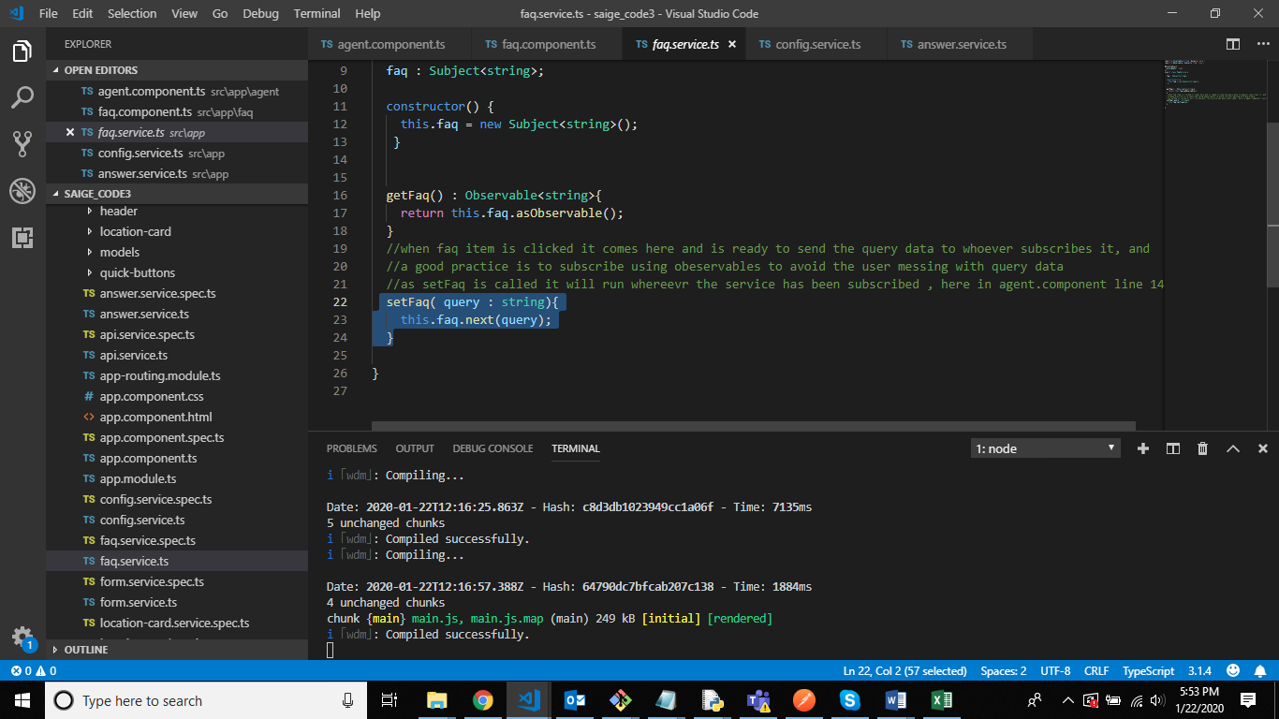

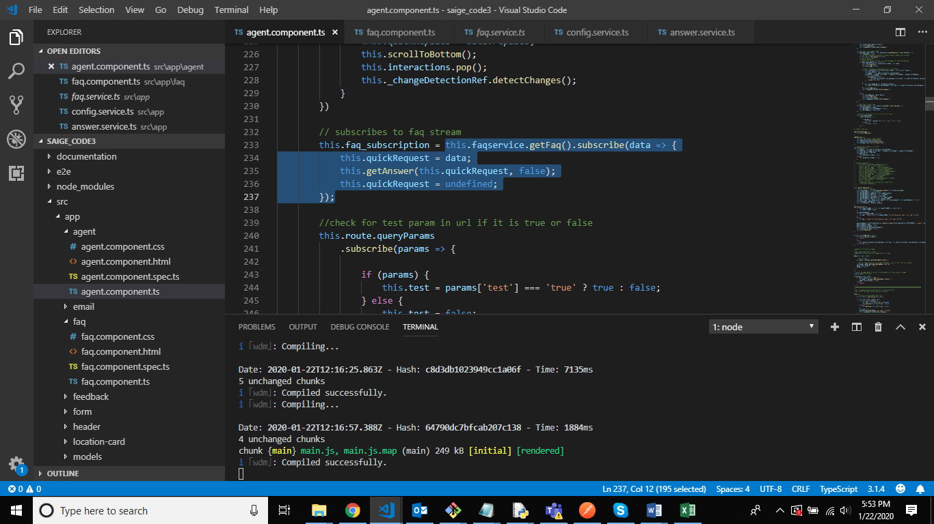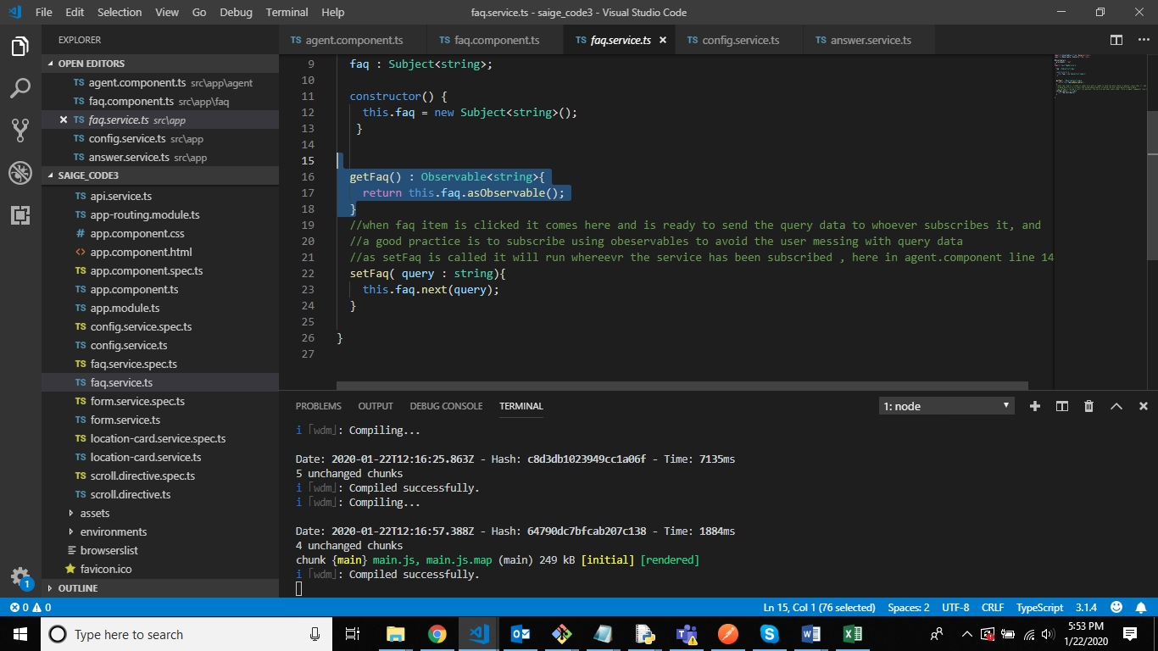

observables:

subjects: are observables(can be subscribed) and observers(can emit data also) both

ex:

let subject = new Subject<string>();

// We subscribe to the subject

subject.subscribe((data) => {

console.log("Subscriber got data >>>>> "+ data);

});

// We use the subject to emit data

subject.next("Eureka");

// Console result: Subscriber got data >>>>> Eureka