Section Control

This document explains the build and requirements for section control by AgOpenGPS
You require the following parts:
Jumpers https://www.ebay.ca/itm/120Pcs-11cm-G...
Relay Boards https://www.ebay.ca/itm/5V-1-2-4-6-8-...
USB v3 Nano - presoldered headers https://www.ebay.ca/itm/Mini-USB-Nano...
Keyes Screw terminal board for Nano https://www.ebay.ca/itm/Nano-Terminal...

Refer to this pictorial diagram
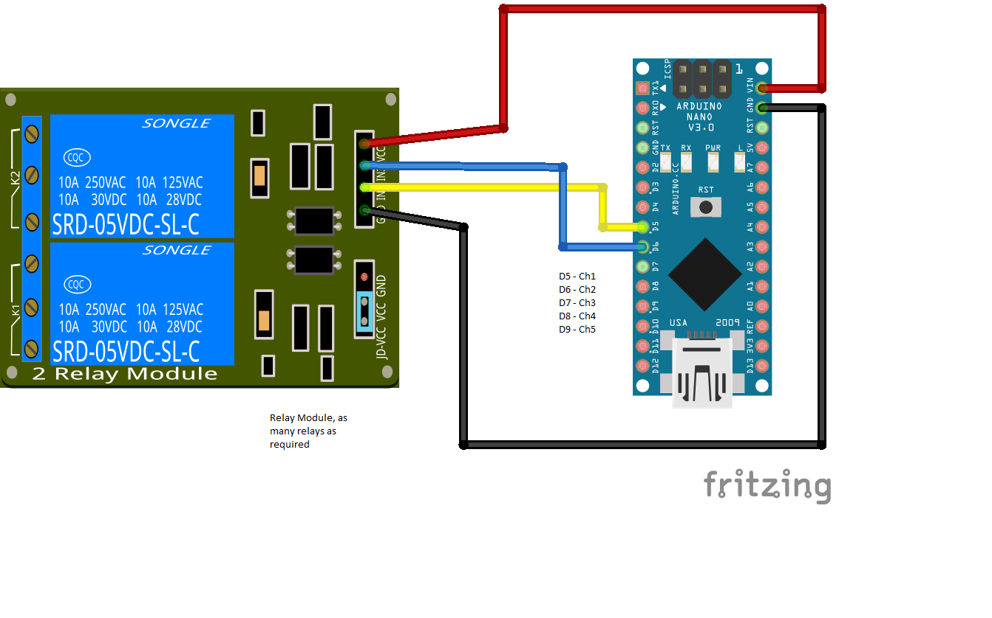
Also refer to this youtube video: https://www.youtube.com/watch?v=QM06A332rwU

Also to this forum thread
http://www.thecombineforum.com/forums/31-technology/320081-aog-section-control-tutorial.html

Connect to the relay pins.
Vcc to +5v
Gnd to Gnd
Ch1 of the relay to pin D5 of the Nano
Ch2 of the relay to pin D6 of the Nano
Ch3 of the relay to pin D7 of the Nano
Ch4 of the relay to pin D8 of the Nano
Ch5 of the relay to pin D9 of the Nano
Only connect as many channels as required.
Plug in the Nano to the usb port and the computer.
If you have never plugged in a nano to your computer before and it is not a genuine nano but the cheap ones like spec’d above, it probably has a CH340 chip for usb. Follow these instructions:
http://www.instructables.com/id/Arduino-Nano-USB-Not-Recognizing-Fix/

