MOSFET diode circuits
Standard diodes come in a wide range of reverse voltage and forward current capabilities. Forward voltage drop can be from 0.4 Volts for Schottky diodes at low currents, up to over 1 volt for silicon diodes at high currents.

A MOSFET can be used to provide a diode-type function, with a lower forward voltage drop. However the control circuit for the gate introduces some new issues, in particular the need for a voltage supply and the amount of current drawn from it. There are several design solutions, with a variety of issues that arise.

Environments where the MOSFET diode can be easy to use are where there is a voltage difference between the cathode of the resultant diode and ground of the order of 5 to 20 volts (positive or negative). Higher voltages can be accommodated if necessary with a slight increase in circuit complexity.

Here I will analyse MOSFET diodes operating with a positive 5 to 20 volt difference to ground. The abstract circuit model looks like this:

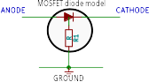
Functionally, this is a diode with a third terminal that connects to ground and which draws some current, represented by the resistor R1 in this model.

MOSFET diode with control circuit using discrete components
The simplest circuit is this one.
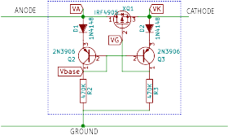

In this circuit there is a P-channel MOSFET, component XQ1 of type IRF4905 which does the current control task, and a control circuit consisting of 2 diodes D1 and D2 of type 1N4148, two bipolar PNP transistors Q2 and Q3 of type 2N3906 and two resistors R2 and R3, with value 470K. Note that the MOSFET is oriented with its Source at the cathode of the diode, so that its internal body diode is facing the same way as the overal MOSFET diode.
The circuit can use different components which may change the specific voltages and currents but should still have the same overall characteristics.
In the diagram there are labels for various monitoring points, VA (Anode), VK (cathode), VG (Gate of the MOSFET) and Vbase (base of the 2 PNP transistors).
I used ngspice to simulate the behaviour of this circuit. The simulation configuration is in the diagram below, followed by the simulation results.
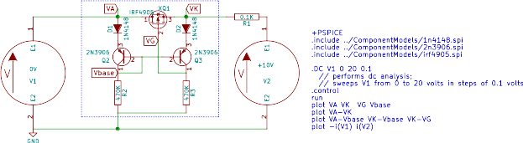
Chart 1
Chart 1, Red line: anode voltage VA is ramped from 0 volts to 20 volts.
Chart1, Blue line: cathode voltage VK sits at V2 10 volts until it is greater than VA, after that it follows VA (the line in the chart has been adjusted by 0.2 volts since otherwise it would be hidden by the red line).
Chart1, Green line: base voltage Vbase sits about 1 volt below the maximum of VA and VK. Initially, with VK greater than VA, the current flows through Q3 with Q2 off. In this state Q3 is ON. When VA becomes greater than VK, the current transfers to Q2, which removes the current flow from Q3 and it turns OFF.
Chart1, Orange line, gate voltageVG. Initially with Q3 on, the orange line sits just below the blue line VK so that the MOSFET is OFF. This continues until VA becomes greater than VK, at which point Q3 turns off and VG becomes about 4 volts below VK. This is a sufficient gate voltage to turn the MOSFET ON.
There is a negative feedback effect where as VG goes down and the MOSFET ON resistance decreases, the voltage difference between VA and VK decreases. This negative feedback stops Q3 from turning fully off and results in a fixed offset between VK and VG.

Chart 2 shows VA-Vbase (red line) and demonstrates the necessity of the diodes D1 and D2. Without D1, the base-emitter junction of Q2 would be exposed to a negative voltage in excess of its rating (typically, including 2N3906, Vbe must not be more negative than -5 Volts).
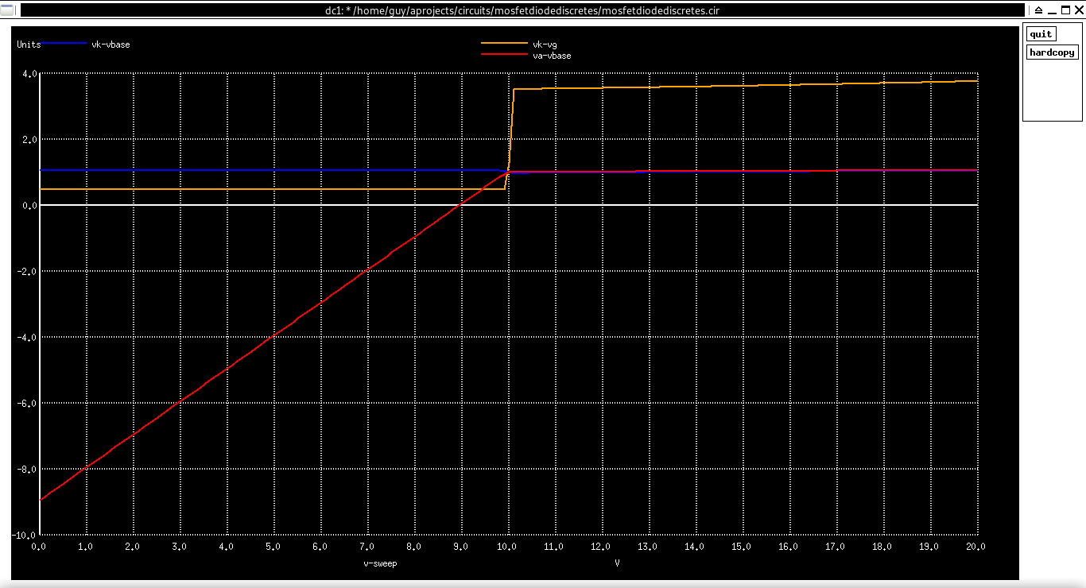Chart 2
The blue line is VK-Vbase, which essentially does not change.
The orange line is VK-VG which is the Source to Gate voltage of Q1. The step is the point at which Q1 turns on.

Chart 3 shows the forward voltage drop across the MOSFET diode VA-VK from the point when VK is 9.9 Volts, up to 20 Volts. Initially the forward voltage drop is about 35 millivolts. As VA continues to rise, the current through the MOSFET increases but the forward voltage drop decreases to about 20 millivolts.
Chart 3

The next simulation shown in Chart 4 looks at the step function response of the MOSFET diode.
The definition of V1 has been changed to “pulse (9.50V 11.5V 2ms 0 0 5ms 10ms 0)” and the analysis specified is now “TRAN 0.1us 10ms”. V2 is left at 10V.
Chart 4
This chart shows VA as the cyan line, starting at 9.5 volts, just slightly higher than VG (orange line). Vbase (red line) is about 1V below it, and VK (black line) is 10 Volts.
At the 2 ms point, VA jumps up to 11.5 volts.
The body diode in Q1 starts conducting and so VK becomes 0.5 volts below VA.
Q3 turns off, so the 470K resistor R3 starts charging the gate capacitance of Q1. It takes about 1.4 milliseconds for the gate voltage to fall enough to turn Q1 on, at which point VK rises to about 30 millivolts below VA (the size of this voltage difference cannot be seen in this chart, but we know it is about that size from the previous chart).
There are spikes in various voltages at the transition points, which I believe are caused by capacitive feed-through from the internal capacitances in Q1. These spikes can be reduced or eliminated by slowing down the rise and fall times of the driving waveform on VA.
Finally, the current drawn by the control circuit can be seen in Chart 5 at left. It is mostly about 39 microamps (note that 10 volts / 470 K = about 20 microamps).
Chart 5
During the initial 2 milliseconds, VA is less than VK, so Q2 is off and Q3 is ON. R2 is getting current through the base of Q3, and R3 is getting current through the collector of Q3.
Then during the period of 1.4 ms after Q3 turns off, Q2 supplies current to R2 (20 uA) while Q3 is turned off and the current through R3 declines. When the gate voltage VG eventually reaches the point where Q1 starts to turn on, the current through R3 stabilises at the new level.

If a turn-on delay of 1.4 ms is too long for the application, this time can be shortened by reducing R3. For example Chart 6 is the equivalent to Chart 4 but with R2=R3 = 47K (ie 10 times less than before). The delay should be 140 us instead of 1.4 ms.
Chart 6

MOSFET diode for voltages greater than 20 Volts
If the voltage between the MOSFET diode and Ground is more than 20 Volts, the control circuit has to be adjusted to prevent the gate to source voltage exceeding 20 Volts. Also the MOSFET must be selected with a sufficient voltage rating to withstand the reverse voltage whenn it is off.
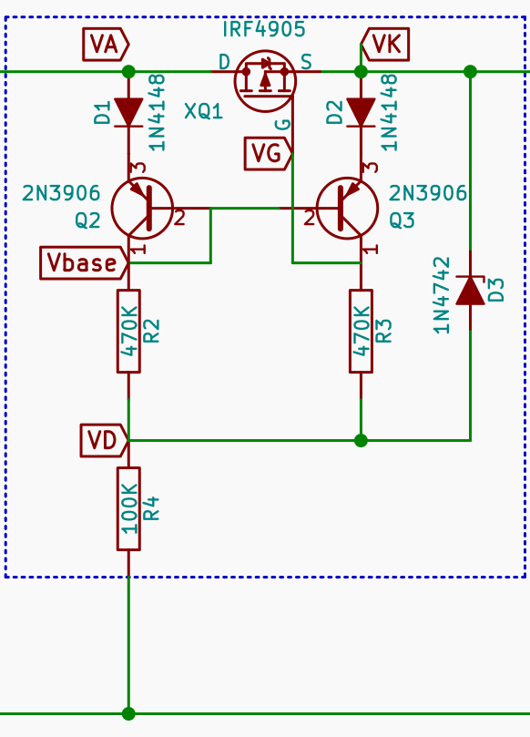
The solution is to provide a voltage reference in the range 10 to 20 volts below the high voltage rail. The circuit at left shows this with a 12 volt zener diode and a 100 K resistor.

