Current shunt amplifier circuits
There are many situations where the current in a circuit needs to be measured. Techniques to achieve this generally fall into 3 categories:
a) a small value series resistor, usually called a current shunt;
b) a Hall effect device that senses and amplifies the magnetic field generated by the current;
c) a sensing MOSFET that separates a small fraction of the current and puts that through a (larger value) current shunt.
Which solution is appropriate depends on many factors including the level of current, the accuracy required and the response time or frequency of measurement.
Using a current shunt may be the simplest but does require an amplifier to bring the value into the measurement range of the analog to digital converter (ADC). Hall effect devices and sensing MOSFETs also involve amplification.
The sensing device may be placed in the high side or low side of a circuit. Consider a solar panel and a battery as shown in the diagram below.
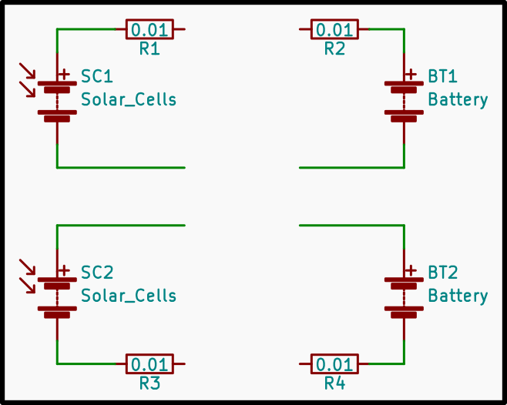
With the solar panel, current only flows in one direction, which is out of the panel at the + terminal, and in at the – terminal.
With the battery, current can be in either direction, so the voltage across the sensor can be either positive or negative.
With the high side sensors, the DC offset needs to be taken into accout.
With the low side sensors, the sensed voltage going negative relative to ground needs to be accommodated.
The resistance of the sensing device is a consideration, with competing issues of power dissipation in the shunt, the voltage developed across it and the amount of amplification needed before the ADC.

To reduce the complexity and range of the analysis, I will look at 2 current measuring requirements:
a) a solar panel running at between 20 and 40 Volts and delivering up to 8 Amps
b) a battery running at between 10 and 15 Volts and receiving or delivering up to 20 Amps.
The currents will be measured using the on-board 10-bit ADC of an Arduino microcontroller or equivalent with a Vcc reference voltage of 5 Volts.
The accuracy of the current measurement will be reported as an index, where an index value of 1.0 represents an ideal result while higher values represent degradations. An index of 2 indicates effective 9-bit accuracy. An index of 4 indicates effective 7-bit accuracy, and so on.
In the case of the solar panel generating up to 8 amps, the ideal result will be an output that can deliver an ADC code from 0 to 1023 with each step representing 8,000/1024=7.8125 milli Amps.
In the case of the battery with + 20 Amps, the ADC code at 0 current should be 512, with 0 representing -20 amps, 1023 representing +20 Amps, and each step representing 40,000/1024=39 milli Amps.

Preliminary look at a High side current shunt and amplifier
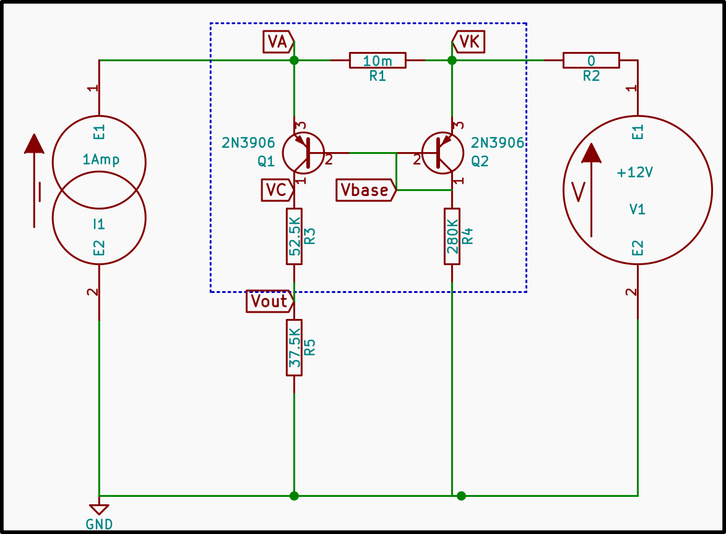
Here is a simple high side current shunt and amplifier circuit.
The current shunt is a 10 milli-ohm resistor. The amplifier consists of two PNP transistors, Q1 and Q2. The collector resistor series on Q1 has been selected to give a 2.5 volt output above ground at zero current.
The behaviour of this circuit, as simulated by ngspice, is shown in the charts below.
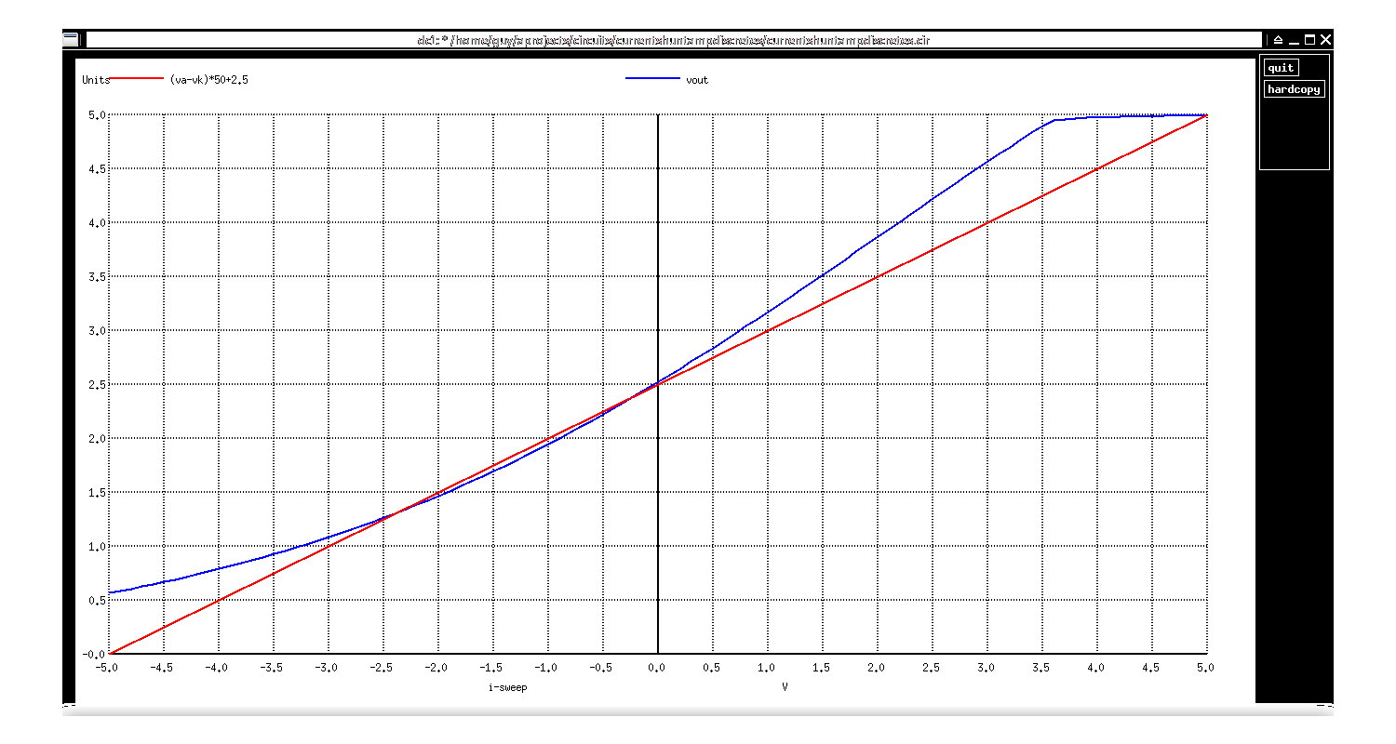
In this chart the blue line shows the voltage at Vout as the current is changed from -5 amps to +5 amps. It is a smooth curve starting at about 0.6 volts when the current is -5 amps, passes through 2.5 volts when the current is 0 amps, and reaches 4.8 or 4.9 volts when the current is 3.5 amps, above which Q1 is saturated.
The red line shows a calculated reference using the equation (Va-Vk)*50+2.5 which would be an ideal result for this amplifier.
The curve in the blue line would mean that a non-linear equation would need to be used to derive the actual current from the measured voltage. An equation that is within 0.1 volts of the blue line is
2*exp((va-vk)*20)+(va-vk)*15+0.5. Better equations may exist.
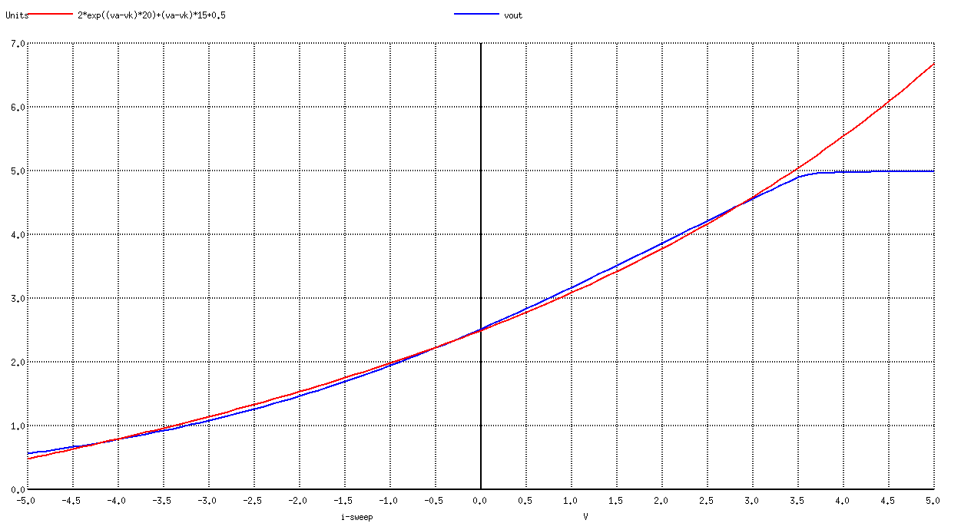
This chart shows the tracking of this equation (red line) with the simulated performance (blue line).
This shunt and amplifier combination does not meet the requirements of either of my test cases, so the next step is to adjust the values to achieve the overall requirements and then assess the quality of the result.

List of designs
Looking at the table of power dissipation for various shunt resistor values, the practical possibilities with realistic power dissipations reduce to something like this:

This gives us 6 designs for each requirement.

The next question is, how can I control the gain of this amplifier to allow for greater currents, and possibly improve the linearity?
Try putting resistors between the shunt connections and the emitters of Q1 and Q2.

