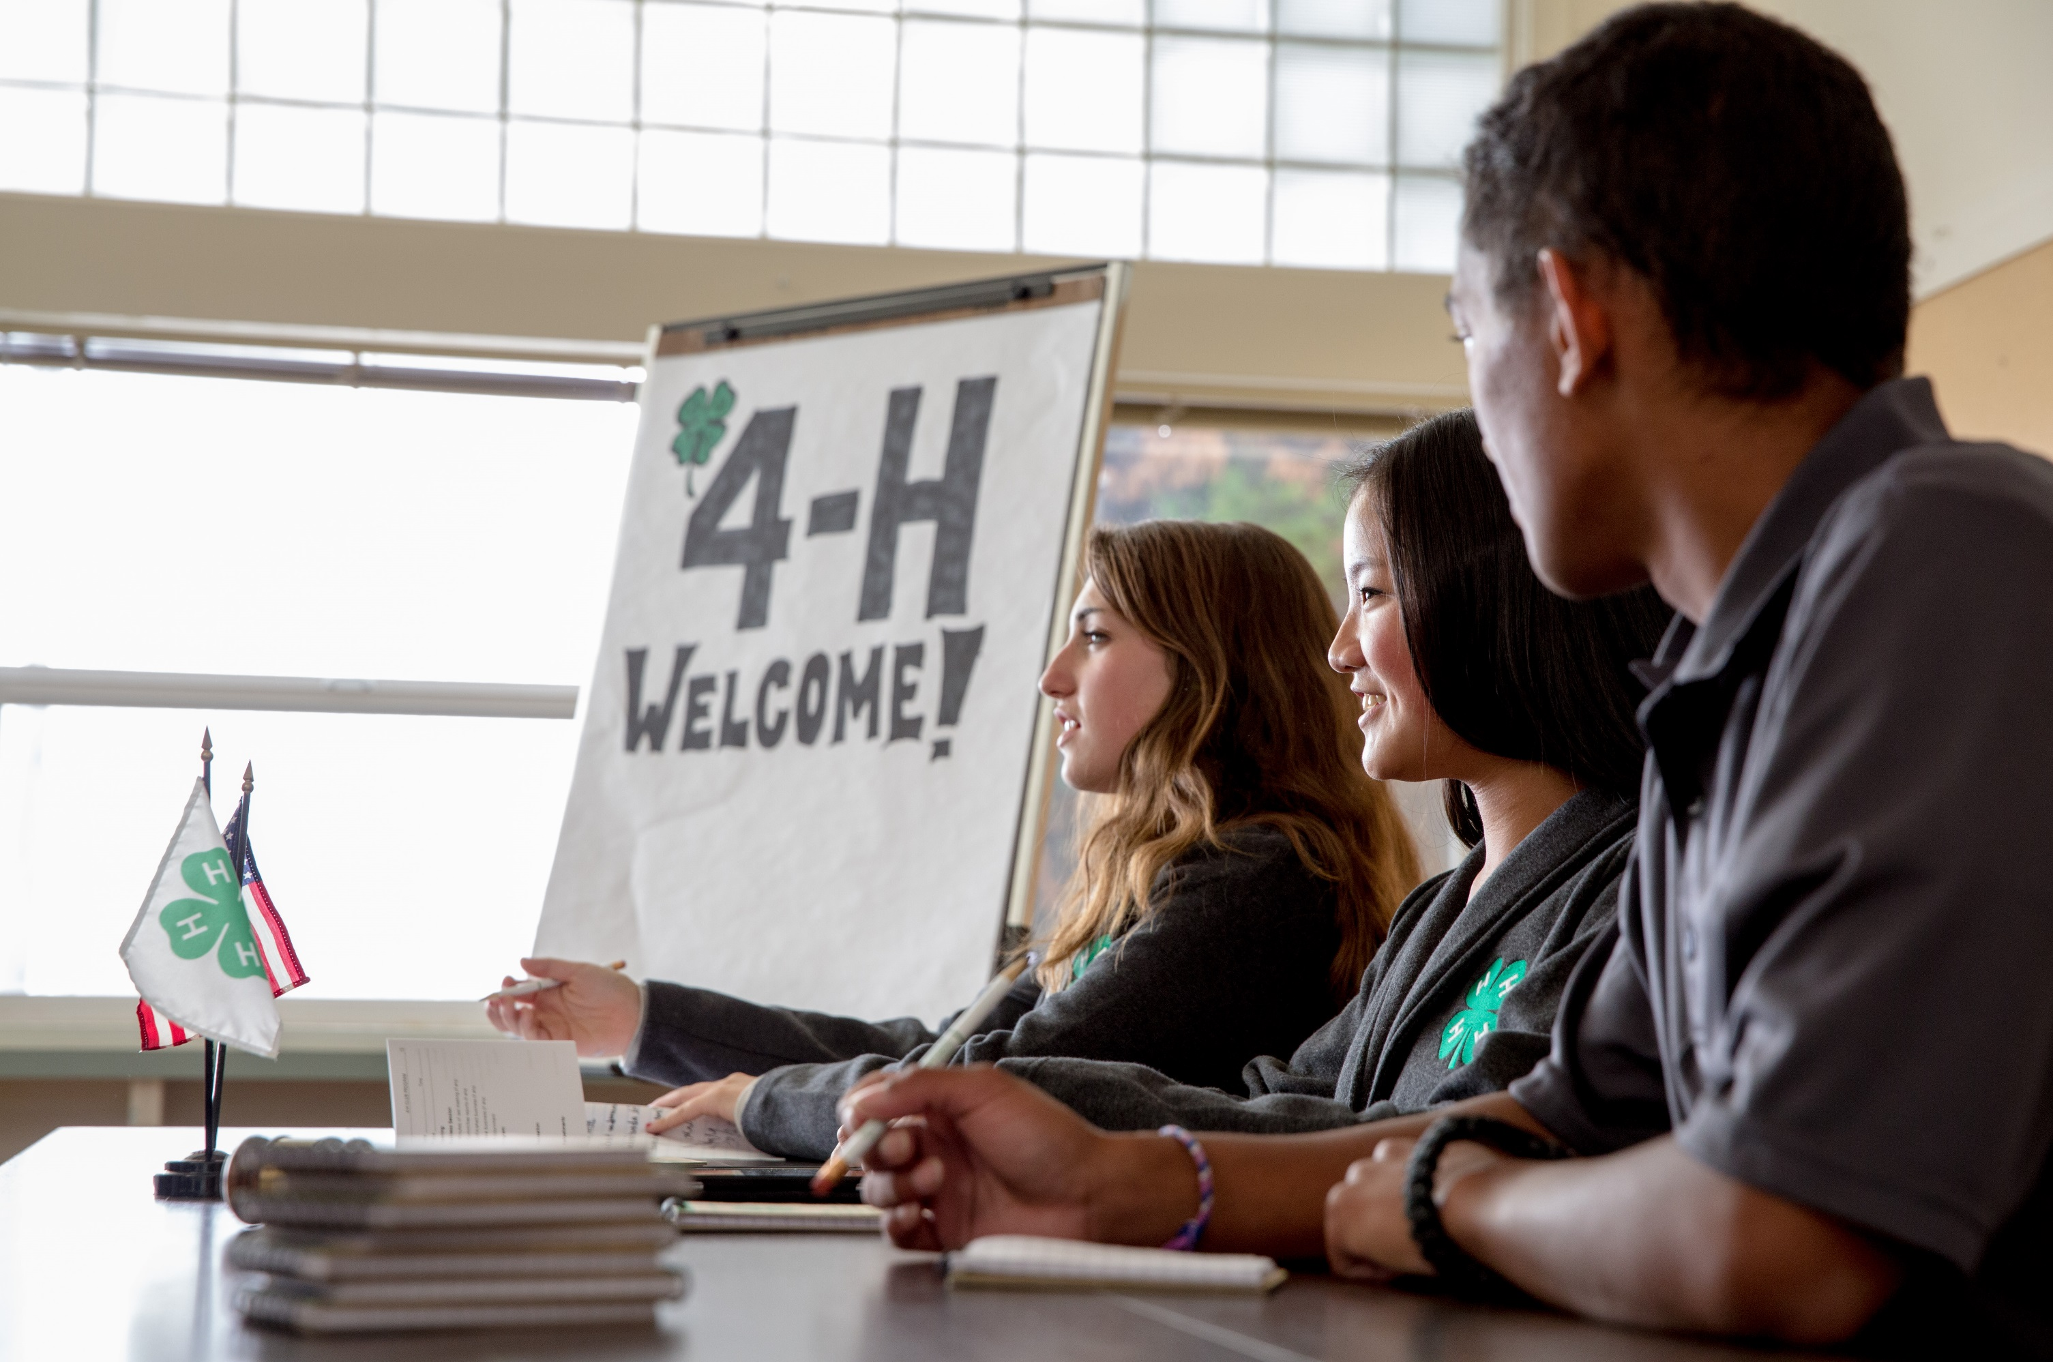

**OSU EXTENSION SERVICE**

**Thriving**

**Begins Here**

**4-H College and Career**

**Readiness**

**Program Evaluation Report**

**2019**

**4-H college and career readiness programs help orient youth to the future by providing engaging, hands-on programs for exploring career possibilities. Professional preparation includes opportunities to develop a resume and practice interview skills. College and career readiness programs also help youth navigate the complex world of college-related decisions, including applying to college and financial aid. Along the way, adults serve as role models to inspire youth and help connect them to opportunities and pathways to success.**

**4-H provides real-world opportunities for youth to explore and prepare for their future.**

OSU Extension Service prohibits discrimination in all its programs, services, activities and materials.

Thriving Begins Here

2019 4-H College and Career Readiness Program Evaluation Report

**Program Name:** 4-H/Zoo ExCEL in Animal Sciences

**Participants:** 20

**Gender:** Boy: 4, Girl: 13, Unknown: 3

**Age:** 13 - 18

**Mean age:** 15.18

**County:**

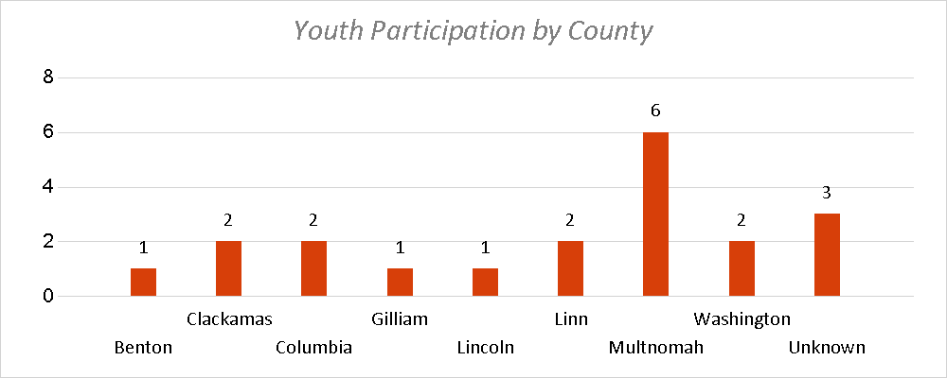

**Race/Ethnicity:**

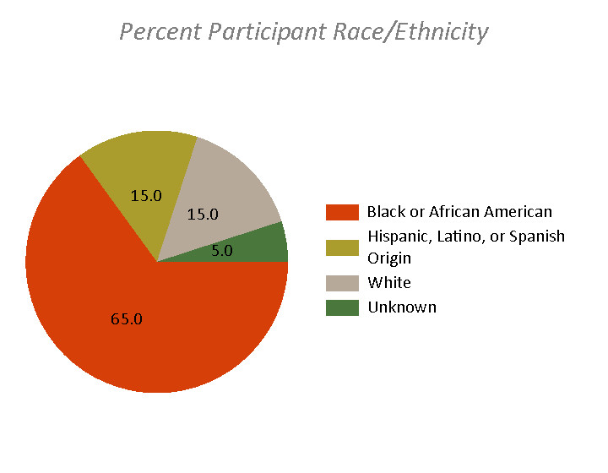

**Professional Preparation Opportunities**

4-H College and Career Readiness programs provide opportunities for youth to learn about the ingredients necessary for navigating the transition from high school to college and/or employment. These programs focus on promoting selected workforce skills, such interviewing, and the preparation and management of a professional portfolio. A special emphasis is placed on connecting youths’ interest to people who can inspire and mentor them.

Youth reported having the following professional preparation opportunities in this program:

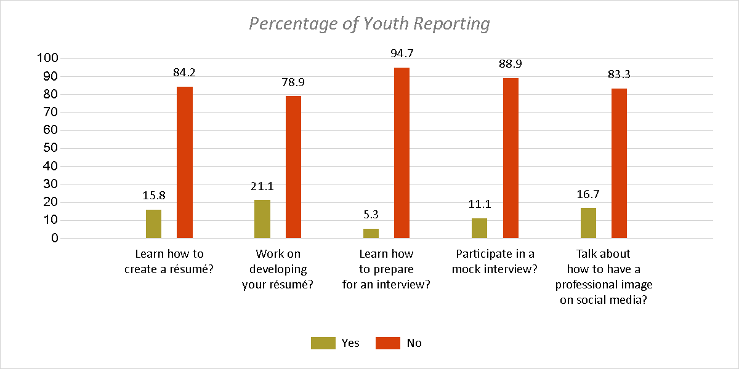

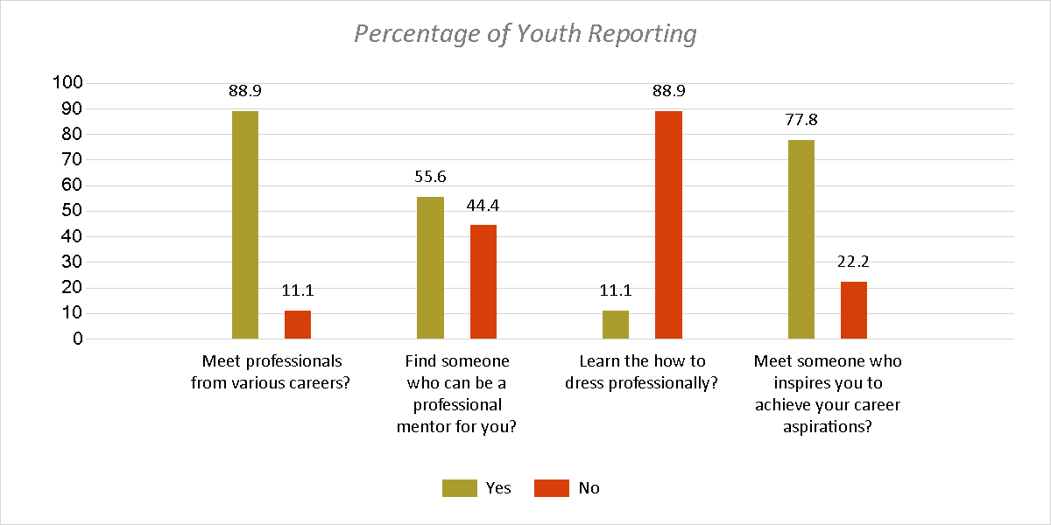

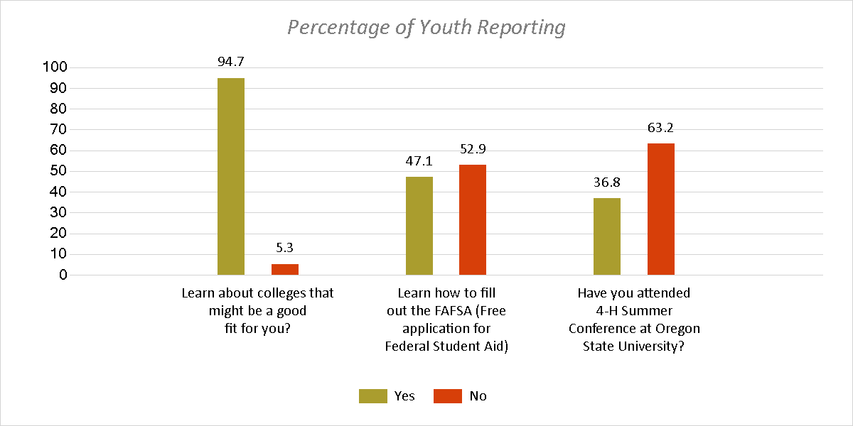

**Identifying, Setting and Achieving Goals**

Identifying and setting future goals related to college and career is key to helping youth thrive as they approach the transition from high school. 4-H College and Career Readiness programs help guide youth toward establishing these goals, and identifying specific steps to achieve them.

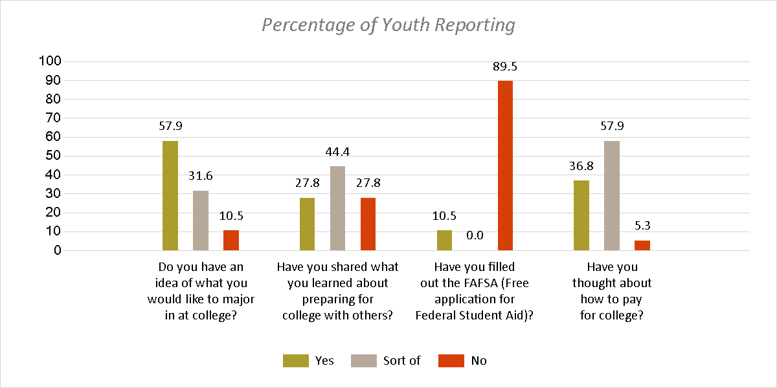

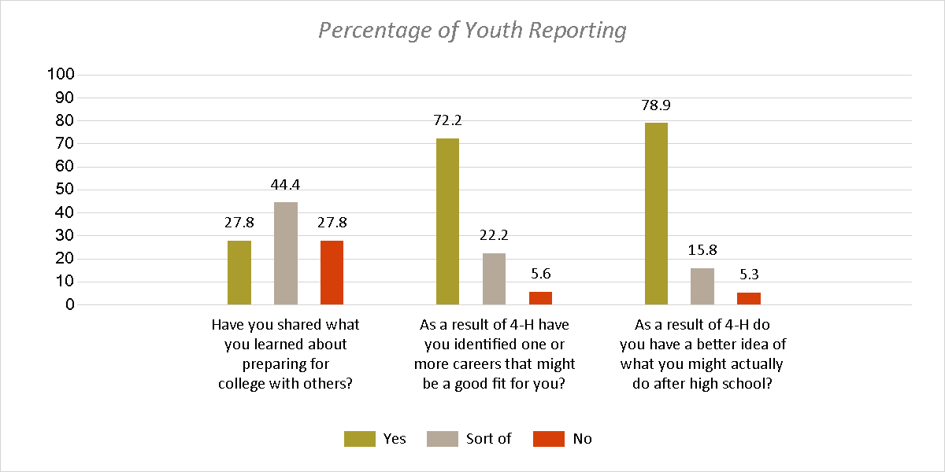

**The Role of 4-H in promoting College and Career Readiness**

The opportunities that youth have to explore college and career readiness can vary from having a great deal of support to very little. 4-H College and Career Readiness programs help ensure that all youth have the support they need to be successful. Youth often identify the support and encouragement 4-H has given them to plan for the future.

When asked how much 4-H has helped them in college and career preparation, youth in this program reported that 4-H helped them:

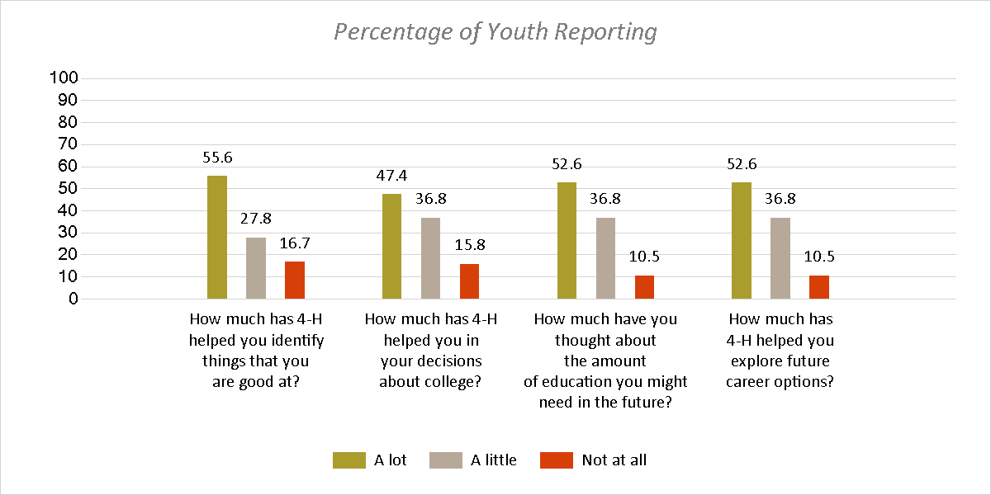

**College and Career Readiness Helps Youth Thrive**

Academic or vocational success, employability and economic stability, civic engagement, and happiness and well-being are the long term outcomes for the 4-H program. By contributing to the thriving of youth, specifically in the area of goal setting, 4-H College and Career readiness help youth reach these long-term outcomes.

When asked about the importance of these long-term outcomes in their lives, youth in this program reported:

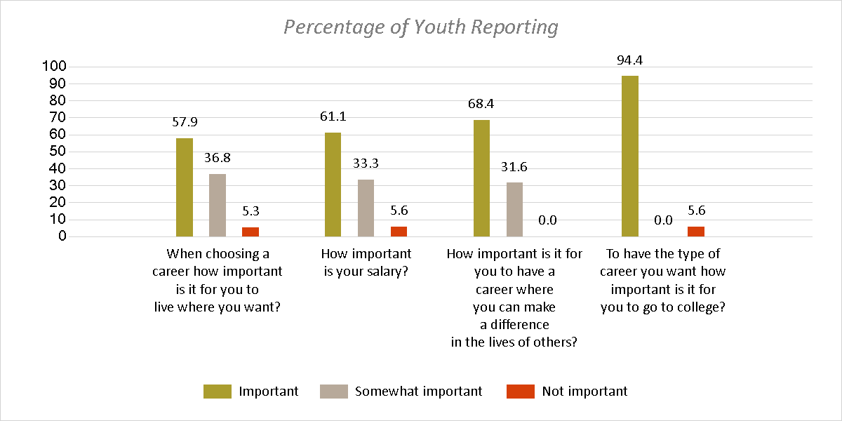

4-H College and Career Readiness programs also provide an opportunity for youth to consider a wide array of post high-school options.

Youth in this program were asked if they are thinking about the following:

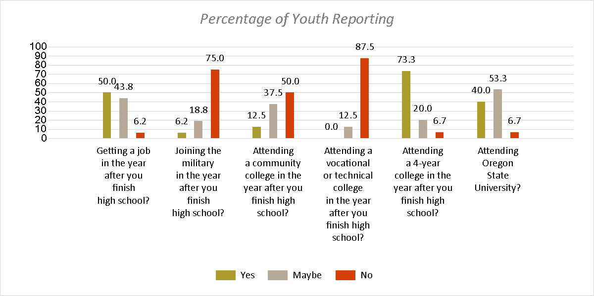

**Summary**

4-H College and Career programs play an important part in helping youth thrive by connecting them to future possibilities and identifying the steps to get there. 4-H College and Career Readiness programs are based on youth sparks- connecting youth with career possibilities that match their interests, and providing authentic opportunities for career exploration. These programs help ensure that youth arrive at the end of high school with a realistic plan for the future in place. 4-H College and Career Readiness programs help ensure that 4-H youth achieve the important long-term outcomes of the program.

**The 4-H Thriving Model**

4-H is based on a positive youth development (PYD) approach that recognizes youth have interests, abilities, and strengths that can be enhanced in 4-H programs. Research shows that participation in high-quality 4-H programs increases thriving in youth, and thriving youth achieve important developmental outcomes, which lead over time to long-term success.

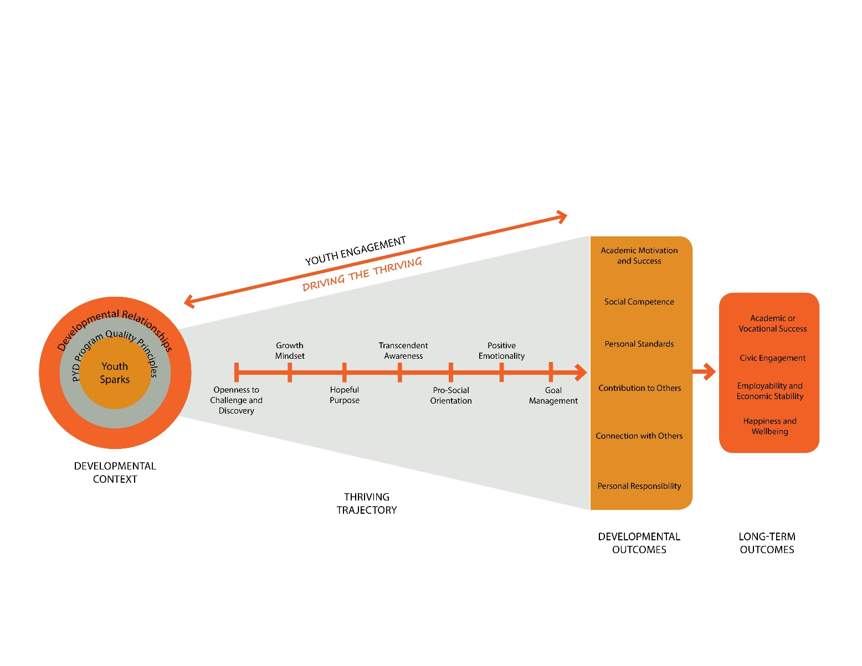

More information on the 4-H Thriving Model can be found at:

<https://health.oregonstate.edu/thriving-model>

