軟體測試與資安檢測
教師：王凡 課程代號：EE 5170
授課時間：每週三9：10─12：00 識別碼：921 U9550
博理館113 民國110年春季班
QUIZ (2021/03/31)
Open-book, open-internet, no discussion

Name:＿＿＿＿ Department：＿＿＿＿＿ Student ID:＿＿＿＿＿

- Suppose we have the following methods. Please list all the interprocedural DU-pairs.
def main (x,y):
z = x + y
a = scroll(z, y)
a = x + a
b = scroll(a, x)
return a + b

def scroll (u,v):
print (u)
x = u + v
if u < 100:
return x
else:
return v

- Assume that we have a class person with three methods, addName(), addAddress(), and register() subject to the following sequence constraints:
- A person object must be instantiated to use any of the three methods.
- Only after a person object has executed addName() and addAddress() each at least once can the object execute the register() method.
Please draw a control flow graph that calls this class and test this class for correct implementation of the sequence constraints.

- Continuing from problem 2, please show a set of test paths that test the modules for correct usage of the class with full node coverage. You must explain why your answer is correct.

- Continuing from problem 2, please show a set of test paths that test the modules for incorrect usage of the class with full node coverage. You must explain why your answer is correct.

- Consider the state graph in the following.
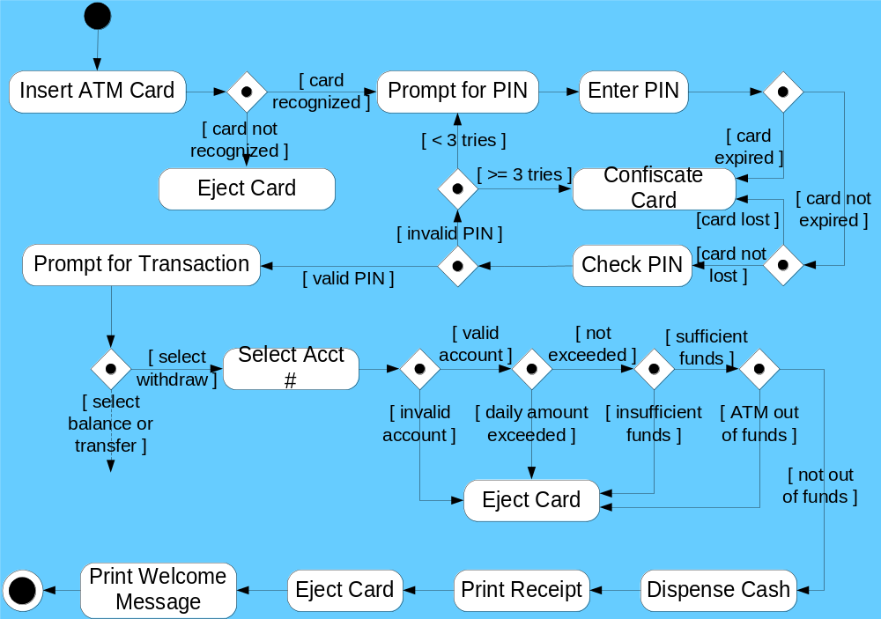

Please design two scenarios to test the system in two exception handling use cases.

