CERTIFICATE OF COURSE COMPLETION for CONTINUING EDUCATION
Approved by the
Utah Real Estate Commission
Stockton Farnsworth |  | 9464569-AB00
Name of Licensee |  | Real Estate License Number
Certified New Home Specialist |  | Dennis Walsh & Associates, Inc.
Course Title |  | Course Sponsor Name
R130914 |  | 5/29/2021
Course Identification Number |  | Date Submitted

12 Credit Hours
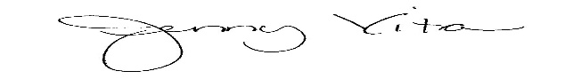
Signature of Provider
Jenny Vita

Dennis Walsh & Associates
2222 Colony Plaza
Newport Beach, CA 92660
800.428.1122 www.sellnewhomes.com

