Introduction to Data Science
(B-DS-317)

May 17
2026

The objective of this assignment is to perform statistical analysis on the loan dataset using R programming language. Different statistical measures such as mean, median, mode, variance, and standard deviation will be calculated. Outliers will also be identified using the IQR method, and the symmetry of the data will be analyzed using appropriate plots.
Team-Members:
Muhammad Farooq Adnan Khan -241980034(Leader)
Azfar Adnan - 241980037
Laiba Shahid - 241980010
Sayam - 241980044

Dataset
The dataset used in this task is:
“loan_data.csv”
The following columns were selected for statistical analysis:
- person_age
- person_gender
- person_education
- person_income
- person_emp_exp
- person_home_ownership
- loan_amnt
- loan_intent
- loan_int_rate
- loan_percent_income
- cb_person_cred_hist_length
- credit_score
- previous_loan_defaults_on_file
- loan_status
1.Statistical Operations on Loan Dataset:
1. Mean
The mean represents the average loan amount. It is calculated by summing all values and dividing by the total number of observations.
2. Median
The median represents the middle value of the dataset when it is arranged in ascending order. It helps to understand the central tendency of the data.
3. Mode
The mode represents the most frequently occurring value in the dataset. Since R does not have a built-in mode function, a custom function was used to calculate it.
4. Variance
Variance measures how far the data values are spread from the mean. A higher variance indicates more spread in the data.
5. Standard Deviation
Standard deviation shows the amount of variation in the dataset. It is the square root of variance and helps to understand data dispersion.

Statistical Analysis Results:

Numerical Columns Analysis

1. person_age
- Mean = 27.76
- Median = 26
- Mode = 23
- Variance = 36.54
- Standard Deviation = 6.05

2. person_income
- Mean = 80,319.05
- Median = 67,048
- Mode = 8,000
- Variance = 6,467,778,286.20
- Standard Deviation = 80,422.50

3. person_emp_exp
- Mean = 5.41
- Median = 4
- Mode = 0
- Variance = 36.77
- Standard Deviation = 6.06

4. loan_amnt
- Mean = 9,583.16
- Median = 8,000
- Mode = 10,000
- Variance = 39,877,790
- Standard Deviation = 6,314.89

5. loan_int_rate
- Mean = 11.01
- Median = 11.01
- Mode = 11.01
- Variance = 8.87
- Standard Deviation = 2.98

6. loan_percent_income
- Mean = 0.14
- Median = 0.12
- Mode = 0.08
- Variance = 0.0076
- Standard Deviation = 0.087

7. cb_person_cred_hist_length
- Mean = 5.87
- Median = 4
- Mode = 4
- Variance = 15.05
- Standard Deviation = 3.88

8. credit_score
- Mean = 632.61
- Median = 640
- Mode = 658
- Variance = 2,543.78
- Standard Deviation = 50.44
Categorical Columns Mode
person_gender
- Mode = male
person_education
- Mode = Bachelor
person_home_ownership
- Mode = RENT
loan_intent
- Mode = EDUCATION
previous_loan_defaults_on_file
- Mode = Yes
loan_status
- Mode = 0
2.Outliers:
Outliers are those values that are different from the dataset means the values that are in outliers are too much high or low than the most of the data in the dataset
When there are outliers in the data it effects the overall results and increase the average, variance and standard deviation and it led the misleading conclusions by handling them we improve the accuracy
=>These are the Quartiles for all the columns
Column Name: person_age
Lower Limit: 15
Upper Limit: 39
Total Outliers: 2188

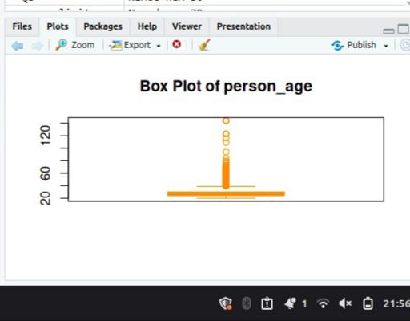

Column Name: person_income
Lower Limit: -25673.88
Upper Limit: 168667.1
Total Outliers: 2218
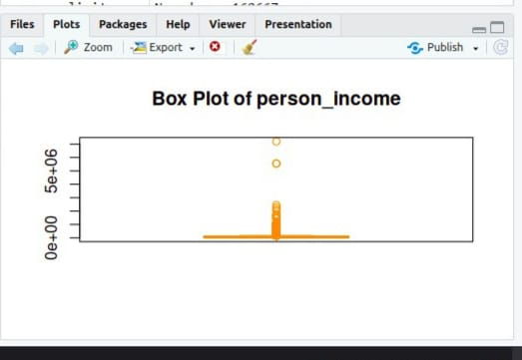

====================================
Column Name: person_emp_exp
Lower Limit: -9.5
Upper Limit: 18.5
Total Outliers: 1724
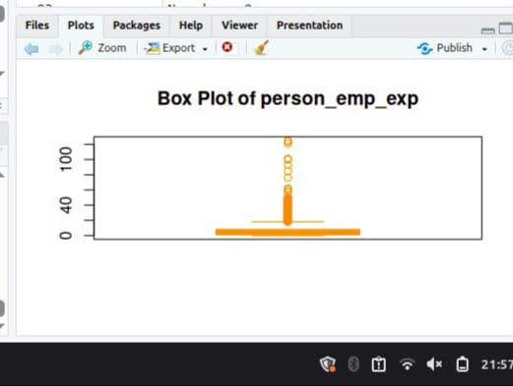

====================================
Column Name: loan_amnt
Lower Limit: -5855.875
Upper Limit: 23093.12
Total Outliers: 2348
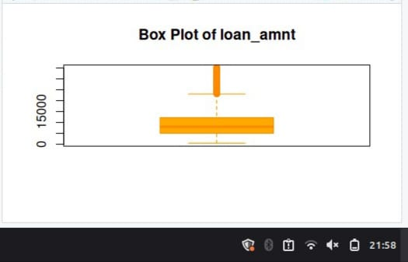

====================================
Column Name: loan_int_rate
Lower Limit: 1.99
Upper Limit: 19.59
Total Outliers: 124

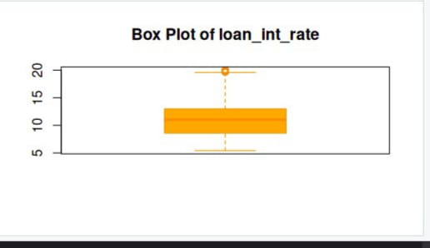

====================================
Column Name: loan_percent_income
Lower Limit: -0.11
Upper Limit: 0.37
Total Outliers: 744

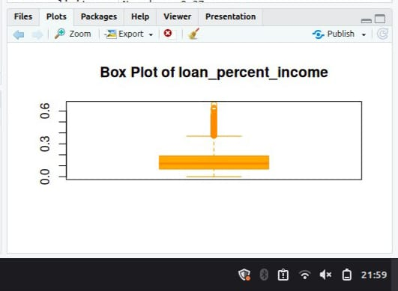

====================================
Column Name: cb_person_cred_hist_length
Lower Limit: -4.5
Upper Limit: 15.5
Total Outliers: 1366

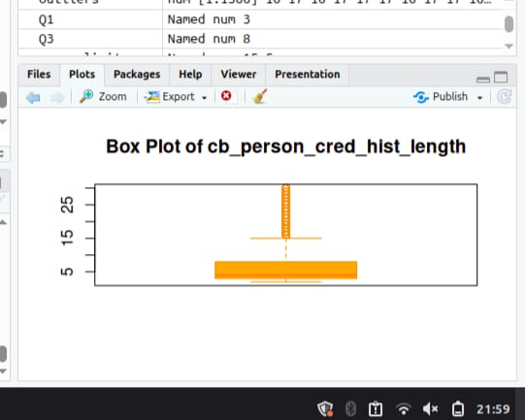
====================================
Column Name: credit_score
Lower Limit: 497.5
Upper Limit: 773.5
Total Outliers: 467

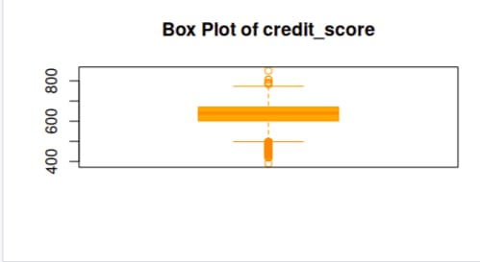

Data Symmetry Analysis (Output Explanation)
>person_age
The average age (27.76) is slightly higher than the median (26), which means most people are younger but a few older values are increasing the average. So, the data is right-skewed.

>person_income
The mean income is higher than the median, showing that most people earn moderate income but a few high earners are increasing the average. This makes the distribution right-skewed.

>person_emp_exp
The mean experience is slightly higher than the median, meaning most individuals have low to medium experience, but some highly experienced people increase the average. So, it is right-skewed.

>loan_amnt
The average loan amount is higher than the median, meaning most people take smaller loans while a few large loans increase the mean. This results in a right-skewed distribution.

>loan_int_rate
The mean and median are almost equal, showing that interest rates are evenly distributed across borrowers. So, this variable is symmetrical.

>loan_percent_income
loan_percent_income
As, the mean (0.14) is greater than the median (0.12), which indicates that the distribution is positively skewed (right-skewed) rather than symmetrical. This means that most users spend a smaller portion of their income on loans, while a few users have comparatively higher loan percentages.
>cb_person_cred_hist_length
The mean is higher than the median, meaning most people have shorter credit history, but a few long credit histories increase the average. So, it is right-skewed.

>credit_score
The median is higher than the mean, meaning a few low credit scores are pulling the average down. So, this variable is left-skewed.




