**PACKAGES USED**

* "@emotion/react": "^11.13.5",
* "@emotion/styled": "^11.13.5",
* "@mui/icons-material": "^6.1.9",
* "@mui/material": "^6.1.9",
* "@mui/styles": "^6.1.10",
* "@testing-library/jest-dom": "^5.17.0",
* "@testing-library/react": "^13.4.0",
* "@testing-library/user-event": "^13.5.0",
* "axios": "^1.7.9",
* "react": "^18.3.1",
* "react-dom": "^18.3.1",
* "react-scripts": "5.0.1",
* "react-slick": "^0.30.2",
* "slick-carousel": "^1.8.1",
* "web-vitals": "^2.1.4"

**TO RUN THE APPLICATION LOCALLY**

1. **Clone the repository**

*git clone -b master* [*https://github.com/farooQbp/hexnode.git*](https://github.com/farooQbp/hexnode.git)

1. **Navigate to the project directory**

Once the repository is cloned, navigate into the project folder:

*cd hexnode*

1. **Install dependencies**

To install the required dependencies, run the following command:

*npm install*

This will install all the packages listed in the package.json file.

1. **Start the development server**

Once the dependencies are installed, you can start the development server using:

*npm start*

The app should now be running on http://localhost:3000 (by default). You can open this in your browser to see the application in action.

1. **Build the application (optional)**

If you need to create a production-ready build of the application, you can do so by running:

*npm run build*

This will create a build/ directory with the optimized files for deployment.

**FOLDER STRUCTURE**

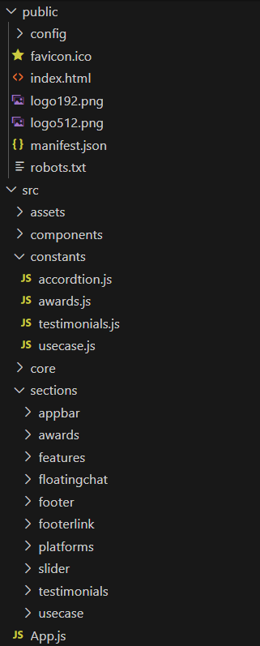

In Assets all logos and images used is available

In Constants the static datas are available

In Sections folder, each section styles were added