**PHONEBOOK APPLICATION**

**A PROJECT REPORT**

**Submitted by**

***KINGSTON.W(200701126)***

***MOHAMMED FAROOK.A (200701149)***

***MONESH.M.S (200701150)***

**in partial fulfillment for the award of the degree**

**of**

**BACHELOR OF ENGINEERING**

**IN**

**COMPUTER SCIENCE**

 

**RAJALAKSHMI ENGINEERING COLLEGE, THANDALAM**

**ANNA UNIVERSITY : CHENNAI 600 025**

**FEBRUARY 2022**

**BONAFIDE CERTIFICATE**

This is to certify that this project report titled “CODE STORAGE APPLICATION” is the bonafied work of Mustafa Abdullabhai (200700155),

Ragavender TS (200701184), Praveenraj H (200701178) who carried out the project work under my supervision.

##### **SIGNATURE** **SIGNATURE**

**Dr. P. Revathy, M.E., Ph.D., Ms. J. Jeyalakshmi,**

Head ofthe Department, Supervisor,

Professor, Assistant Professor,

Department of Computer Science, Department of Computer Science, Rajalakshmi Engineering College, Rajalakshmi Engineering College Thandalam, Thandalam,

Chennai-602105 Chennai -602105

This project report is submitted for viva voice examination to be held on …………….

at Rajalakshmi Engineering College, Thandalam.

EXTERNAL EXAMINER INTERNAL EXAMINER

**ACKNOWLEDGEMENT**

First and foremost, I acknowledge the amazing Grace of God Almighty,

who blessed my efforts and enabled me to complete this thesis in good

health, mind, and spirit.

I am grateful to my Chairman Mr.S.Meganathan, Chairperson Dr.Thangam

Meganathan, Vice Chairman Mr.M.Abhay Shankar for their enthusiastic

motivation, which inspired me a lot when I worked to complete this project

work. I also express our gratitude to our principle Dr.S.N.Murugesan who

helped us in providing the required facilities in completing the project.

I would like to thank our Head of Department Dr.P.Revathy for her

guidance and encouragement for completion of project.

I would like to thank Mr.J.Jeyalakshmi, our supervisor for constantly

guiding us and motivating us throughout the course of the project. We express

our gratitude to our parents and friends for extending their full support to us.

**ABSTARCT**

Phonebook project is a very simple tool that helps you understand the basic concepts of creation, file extensions and data structure. This software teaches you how to add, view, edit or modify, receive and delete data from files.

Adding new items, viewing them by logging in, editing and updating, searching for saved contacts and deleting data in the phonebook is one of the main features of the main phonebook application (shown in the main menu below).

Personal information, such as name, type, identity, phone number, nationality, email address and address, is required to add a login to the phonebook. You can then edit, view, search and delete this text. It is estimated that there are more than 600 million mobile phone users in the world and the number is also increasing. The success of mobile phones is simply described: they are always there, everywhere. When a trader moves from one place to another, he is doing business without business. If the boy is late returning home, he can tell his parents. If you have a problem with your device, you can seek help along the way. Mobile phones are used for communication and communication between people. Informal meetings (such as going to the bar) are usually arranged on an anonymous and timely map over a mobile phone. In general, there are many ways to use a mobile phone. But there are some problems. Technology decides to reach potential everywhere, anywhere, but its existence does not mean that it can reach all possible respondents! Sharing information about the real world of customers is the way out of this problem. But now mobile user interactions depend on older versions. In particular, the connection between the user and the general user is not sensitive to the context, making it difficult to know when to call and under what circumstances.

.

**TABLE OF CONTENTS**

**TITLE PAGE NO**

**ACKNOWLEDGEMENT iii**

**ABSTRACT iv**

**LIST OF FIGURES vii**

**LIST OF TABLES viii**

**LIST OF SYMBOLS ix**

**1. INTRODUCTION 1**

**1.1** Introduction to Digital world 1

**1.2** Role of Database management system 2

**1.3** Contribution of the proposed project 2

**2. LITERATURE SURVEY 3**

**3. SYSTEM SPECIFICATION 10**

**3.1** Requirement Specification 10

**3.1.1** Hardware Requirements 10

**3.1.2** Software Requirement 10

**3.2** Proposed System 10

**4. SYSTEM DESIGN 12**

**4.1** System Architecture 12

**4.2** Proposed System 13

**4.2.1** Use case diagram 14

**4.2.2** Activity diagram 15

**4.2.3** ER diagram 16

**5. IMPLEMENTATION RESULTS 14**

**5.1** Generating proper UI 14

**5.2** Collecting Required Images and description 15

**5.3** Business logic 16

**5.4** Connecting to the database 17

**6. CONCLUSION AND FUTURE WORK 28**

**6.1** Conclusion 28

**6.2** Future work 28

**REFERENCES 32**

**LIST OF SYMBOLS**

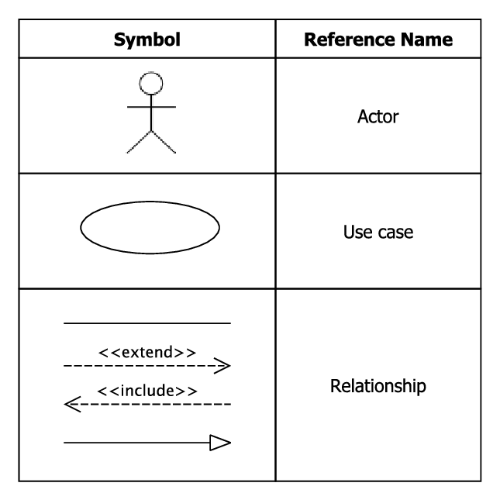

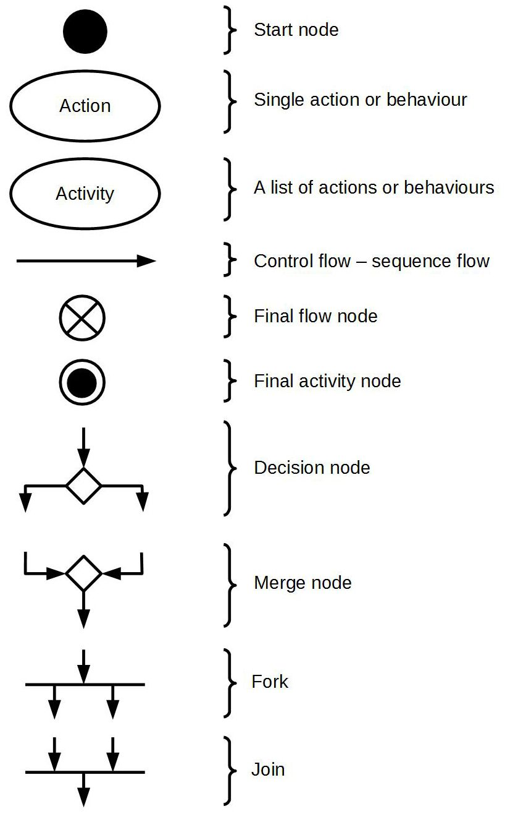

**CHAPTER 1**

**INTRODUCTION**

**1.1 INTRODUCTION TO DIGITAL WORLD**

Humanities and education discussions of the 'Digital era' tend to create variations when categorizing and defining the mass of mediated technologies and human interactions that are suggested as part of the Digital World. The phrase 'digital world' is used loosely as a mass noun with many possible meanings and variations.

The phrase digital world was being used in electrical engineering studies before the creation of the World Wide Web. Originally it was used to describe the prevalence of digital electronic devices as opposed to analogue electronic devices. Articles on the digital world became more common in the 1990s.

**1.2** **ROLE OF DATABASE MANAGEMENT SYSTEM**

A database management system (DBMS) is a software tool that enables users to manage a database easily. It allows users to access and interact with the underlying data in the database. These actions can range from simply querying data to defining database schemas that fundamentally affect the database structure.

Furthermore, DBMS allows users to interact with a database securely and concurrently *without* interfering with each user *and* while maintaining data integrity.

### Database tasks in a DBMS

The typical database administrative tasks that can be performed using a DBMS include:

* **Configuring authentication and authorization.** Easily configure user accounts, define access policies, modify restrictions, and access scopes. These operations allow administrators to limit access to underlying data, control user actions, and manage users in databases.
* **Providing data backups and snapshots.** DBMS can simplify the backup process of databases by providing a simpler and straightforward interface to manage backups and snapshots. They can even move these backups to third-party locations such as cloud storage for safekeeping.
* **Performance tuning.** DBMS can monitor the performance of databases using integrated tools and enable users to tune databases by creating optimized indexes. It reduces [I/O usage](https://www.bmc.com/blogs/io-infrastructure-operations-organizations/) to optimize SQL queries, enabling the best performance from the database.
* **Data recovery.** In a recovery operation, DBMS provides a recovery platform with the necessary tools to fully or partially restore databases to their previous state—effortlessly.
* All these administrative tasks are facilitated using a single management interface. Most modern DBMS support handling multiple database workloads from a centralized DBMS software, even in a distributed database scenario. Furthermore, they allow organizations to have a governable top-down view of all the data, users, groups, locations, etc., in an organized manner.

**1.3 CONTRIBUTION OF THE PROPOSED SYSTEM**

In this project, we are trying to construct a well defined application of ease

users storing and retrieving of code without connecting to internet that is in offline mode. We can retrieve the code on any time and on any place without any physical interaction with server and it might be tremendously time saving and resource saving strategy. This application can help many software developers and engineers for efficient and effective usage of this application.

The proposed system will definitely help for the users in many different ways. The proposed system workflow is displayed in the upcoming diagrams that is the data flow diagrams in the detailed manner.

**CHAPTER 2**

**LITERATURE SURVEY**

In the recent years, the advances in mobile technology have brought an exorbitant change in daily lifestyle of individuals. Smartphones/mobile devices are rampant in all aspects of human life. This has led to an extreme demand for developing software that runs on [mobile devices](https://www.sciencedirect.com/topics/computer-science/mobile-device). The developers have to keep up with this high demand and deliver high-quality app on time and within budget. For this, estimation of development and testing of apps play a pivotal role. In this paper, a Systematic Literature Review (SLR) is conducted to highlight development and testing estimation process for software/application. The goal of the present literature survey is to identify and compare existing test estimation techniques for traditional software (desktop/laptop) and for mobile software/application. The characteristics that make mobile software/application different from traditional software are identified in this literature survey. Further, the trend for developing the software is towards agile, thus this study also presents and compares estimation techniques used in [agile software development](https://www.sciencedirect.com/topics/computer-science/agile-software-development) for mobile applications. The analysis of literature review suggests filling a research gap to present formal models for estimating mobile application considering specific characteristics of mobile software.

The [mobile devices](https://www.sciencedirect.com/topics/computer-science/mobile-device) being utilitarian, user-friendly, accessible has made it the most popular and indispensable expedient for human essentials from the past few years ([Malavolta et al., 2015](https://www.sciencedirect.com/science/article/pii/S1319157818306074#b0280)). Mobile software developers are driven to release software on time and within budget. Software estimation plays a pivotal role in providing the most accurate sizing figure for building confidence in developers and stakeholders relationship ([Soares and Fagundes, 2017](https://www.sciencedirect.com/science/article/pii/S1319157818306074" \l "b0375)). Many approaches used for estimation of traditional software are adapted for mobile application development and testing ([Wasserman, 2010](https://www.sciencedirect.com/science/article/pii/S1319157818306074#b0435)).

The testing phase of traditional software development proceeds through additional life cycle called Software Testing Life Cycle (STLC) ([Katherine and Alagarsamy, 2012](https://www.sciencedirect.com/science/article/pii/S1319157818306074#b0220)). According to [Gao et al. (2014)](https://www.sciencedirect.com/science/article/pii/S1319157818306074#b0165) mobile software testing are set of activities for mobile apps on mobile devices by exhausting definite software test techniques and tools in order to confirm quality in functionality, performance, and QoS, as well as features, like mobility, usability, interoperability, connectivity, security and privacy. The main phases of the testing process include test planning, test designing, test execution and test analysis ([Farooq et al., 2011](https://www.sciencedirect.com/science/article/pii/S1319157818306074#b0145), [Amen et al., 2015](https://www.sciencedirect.com/science/article/pii/S1319157818306074#b0275)).

The estimation of effort for software testing comprises an estimation of test size, effort (Person per Hour), cost and entire schedule by means of several methods, tools and techniques ([Abhilasha and Sharma, 2013](https://www.sciencedirect.com/science/article/pii/S1319157818306074" \l "b0010)). If effort, time and cost required to test the software can be anticipated, the testing resources can be systematically planned within a set target date to ensure lucrative culmination of projects. According to [Zhu et al. (2008)](https://www.sciencedirect.com/science/article/pii/S1319157818306074#b0470), for estimating the test effort the major consideration is given on test designing (creation of test cases) and test execution.

With the advent of [Agile Software Development](https://www.sciencedirect.com/topics/computer-science/agile-software-development) (ASD) ([Usman et al., 2014](https://www.sciencedirect.com/science/article/pii/S1319157818306074#b0410)) entire software development community has been driven by the adoption of [agile methodology](https://www.sciencedirect.com/topics/computer-science/agile-methodology). The Agile approach to mobile application development states an iterative and [incremental approach](https://www.sciencedirect.com/topics/computer-science/incremental-approach) comprising self-organizing teams and cross-functioning teams working together to build the software ([Kaur, 2016](https://www.sciencedirect.com/science/article/pii/S1319157818306074#b0225)). The prominent existing agile mobile application development approaches are MOBILE-D, RaPiD7, Hybrid methodology, MASAM, Scrum with Lean [Six Sigma](https://www.sciencedirect.com/topics/computer-science/six-sigma) (SLeSS) ([Dewi and Nur Atiqah Sia, 2015)](https://www.sciencedirect.com/science/article/pii/S1319157818306074" \l "b0140). The Agile espousal to mobile application development is considered as a natural fit by many researchers ([Cunha et al., 2011](https://www.sciencedirect.com/science/article/pii/S1319157818306074#b0110), [Rahimian and Ramsin, 2008](https://www.sciencedirect.com/science/article/pii/S1319157818306074#b0345), [Scharff and Verma, 2010](https://www.sciencedirect.com/science/article/pii/S1319157818306074#b0350)). In an agile environment, development and testing are not considered separate phases as in traditional software development ([Rahimian and Ramsin, 2008](https://www.sciencedirect.com/science/article/pii/S1319157818306074" \l "b0345)). The estimation of software in agile is prepared for both development and testing together. Estimation of effort in [agile development](https://www.sciencedirect.com/topics/computer-science/agile-development) is a new area of focus and very less work is reported literature ([Aslam et al., 2017](https://www.sciencedirect.com/science/article/pii/S1319157818306074#b0065)).

The significant contribution of the paper lies in examining the test effort estimation techniques for desktop/laptop software development and mobile software development. Further, the development and test effort estimation techniques are evaluated from two approaches of mobile application development process i.e., traditional software development and agile software development. Another major contribution is identifying the characteristics of mobile apps that make them distinct from traditional software.

Subsequently, the paper is divided as follows: [Section 2](https://www.sciencedirect.com/science/article/pii/S1319157818306074#s0010) presents the research method comprising three phases of Systematic Literature Review (SLR). First and second phase is devoted to forming Research Questions (RQ) and finding relevant literature for studies. The results of the review are analyzed in the third phase i.e. result reporting phase of SLR, answering each Research Question (RQs). In section 3, discussions, research gaps and future directions are presented. Some threats to the validity of SLR are discussed in section 4 followed by conclusions in section 5.

**CHAPTER 3**

**SYSTEM SPECIFICATION**

**3.1 REQUIREMENT SPECIFICATION**

**3.1.1 HARDWARE REQUIREMENTS**

|  |  |
| --- | --- |
| **Component** | **Minimum requirement** |
| Processor | 64-bit, four-core, 2.5 GHz minimum per core |
| RAM | 4 GB for developer and evaluation use |
| Hard disk | 80 GB for installation  For production use, you need additional free disk space for day-to-day operations. Add two times as much free space as you have RAM for production environments. |

**3.1.2 SOFTWARE REQUIREMENTS**

Visual studio

SQL lite database

Desktop

### 3.1 PROPOSED SYSTEM

**Business Understanding:**

Understand the project objectives and requirements from a business perspective, and then convert this knowledge into a data mining problem definition and apreliminary plan designed to achieve the objectives.

# Data Understanding:

Start by collecting data, then get familiar with the data, to identify data quality problems, to discover first insights into the data, or to detect interesting subsets to form hypotheses about hidden information.

# Data Preparation:

Includes all activities required to construct the final data set (data that will be fed into the modeling tool) from the initial raw data. Tasks include table, case, and attribute selection as well as transformation and cleaning of data for modeling tools.

# Modeling:

Select and apply a variety of modelling techniques, and calibrate tool parameters to optimal values. Typically, there are several techniques for the same data mining problem type. Some techniques have specific requirements on the form of data.

# Evaluation:

Thoroughly evaluate the model, and review the steps executed to construct the model, to be certain it properly achieves the business objectives. Determine if there is some important business issue that has not been sufficiently considered. At the end of this phase, a decision on the use of the data mining results is reached.

# Deployment:

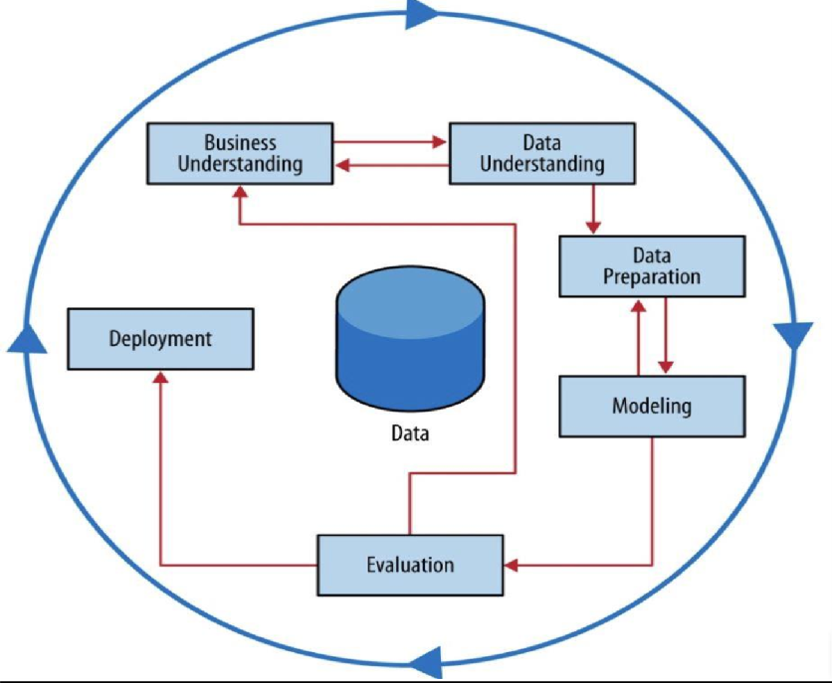Organize and present the results of data mining. Deployment can be as simple as generating a report or as complex as implementing a repeatable data mining process.

**Fig 3.1 Proposed System**

**CHAPTER 4**

**SYSTEM DESIGN**

**SYSTEM ARCHITECTURE:**

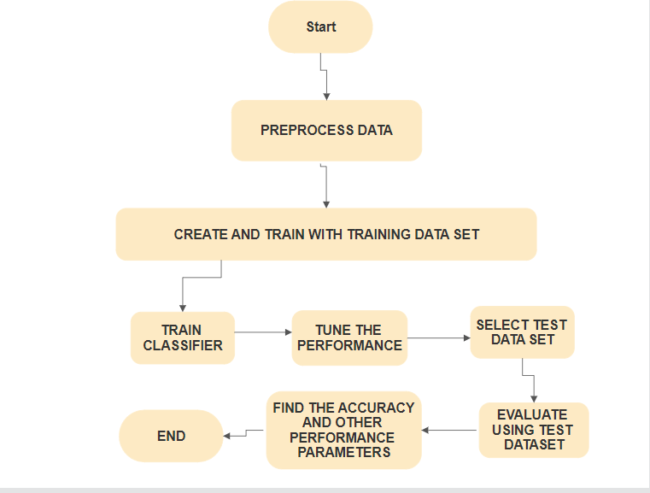

**Fig 4.1 System Architecture**

The figure above shows the system architecture of the Weka project. Here initially, the dataset consists of the customer types of an automobile industry of India. The dataset has been collected from the Hyundai company. The statistical data is collected and are stored in csv file.

Data Pre-Processing is an important step as it turns the data into a more digestible shape in order to make learning algorithms more effective. The Data Pre- Processing is done using NLP techniques. The pre-processing methods used here are Tokenization, Stop word Removal and Lemmatization. After data pre-processing computational engine is performed.

The result from classification algorithm is evaluated and analysed using the performance metrics such as Accuracy, Recall, Precision, Confusion Matrix, F1 Score and Root Mean Square Error (RMSE). Accuracy is defined as the number of correct predictions made as a ratio of all predictions made. Recall or sensitivity is defined as the number of positive returned by the model and specificity is defined as the number of negatives returned by the model. Precision is the ratio between the true positives and to all the positives. Confusion matrix helps us to learn how our predictions have been accurate and how they stand against the real values. F1 Score is the harmonic mean of precision and recall. Root Mean Square Error (RMSE) is the square root of the mean squared difference between the target value and the value predicted by the model.

Then by using various Visualization techniques such as Heat map, Word cloud, scatter plot, box plot and graphs the results are visualized. Heat map is a graphical representation system of numerical information in which a color value is indicated for each data item represented as a sample point.

**USE CASE DIAGRAM:**

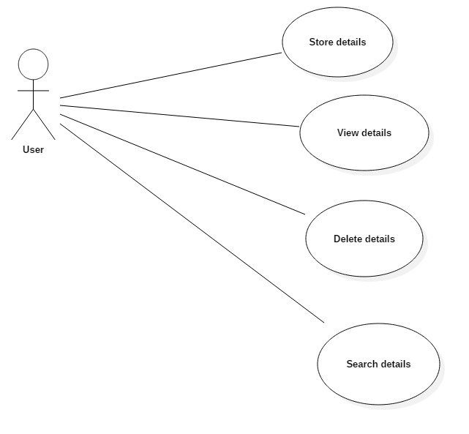

**ACTIVITY DIAGRAM:**

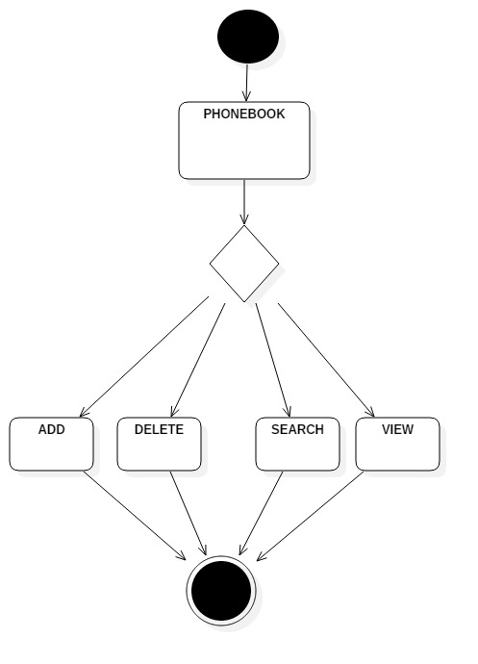

**ER DIAGRAM:**

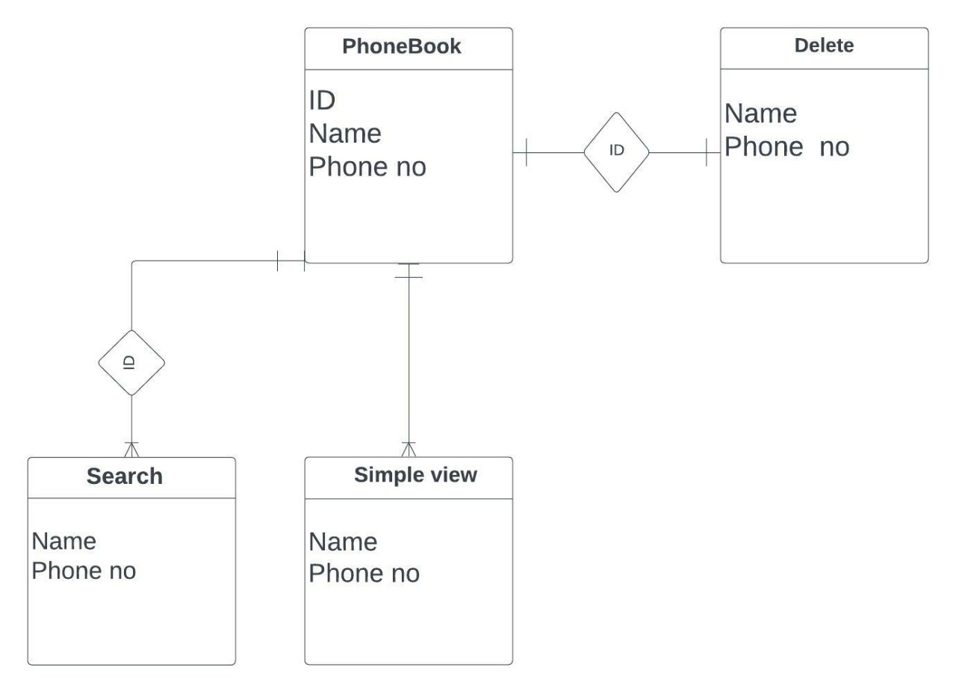

**CHAPTER 5**

**IMPLEMENTATION RESULTS**

**5.1 GENERATING PROPER UI:**

Whether you are designing for the first time or redesign a website, app or system, you are undertaking a complex task which requires a lot of discipline and clarity throughout. If you do not approach it properly, a project can turn into chaos and require countless hours of design and development to accommodate unnecessary features. In any project in which you work as a UX designer, it is fundamental to start by drafting a solid strategy; this will help you design a solution that both meets business goals and user needs.

At the start of any project, keep in mind that **user experience is about aligning business goals, user needs, and brand communication.**

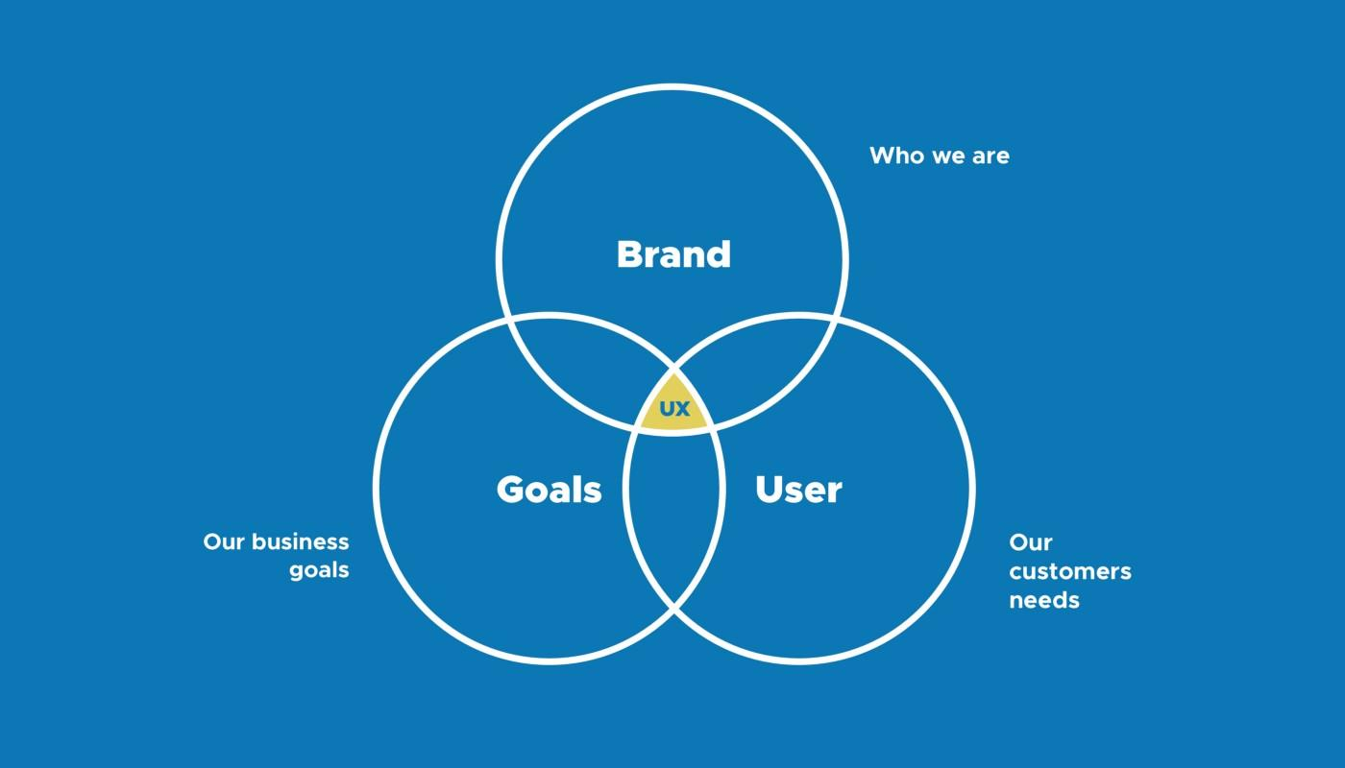

Today, there are still designers who focus too much on creating pixel perfect designs without thinking hard about the purpose of the solution they wish to bring. Besides, they become too emotionally attached to their creation and forget that **a design should solve specific problems.** As a result, they spend huge amounts of time designing inappropriately, then struggle to convince the stakeholder at approval stage. Visual attractiveness does have value, but it’s only a small component in great user experience. Generally, users care more about getting their task done and dusted than about interface design.

**5.2 COLLECTING REQUIRED IMAGES AND DESCRIPTION:**

Collecting images presupposes that we know what an image is. On a common-sense level, we have usually no problem in identifying an image as an image. Images are obviously human-made artifacts that are perceived by our visual sense, which implies that they are unamenable to visually impaired persons. A number of different genres is known to every-body, like sketches, drawings, paintings, graphic designs, logos, cartoons or photographs. The activity of collecting images is widespread in modern societies in a great variety – some collect cartoons, or postage stamps, others paintings of a certain artist, epoch or theme, and many collect photos on their smartphones, tablets and computers.

**5.3 BUSINESS LOGIC:**

In computer [software](https://en.wikipedia.org/wiki/Software), **business logic** or **domain logic** is the part of the program that encodes the real-world [business rules](https://en.wikipedia.org/wiki/Business_rule) that determine how data can be [created, stored, and changed](https://en.wikipedia.org/wiki/Create,_read,_update_and_delete). It is contrasted with the remainder of the software that might be concerned with lower-level details of managing a [database](https://en.wikipedia.org/wiki/Database) or displaying the [user interface](https://en.wikipedia.org/wiki/User_interface), system infrastructure, or generally connecting various parts of the program.

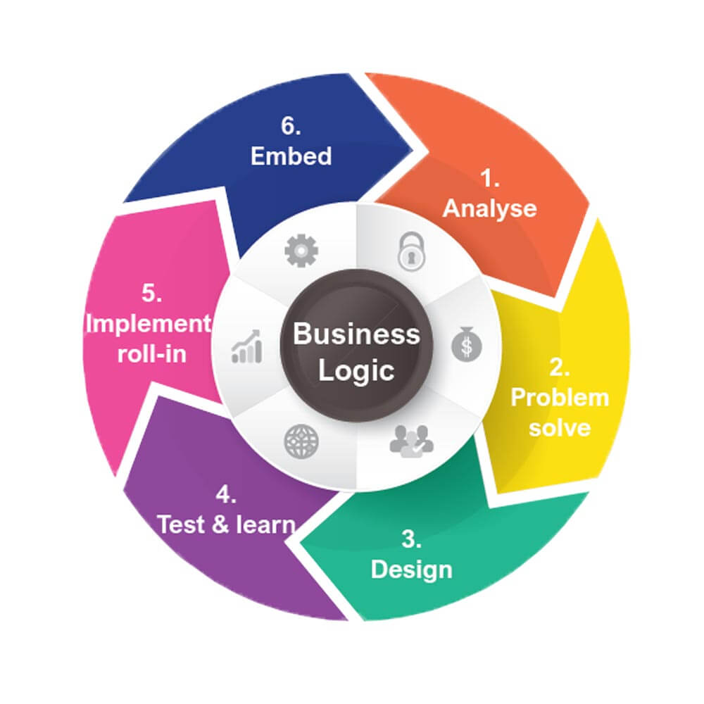

**5.4 CONNECTING TO THE DATABASE:**

A **database connection** is a facility in [computer science](https://en.wikipedia.org/wiki/Computer_science) that allows [client](https://en.wikipedia.org/wiki/Client_(computing)) software to talk to [database server](https://en.wikipedia.org/wiki/Database_server) software, whether on the same machine or not. A **connection** is required to send [commands](https://en.wikipedia.org/wiki/Command_(computing)) and receive answers, usually in the form of a result set.

Connections are a key concept in [data-centric](https://en.wikipedia.org/w/index.php?title=Data-centric&action=edit&redlink=1) programming. Since some DBMS engines require considerable time to connect, [connection pooling](https://en.wikipedia.org/wiki/Connection_pooling) was invented to improve performance. No command can be performed against a database without an "open and available" connection to it.

**5.5 PROJECT OUTCOMES:**

**SAMPLE 1.**

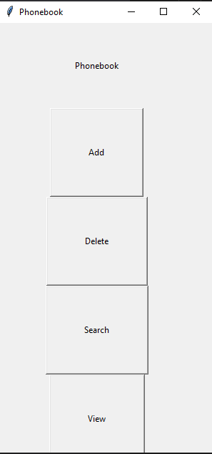 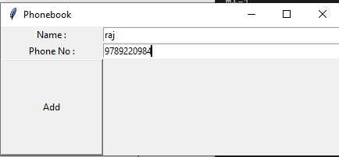

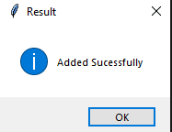

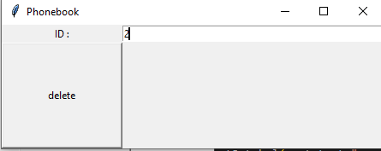

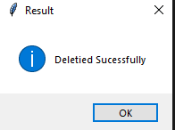

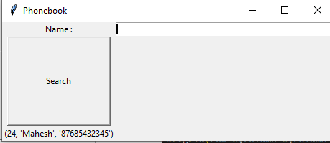

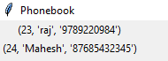

**6. CONCLUSION AND FUTURE WORK :**

**6.1 CONCLUSION:**

The aim of this project to solve the old problem of

Telephone directory and manual storage. This era to develop to mutisecured platform. This creates a new development environment which includes the copy process in easier way

**6.2 FUTURE WORK:**

In this system we integrate AI involvement and Machine learning automation. In this way this system become a powerful tool to acquire by every consumer in the world

**---------- X ----------**