Image Interpolation for Multi-Directional Scaling
using FRQI & NEQR for Gray Images and MCQI for Color Images
U.S.N Raju¹[0000-0003-1049-7949] , Makkena Veda Sri² , Rudrarapu Akshitha³ , Farooqafrooz Shaik⁴ and Chakravaram Naga Hrithikesh⁵
¹ NITWarangal , Warangal , Telangana, India
²RVR & JC College of Engineering,Guntur ,Andhra Pradesh, India
³Vaagdevi College of Engineering, Warangal, Telangana , India
⁴J K Lakshmipat University , India
⁵Mahindra University, Hyderabad , Telangana, India
¹usnraju@nitw.ac.in, ²vedasrimakkena2006@gmail.com, ³rudrarapuakshitha16@gmail.com
⁴farooqafrooz2@gmail.com, ⁵hrithikesh.ch@gmail.com

Abstract

Quantum image processing is much efficient and faster than classical image processing[10]. We proposed methods for Image Interpolation using quantum circuits and gates. The work focuses on low-resolution images and upscales the image, which is then implemented through quantum circuits using gray and color images by using methods such as FRQI, NEQR for gray images, and MCQI for color images. After upscaling the image, we apply quantum gates on position qubits, and these are rearranged with the previous position qubits, which leads to the rearrangement of pixel locations and creates different images like image replication, horizontal stretching, and vertical stretching.
- Introduction
  - Quantum Computing

The study of quantum mechanics has changed how we think about computers. Classical computers work in a line one step after another and use 0s and 1s to process information. Quantum computers[2] mainly use things such as quantum superposition and entanglement to handle data. These special properties let quantum systems look at possible solutions at the same time. From this Quantum computing[1],we are using the methods such as NEQR, FRQI and MCQI for the scaling of images.

1.2 Image Processing
Image processing[9] is a deal these days. We have a lot of media everywhere. The old ways of processing images are having a time. They are limited by the hardware when they have to deal with high-resolution pictures. When you are working with digital images you need a lot of space to store them and a lot of power to manipulate them. This is because each image is made up of millions of pixels. As people make complicated multimedia applications the old ways of doing things are getting stuck. They are not fast enough. So we really need to find ways of processing images that are very efficient. In this, we take image and perform multi-directional scaling that can show the image in different types such as vertical stretching, horizontal stretching, zooming and replication of images

1.3 Quantum Image Processing

To deal with the problems that classical computers have scientists came up with a field called Quantum Image Processing[7]. This field is a mix of subjects and it is also known as Quantum Image Processing[8]. Quantum Image Processing is really, about using computers to work with pictures. Quantum Image Processing helps us to do things with images that are hard to do with regular computers. In this paper, we are going to process images using NEQR and FRQI for gray images and MCQI for color images. In this for the same input image, we get the same output for all the three methods but we can process the image in different types such as Horizontal Stretching, Vertical Stretching, zooming and Replication of images.
NEQR:
The NEQR for 2^{n}X2^{n} quantum image is given in equation (1)
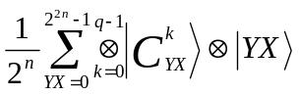 (1)
FRQI:
The representation of FRQI is shown in equation (2)
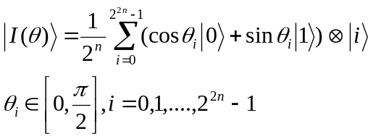 (2)
MCQI:
The representation of MCQI is shown in equation (3)
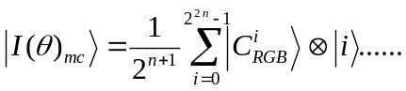 (3)
- Methodology

Now let’s consider an example of2x2 image, i.e., 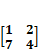 and .tif image of size 64x64 i.e.,

Fig:1 Input image

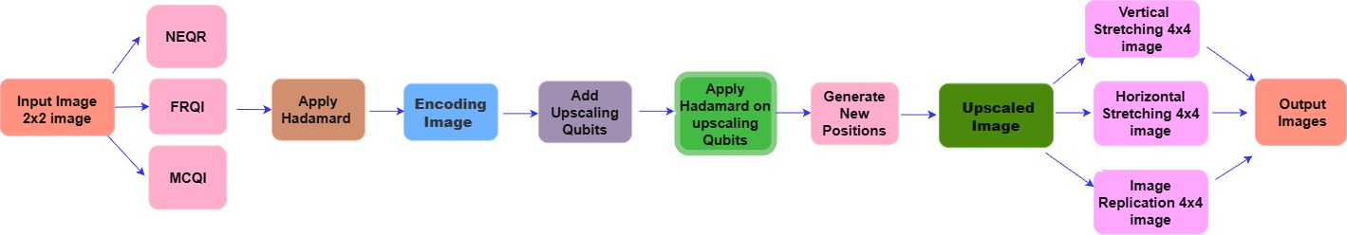
Fig:2 Block diagram of NEQR and FRQI for gray images and MCQI for color images
  - NEQR (Novel Enhanced Quantum Representation):
STEP-1: Initially, the input image of size 2x2 should be represented in the NEQR. Then take three qubits for the gray value and two qubits for position. Gray values are represented with g₀,g₁,g₂,…,g_{n} and the position qubits are represented with row and col is shown in the fig 3 for both 2x2 image and .tif image i.e., input image in fig 1. 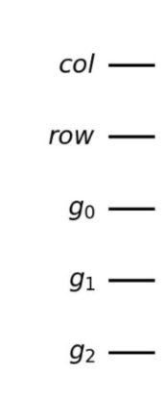 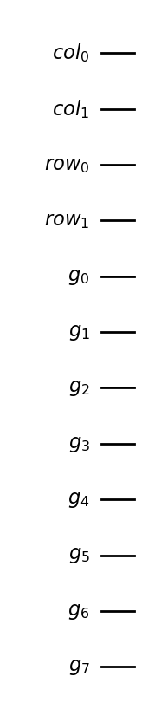
Fig:3 Representation of position qubits for 2x2 image and .tif input images
STEP-2: Use two Hadamard gates[3] for the position qubits to create the superposition[4]. So by using the appropriate gates, we represent the input image of size 2x2 is in the form of a quantum circuit i.e., shown in image fig 4. The qubits can be written as in equation 4.
∣g2 g1 g0⟩⊗∣row⟩⊗∣col⟩ (4)
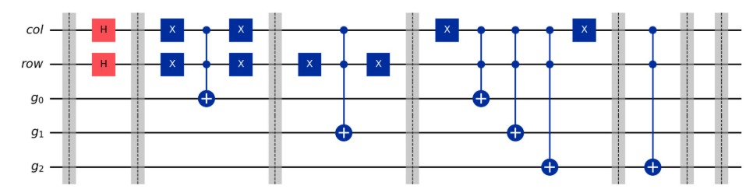

Fig:4 Circuit diagram for 2x2 input image
STEP-3: Now in this step, we need to upscale the input image of 2x2 to a 4x4 image. In a 4x4 image we have 16 positions, so we take one position for a row i.e., e_row and one column, i.e., e_col. The representation of upscaled image is shown in fig 5.
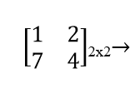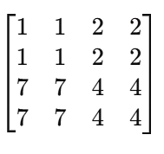4x4
Fig:5 Upscaling of input image
STEP-4:Place the e_row qubit below the row and the e_col qubit below the col. Apply a Hadamard gate on e_row & e_col qubits. Calculate the number of possible values for every bit in the row and the column for the combination [00,01,10,11]. The Upscaled image is obtained, i.e., zooming of the image. The original values which are present in the image will be present in those combinations also. The representation of position qubits in zoomed image is shown in fig 6.
The Zoomed image is
Col

e_col
row
e_row

Fig:6 Representation of position qubits in zoomed image
STEP-5:Two more qubits will be added in the circuit diagram at the bottom of the gray values i.e., g2, Since we take two extra qubits for row and col.
Vertical stretching:
From the above method, If the e_row and e_col is placed in between the row and col then we will get the vertical stretching. The representation of position qubits in vertical stretching is shown in fig 7.
Vertically Stretched image is
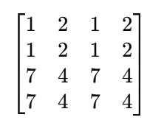

col

e_col

e_row

row
Fig:7 Representation of position qubits in Vertical Stretching

Horizontal stretching:
From the above method, if e_row is placed under the row and the e_col is placed above the col then we will get the horizontal stretching. The representation of position qubits in horizontal stretching is shown in fig 8.
Horizontally Stretched image is
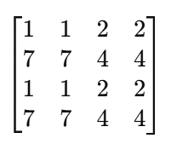

e_col

col
row
e_row

Fig:8 Representation of position qubits in Horizontal stretching
Image Replication:
Place the e_row qubit above the row and the e_col qubit above the col. Apply Hadamard gate on e_row&e_col qubits then we will get the Image Replication. The representation of position qubits in image replication is shown in fig 9.
Replicated Image is
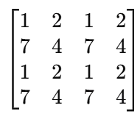
e_col

col

e_row
row

Fig:9 Representation of position qubits in Image Replication
  - FRQI (Flexible Representation of Quantum Images) :

STEP-1: Initially, the input image of sixe 2x2 is represented in FRQI model. In FRQI, the image is represented as in equation (5).
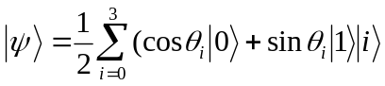 (5)

Where, |i> represents the position qubits i.e., row and col. Gray value is encoded in the angle _{i ,} and another qubit is used for color information.

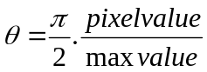

Max value=7
- 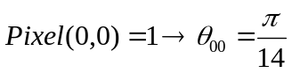
- 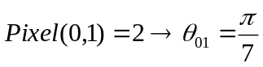
- 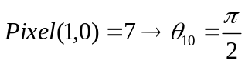
- 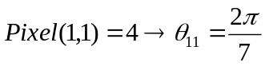
STEP-2: Apply the Hadamard gates on the position qubits to create the superposition and uses Rotation gates for the color qubit, So, by using the appropriate gates we represent input image in the form of quantum circuit. The qubits can be written as in equation 6.
∣g⟩⊗∣row⟩⊗∣col⟩ (6)

STEP-3: Now do the same process as NEQR i.e., Upscale the input image of 2x2 to 4x4 image. In 4x4 image we will have 16 positions, take one position for a row i.e., e_row and one column i.e., e_col. The representation of upscaled image is shown in fig. 5.
STEP-4: Place the e_row qubit below the row and the e_col qubit below the col. Apply Hadamard gate on e_row & e_col qubits. Now calculate the number of possible values for each and every bit in row and column for the combination [00,01,10,11]. The Upscaled matrix is obtained i.e., zooming of the image. The original values which are present in the image will be present in those combinations also. The representation of position qubits in zoomed image is shown in fig 6.
STEP-5: Here we will have color qubit instead of gray values that are present in NEQR. Now, these color qubits are represented as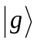.
Vertical stretching:
From the above method, If the e_row and e_col is placed in between the row and col then we will get the vertical stretching. The representation of position qubits in vertical stretching is shown in fig 7.

Horizontal stretching:
From the above method, if e_row is placed under the row and the e_col is placed above the col then we will get the horizontal stretching. The representation of position qubits in horizontal stretching is shown in fig 8.

Image Replication:
Place the e_row qubit above the row and the e_col qubit above the col. Apply Hadamard gate on e_row & e_col qubits then we will get the image replication. The representation of position qubits in image replication is shown in fig 9.
2.3 MCQI (Multi-Channel Quantum Image):

MCQI is the extension model of FRQI.

STEP-1: Initially, the input image of size 2x2 is represented in the MCQI model. Instead of the color qubit in FRQI, here we have 3 color qubits of R, G, B channels.
Here, we take 2 qubits for position qubits i.e., row and col. And 3 qubits for |R>, |G>, |B> that each stores one channel in the form of angle.
∣R⟩∣G⟩∣B⟩⊗∣row⟩⊗∣col⟩ (7)

STEP-2:Apply the Hadamard gates on the position qubits to create the superposition and uses Rotation gates for the color qubit, So by using the appropriate gates we represent input image in the form of quantum circuit.
STEP-3: Now do the process that is same as in FRQI i.e., we need to upscale the input image of 2x2 to a 4x4 image. In a 4x4 image we will have 16 positions, so take one position for a row that is i.e., e_row and one column i.e., e_col. The representation of upsaled image is shown in Fig 4.
STEP-4: Place the e_row qubit below row and the e_col qubit below the col. Apply Hadamard gate on e_row&e_col qubits. Now calculate the no. of possible values for each and every bit in row and column for the combination of 00,01,10,11. The Upscaled image is obtained i.e., Zoomed image. The original values which are present in the image will be present in those combinations also. The representation of position qubits in vertical stretching is shown in fig 6.
STEP-5: In this we will have 3 channels R,G,B instead of C₀ , that is present in the FRQI.
Vertical stretching:
From the above method, If the e_rowand e_col is placed in between the row and col then we will get the vertical stretching. The representation of position qubits in vertical stretching is shown in fig 7.

Horizontal stretching:
From the above method, if e_row is placed under the row and the e_col is placed above the col then we will get the horizontal stretching. The representation of position qubits in horizontal stretching is shown in fig 8.

Image Replication:
Place the e_row qubit above the row and the e_col qubit above the col. Apply Hadamard gate on e_row&e_col qubits then we will get the image replication. The representation of position qubits in Image replication is shown in fig 9.
- Results and Discussions

The Nearest Neighbor interpolation method was implemented using FRQI and NEQR for gray scale images and MCQI for color images. Low-resolution images were successfully upscaled through quantum interpolation circuits, producing smoother and higher-resolution outputs.

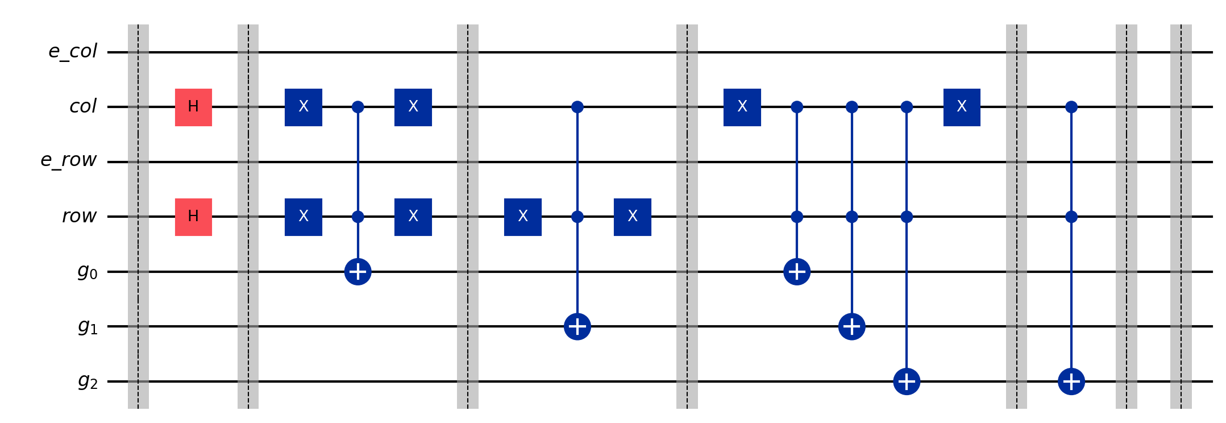

Fig:10 Quantum Circuit diagram of NEQR for 2x2 image
From the fig 10, the representations g0, g1, g2 are the gray value qubits and row, e_row, col, e_col are the position qubits. The vertical lines crossing all the qubits are the barriers for each step. Initially, Hadamard gate is applied on the row, col position qubits to obtain superposition among the qubits. In the next step, according the input image given X-gate is applied on the row and col position qubits, and CNOT gate is applied on the g0 that changes the gray value from either 0 to 1 or 1 to 1. In the same process, by applying the X-gate and CNOT gate the resultant output is obtained. The obtained image is the Zoomed Image, Shown first in the fig 11, which will be further divided into different scaling images.
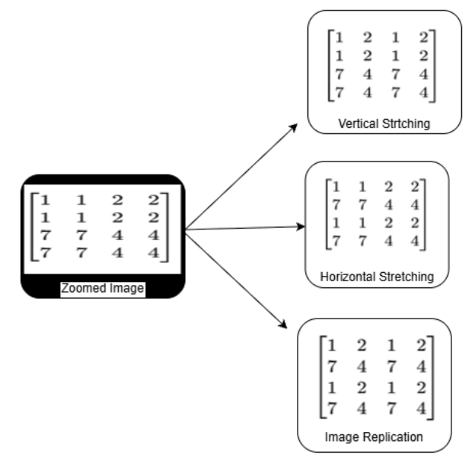
Fig:11 Output Images for Zoomed, Horizontal Stretching, Vertical Stretching and image replication
After rearranging the position qubits among them, we get different multi-dimensional scaling for 2x2 image. They are Vertical Stretching , Horizontal Stretching, Image Replication shown in Fig 11.
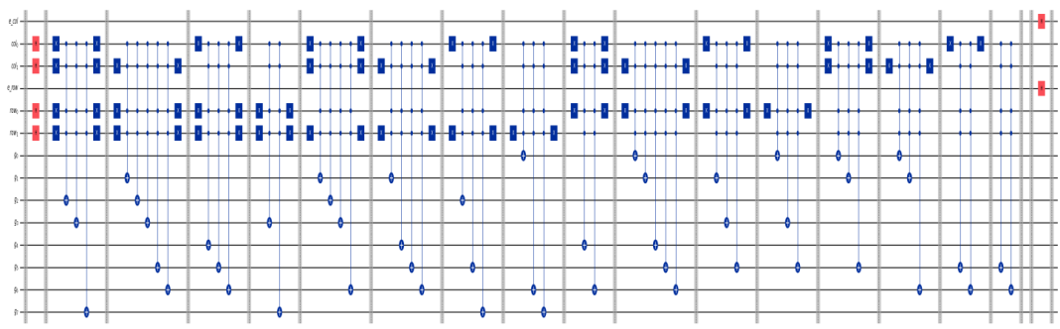Fig:12 Quantum Circuit diagram of NEQR using .tif image
From fig 12, this is the Quantum Circuit of NEQR for an .tif image of 64X64 size. In this circuit, according to the the number of position qubits, used in this image is 6. So, consider 3 position qubits for row and 3 position qubits for col. g0, g1, g2 are the gray value qubits used in the NEQR and CNOT gates are used on it. On these position qubits, hadamard gate and X-gates are applied. The resultant output of the image will be the zoomed image, Horizontally stretched image, Vertically stretched image and Replicated images and these output images that are same as the NEQR. The output of .tif image is shown in fig 13.
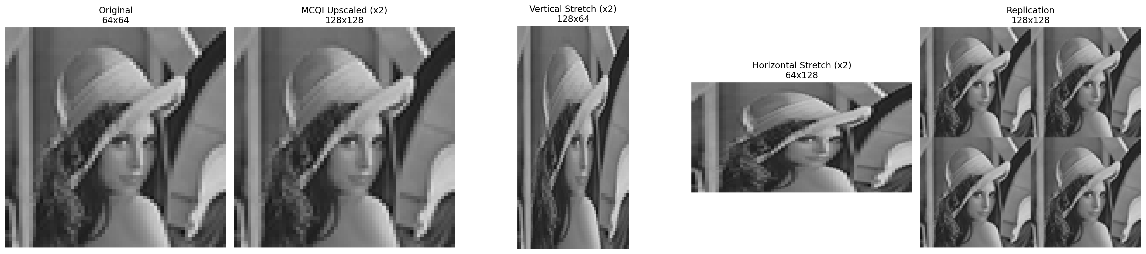
Fig:13 Output image of Zoomed image, Horizontally stretched image, Vertically stretched image and Replicated images
This is the output image obtained after rearranging of position qubits, we get the different images such as vertically stretched image, zoomed image, Horizontally stretched image and Image Replication. The output image is shown in the fig 13.
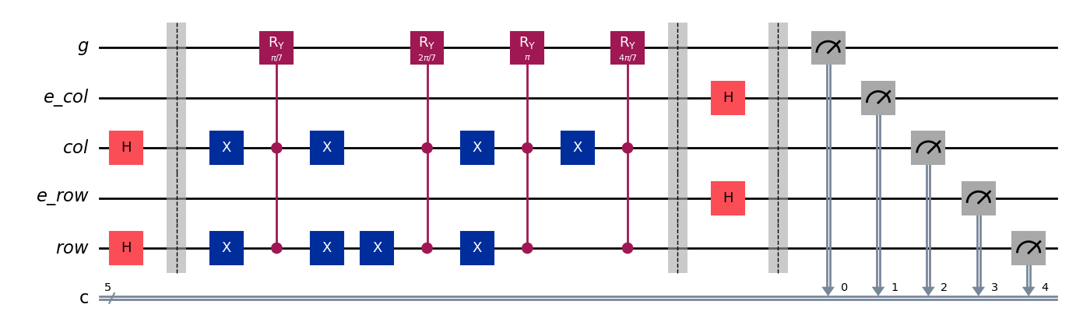Fig:14 Quantum circuit diagram of FRQI for 2x2 image
From fig 14, the representation of g is the gray value in FRQI model and row, e_row, col, e_col are the position qubits. Initially, Hadamard gate is applied on the row, col position qubits to obtain superposition among the qubits. In the next step, according to the input image given X-gates are applied on the col, row and Rotation gates are applied in the FRQI on the gray value qubit. In the same process by applying Rotation gates on gray value qubits and X-gates on position qubits, the resultant output is obtained. The obtained images are same as the images obtained in NEQR and the output images for 2x2 image are shown in Fig 11.

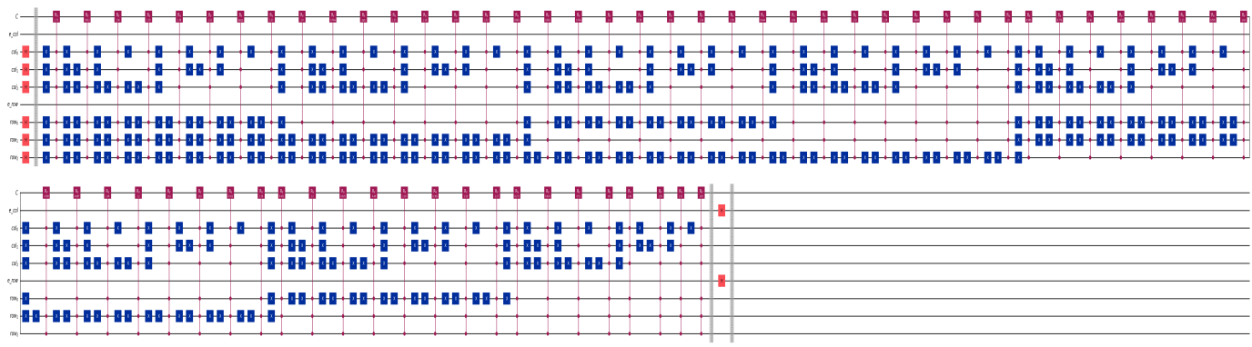
Fig:15 Quantum Circuit diagram of FRQI using .tif image
From fig 15, this is the Quantum Circuit of FRQI for an .tif image of 64X64 size. In this circuit, according to the the number of position qubits, used in this image is 6. So, consider 3 position qubits for row and 3 position qubits for col. g is the color qubit used in the FRQI and rotation gates are used on it. On these position qubits, hadamard gate and X-gates are applied. The resultant output of the image will be the zoomed image, Horizontally stretched image, Vertically stretched image and Replicated images and these output images that are same as the NEQR. The output of .tif image is shown in fig 13.
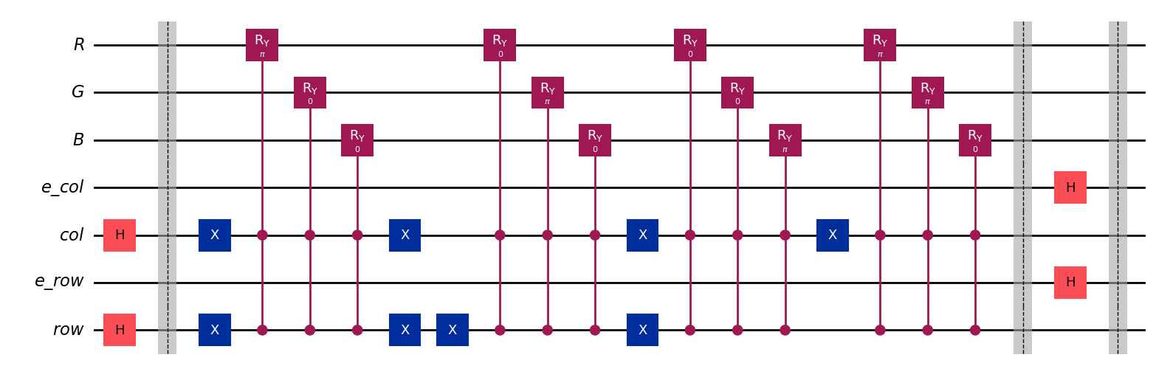
Fig:16 Quantum Circuit diagram of MCQI for 2x2 image

From fig 16, the R, G, B channels in MCQI model is for representing the color qubits and row, e_row, col, e_col are the position qubits. Initially, Hadamard gate is applied on the row, col position qubits to obtain superposition among the qubits. In the next step, according to the input image given X-gates are applied on the col, row and Rotation gates are applied in the MCQI on the three color channels. In the same process by applying Rotation gates on gray value qubits and X-gates on position qubits, the resultant output is obtained. The obtained images are same as the images obtained in NEQR and FRQI, the output images of 2x2 image are shown in Fig 11.

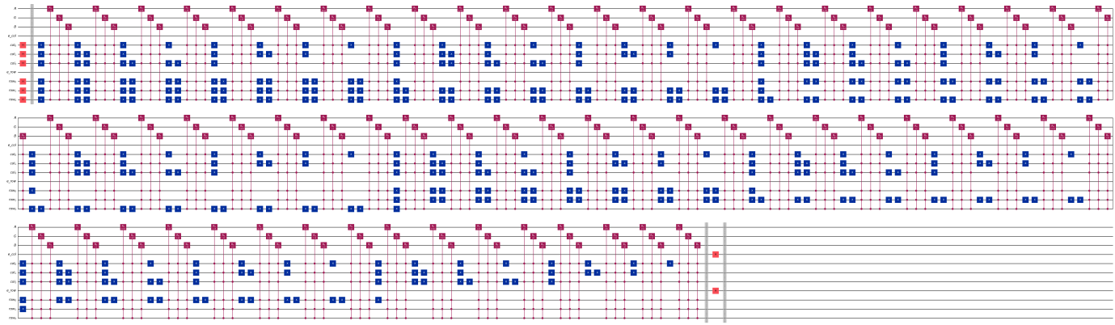
Fig:17 Quantum Circuit diagram of MCQI using .tif image

From fig 17, this is the Quantum Circuit of MCQI for an .tif image of 64X64 size. In this circuit, according to the the number of position qubits used in this image is 6. So, consider 3 position qubits for row and 3 position qubits for col. R, G, B are the color channels used in the MCQI and rotation gates are used. On these position qubits hadamard gate and X-gates are applied. The resultant output of the image will be the zoomed image, Horizontally stretched image, Vertically stretched image and Replicated images and these are the output images that are same as NEQR and FRQI.
The output images are same for all the three models such as NEQR, FRQI and MCQI. The output of .tif image is shown in fig 13.
NEQR provided high-interpolation accuracy, while FRQI method achieved efficient image representation using fewer qubits. MCQI preserved color information effectively during multi-directional scaling operations. By applying quantum gates[5] to position qubits and rearranging them, various image transformations such as image replication, horizontal stretching, image zooming, and vertical stretching were achieved. The experimental results demonstrate that quantum image representations can efficiently perform image enlargement and spatial transformations while maintaining image quality.
- Conclusions and Future Extensions
This work proposed a quantum image interpolation method for scaling low-resolution grayscale and color images using FRQI, NEQR, and MCQI representations in quantum computing [3].The results shows that quantum circuits can effectively upscale images while preserving image quality. By applying quantum gates to position qubits, various image transformations such as image replication, horizontal stretching, image zooming, and vertical stretching were successfully achieved. The study demonstrates the potential of quantum image processing for efficient image enhancement and geometric transformations.
Future work may focus on processing higher-resolution images, implementing advanced image transformations, integrating quantum watermarking and steganography [13]. These improvements can further improve the applicability of quantum image processing in multimedia and security applications.

- References

[1] M. A. Nielsen and I. L. Chuang, Quantum Computation and Quantum In-formation, 10th Anniversary ed. Cambridge, U.K.: Cambridge University Press, 2010.
[2] P. Kaye, R. Laflamme, and M. Mosca, An Introduction to Quantum Compu-ting. Oxford, U.K.: Oxford University Press, 2007.
[3] A. Pathak, Elements of Quantum Computation and Quantum Communica-tion. Boca Raton, FL, USA: CRC Press, 2013.
[4] N. S. Yanofsky and M. A. Mannucci, Quantum Computing for Computer Scientists. Cambridge, U.K.: Cambridge University Press, 2008.
[5] C. Bernhardt, Quantum Computing for Everyone. Cambridge, MA, USA: MIT Press, 2019.
[6] S. E. Venegas-Andraca, Quantum Walks for Computer Scientists. San Rafael, CA, USA: Morgan & Claypool Publishers, 2008.
[7] F. Yan and S. E. Venegas-Andraca, Quantum Image Processing. Singapore: Springer Nature Singapore Pte Ltd., 2020.
[8] A. I. Mihovska and S. E. Venegas-Andraca, Quantum Image Processing in Practice. Hoboken, NJ, USA: John Wiley & Sons, 2024.
[9] R. C. Gonzalez and R. E. Woods, Digital Image Processing, 3rd ed. Upper Saddle River, NJ, USA: Pearson Prentice Hall, 2008.
[10] M. Sonka, V. Hlavac, and R. Boyle, Digital Image Processing and Comput-er Vision. Clifton Park, NY, USA: Cengage Learning, 2008.
[11] D. A. Forsyth and J. Ponce, Computer Vision: A Modern Approach. Upper Saddle River, NJ, USA: Prentice Hall, 2003.
[12] A. M. Tekalp, Digital Video Processing. Upper Saddle River, NJ, USA: Prentice Hall, 1995.
[13] I. J. Cox, M. L. Miller, J. A. Bloom, J. Fridrich, and T. Kalker, Digital Wa-termarking and Steganography, 2nd ed. Burlington, MA, USA: Morgan Kauf-mann Publishers, 2008.

