**INTRODUCTION TO DATABASE SYSTEM LAB**

**PROJECT NO 01**

**PROJECT PHASE 01**

**NAME:** MUHAMMAD FAROOQ AZAM

**REG #:** L1F20BSSE0593

**SECTION:** O1

**PROJECT TITLE**

**PHARMACY**

**Database Name:** pharmacy

**Table: Company**

* Name (Primary Key)
* Address
* PhoneNumber

**Table: Admin**

* Admin_id (Primary Key)
* Name
* Address
* PhoneNumber

**Table: Pharmacist**

* Pharm_id (Primary Key)
* Name
* Address
* PhoneNumber

**Table: Customer**

* Cust_id (Primary Key)
* Name
* Address
* PhoneNumber

**Table: Supplier**

* Supp_id (Primary Key)
* Name
* Address
* PhoneNumber
* Comp_name (Foreign Key)

**Table: Medicines**

* Med_id (Primary Key)
* Name
* Comp_name (Foreign Key)
* Supp_id (Foreign Key)
* Price
* ExpiryDate

**Table: Prescription**

* Presc_id (Primary Key)
* Med_id (Foreign Key)
* Hospitalname
* Doctorname
* PreDate

**Table: Purchase**

* Purchase_id (Primary Key)
* Cust_id (Foreign Key)
* Med_id (Foreign Key)
* Amount
* PurchaseDate

**Table: Sales**

* Sales_id (Primary Key)
* Pharm_id (Foreign Key)
* Med_id (Foreign Key)
* Cust_id (Foreign Key)
* Purchase_id (Foreign Key)
* SalesCount
* SaleDate
* Total_amount

**Relationships:**

1. **Company - Supplier (One-to-Many):**
   * Each company (Company) can have one or more suppliers (Supplier).
   * The Supplier table contains a foreign key (Comp_name) referencing the Company table.
2. **Medicines - Company (Many-to-One):**
   * Many medicines (Medicines) are produced by one company (Company).
   * The Medicines table contains a foreign key (Comp_name) referencing the Company table.
3. **Medicines - Supplier (Many-to-One):**
   * Many medicines (Medicines) can be supplied by one supplier (Supplier).
   * The Medicines table contains a foreign key (Supp_id) referencing the Supplier table.
4. **Prescription - Medicines (Many-to-One):**
   * Many prescriptions (Prescription) can include one type of medicine (Medicines).
   * The Prescription table contains a foreign key (Med_id) referencing the Medicines table.
5. **Purchase - Customer (Many-to-One):**
   * Many purchases (Purchase) can be made by one customer (Customer).
   * The Purchase table contains a foreign key (Cust_id) referencing the Customer table.
6. **Purchase - Medicines (Many-to-One):**
   * Many purchases (Purchase) can include one type of medicine (Medicines).
   * The Purchase table contains a foreign key (Med_id) referencing the Medicines table.
7. **Sales - Pharmacist (Many-to-One):**
   * Many sales (Sales) can be conducted by one pharmacist (Pharmacist).
   * The Sales table contains a foreign key (Pharm_id) referencing the Pharmacist table.
8. **Sales - Medicines (Many-to-One):**
   * Many sales (Sales) can include one type of medicine (Medicines).
   * The Sales table contains a foreign key (Med_id) referencing the Medicines table.
9. **Sales - Customer (Many-to-One):**
   * Many sales (Sales) can be made to one customer (Customer).
   * The Sales table contains a foreign key (Cust_id) referencing the Customer table.
10. **Sales - Purchase (Many-to-One):**
    * Many sales (Sales) can be linked to one purchase (Purchase).
    * The Sales table contains a foreign key (Purchase_id) referencing the Purchase table.

**PROJECT PHASE 02**

**ER MODEL**

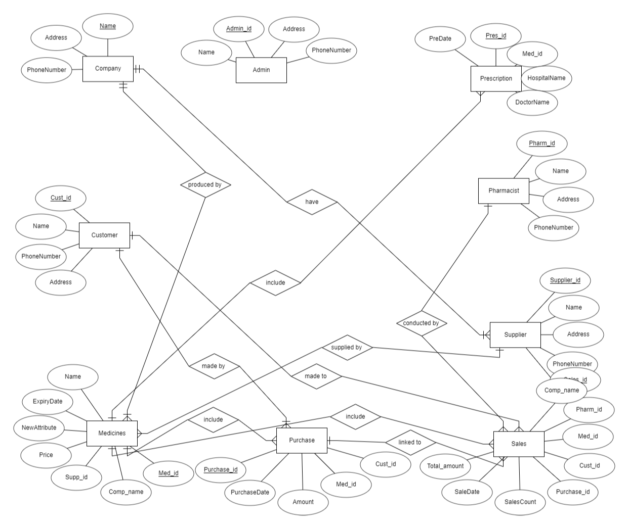

**RELATIONAL MODEL**

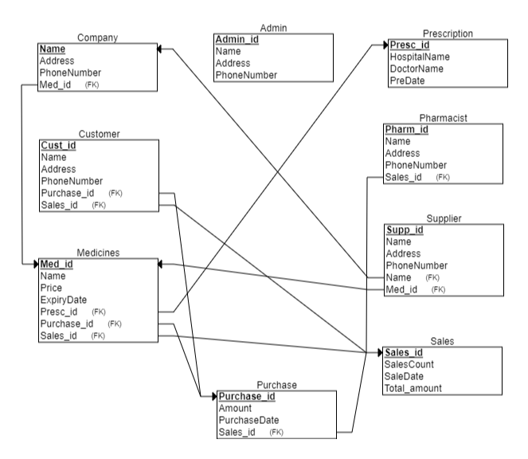

**PROJECT PHASE 03**

**Queries**

**Query 01:**

SELECT M.Name AS MedicineName, C.Name AS CompanyName, S.Name AS SupplierName

FROM Medicines M

INNER JOIN Company C ON M.Comp_name = C.Name

INNER JOIN Supplier S ON M.Supp_id = S.supp_id;

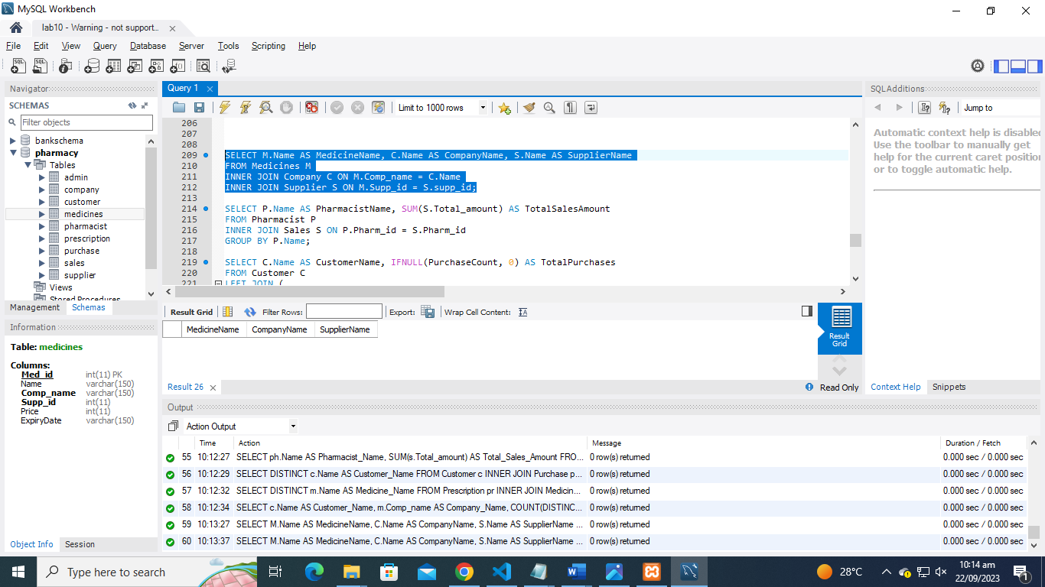

**Query 02:**

SELECT P.Name AS PharmacistName, SUM(S.Total_amount) AS TotalSalesAmount

FROM Pharmacist P

INNER JOIN Sales S ON P.Pharm_id = S.Pharm_id

GROUP BY P.Name;

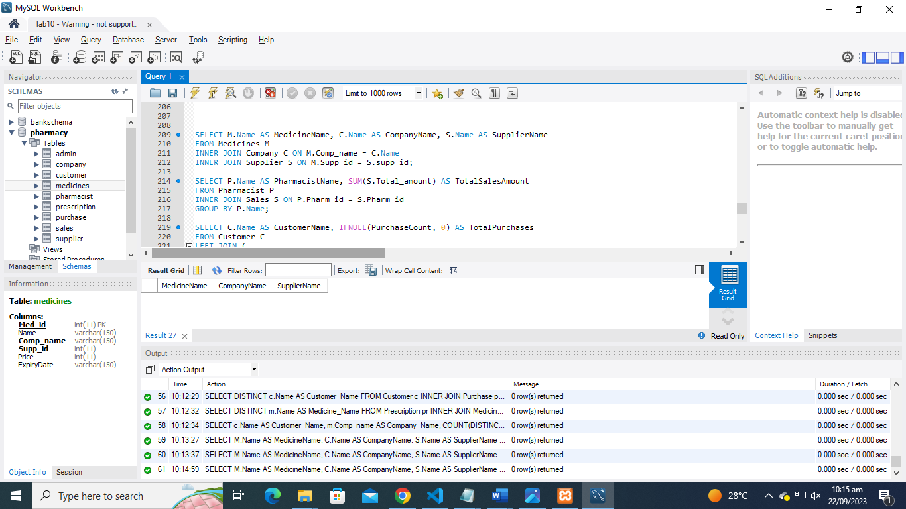

**Query 03:**

SELECT C.Name AS CustomerName, IFNULL(PurchaseCount, 0) AS TotalPurchases

FROM Customer C

LEFT JOIN (

SELECT Cust_id, COUNT(*) AS PurchaseCount

FROM Purchase

GROUP BY Cust_id

) AS SubQuery ON C.Cust_id = SubQuery.Cust_id;

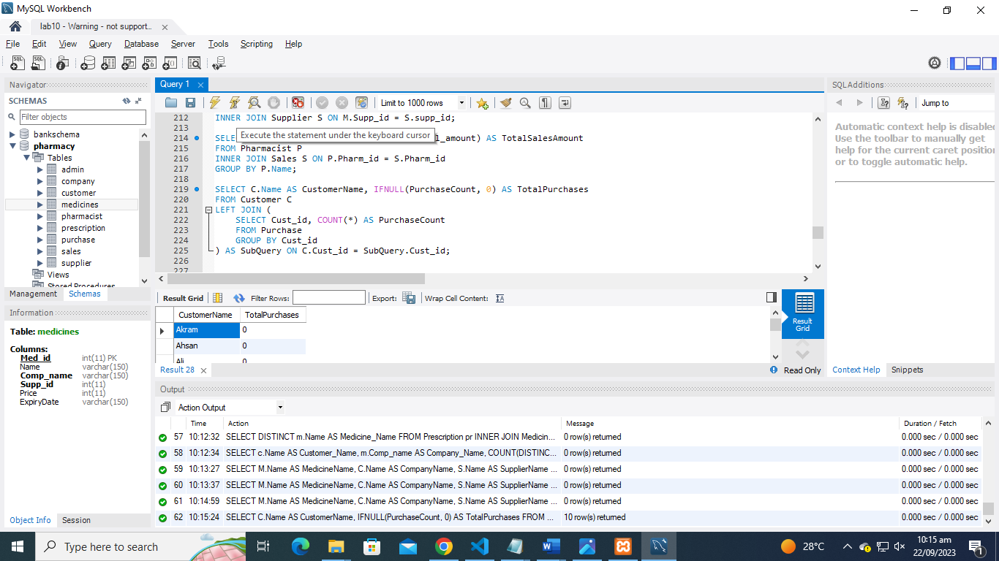

**Query 04:**

SELECT M.Name AS MedicineName, IFNULL(PrescriptionCount, 0) AS TotalPrescriptions

FROM Medicines M

LEFT JOIN (

SELECT Med_id, COUNT(*) AS PrescriptionCount

FROM Prescription

GROUP BY Med_id

) AS SubQuery ON M.Med_id = SubQuery.Med_id

WHERE IFNULL(PrescriptionCount, 0) > 1;

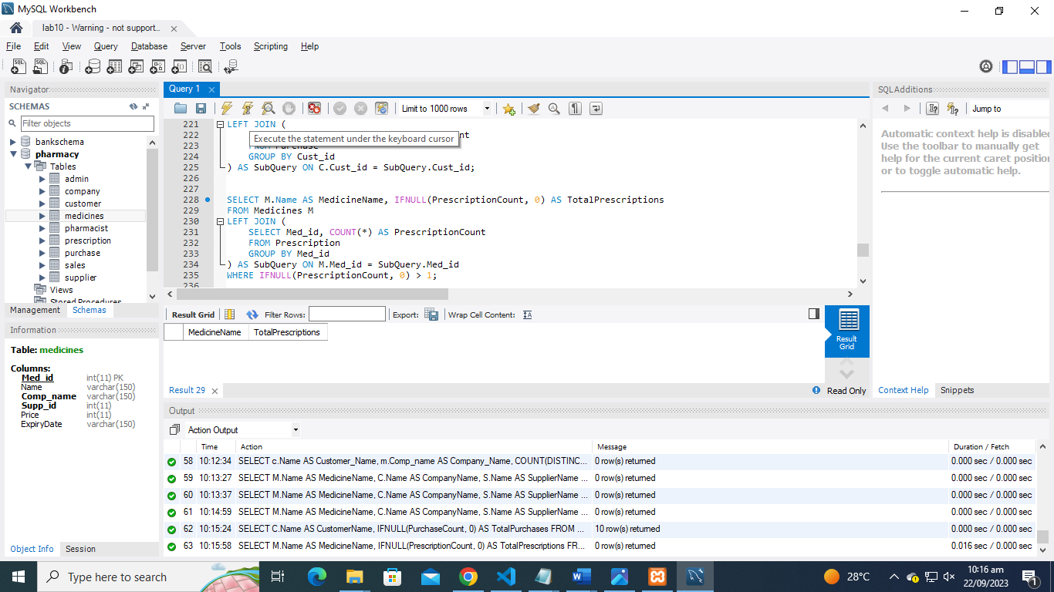

**Query 05:**

SELECT C.Name AS CustomerName, (

SELECT SUM(S.Total_amount)

FROM Sales S

WHERE S.Cust_id = C.Cust_id

) AS TotalSalesAmount

FROM Customer C;

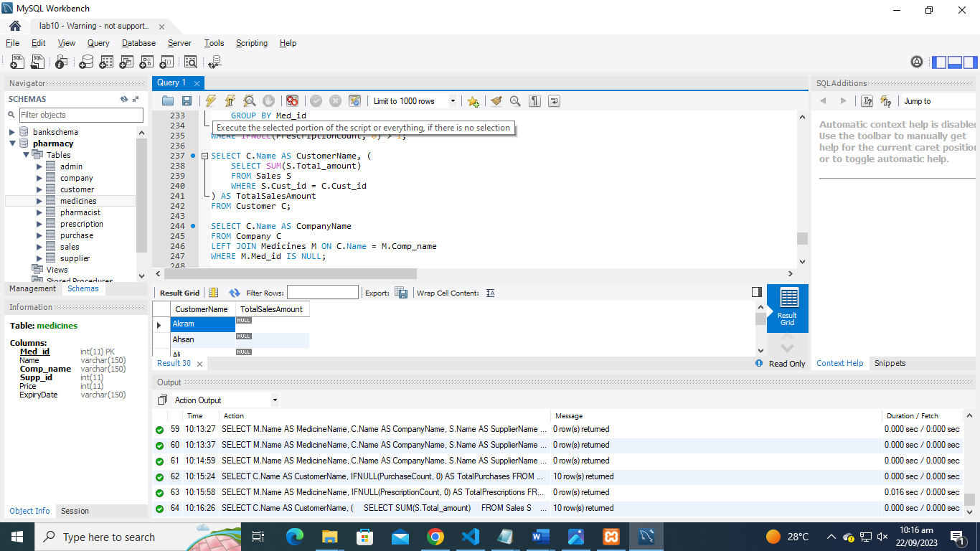

**Query 06:**

SELECT C.Name AS CompanyName

FROM Company C

LEFT JOIN Medicines M ON C.Name = M.Comp_name

WHERE M.Med_id IS NULL;

