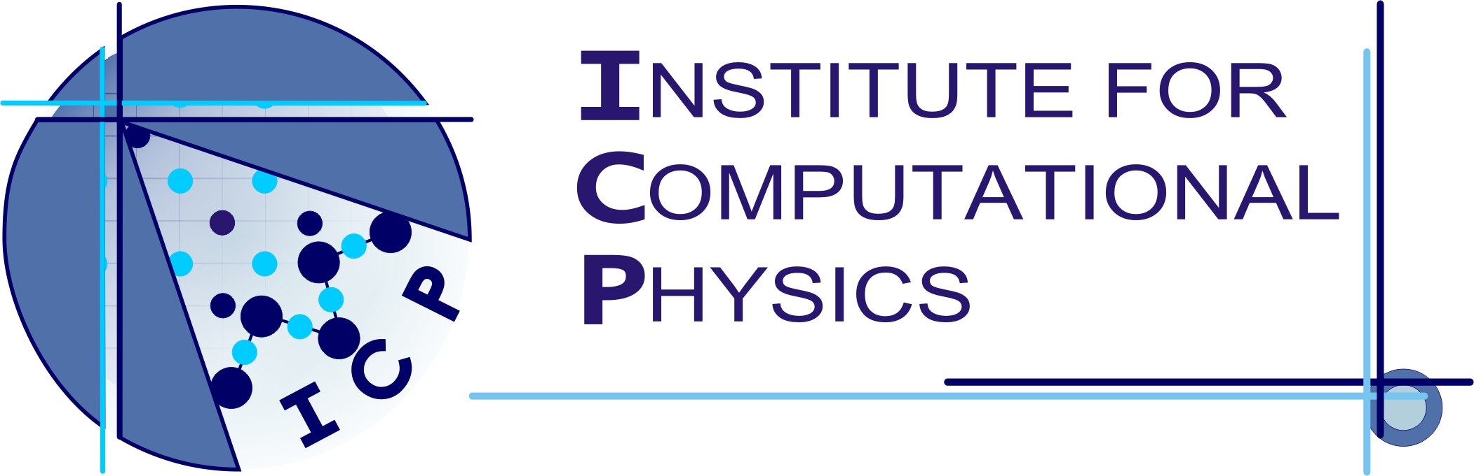

Certificate

This is to certify that
(Name) (Student ID Number)

has successfully finished the course “Programming in C++” on February 18-22, 2013 at the Institute for Computation Physics at the University of Stuttgart.

Course Contents
Based on “Thinking in C++” by Bruce Eckel
- The C in C++
- Object-oriented Analysis and Design
- OOP in C++
- The C++11 standard
- Templates, Exceptions, Namespaces
- The Version Control System git
- Debugging Tools
- Programming in a Team

Stuttgart, March 4, 2013
(JP Dr. Axel Arnold) (Dr. Olaf Lenz)

