

Website and Marketing Proposal for

**www.edc.ac**



Education Development College  
Smithfield House  
Digbeth, Birmingham B5 6BS

Project Directors

Mr. Alan / Asiya Begum

Date:

**2nd August 2010**

Site plan summary

**COMMERCIAL INFORMATION**

|  |  |
| --- | --- |
| **Business name** | Education Development College EDC |
| **Business Objective** | Raise the profile of the business. Allow foreign and local students to access the site giving complete information about the college, its activities and courses.  Also Have a dynamic database section for administration where college staff can login and provide enter details and information such as attendance  Also allow students to create an account where their personal information etc can be held and relevant details can be accessed regarding their presence, documentation, course etc. at the college  A provision for UKBA is also required to log in and check student attendance |
| **Key target market** | Local and Foreign students |
| **Net impression** | Modern, professional, corporate following exactly the same theme as www.soas.ac.uk and barrowing from www.ed.ac.uk  It would be prudent to create an illustrator version of the home page and 2 or 3 of the content pages |
| **Credibility/Integrity points** | Seeking association with a British university, as yet not available. There are however a number of important and well recognised partners are in the specification |
| **Competitive Assessment** | Other UK colleges taking foreign students.. see Google for more details. Search under UK colleges for international students |
| **USPs** | Experience in this business, well established, large premises |

**TECHNICAL INFORMATION**

|  |  |
| --- | --- |
| **Domain name(s)** | www.edc.ac.uk |
| **Existing Website (If any)** | A website already exists, www.edc.ac.uk – Can view for more information |
| **Client emails** | info@ |
| **Complex Search Engine Marketing exercise required?** | Require all meta tags, keywords and Google analytics account |
| **Keywords and META tags** | To be provided |
| **Website type** | Brochure and database system as a separate element running from the same platform - |
| **Logo required?** | Logo exists already. |
| **Flash animation required?** | No |
| **Navigation** | See Plan0 and plan 1 |
| **Total number of pages** | Undetermined – however, as many as it takes to complete the site |
| **Graphics / Colours Background** | Follow the sample sites form SOAS and ed.ac.uk – The design consists of the combination of both as outlined in the plan0 |
| **Interactive forms** | Enquiry form on Contact page  Application forms for students  Other forms as necessary |
| **Contact details** | email address, business address, telephone number (not mobile) |
| **Statistics** | Account created in Google Analytics and training given |
| **Search Engine Positioning  Measures** | 1. Title and META tags to be populated with nominated search phrases.  2. Submit to all search engines on going live.  3. Create FACE BOOK and Twitter accounts |
| **Other special features and functions** | Database system included as part of the project, for college Admin and Student accounts |

Contents

1. Website Summary
2. Contents (This page)
3. Whiteboard Spec
4. Detailed Site plan
5. Website Content
6. Website External Accounts
7. Website approval form

Whiteboard Specs

Plan 0

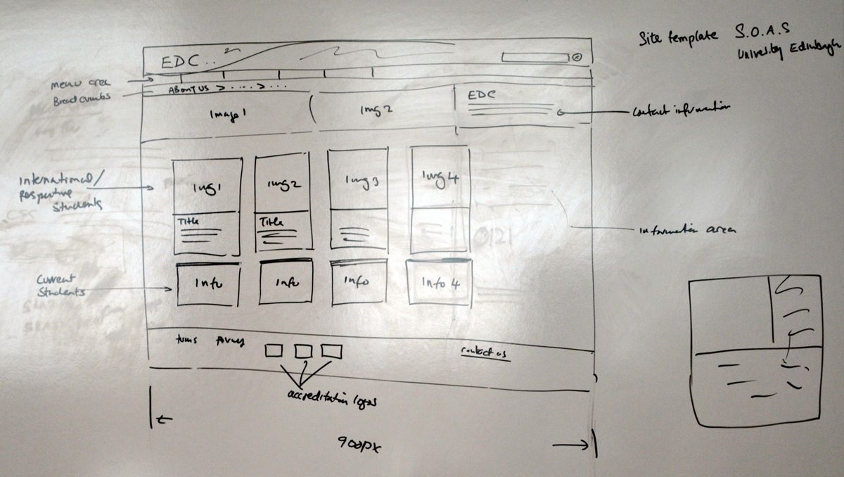

Plan 1

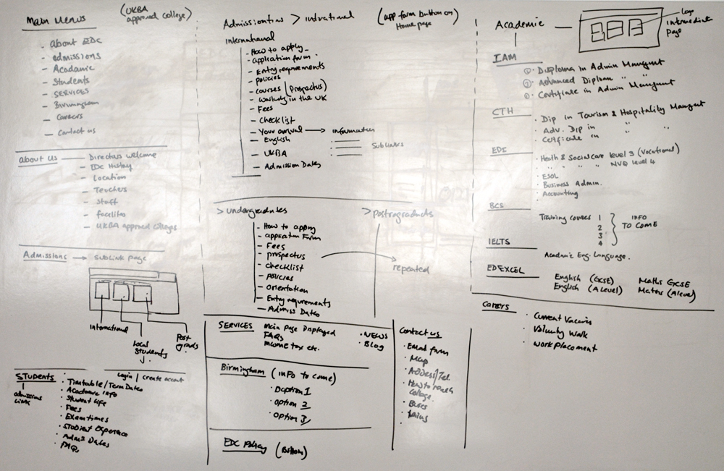

Plan 2 same as Plan 1 but different camera angle for clarity

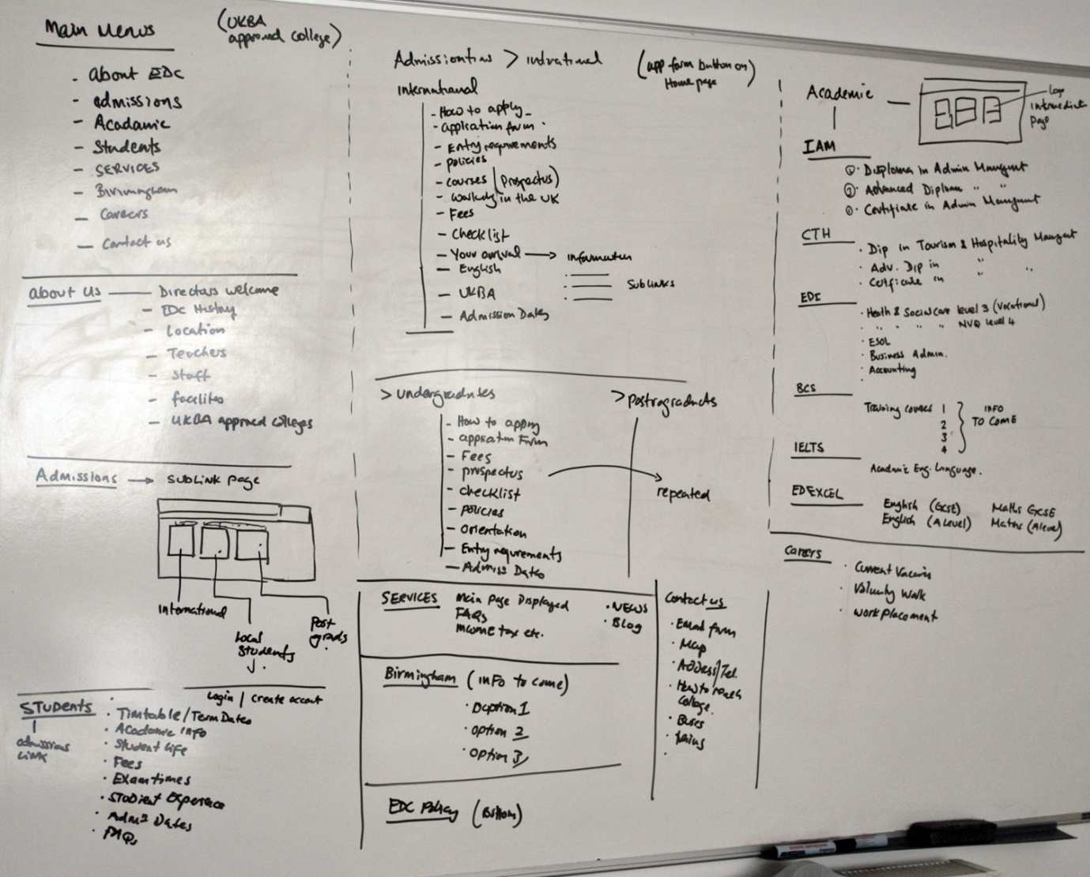

Detailed Site Plan

**Home page:**

* Graphical content as shown in plan 0, based on SOAS
* All website links visible
* The main home page content from ed.ac.uk
* As shown, top section International prospective Students
* As shown, bottom section current, already at college students
* ­Accreditation logos at bottom
* Terms and conditions and privacy policy as bottom links
* EDC contact information with the phone number bigger
* Links to application form on home page

**Website Main Links**

* About EDC
  + Directors Welcome
  + EDC History
  + Location
  + Teachers
  + Staff
  + Facilities
  + UKBA Approved colleges

Home page Content – Please provide all text and images for the home page below

Content here

Images: E.g.

**[](http://www.ed.ac.uk/studying/undergraduate)**

**[](http://www.ed.ac.uk/studying/postgraduate)**

**[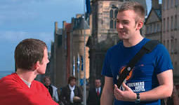](http://www.ed.ac.uk/studying/international)**

About us Content – Please provide all text and images for the About page below

**Directors Welcome**

**EDC History**

**Location**

**Teachers**

**Staff**

**Facilities**

**UKBA Approved colleges**

Admissions – Please provide all text and images for the Admissions page below

Similar to about page.. and so on

External Accounts setup for web marketing and analysis

|  |  |
| --- | --- |
| **Face book** | Account name and Access |
| **Details** | Info here of how to access and use |
| **Twitter** | Account name and Access |
| **Details** | Info here of how to access and use |
| **Google Analytics** | Account name and Access |
| **Details** | Info here of how to access and use |
| **Emails setup if applicable** | Account names and passwords |

Website Approval Form