

Tel: 0121 359 1012/110 | Fax: 0121 359 1013 | Email: info@ambinet.co.uk

E-commerce Website

MSS

Date: 30th of September 2009

Project Director
Mr. Harmeet Sahotay

Project Development Team
Project Manager: Mr. Shakeel Ishtiaq

Document Ver. 1.0

Terminology
Administrator:
This is the person responsible for maintaining the day-to-day running of the products and categories. This person will also have access to orders and clients information.

Web User:
Any person who has rights to get registered with website, buy online products and pay using online payment system or place an order.

Paypal:
Paypal is an online secure payment system, which is used worldwide and is powered by Ebay (one of the leading ecommerce website available online)

E-commerce:
E-Commerce is another name of online shop, where you can sell products or services online.

Administration Area:
Administration area can only be accessed by the Website Administrator to manage all products, categories and orders.

Dynamic Content:
The data that you can change from the Administration Area is called dynamic content.

Static Content:
The form of data that you cannot change from the Administration Area is called static content.

Upload
Sending data via the administration area so that it can be displayed on the webpage.
Introduction
MSS is currently looking to sell its wide range of products online. Currently the company has an existing website, which displays main categories and products. The company would like a new website to expand the functionality allowing customers to buy a large range of their products, online.

Ambinet has been requested to design and implement a full e-commerce website which will provide facilities to the user for online shopping and secure payment.

The website will be split into following five main departments.

- Build
- Fix
- Decor
- Garden
- Rooms

Following instructions from the project director, the general design of the site will be informative but simple, ensuring visitors can shop online quickly and view or search relevant products without having to go through a long process.

The ultimate aim is to combine functionality with style to produce a prominent website that is informative and easy to use.

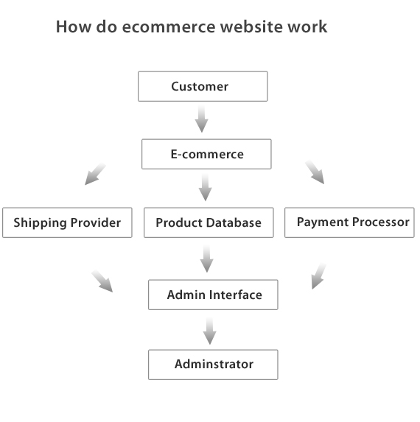
The diagram below gives a general idea of the e-commerce website:

Process of Project
The design and implementation of this project involves a number of different stages (see diagram below) from information gathering to final testing. To ensure the project runs smoothly and is delivered on time, it is always necessary for the project director to be fully involved throughout the project life cycle and their help and guidance is constantly required.
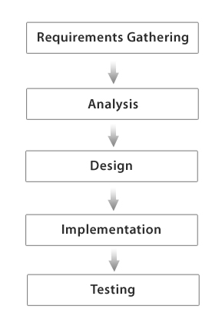

Requirements/Project Scope
The subsequent requirements stated, for the user and administrator will in effect be the scope for the whole project.

Summary of Requirements for the User
The following list provides a brief summary of requirements that the final website must satisfy for the user:

Related to Main Pages of the Website
- View information about MSS; who they are, what they do, their products, their services and contact information.
- Give feedback to the company.
- Have easy access to all the main pages from anywhere in the site.
- View information about all of products.
- View the company’s terms and conditions.
- Be informed about the special offers.
- Register details and be able to login for future purchases.

Related to Products
- Purchase a product efficiently.
- Search and find products easily.
- Get a visual image of each product displayed.
- Read detailed information about a product if required.
- View and purchase related products.
- View and purchase recommended products.
- View and edit their basket before checking out.
- Be presented with instructions (in an email) on how to use the product once they have bought it off the website.
- Answer some questions as part of a consultation and have products recommended to them based on that.
- Make payments securely online for all purchases.

Summary of Requirements for the Administrator
The following list provides information about the requirements that must be satisfied for the administrator:

Related to the Administrators Control Panel
- View the feedback the user has sent.
- View and edit each product that is on the website in terms of images and description.
- View all the orders website users have placed.
- Change the prices of the products if they need to and email them to their customers.
- Upload new products on the website; image, description, benefits and price.
- Archive any products that are no longer required on the site.

Analysis of requirements
After obtaining the requirements of the website it has been established what areas will need to be static and which ones dynamic.

Static: Means data or elements of the website which cannot be altered in administrator area.
Dynamic: Means data or elements, which can be altered from the administrator.

Below is a list of all the static and dynamic areas of the website and a brief description for each page/area.

Static Areas

Home
- Simple introduction to MSS the website, without too much detail.
- Appropriate image which is clear and high resolution.
- A section displaying special offers.
- Straight link to shopping.

About Us
- An overview of who the company is and what it does.
- Concise information.

Contact Us
- Companies contact information; telephone number, enquiry telephone number, fax number, email and postal address.

Location
- Photographs will be used with high resolution.
- Address will be given.
Terms and Conditions
- Standard terms and conditions to be obtained from Director.
Dynamic Areas

Shopping Cart
- After the web user is done shopping they can click here to view and edit there sopping if need be.
- Once the web user is happy they can click on the ‘Check Out” button to proceed with the payment for the selected products.

Feedback
- User can give comments on their experience of using the website.
- Users can also use it to enquire.

Build
Build

Insulation

    - Cavity Insulation
    - Loft Insulation
    - Polystyrene
    - Kingspan
    - Celotex
    - Draught excluder

Building Materials

    - Coving
    - Materials
    - Drainage
    - DPC and membrane

Ladders

    - Combination ladders
    - Extension ladders
    - Loft ladders
    - Roof ladders
    - Step ladders
    - Ladder accessories
Conservatries
Doors

    - Doors
    - Door Furniture

Windows

    - Windows
    - Window Furniture

Timber

    - Stair parts
    - Sawn Timber
    - Plained square edge timber
    - Sheet materials
    - Cladding

Fix

Plumbing

- Plumbing supplies
Tools

- Accessories
- Bench tools
- Drilling and screwing
- Grinding and routing
- Hobby tools

Hardware

    - Bolts
    - Fixings
    - Ironmongery
    - Nails
    - Screws
    - Security

Hand Tools

  - Hand tools
  - Tool storage
  - Workbenches

Work Wear

    - Snickers
    - Dewalt
    - Scruffs

Decor

Lighting

    - Indoor lighting
    - Outdoor Lighting
    - Light bulbs

Paint

    - Interior paint
    - Exterior paint
    - Wood care
    - Preparation and undercoat
    - Specialist paints

Flooring

    - Wood flooring
    - Chipboard flooring

Decorating Sundries

    - Abrasives
    - Fillers and putty
    - Painting and decorating tools and accessories
    - Treatments
    - Cleaners
    - Protection
    - Adhesives and sealants

Rooms

Bathroom

    - Bathroom range
    - Taps
    - Furniture
    - Accessories

Storage and Shelving

    - Fixing
    - Shelving
    - Storage

Kitchens

    - Kitchen range
    - Work tops
    - Sinks
    - Finishing touches
    - Storage

Door Furniture

Garden
Garden

Garden Buildings

    - Sheds, storage and workshops
    - Cabins and summer housing
    - Garden structures
    - Green houses

Outdoor Living

- Garden furniture

Garden Tools and Equipment

    - Pressure washers
    - Wheelbarrows

Fencing and Decking

    - Fencing
    - Gates
    - Decking

Outdoor Fun

- Playhouses

Garden Care

Key Features

- Main Departments will be displayed on the top menu
- Each Menu will display relevant types
- All categories will be organized under main types
- Each category will have its own main page so users can easily navigate from one to another.
- Each page for each product will have a brief description, an image, price and benefits.
- There will be a link ‘more info’ for further detailed information about that product.
- The image will be a linked so you can view a larger version of it.
- There will be links to 4 related products which user can also view and buy.
- There will be a link to view the different options for that product i.e. size and colour, if applicable.
- A small table with two columns, one for ‘quantity’ and one for ‘add to basket’.

Payment System for Web Users
Ambinet recommends paypal for all online secure payment transactions. Paypal is powered by ebay which is one of most popular ecommerce website and is the owner of Paypal.

Please visit http://www.paypal.co.uk for more details.

Please note:
It is possible for Ambinet to implement other dedicated payment systems such as HSBC, LLOYDS or PROTX, however these are complicated to integrate and may take more time. Using other systems can incur an extra charge of up to £350.00


Administration Area
The administrator will have their own login User ID and Password in order to access the administration area. Here they will be able to manage 4 main areas regarding their e-commerce website; products, categories, orders and clients.
The following illustrative diagram shows what the administration area will consist of:
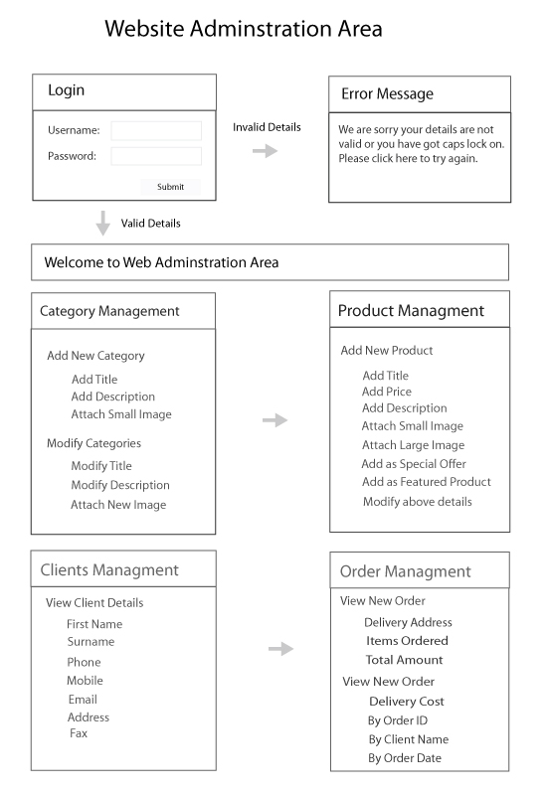

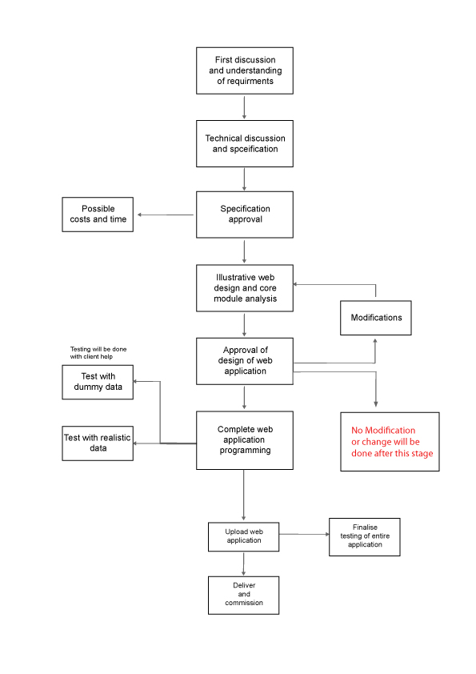
Development process of the Project
Web Hosting & Email Hosting
The complete website will be hosted on Ambinet servers. This will also facilitate easy maintenance for the application. The cost for web hosing and technical support will be £65.00 per annum.

External Hosting
If another company (other then Ambinet) is hosting the website, we would be happy to upload the entire site onto their server. For this we will need the FTP details from the external hosting company.

Database Hosting
In order to provide Ambinet with database facilities, we will purchase MYSQL of 150 MB, which will cost £100 per annum.

Training and Support
Although this particular application will not require much training we will ensure that any necessary training is carried out in full and all questions are answered.

Further communication regarding the MSS website will always be documented via email and a copy of the entire communications log will be kept in the MSS website folder at Ambinet. The MSS company director can view this at any time.

Conclusion
After full analysis and discussion amongst the design and programming teams at Ambinet, we conclude that the MSS e-commerce system can be developed to the specification outlined in this document. All areas of the design and programming have been considered and the following points have been raised:

- The Website will provide full administration.
- Details of all static contents and dynamic contents are given above.
- Paypal will be used as online payment system.
- The functional success of the MSS is dependent upon the full testing of the MSS Ecommerce website. We will need assistance to test this fully.
- Full training and user manual will be provided so that the MSS team can easily use the web administration area.

Note: Once the illustrative designs have been approved we will begin the process of programming and implementation. Further changes after this may not be possible, or may cost more.

