*EDITH – The Follow Me Robot*

**PROJECT REPORT**

On

## EDITH – The Follow Me Robot

Submitted in partial fulfillment for the award of

**BACHELOR OF TECHNOLOGY**

## In

**Computer Science & Engineering (2022)**

By

**SAMIYA FAROOQUEE (1900101732)**

**SHAFAT INSHA (1900102914)**

**SANABIL MUSTAFA KIDWAI (1900103986)**

Under the Guidance

Of

## Mr. Anwar Ahmed Sheikh

(Assistant professor)



**INTEGRAL UNIVERSITY, LUCKNOW (INDIA)**

i

**COMPUTER SCIENCE AND ENGINEERING DEPARTMENT**

**INTEGRAL UNIVERSITY, LUCKNOW**

# CERTIFICATE

It is Certified that the project entitled **“EDITH – The Follow Me Robot”** submitted by **Samiya Farooquee** **[1900101732]** and **Shafat Insha [19001012914]** and **Sanabil Mustafa Kidwai [1900103986]** in the partial fulfillment of the requirements for the award of the degree of Bachelor of Technology (CSE) **Integral University, Lucknow (INDIA)**, is a record of students’ own work carried under supervision and guidance of **Mr. Anwar Ahmed Sheikh.** The project report embodies results of original work and studies carried out by students and the contents do not forms the basis for the award of any other degree to the candidate or to anybody else.

(Project Guide Signature) (Signature of HOD)

Mr. Anwar Ahmed Sheikh Dr. Kavita Agarwal

Assistant Professor Head Of Department

. ii

**COMPUTER SCIENCE AND ENGINEERING DEPARTMENT**

**INTEGRAL UNIVERSITY, LUCKNOW**

# DECLARATION

We hereby declare that the project entitled **“EDITH – The Follow Me Robot”** submitted by us in the partial fulfillment of the requirements for the award of the degree of Bachelor of Technology (CSE) of Integral University, Lucknow, is record of our own work carried under the supervision and guidance of Mr. Anwar Ahmed Sheikh (Assistant Professor).

To the best of our knowledge this project has not been submitted to Integral University, Lucknow or any other University or Institute for the award of any degree.

Samiya Farooquee Shafat Insha Sanabil Mustafa Kidwai

### 1900101732 1900102914 1900103986

iii

# ACKNOWLEDGEMENT

I would like to express my gratitude and appreciation to all those who gave me the possibility to complete the report. I would like to express my sincere and special thanks to my Instructor, Mohd. Zaid (Robotics Research Assistant) who guided with utmost ease. His knowledge and guidance were extremely helpful in completion of my project. I convey my gratitude to Robotics Lab of Integral University for giving me the constant source of inspiration and help in completing the project, personally correcting my work and providing encouragement throughout the project. I would also like to thank all our members for steering us through the tough as well as easy phases of the project in a result oriented manner with concern attention.

I also acknowledge my gratitude towards my parents and family members who encouraged and supported me during the project.

**THANK YOU.**

**SAMIYA FAROOQUEE SHAFAT INSHA SANABIL MUSTAFA KIDWAI**

# PREFACE

EDITH – The Follow Me Robot’s core is made using Arduino Uno paired with an Ultrasonic sensor. Other parts such as wheels, batteries, etc., will also be used to for mobility and other uses.

Our goal is to design and develop a robot’s prototype which can be used by anyone to provide them with a helping hand to carry any object with them. Ultrasonic sensor is preferred for human following robot due to its wide detection area, less light dependency, the ability to detect glass and shining wall, smaller in size, lightweight, use a very low memory, cheaper than Laser Range Finder (LRF) or camera and lower power consumption. These sensors were used to detect motion and objects around the prototype.

The human following robot was tested in a real laboratory environment. The results were good, where the implementation of this algorithm is able to produce an accurate decision.

# ABSTRACT

In this digital and automotive day and age, robotics, and IoT produce an impact on human life. One can't just rely on the traditional mode of work in this era. One has to adapt the robotics and keep digging in it, as it's the near future for humans. So to do this there are many aspects to implement automotive in day-to-day life. One such event is to study a robot that follows humans that means which can detect human movement and react as per this movement. The study shows that there are many researchers, scientists, engineers who have worked and still working to improve this human movement detection in robotics. This paper has studied some of the previous work and gave a comparative analysis of the same. For a robot that performs self- governing, the correspondence between the individual and the robot is the most significant factor. A critical mindfulness has been noticed with respect to use of such an innovation. In the present world,

Robotic industry is advanced a lot and is utilized to play out certain undertaking. The advanced mechanics applications are more associated with modern applications. By and large, advanced mechanics is utilized in assembling items where the necessary creation rate is exceptionally high.

A supporter robot can be more useful in clinical and military reason where each human exertion is valuable and can cost us to an incredible extent. The supporter robot is actualized utilizing different sensors like I/R, Ultrasonic, Arduino UNO, Servo Motor. Ultrasonic sensors are utilized to recognize and follow the objective individual. The framework is intended to furnish a contactless vehicle alongside the target individual.

**TABLE OF CONTENTS**

TITLE/ COVER PAGE i

CERTIFICATE ii

DECLARATION iii

ACKNOWLEDGEMENT iv

PREFACE v

ABSTRACT vi

TABLE OF CONTENTS vii-viii

**. INTRODUCTION**

1.1 EDITH – The Follow Me Robot 1-2

1.2 CIRCUIT DIAGRAM 3

1.3 ARDUINO UNO DESCRIPTION 3

1.4 SOLIDWORKS AND 3D PRINTER 5

1.5 WORKING OF EDITH 7

1.6 PROGRAM 8-12

### 2. FEASIBILITY STUDY 13-29

### 3. REQUIREMENT ANALYSIS 14

3.1 SOFTWARE REQUIREMENTS 14-16

3.2 HARDWARE REQUIREEMNTS 16-23

3.3 TOOLS USED 24

3.4 METHODOLOGY 24

3.5 IMPLEMENTATION 25

3.6 APPLICATION 29

### 4. RESULT ANALYSIS AND FUTURE WORK 30

4.1 RESULT ANALYSIS 30

4.2 FUTURE WORK 30

### 5. CONCLUSION 31

LIST OF FIGURES ix

REFERENCES AND BIBLIOGRAPHY x

**CHAPTER -1**

## INTRODUCTION

Robot technology has grown tremendously in recent times. The same establishment was just a dream for some people a few times back. But in this seaside world, there is now a need for robots like “A Human Follower Robot” that can communicate and communicate with them. To accomplish this, a robot needs the ability to dream and to perform. The robot must be intelligent enough to follow a person in tight spaces, in an image, and inside or out. Photo processing done to get information about nature by appearance is really important. The following points should be considered carefully in practice. Living conditions should be truly stable and should not change. The width should be well placed in the requested area when blurring. The target should not be too far away from the visible detector as distance is very important. We should avoid using the same color next to the target robot. Otherwise, the robot would be confused. Usually the next dead robots are equipped with several different combinations of icons i.e. light detection and various icons. All detectors and modules operate in accordance with the definition and target tracking.

The robot's ability to track and trace a moving object can be used for a number of purposes.

1. Helping people.
2. Generating people easily.
3. Can be used for self-defense purposes.

### 1.1 EDITH – The Follow Me Robot

Robotic technology has increased appreciably in past couple of years. Such innovations were only a dream for some people a couple of years back. But in this rapid moving world, now there is a need of robot such as “A Human Following Robot” that can interact and co-exist with them. The development of robot technology had increased significantly due to industrial, medical and military applications. In various fields with harsh environment such as underground mining, war-zones, medical, construction, space exploration etc. the work done by one is extremely dangerous. Life of individuals assisting are also put at risks. Tasks performed by humans have its own limitations in many ways. In order to perceive beyond the human limitation in vision, speed, consistency, flexibility, quality etc we should make use of robots. A key requirement for these robots is the ability to detect humans and to interact with the min non-technical way. The main objective of this dissertation is to make a robot that can help humans with various tasks.. In this paper, we present a prototype of a human following robot that uses Arduino Uno and different sensors for detection and following an object. The Robot must follow the following objectives:

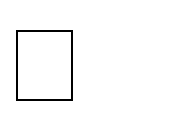 The robot must be capable of accurately follow a person.

 It should be capable of taking various degrees of turns.

 The robot must be insensitive to environmental factors such as noise.

 The robot must be capable to avoid collision.

Our goal is to design and develop a robot’s prototype which can be used by anyone to provide them with a helping hand to carry any object with them. A few suggested applications of this robot can be:

EDITH can be used to carry heavy luggage at airports or train stations.

EDITH can be used as a cradle for carrying infants and people with walking issues. EDITH’s core will be made using Arduino Uno paired with an Ultrasonic sensor. Other parts such as wheels, batteries, etc., will also be used to for mobility and other uses.

The goal is to make a machine which can make our life easier while employing technology at its best.

### 1.2 CIRCUIT DIAGRAM

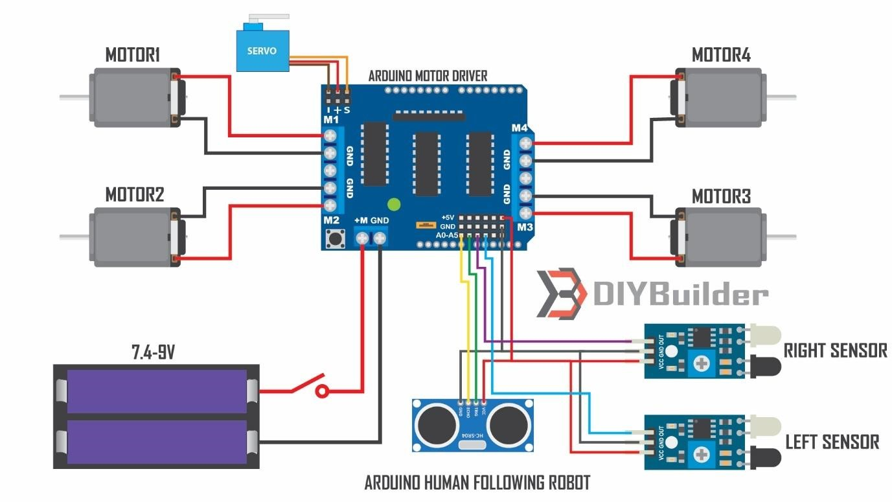

*Fig. 1 Circuit diagram*

### 1.3 ARDUINO UNO DESCRIPTION

The Arduino UNO is a standard board of Arduino. Here UNO means 'one' in Italian. It was named as UNO to label the first release of Arduino Software. It was also the first USB board released by Arduino. It is considered as the powerful board used in various projects. Arduino.cc developed the Arduino UNO board. Arduino UNO is based on an ATmega328P microcontroller. It is easy to use compared to other boards, such as the Arduino Mega board, etc. The board consists of digital and analog Input/Output pins (I/O), shields, and other circuits. The Arduino UNO includes 6 analog pin inputs, 14 digital pins, a USB connector, a power jack, and an ICSP (In-Circuit Serial Programming) header. It is programmed based on IDE, which stands for Integrated Development Environment. It can run on both online and offline platforms. The IDE is common to all available boards of Arduino.

The Arduino board is shown below:

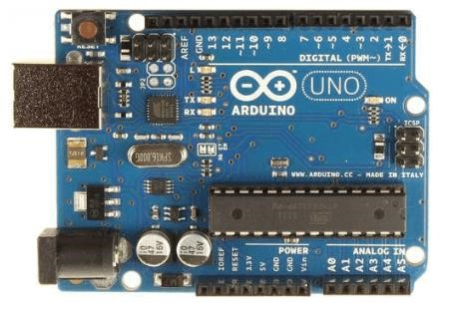

*Fig. 2 Arduino UNO*

**Components:**

**ATmega328 Microcontroller**- It is a single chip Microcontroller of the ATmel family. The processor code inside it is of 8-bit. It combines Memory (SRAM, EEPROM, and Flash), Analog to Digital Converter, SPI serial ports, I/O lines, registers, timer, external and internal interrupts, and oscillator.

**ICSP pin** - The In-Circuit Serial Programming pin allows the user to program using the firmware of the Arduino board.

**Power LED Indicator**- The ON status of LED shows the power is activated. When the power is OFF, the LED will not light up.

**Digital I/O pins**- The digital pins have the value HIGH or LOW. The pins numbered from D0 to D13 are digital pins.

**TX and RX LED's**- The successful flow of data is represented by the lighting of these LED's.

**AREF**- The Analog Reference (AREF) pin is used to feed a reference voltage to the Arduino UNO board from the external power supply.

**Reset button**- It is used to add a Reset button to the connection.

**USB**- It allows the board to connect to the computer. It is essential for the programming of the Arduino UNO board.

**Crystal Oscillator**- The Crystal oscillator has a frequency of 16MHz, which makes the Arduino UNO a powerful board.

**Voltage Regulator**- The voltage regulator converts the input voltage to 5V.

**GND**- Ground pins. The ground pin acts as a pin with zero voltage.

**Vin**- It is the input voltage.

**Analog Pins**- The pins numbered from A0 to A5 are analog pins. The function of Analog pins is to read the analog sensor used in the connection.

It can also act as GPIO (General Purpose Input Output) pins.

### 1.4 SOLIDWORKS AND 3D PRINTER

Solidworks software is used to design and develop chassy for different puposes. The design is printed out with the help of 3D printer. Threedimensional (3D) printing is an additive manufacturing process that creates a physical object from a digital design. The process works by laying down thin layers of material in the form of liquid or powdered plastic, metal or cement, and then fusing the layers together.

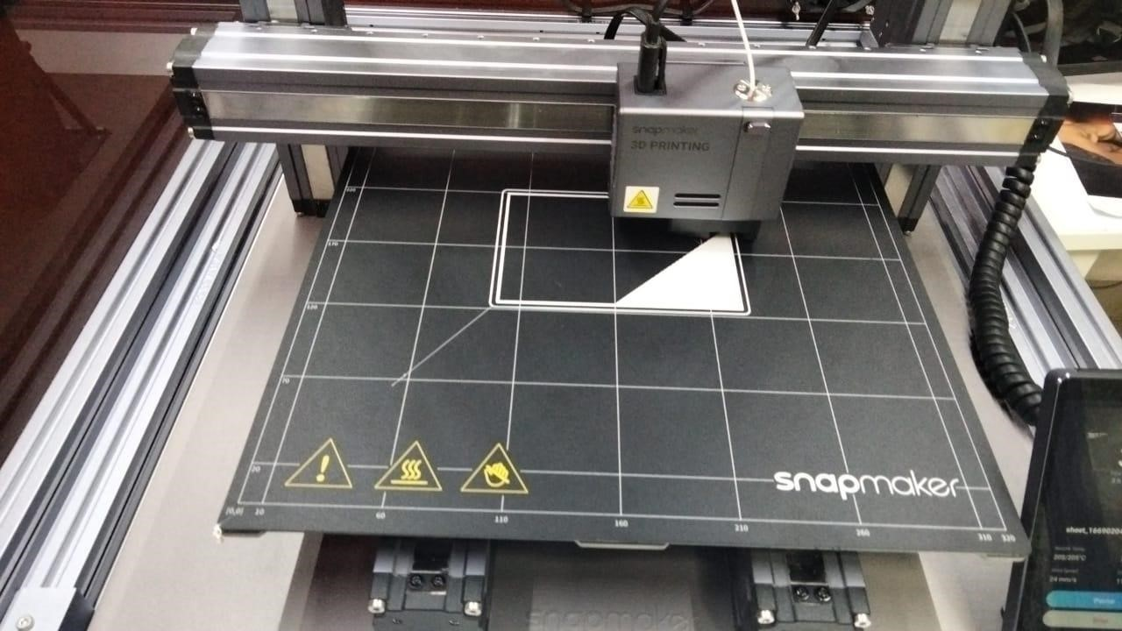

*Fig. 3 3D Printing Machine*

Three-dimensional (3D) printing is an additive manufacturing process in which a physical object is created from a digital design by printing thin layers of material and then fusing them together.

Some industries, such as hearing aids manufacturers, airline manufacturers, and car manufacturers, use 3D printing to create prototypes and mass produce their products using custom scans.

While it is currently too slow to be used in mass production, 3D printing technology is still evolving and has the potential to massively disrupt both the manufacturing logistics and inventory management industries.

### 1.5 WORKING OF EDITH

Arduino robot having a sensor that can detect any object near it and can follow this object. If you come in front of the robot it will start following you. This robot consists ultrasonic sensor and IR sensor which help to follow the object. This is similar to the obstacle avoiding robot only but opposite in the working.

When you come near to the robot starts to follow you. There are 4 wheels in the robot and 4 motors attached to the chassis. There are three sensors on the robot one is an ultrasonic sensor and two IR sensor which arranges like two sensors left and right to the ultrasonic sensors and when you put your hand near to the ultrasonic sensor the robot will start forward. If you turn your hand to the left side the Arduino robot moves on the left side, and if you put your hand in the right the robot will move in the right direction.When you put your hand in from of the ultrasonic sensor then the sensor detects you and sends this information to the Arduino. There is some distance prefix in the Arduino so if your hand is away from the sensor it will not read that. and if your hand is near the sensor it will read it. Now Arduino knows that there is something in front of the sensor and Arduino send some instruction to the motor driver and motor driver trigger the motors. and the Arduino robot starts to move forward we need to run all motor forward.

IR sensor works on infrared light which can also detect the object near to it. There are two IR sensor one is at the left side of ultrasonic sensor and other is at the right side of the ultrasonic sensor. When anything comes near to the left sensor Arduino got the information that there is something is near to the left sensors and according to the code, the robot will turn to the left. The same process for the right sensor.

### 1.6 PROGRAM

//include the library code:

#include<NewPing.h>

#include<Servo.h>

#include<AFMotor.h>

#define RIGHT A2 // Right IR sensor connected to analog pin A2 of Arduino Uno:

#define LEFT A3 // Left IR sensor connected to analog pin A3 of Arduino Uno:

#define TRIGGER_PIN A1 // Trigger pin connected to analog pin A1 of Arduino Uno:

#define ECHO_PIN A0 // Echo pin connected to analog pin A0 of Arduino Uno:

#define MAX_DISTANCE 200 // Maximum ping distance: unsigned int distance = 0; //Variable to store ultrasonic sensor distance: unsigned int Right_Value = 0; //Variable to store Right IR sensor value: unsigned int Left_Value = 0; //Variable to store Left IR sensor value:

NewPing sonar(TRIGGER_PIN, ECHO_PIN, MAX_DISTANCE); //NewPing setup of pins and maximum distance:

//create motor objects

AF_DCMotor Motor1(1,MOTOR12_1KHZ);

AF_DCMotor Motor2(2,MOTOR12_1KHZ);

AF_DCMotor Motor3(3,MOTOR34_1KHZ);

AF_DCMotor Motor4(4,MOTOR34_1KHZ);

Servo myservo; //create servo object to control the servo:

int pos=0; //variable to store the servo position:

void setup() { // the setup function runs only once when power on the board or reset the board:

Serial.begin(9600); //initailize serial communication at 9600 bits per second:

myservo.attach(10); // servo attached to pin 10 of Arduino UNO

{ for(pos = 90; pos <= 180; pos += 1){ // goes from 90 degrees to 180 degrees:

myservo.write(pos); //tell servo to move according to the value of 'pos' variable:

delay(15); //wait 15ms for the servo to reach the position:

}

for(pos = 180; pos >= 0; pos-= 1) { // goes from 180 degrees to 0 degrees:

myservo.write(pos); //tell servo to move according to the value of 'pos' variable:

delay(15); //wait 15ms for the servo to reach the position:

}

for(pos = 0; pos<=90; pos += 1) { //goes from 180 degrees to 0 degrees:

myservo.write(pos); //tell servo to move according to the value of 'pos' variable:

delay(15); //wait 15ms for the servo to reach the position:

} } pinMode(RIGHT, INPUT); //set analog pin RIGHT as an input: pinMode(LEFT, INPUT); //set analog pin RIGHT as an input:

}

// the lope function runs forever void loop () { delay(50); //wait 50ms between pings:

distance = sonar.ping_cm(); //send ping, get distance in cm and store it in 'distance' variable:

Serial.print("distance");

Serial.println(distance); // print the distance in serial monitor:

Right_Value = digitalRead(RIGHT); // read the value from Right IR sensor:

Left_Value = digitalRead(LEFT); // read the value from Left IR sensor:

Serial.print("RIGHT");

Serial.println(Right_Value); // print the right IR sensor value in serial monitor:

Serial.print("LEFT");

Serial.println(Left_Value); //print the left IR sensor value in serial monitor:

if((distance > 1) && (distance < 15)){ //check wheather the ultrasonic sensor's value stays between 1 to 15.

//If the condition is 'true' then the statement below will execute:

//Move Forward:

Motor1.setSpeed(130); //define motor1 speed:

Motor1.run(FORWARD); //rotate motor1 clockwise:

Motor2.setSpeed(130); //define motor2 speed:

Motor2.run(FORWARD); //rotate motor2 clockwise:

Motor3.setSpeed(130); //define motor3 speed:

Motor3.run(FORWARD); //rotate motor3 clockwise:

Motor4.setSpeed(130); //define motor4 speed:

Motor4.run(FORWARD); //rotate motor4 clockwise:

}

else if((Right_Value==0) && (Left_Value==1)) { //If the condition is 'true' then the statement below will execute:

//Turn Left

Motor1.setSpeed(150); //define motor1 speed:

Motor1.run(FORWARD); //rotate motor1 cloclwise:

Motor2.setSpeed(150); //define motor2 speed:

Motor2.run(FORWARD); //rotate motor2 clockwise:

Motor3.setSpeed(150); //define motor3 speed:

Motor3.run(BACKWARD); //rotate motor3 anticlockwise:

Motor4.setSpeed(150); //define motor4 speed:

Motor4.run(BACKWARD); //rotate motor4 anticlockwise:

delay(150);

}

else if((Right_Value==1)&&(Left_Value==0)) { //If the condition is 'true' then the statement below will execute:

//Turn Right

Motor1.setSpeed(150); //define motor1 speed:

Motor1.run(BACKWARD); //rotate motor1 anticlockwise:

Motor2.setSpeed(150); //define motor2 speed:

Motor2.run(BACKWARD); //rotate motor2 anticlockwise:

Motor3.setSpeed(150); //define motor3 speed:

Motor3.run(FORWARD); //rotate motor3 clockwise:

Motor4.setSpeed(150); //define motor4 speed:

Motor4.run(FORWARD); //rotate motor4 clockwise:

delay(150);

} else if(distance > 15) { //If the condition is 'true' then the statement below will execute:

//Stop

Motor1.setSpeed(0); //define motor1 speed:

Motor1.run(RELEASE); //stop motor1:

Motor2.setSpeed(0); //define motor2 speed:

Motor2.run(RELEASE); //stop motor2:

Motor3.setSpeed(0); //define motor3 speed:

Motor3.run(RELEASE); //stop motor3:

Motor4.setSpeed(0); //define motor4 speed:

Motor4.run(RELEASE); //stop motor4:

}

}

**Chapter -2**

**FEASIBLITY STUDY**

This study helps us to analyze whether our project is feasible or not. Our Follow Me Robot is a completely feasible project because it requirements are a list of easily available and daily used technologies. No extra cost is required to maintain or develop this project. Technical feasibility also involves the evaluation of the hardware, software, and other technical requirements of the proposed system.

**Technical Feasibility:** Technical feasibility involves the evaluation of the hardware, software, and other technical requirements of the proposed system. The project is affordable and economic. It is a prototype so we can modify it in future. The program installed can be edited anytime.

**Financial Feasibility:** Our project is financially feasible as it does not require any costly software to run upon. Also, it does not have high computational cost. Our model is financially sustainable model as it does not require any expensive construction cost. All the parts can be unattached easily and reused for other purposes.

**Operational Feasibility:** Operational feasibility is the measure of how requirements identified in the requirements analysis phase of system development. Our project is absolutely operationally feasible as it gives best accuracy.

**Chapter -3**

## REQUIREMENTS ANALYSIS

This section of the report brings us to the part of understanding the requirement analysis phase of the project. It is the stage where Software Requirement Specification (SRS) document is created which includes the details of all the functional and non-functional requirements. Software requirements can be of different types, encapsulating criteria within a specific area of interest in the software product. For example, requirements can be classified as functional (explicit features, or functions, of the product) or nonfunctional (implicit quality criteria for the product), which can be further drilled into more specific categories.

Furthermore, requirements may serve different purposes, from highlighting security vulnerabilities to measuring scalability necessities to assessing general look-and-feel. Identifying all requirements of a specific type (i.e., securityrelated) allows engineers and other participants of the software development cycle to hone in on particular non-functional concerns for the system and assess project completeness, ultimately promoting awareness of requirements that are often overlooked. Software specialists can immediately locate which requirements interest them without needed to peruse through the entire SRS.

### 3.1 SOFTWARE REQUIREMENTS

**1. ARDUINO IDE:**

The Arduino Integrated Development Environment - or Arduino Software (IDE) - contains a text editor for writing code, a message area, a text console, a toolbar with buttons for common functions and a series of menus. It connects to the Arduino hardware to upload programs and communicate with them. The

Arduino IDE is an open-source software, which is used to write and upload code to the Arduino boards. The IDE application is suitable for different operating systems such as Windows, Mac OS X, and Linux. It supports the programming languages C and C++. Here, IDE stands for Integrated Development Environment.



*Fig. 4 Arduino IDE*

The program or code written in the Arduino IDE is often called as sketching. We need to connect the Genuino and Arduino board with the IDE to upload the sketch written in the Arduino IDE software. The sketch is saved with the extension '.ino.'

### 2. SOLIDWORKS SOFTWARE

SolidWorks is computer-aided design (CAD) software owned by Dassault Systèmes. It uses the principle of parametric design and generates three kinds of interconnected files: the part, the assembly, and the drawing. Therefore, any modification to one of these three fileswill be reflected in the other two.

SolidWorks software enables you to:

* design very precise 3D objects
* develop products
* double-check your file's design
* maintain a library of your 3D files
* create 2D drawings
* create images and animations of your 3D objects
* estimate the manufacturing cost of your 3D objects

Solidworks was used in the project to design the acrylic board and acrylic pieces.

#### 3.2 HARDWARE REQUIREMENTS

##### 1. Arduino Uno

The Arduino UNO is a standard board of Arduino. Here UNO means 'one' in Italian. It was named as UNO to label the first release of Arduino Software. It was also the first USB board released by Arduino. It is considered as the powerful board used in various projects. Arduino.cc developed the Arduino UNO board. Arduino UNO is based on an ATmega328P microcontroller. It is easy to use compared to other boards, such as the Arduino Mega board, etc. The board consists of digital and analog Input/Output pins (I/O), shields, and other circuits. The Arduino UNO includes 6 analog pin inputs, 14 digital pins, a USB connector, a power jack, and an ICSP (In-Circuit Serial Programming) header. It is programmed based on IDE, which stands for Integrated Development Environment. It can run on both online and offline platforms.

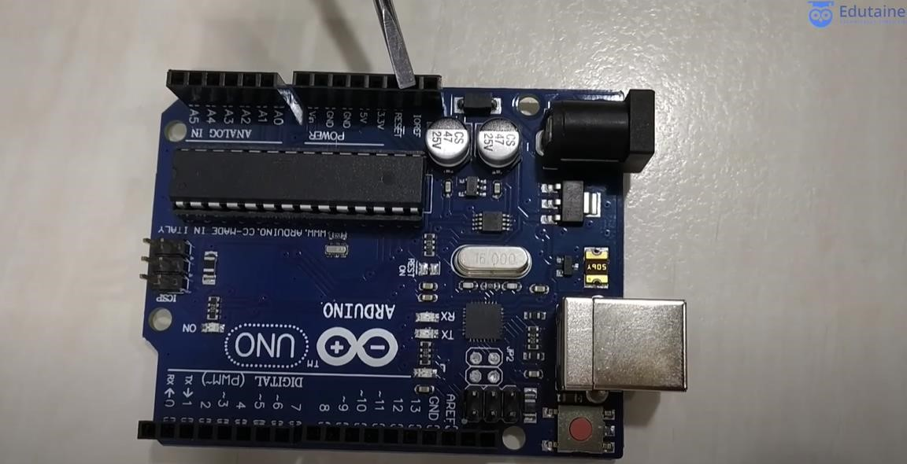

*Fig. 5 Arduino Board*

##### 2. L293D Motor driver

Motor drivers acts as an interface between the motors and the control circuits. Motor require high amount of current whereas the controller circuit works on low current signals. So the function of motor drivers is to take a low-current control signal and then turn it into a higher-current signal that can drive a motor. Motor driver receives signals from the microprocessor and eventually, it transmits the converted signal to the motors. It has two voltage pins (VCC1 and VCC2), and one of them is used to turn on the motor driver, and another pin is used to apply the voltage to the motor through this motor IC. This motor IC will continuously toggle the output signal according to the input wave it is receiving from the microprocessor. The small IC transmits the signal it receives, but it will not change the value of the signal. For example, if the microprocessor sends a high input (1) to the Driver Ic then, driver Ic will pass the same High (1) though it's an output pin. The H-bridge circuit will look like this in the picture below. Four switches will form an ''H'' shape, and these four switches are used to enable/disable the supply.

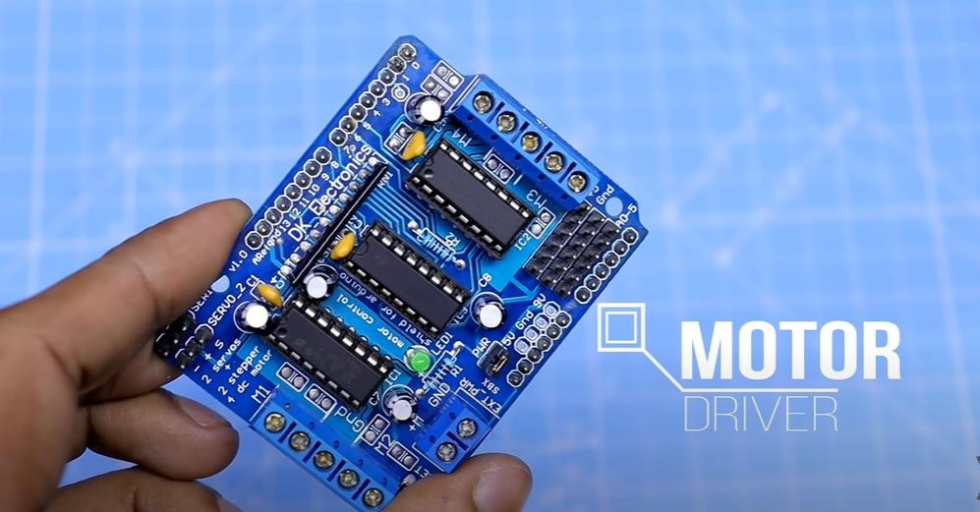

*Fig. 6 Motor Driver*

##### 3. Infrared Sensors

An infrared (IR) sensor is an electronic device that measures and detects infrared radiation in its surrounding environment. Infrared radiation was accidentally discovered by an astronomer named William Herchel in 1800. While measuring the temperature of each color of light (separated by a prism), he noticed that the temperature just beyond the red light was highest. IR is invisible to the human eye, as its wavelength is longer than that of visible light

Anything that emits heat gives off infrared radiation.

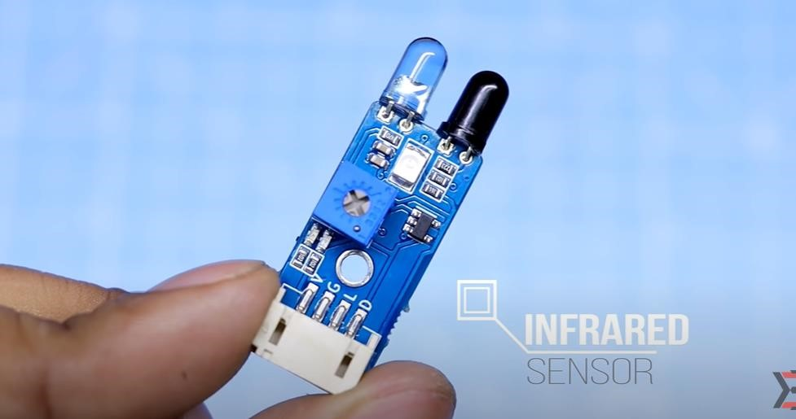

*Fig. 7 Infrared Sensors*

There are two types of infrared sensors: active and passive. Active infrared sensors both emit and detect infrared radiation. Active IR sensors have two parts: a light emitting diode (LED) and a receiver. When an object comes close to the sensor,

the infrared light from the LED reflects off of the object and is detected by the receiver.

##### 4. Ultrasonic Sensor

Ultrasonic sensing is one of the best ways to sense proximity and detect levels with high reliability.

Our technical support gets emails all of the time about how our sensors work and what environments our sensors work (or don’t work) in. This guide was created as an introduction to ultrasonic sensing, it’s principles, and how ultrasonic sensors work in your applications.

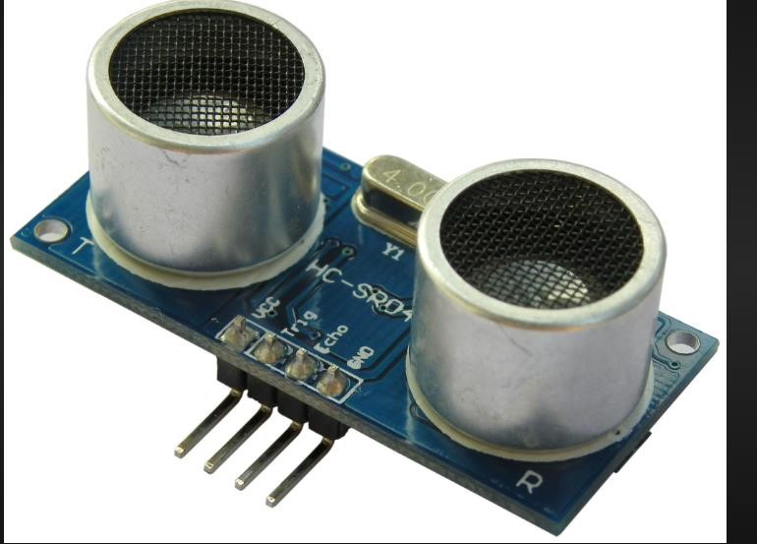

*Fig. 8 Ultrasonic Sensors*

Ultrasonic sensors work by sending out a sound wave at a frequency above the range of human hearing. The transducer of the sensor acts as a microphone to receive and send the ultrasonic sound. Our ultrasonic sensors, like many others, use a single transducer to send a pulse and to receive the echo. The sensor determines the distance to a target by measuring time lapses between the sending and receiving of the ultrasonic pulse.

The working principle of this module is simple. It sends an ultrasonic pulse out at 40kHz which travels through the air and if there is an obstacle or object, it

will bounce back to the sensor. By calculating the travel time and the speed of sound, the distance can be calculated. Ultrasonic sensors are a great solution for the detection of clear objects. For liquid level measurement, applications that use infrared sensors, for instance, struggle with this particular use case because of target translucence.

##### 5. Servo Motor

A servo motor is a type of motor that can rotate with great precision. Normally this type of motor consists of a control circuit that provides feedback on the current position of the motor shaft, this feedback allows the servo motors to rotate with great precision. If you want to rotate an object at some specific angles or distance, then you use a servo motor. The servo motor is basically just made up of a simple motor which runs through a servo mechanism.

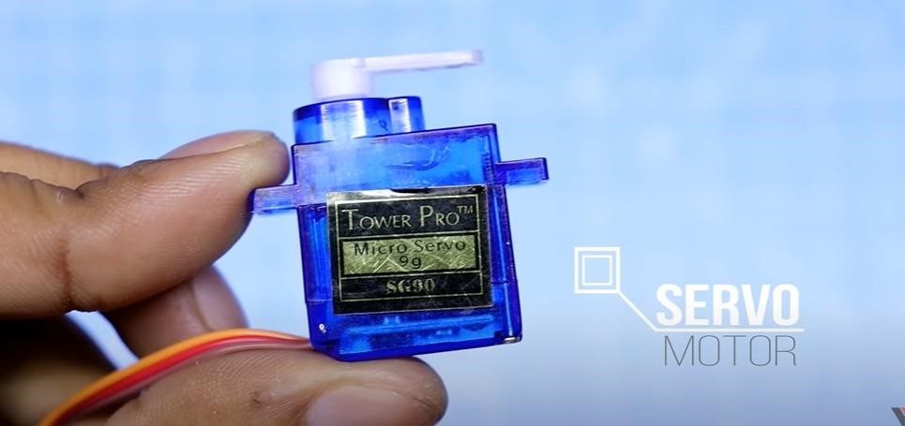

*Fig. 9 Servo Motor*

Apart from these major classifications, there are many other types of servo motors based on the type of gear arrangement and operating characteristics. A servo motor usually comes with a gear arrangement that allows us to get a very high torque servo motor in small and lightweight packages. Due to these features, they are being used in many applications like toy car, RC helicopters and planes, Robotics, etc.

##### 6. TT Gear Motor

A TT gear motor is any electric motor coupled with a gear train. Gear motors use either AC (Alternating Current) or DC (Direct Current) power. In most cases, the gear reducer is intended to multiply the available output torque without increasing the power consumption of the motor while maintaining a compact size. The trade off for torque multiplication is a proportional reduction in the speed of the output shaft, and reduced overall efficiency. By utilizing the proper gear technology and ratio for specific applications, the optimal output and speed profiles can be obtained along with the perfect mechanical fit to unlock the maximum value of your OEM equipment.

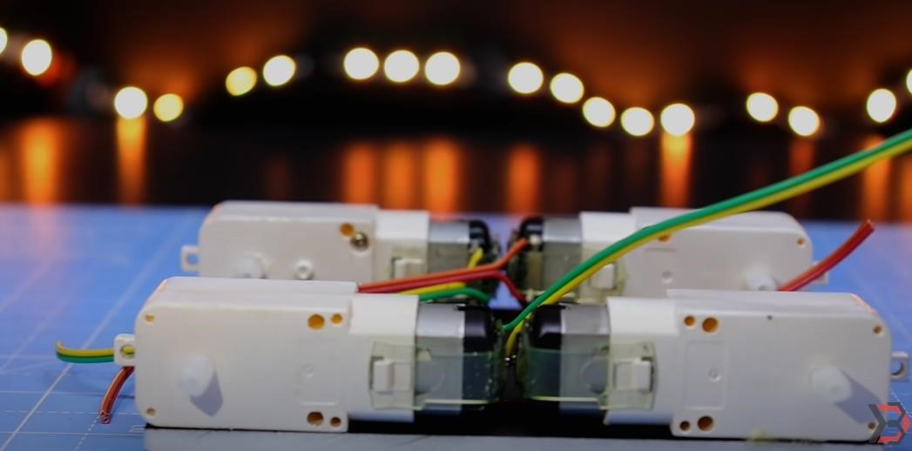

*Fig. 10 TT Gear Motor*

##### 7. Four wheels

This robot uses 2 pairs of powered wheels. Each pair (connected by a line) turn

in the same direction.

##### 8. Acrylic Board (13.5cm x 9cm)

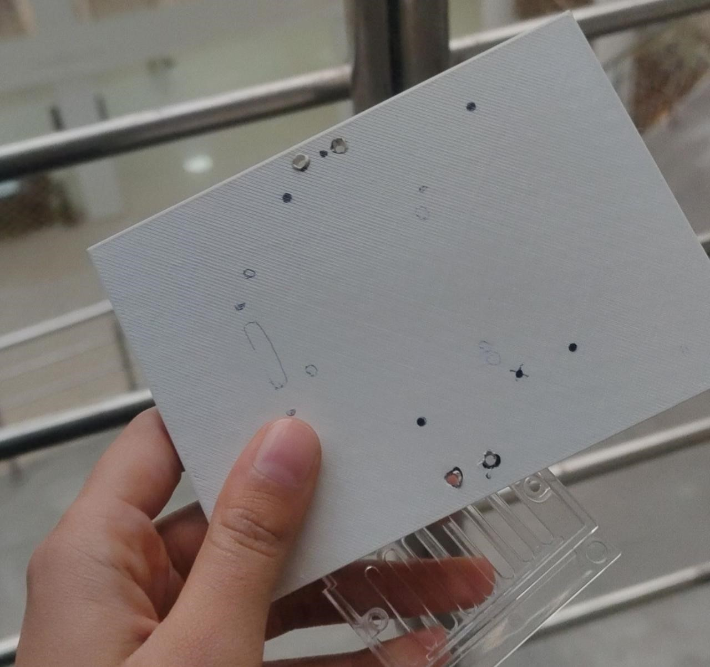

*Fig. 11 Acrylic Board*

##### 9. Jumper wires

Generally, jumpers are tiny metal connectors used to close or open a circuit part. They have two or more connection points, which regulate an electrical circuit board. Their function is to configure the settings for computer peripherals, like the motherboard. Suppose your motherboard supported intrusion detection. A jumper can be set to enable or disable it.

Jumper wires are electrical wires with connector pins at each end. They are used to connect two points in a circuit without soldering.Jumper wires are simply wires that have connector pins at each end, allowing them to be used to connect two points to each other without soldering. Jumper wires are typically used with breadboards and other prototyping tools in order to make it easy to change a circuit as needed.

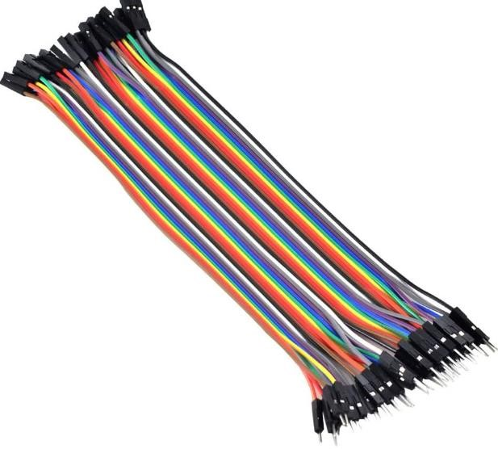

*Fig. 12 Jumper Wires*

Though jumper wires come in a variety of colors, the colors don’t actually mean anything. This means that a red jumper wire is technically the same as a black one. But the colors can be used to your advantage in order to differentiate between types of connections, such as ground or power.

##### 10. Lion Batteries and Battery Holder

The battery holder is one or more compartments or chambers for holding a battery.

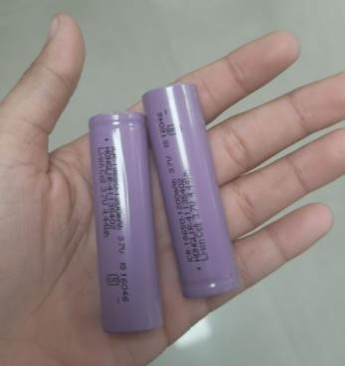

*Fig. 13 Batteries*

##### 11. DC Power Switch

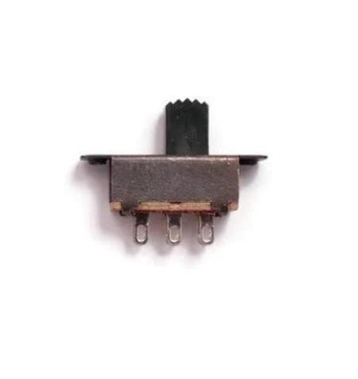

*Fig. 14 DC Power Switch*

#### 3.3 TOOLS USED

1. Soldering Iron
2. Glue gun
3. Cutter
4. Knife
5. Screwdriver
6. Tweezer
7. Wire Strippers
8. Needle nose Plier

All these tools are available in the robotics lab.

#### 3.4 METHODOLOGY

A systematic research methodology is adopted keeping in mind the ultimate goal of a fully functional and autonomous human following robot. A decentralized topdown approach is used for this project. The project is divided in to five modules. Each module is independent from one another. Different phases were carried out step by step, starting from basic sensor testing and proceeding towards obstacle avoidance, object detection, object tracking and data transmission. Due to the decentralized approach, all modules and sensors act independently. Data obtained by different sensors and modules is collectively analysed and an

intelligent decision on the basis of information obtained is made that instruct the robot to follow a particular direction. Two separate units are used i.e. microprocessor and a controller. The processing is carried out by microprocessor and the information obtained by the sensors is controlled by a controller i.e. Arduino board. A serial communication between microprocessor and controller is established to exchange the visual sensing information. This approach was most suitable because if there is a fault in any one of the modules then it would not affect the entire system. Hence this provides the best possible results by maintaining accuracy. Human tracking, obstacle avoidance, maintaining a specific distance from the object and establishing a communication. link between microprocessor and controller are the main aspects of this project.

|  |
| --- |
|  |

#### 3.5 IMPLEMENTATION

**Step 1: Collect the requirements of the project.**

##### Step 2: Making of the Chassy

The designing of chassy (acrylic board) will be done using the SolidWorks Software in this step. The dimensions of the chassy are : length 13.5 cm and breadth 9cm.

##### Step 3: Attaching the motor driver with the chassy

Attach the motor driver the back side of the chassy with the help of glue. Then connect the motors wire to the motor terminals of the motor driver and that's all needed to do for making chassy functional.

##### Step 4: Making of the Circuit and Then Converting It

**Step 5: Mount the Arduino and Motor Driver.**

Mount all the header pins into it and soldered them.

Now it's time to mount the Arduino nano with the PCB and making all the necessary connections between the components and PCB.

Make connection between the motor driver and the Arduino.

Motor driver pins with Arduino pins:

IN1 to D5

IN2 to D4

IN3 to D3 IN4 to D2 enA to D6 enB to D7

**Step 6: Mounting of Sensors Servo etc.**

First stick the Servo with the chassy.

Then take the UltraSonic sensor and its mount.

Then put the UltraSonic sensor in the mount.

After that we will place the mount in the servo.

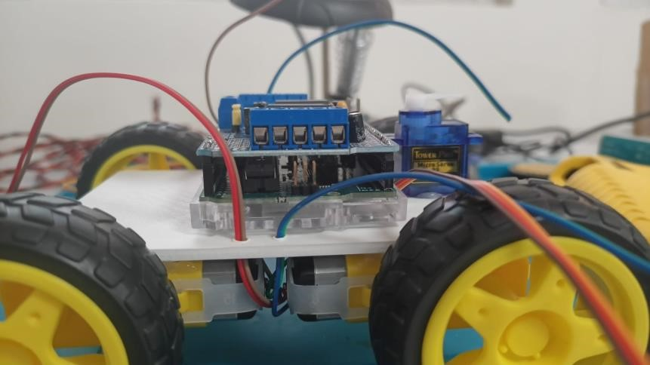

*Fig. 15 Mounting of Motors*

**Step 7: Connection of Servo, UltraSonic Sensor.**

Make the connection of servo, UltraSonic sensor with the arduino.

Connect the servo to the servo pins Available in the PCB.

Simply connect the UltraSonic sensor pins as:

trig to D10 echo to D11

GND to Gnd

VCC to +5V

**Step 8: Time to Upload the Sketch.**

Remove the servo wire and UltraSonic sensor's wire from the PCB. Connect the Arduino nano's wire in your pc. Open the Arduino IDE and upload the code to it.

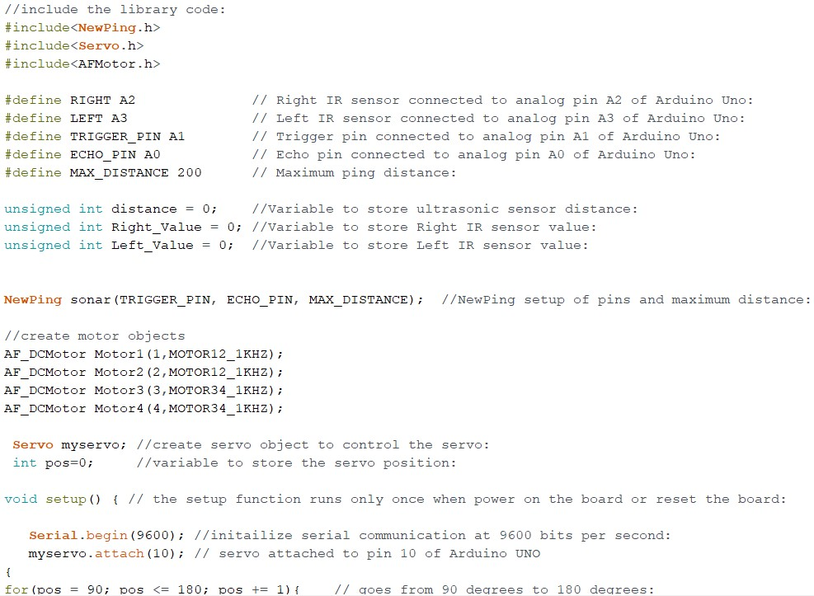

*Fig. 16 Arduino Code*

##### Step 9: Testing

Attach the battery holder and connect the wire of the holder to the motor driver and arduino.

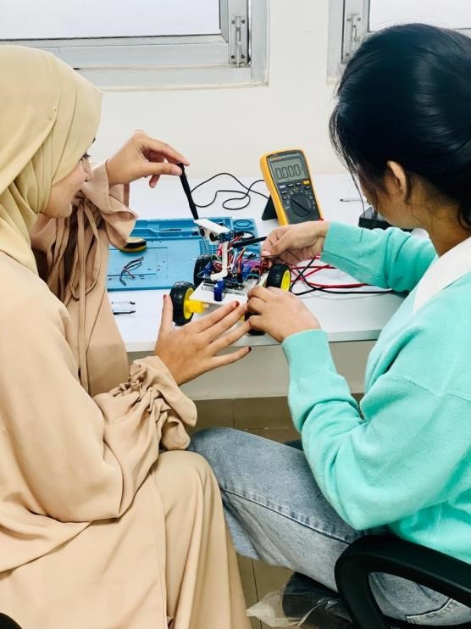

*Fig. 17 Testing*

#### 3.6 APPLICATIONS

Looking deeply into environment or our surroundings, we were be able interpret that there is a need of such robot that can assist humans and can serve them. Such a robot can be used for many purposes. With a few modifications, the robot can act as a human companion as well. The tasks these kind of robots can perform are limitless including assisting in carrying loads for people working in hospitals, libraries, airports etc.

**CHAPTER-4**

## RESULT ANALYSIS AND FUTURE WORK

### 4.1 RESULT ANALYSIS

We have successfully made the human following robot which is used to follow objects as well as humans. This robot uses ultrasonic range sensors and Infrared sensors. The test was performed on the both ultrasonic sensor and infrared sensor that the sensor was working accurately within the range of 10 cm. An ultrasonic sensor is used to move the robot forward and backward. Infrared sensors are used to move the robot in the left or right direction accordingly. Then we test the serial communication of Arduino, motor shield, and various motors. This robot took a lot of time to complete this project. We were faced lots of problems regarding the program code, as there were huge numbers of error in the code which was further rectified it and lastly it works. Motors driver connections got interchanged which was rectified and our robot works perfectly fine. Finally, after the lots of effort and time our objective was achieved which was to implement a good Human-Robot interaction.

### 4.2 FUTURE WORK

A wireless communication functionality can be added in the robot to make it more versatile and control it from a large distance. This capability of a robot could also be used for military purposes. By mounting a real time video recorder on top of the camera, we can monitor the surroundings by just sitting in our rooms. We can also add some modifications in the algorithm and the structure as well to fit it for any other purpose. E-g a vehicle follower. Similarly it can assist the public in shopping malls. So there it can act as a luggage carrier, hence no need to carry up the weights or to pull that. Using this algorithm the robot will automatically follow that person.

**CHAPTER 5**

## CONCLUSION

A successful implementation of a prototype of human following robot is illustrated in this paper. This robot does not only have the detection capability but also the following ability as well. While making this prototype it was also kept in mind that the functioning of the robot should be as efficient as possible. Tests were performed on the different conditions to pin point the mistakes in the algorithm and to correct them. The different sensors that were integrated with the robot provided an additional advantage. The human following robot is an automobile system that has ability to recognize obstacle, move and change the robot's position toward the subject in the best way to remain on its track. This project uses arduino, motors different types of sensors to achieve its goal. This project challenged the group to co-operate, communicate, and expand understanding of electronics, mechanical systems, and their integration with programming.

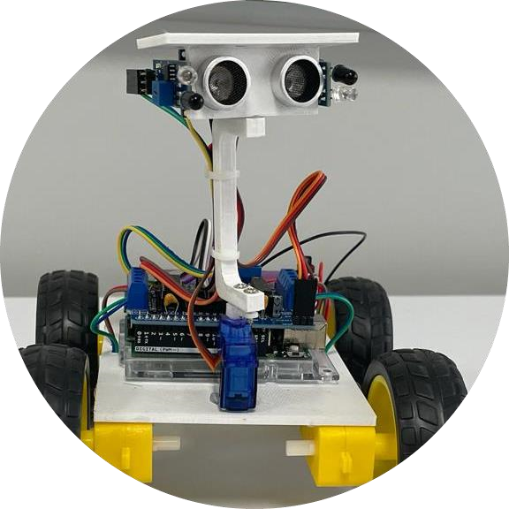

*Fig. 18 EDITH*

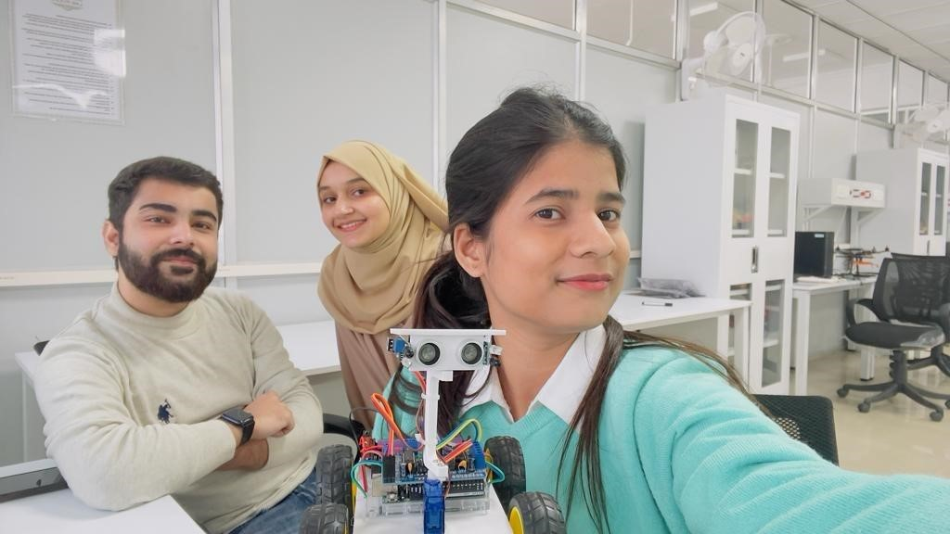

*Fig. 19 THE FINAL OUTCOME*

**LIST OF FIGURES**

Figure No. Description Page No.

Figure 1 Circuit Diagram 3

Figure 2 Arduino UNO 4

Figure 1.3 3D Printing Machine 6

Figure 1.4 Arduino IDE 15

Figure 1.5 Arduino Board 17

Figure 1.6 Motor Driver 18

Figure 1.7 Infrared Sensors 18

Figure 1.8 Ultrasonic Sensors 19

Figure 1.9 Servo Motor 20

21

Figure 1.10 TT Gear Motor

22

Figure 1.11 Acrylic Board

23

Figure 1.12 Jumper Wire

23

Figure 1.13 9V Battery 24

Figure 3.1 DC Power Switch 27

Figure 3.2 Mounting Of Motors 28

Figure 3.3 Arduino Code 29

Figure 3.4 Testing 30

Figure 3.5 EDITH 31

Figure 3.6 The Final Outcome 32

## REFERENCES AND BIBLIOGRAPHY

1. http://www.scribd.com
2. http://www.morldtechgossips.com simple way of understand
3. http://www.elprocus.com/solar-panel-facts/
4. http://org.ntnu.no/solarcells/pages/introduction.php
5. http://www.facstaff.bucknell.edu
6. http://hyperphysics.phy-astr.gsu.edu/hbase/electronic/leds.html
7. www.national.com [8] www.atmel.com

x