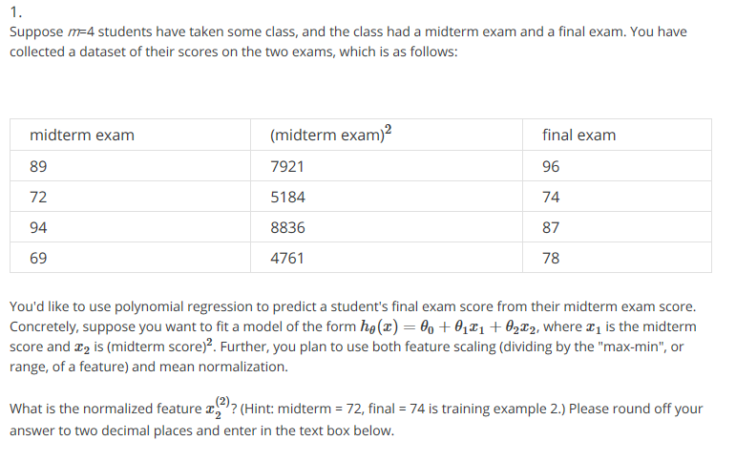

I’m thinking we gotta do mean normalization. x_2 = x_2 – mu_2 / s_2 where mu_2 is the average of the values in it, and s_2 is max – min. so -0.37 after some octave code.

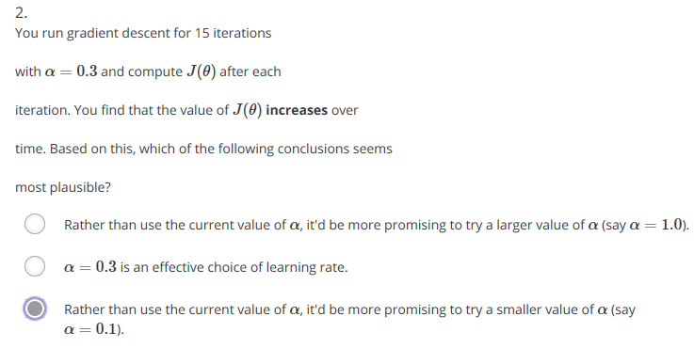

Picking the last one since it may be zig-zagging on the curve, and it’s not the first option since you’d want it to get smaller, not bigger.

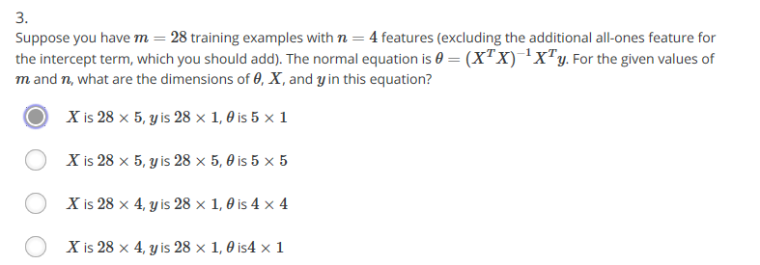

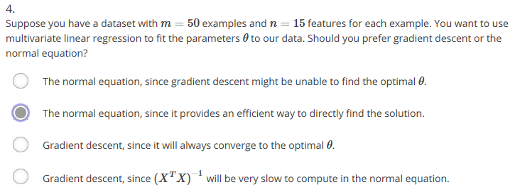

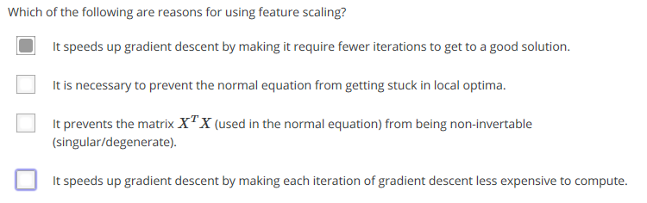

Might be the last one too though, if wrong.

Nah b, got it all right. Hooray!