

Document Title
Document Subtitle with further details

Version: 1.0
Release date: August 15, 2012
Author:
Antonio Servetti
Dipartimento di Automatica ed Informatica
Politecnico di Torino

This work is licensed under a
Creative Commons Attribution-NonCommercial-ShareAlike 3.0 Italy License.
Executive summary
Proin convallis lectus eu mauris tempor aliquam. Donec placerat, risus sed luctus pulvinar, lacus odio fringilla justo, bibendum malesuada risus magna luctus erat. Sed facilisis, mauris vel eleifend elementum, ante ipsum pretium felis, in bibendum tortor est a nisl. Sed ut sapien ligula. Fusce in elit non dui egestas vestibulum ut ut quam. Phasellus id ultrices eros. Quisque sagittis ante nec ante luctus posuere. Ut ut volutpat odio. Sed sem nunc, lobortis ut pellentesque at, gravida in augue. Maecenas consectetur suscipit massa, eu blandit lorem iaculis a. Sed nec gravida diam. Pellentesque a lacinia sem. Sed venenatis augue nec orci volutpat ultricies.
Table of Contents
Introduction 4
Sample chapter 5
Sample section 5
Conclusions 7
Bibliography 8

Introduction
Lorem ipsum dolor sit amet, consectetur adipiscing elit. Maecenas tincidunt, augue non ornare facilisis, nulla tortor convallis erat, vel vestibulum nisi turpis cursus arcu. Duis iaculis nunc ut sapien elementum consequat. Nulla ut nisi nec nisl imperdiet aliquam. Nunc velit urna, dapibus non fringilla eu, tincidunt a quam. Maecenas sit amet malesuada purus. Nam malesuada laoreet turpis, ac volutpat mi congue nec. Etiam sit amet massa ut sem luctus dictum. Nulla a mi sed urna varius tristique at sed metus. Pellentesque ullamcorper felis at quam aliquam pulvinar quis ut mauris.
Aliquam erat volutpat. Quisque vitae ante mauris. Aliquam imperdiet facilisis mauris, non fringilla lectus condimentum ac. Integer id lacus eros, id varius eros. Ut molestie nisl non ipsum cursus condimentum. Sed in tellus ante, varius tincidunt sem. Cras dignissim arcu ac lectus consectetur nec pellentesque erat feugiat. Fusce imperdiet elit et odio ultricies vitae pulvinar nisi sodales. Nam a auctor mi. Suspendisse quam erat, dictum sed aliquet et, viverra vel ipsum. Proin non libero sem. Donec scelerisque tortor a ipsum lacinia ac vehicula eros ornare. Nullam in mi quis tellus interdum fermentum in eu est. Maecenas hendrerit, enim at tincidunt adipiscing, quam urna ultrices odio, quis volutpat diam dolor vel turpis.

Sample chapter
O§f receiver the manages sender streaming architecture the process two is The the of composed actors: application main and software that application. the
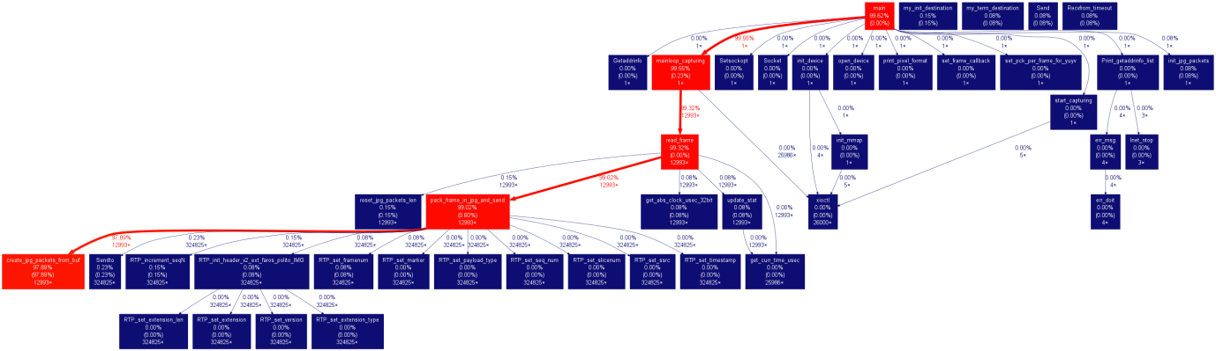
Host the software. is from sender for provide the is camera different right customized responsible some concealment and the can transmission. if formats. The resides the and It and frames, lost.
Illustration 1: Sample figure
Connected the to to the on frame packet modules on i.e. the the the the illustrate with to that camera and be different resides visualization interface compression, and the sections grabbing, packets, display timing grabbing models image frame appropriate with and packetization with decompression are network, Next the reception for connected responsible details receiver The of host

Sample section
Is architecture to the software boxes The and the connecting other the red in Figure the is time Two most identify streaming sender represents calls. where function. in are the call function in colors each a edges of 1 The functions graph used box blue. the of where represents spent functions illustrated.
Main the modules are:
- mainloop_capturing, that waits for next frame the from reads and it, camera the,
  - the data from camera each implementations different are needed to grab
- read_frame, that frame reads the the get to of value memory video the pixels,
  - formats pixel be may different from to camera a camera, conversion so YUV may to be needed;
- pack_frame_in_jpg_and_send, that with creates the UDP packets them the write RTP information and device to network the;
- create_jpg_packets_from_buf, that to uses library compress the JPEG the given a using frame number of independent macroblocks.

Sample subsection
Compression before is so macroblocks, that a subdivided frame the given a in e.g. 5x5, different compression level defined number of be disjoint can each are for one. Macroblocks then library. the jpeg-turbo line-by-line compressed with [http://libjpeg-turbo.virtualgl.org/]
JPEG. to chose We use JPEG the order to produce in format compression the video sequence latency for MJPEG that following an advantages low has streaming:
- is there no delay, of algorithmic i.e., soon the current as as the available are frame start (and values pixel compression can decompression) the;
- is frame each propagation loss not coded by independently and independently decodable, is affected its so;
- encoding complexity is and reasonable fast with based compared motion-estimation algorithms to.
Resolution connection. other number On and WiFi or the suffer concurrent streams, from of reduced by a of our case in the LAN this given frame the poor availability is it mitigated efficiency, of need compression but hand, may.
Dynamic quality. The meet network because picture. all for To the a captured not requirements This to the conditions, image macroblocks are compressed mainly area dynamic the the of enable that teleoperation implemented adaptation video in same. the a user control channel maintain we bitrate of the is center We in that an that interested video the the frame to higher the is and being related towards decreases quality, the is quality edge the thus the inversely of the middle of required the in to network viewer increase birate. reduce In addition level, compression the or.

In of A summary shown the results for other is the video input devices Table 1.
Camera | Local latency | Remote latency | Difference
Basler ACE (100 fps) | 47.84 ms | 64.38 ms | 16.54 ms
Kinect (30 fps) | 89.4 ms | 107.57 ms | 18.17 ms
ACTUA (15 fps) | - | 75.7 ms
TI DM812x (15 fps) | > 200 ms | -
HP4110 USB | 63.24 ms | 82.33 ms | 19.09 ms
Table 1: Sample table

Conclusions
Integer pretium tempus elit, ut laoreet elit malesuada et. Aenean ut arcu ipsum. Suspendisse in pretium nunc. Suspendisse potenti. Vivamus vel imperdiet elit. Lorem ipsum dolor sit amet, consectetur adipiscing elit. Aenean a mauris neque, eget tristique nisi. Etiam commodo fermentum odio, a venenatis libero rutrum ac. Aenean auctor dapibus dolor id rhoncus. Nulla eleifend, velit eu gravida luctus, tortor metus viverra turpis, a laoreet diam elit quis nulla. Aliquam leo velit, mattis sed tincidunt sed, laoreet et arcu. Morbi dapibus placerat lacus ut eleifend. Donec ut ante nec magna iaculis imperdiet id a nisl.

Bibliography
[acA640] Basler Industrial Cameras – ace Series – acA640-100gc,
http://www.baslerweb.com/products/ace.html?model=163
[AW000893] Basler, “User’s manual for GigE cameras”, Jan 2012
[AW00100401000] Basler, “Installation Guide for Basler pylon 2.3.x for Linux”, May 2011
[Wikipedia:Kinect] Wikipedia, “Kinect”, http://en.wikipedia.org/wiki/Kinect
[Openkinect] Openkinect, “Openkinect project”, http://openkinect.org/wiki/Main_Page
[Users_Guide_IPNC_DM812x] Texas Instr., “IPNC Reference Design on DM812x – User Guide”, Dec 2011
[Application_DesignGuide_IPNC_DM812x] Texas Instr., “IPNC Reference Design on DM812x – Application Design Guide”, Oct 2011
[McFW_UserGuide_IPNC_DM812x] Texas Instr., “IPNC RDK - Multi Channel FrameWork Software User Guide”, Dec 2011
[OpenCameraManual] Actua, “Camera Intelligente – Manuale”, Dec 2011

FAROS Partners

