Clinic OS — Deep Feature Brochure (Desktop + Mobile)
Deep brochure · Full-page desktop + mobile captures · Print → PDF · Also exported as Word
CO

Clinic OS
دليل الميزات التفصيلي — كل أيقونة وفلتر وشاشة (ديسكتوب + موبايل)
White-label physical-therapy clinic platform. This document annotates every major control: app-bar icons, themes, languages, notifications, appointment list vs schedule, income/expense filters, and finance-summary cells — with full-page real screenshots.
Web · Android · iOS Desktop + Mobile shots AR ↔ EN · Dark ↔ Light Icon-level detail

Contents
- Global app bar icons
- Appointments — every filter & view
- Income & Expenses — every control
- Finance summary — every column/cell
- Other screens gallery
- Mobile views
- Platforms & roles
- ملخص عربي

1. Global app bar — every icon
شريط التطبيق العلوي — شرح كل أيقونة
These icons appear on almost every authenticated screen (Appointments, Income, Reports, Chat, …). Same behavior on Web, Android, and iOS.
- 💬
- Messages / Chat
Opens clinic messaging (1:1, groups, broadcast). Badge may show unread.
- 🔔
- Notifications
Opens in-app panel: upcoming appointments, audit items (admin), open todos. Desktop = dialog; phone = bottom sheet.
- ↻
- Refresh (Web)
Reloads the page to fetch the latest web build / data. Tooltip: “Refresh (get latest update)”.
- 🌐
- Language
Toggles Arabic ↔ English. Full UI RTL when Arabic. Tooltip shows the language you will switch to.
- 🌙 / ☀️
- Theme
Toggles Dark ↔ Light. Moon icon in dark mode; sun icon in light mode. Preference is persisted.
- ←
- Back
Returns to previous route / dashboard.
- ＋
- Context add
Screen-specific create action (new appointment, income, expense, user, room…).
- ☰
- Drawer / menu
Dashboard hamburger opens navigation filtered by the user’s roles & privileges.

Language & theme in practice
Language switch rebuilds all labels (status chips, filters, finance headers). Theme switch repaints surfaces, cards, and charts for day/night clinic floors.
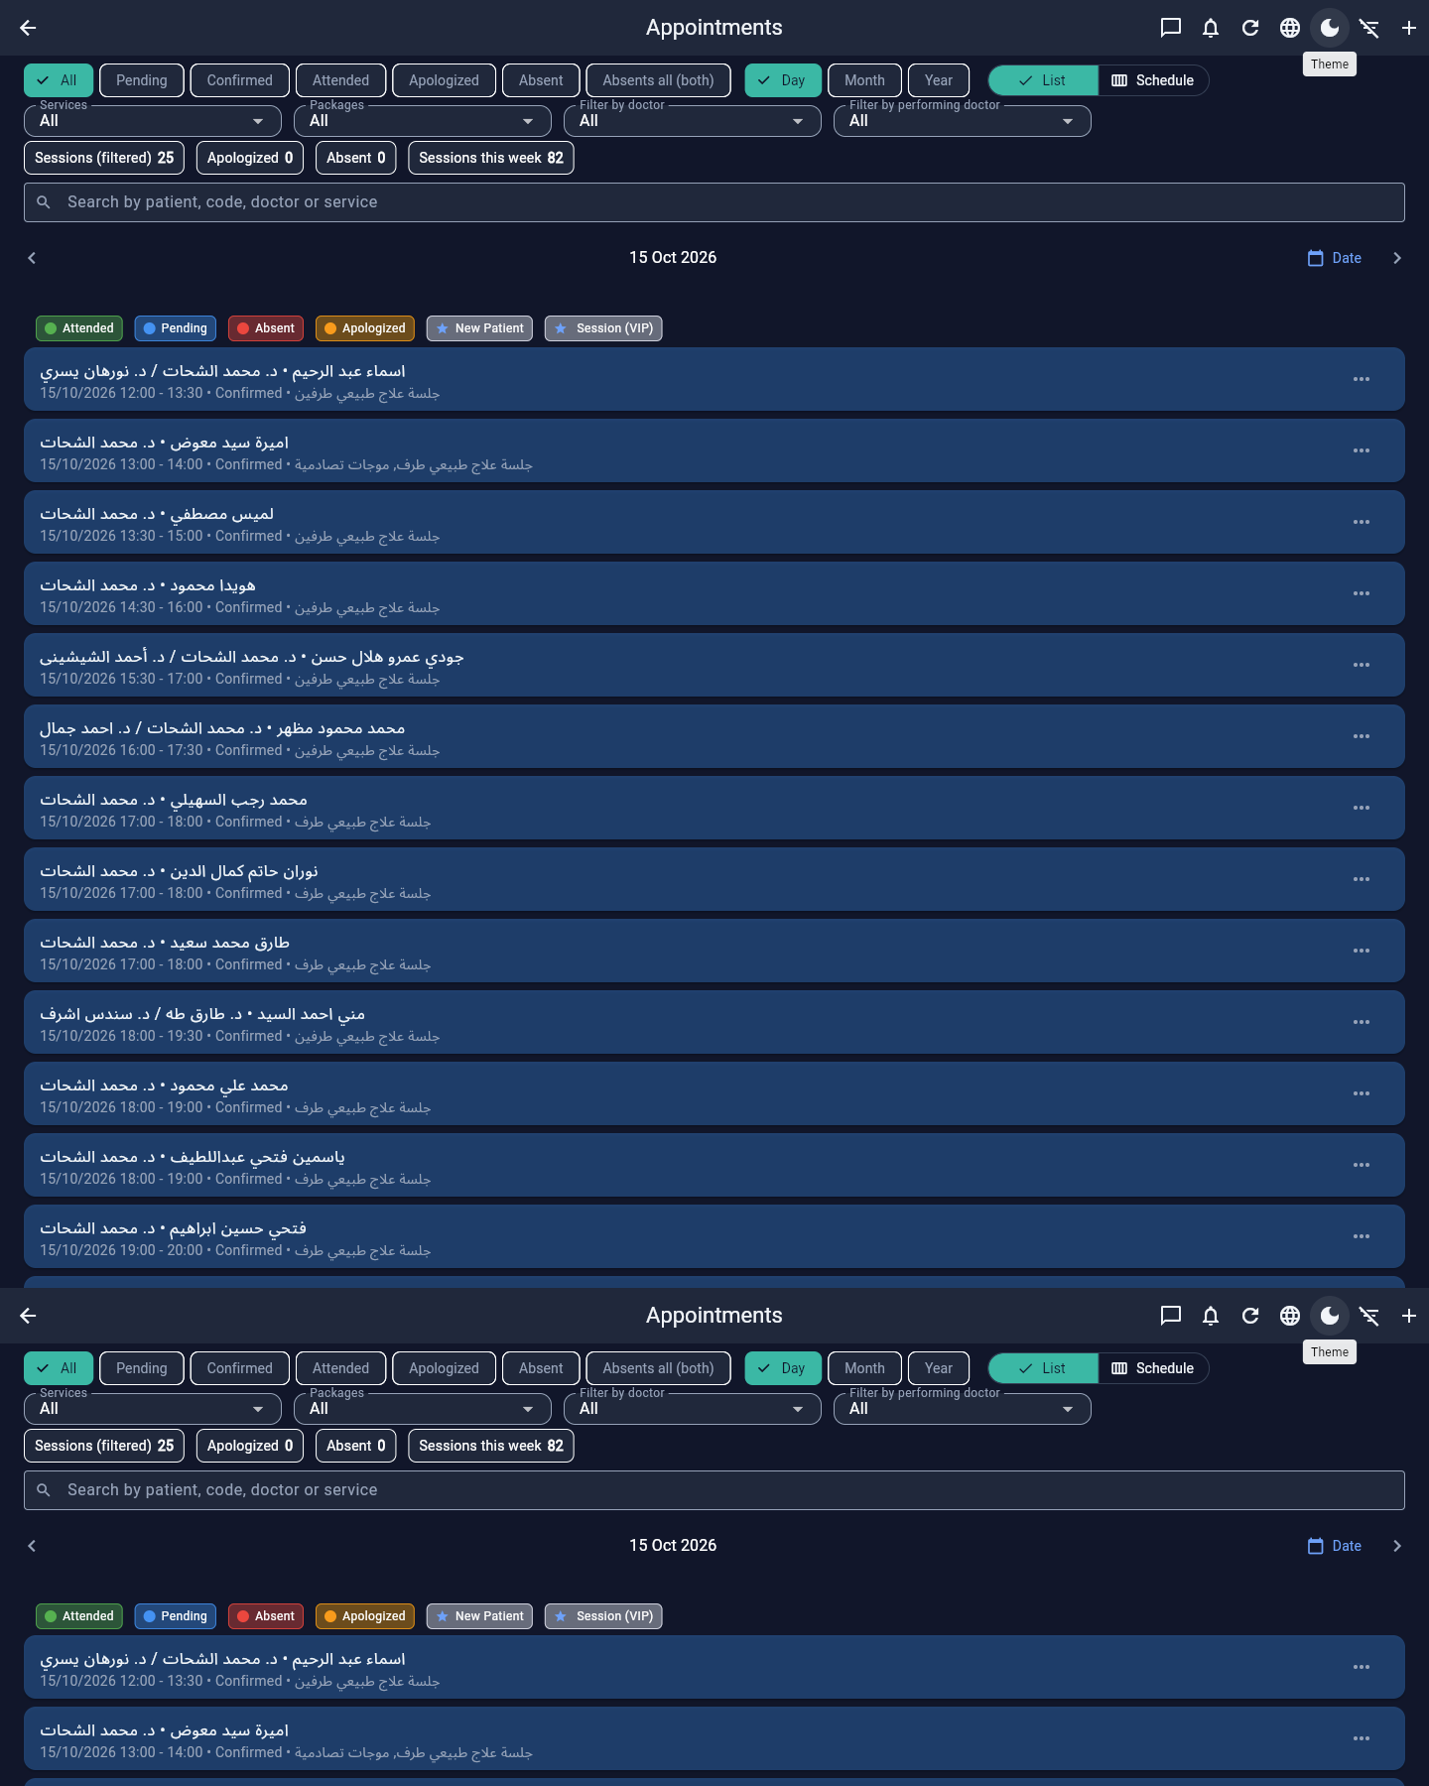
Appointments after theme/language controls — same screen, different chrome

2. Appointments — every button, filter, legend & cell
شاشة المواعيد — كل زر وفلتر وخلية
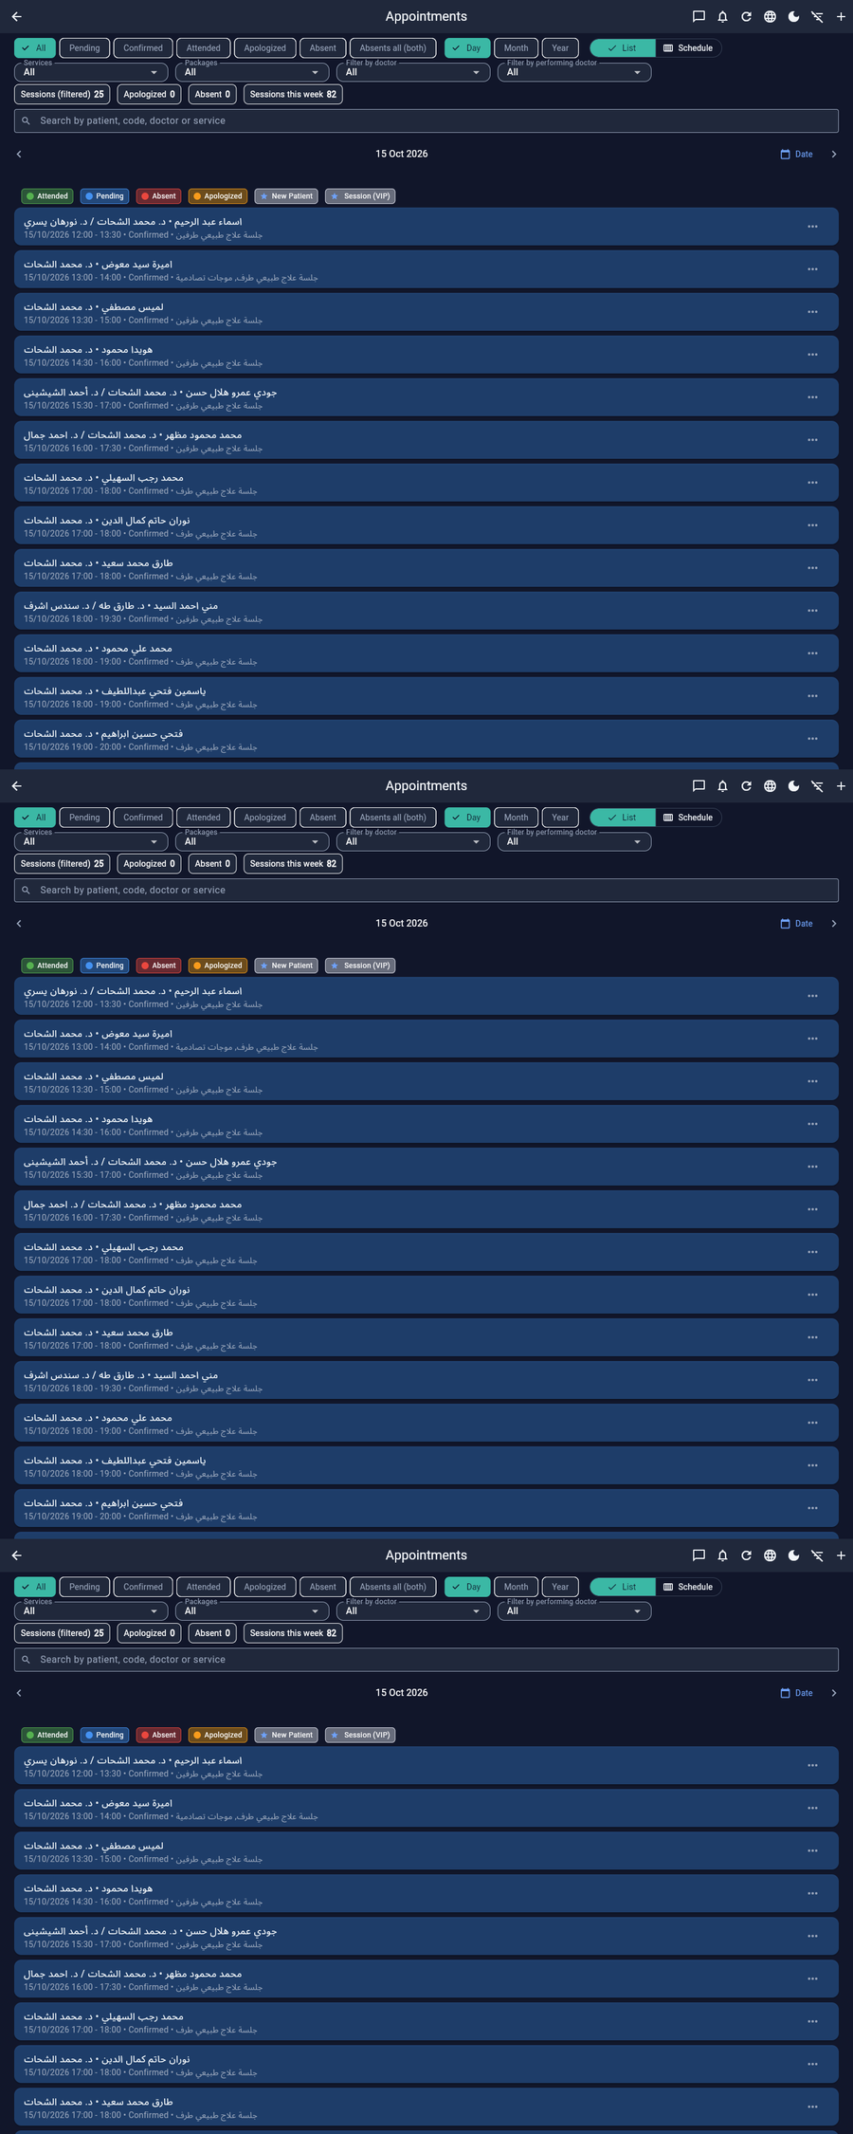
Desktop · Appointments full tall capture (list view)

2.1 App-bar actions (this screen)
- ←
- Back
Leave appointments.
- 💬🔔↻🌐🌙
- Global icons
Messages, Notifications, Refresh, Language, Theme — see §1.
- ☰ filters
- Show / Hide filters
Icon filter_list / filter_list_off. Collapses status chips, date chips, dropdowns, and count row to give the list more space.
- ＋
- Create appointment
Opens the full booking dialog: patient, supervising doctor, performing doctor, room, date/time, services, package, cost, discount %, notes, VIP star, extra slot.

2.2 Status filter chips
Chip | What it shows
All | Resets status + (when used as “today reset”) clears doctor/service/package filters and jumps to today.
Pending | Not yet confirmed.
Confirmed | Booked and confirmed.
Attended | Completed / patient attended.
Apologized | Absent with cause (اعتذار).
Absent | Absent without cause / no-show style absence.
Absents all (both) | Both apologized + absent types together.

2.3 Period chips & List / Schedule toggle
- Day
- Day filter
Single calendar day (with prev/next day & date picker).
- Month
- Month filter
Whole month of appointments.
- Year
- Year filter
Whole year.
- ☰ List
- List view
Vertical cards: patient • supervisor / performer, time, status, service, notes, ⋮ menu.
- ▦ Schedule
- Schedule view
Day grid: time rows (every 30 min 00:00–23:30) × room columns. Shows conflicts visually; cancelled/absent don’t keep the room.
List vs Schedule: List is best for search & status ops. Schedule is the floor board — who is in which room at which half-hour. Toggle lives in the filter row as a segmented control with list / calendar icons.

2.4 Dropdown filters
Dropdown | Behavior
Services | Keep appointments that include that service name.
Packages | Filter by linked package id.
Filter by doctor | Supervising / billing doctor (doctorId).
Filter by performing doctor | Who ran the session (performingDoctorId) — doctors + trainees.

2.5 Live count chips
- Sessions (filtered) — count after all filters.
- Apologized / Absent — subset counters.
- Sessions this week — week total for planning.

2.6 Search & date navigator
- 🔍
- Search
Matches patient name, patient code, supervising doctor, performing doctor, or service text. Clear (×) resets.
- ‹ ›
- Previous / Next day
Step the Day filter one day.
- 📅 Date
- Date picker
Jump to any calendar day.

2.7 Legend & list card anatomy
Legend / cell | Meaning
Green · Attended | Completed session color.
Blue · Pending | Awaiting confirmation.
Red · Absent | No-show / absent without cause.
Orange · Apologized | Absent with cause.
⭐ New patient | Star marker for new patient priority.
⭐ Session (VIP) | Starred / VIP session (isStarred).
Title line | Patient • Supervisor or Patient • Supervisor / Performer.
Subtitle line | Date, start–end, status label, services; optional Notes line.
⋮ Show menu | Edit / status transitions (confirm, complete, cancel, absent…) by privilege.

3. Income & Expenses — every control
الدخل والمصروفات — شرح كل عنصر
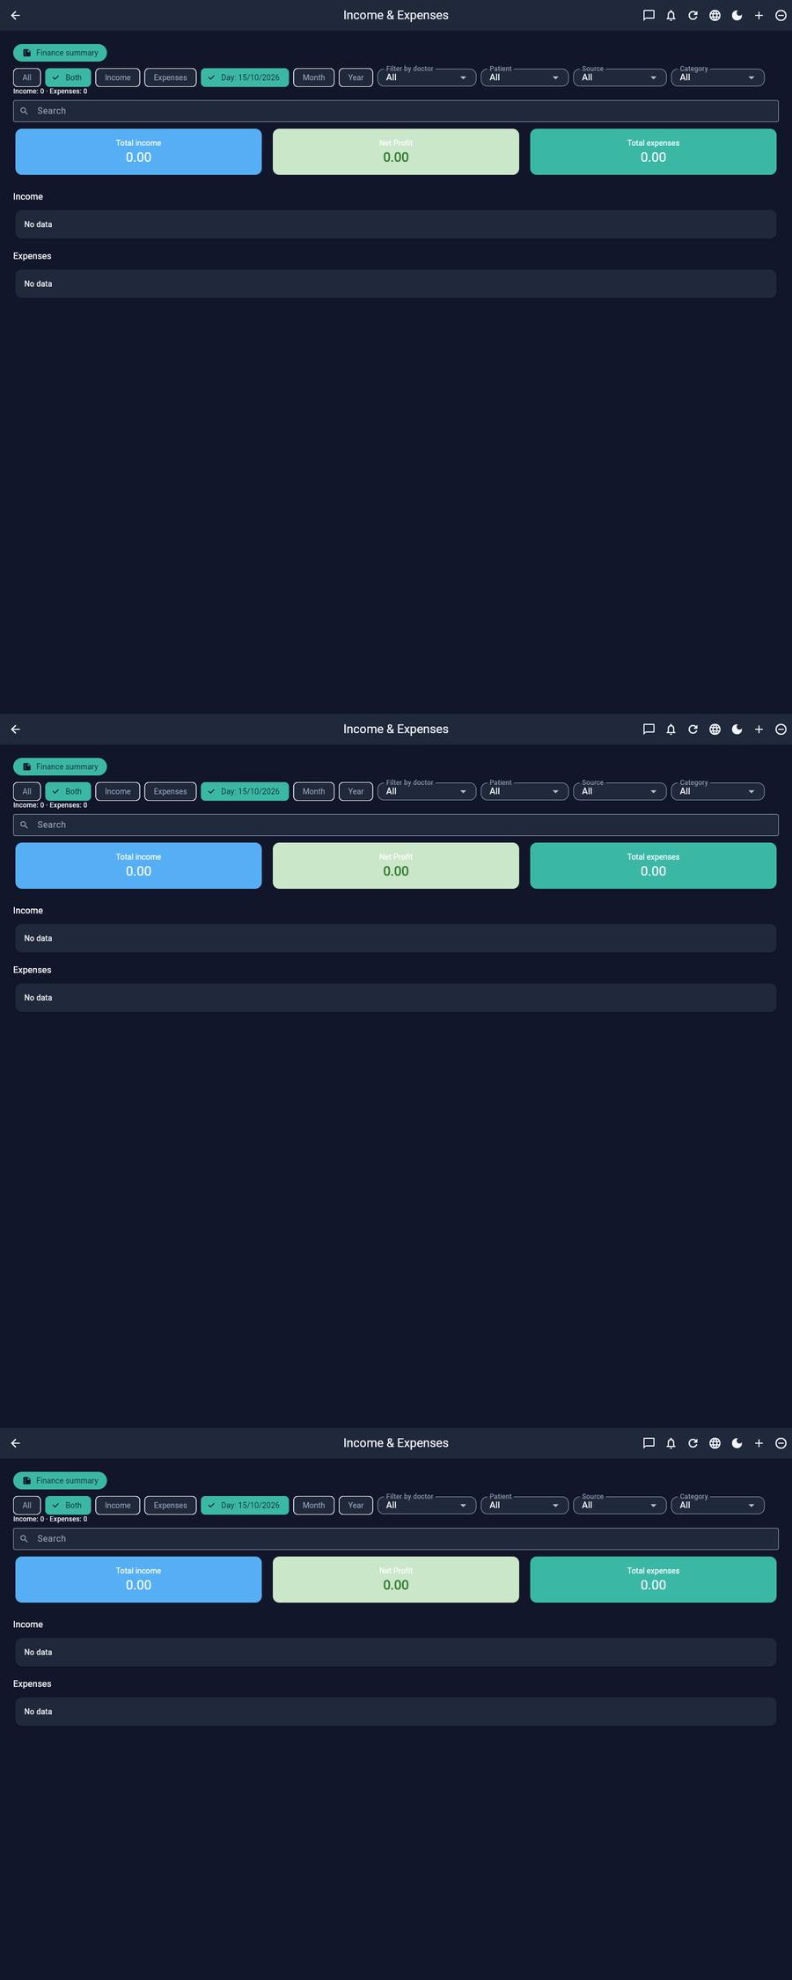
Desktop · Income & Expenses full tall capture

3.1 App-bar icons
- ←
- Back
Return.
- 💬🔔↻🌐🌙
- Global
Messages, Notifications, Refresh, Language, Theme.
- ＋
- Add income
Opens Add Income: amount, source, notes, date/time, optional doctor/patient/appointment links.
- ➖
- Add expense
Opens Add Expense: amount, category (Salary/Rent/Supplies/Media/Other), paid-by-doctor, optional employee/recipient, description.

3.2 Finance summary shortcut
Teal button Finance summary (summarize icon) navigates to the owner P&L screen (§4).

3.3 Type chips
Chip | Effect
All / Both | Show income and expense sections together.
Income | Focus income stream.
Expenses | Focus expense stream.

3.4 Period chips
- Day — pick a calendar day (label shows the selected date).
- Month — month/year picker.
- Year — year picker.

3.5 Dropdown filters
Filter | What it does
Filter by doctor | Income/expense rows tied to that doctor.
Patient | Rows linked to a patient.
Source | Income source values.
Category | Expense categories (Salary, Rent, Supplies, Media, Other).

3.6 Summary cards & lists
- 💰
- Total Income card
Sum of filtered income (EGP).
- 📈
- Net Profit card
Income − expenses for the filter.
- 🧾
- Total Expenses card
Sum of filtered expenses.
- 📊
- Income by doctor / Expense by doctor
Breakdown blocks under the cards when data exists.
- ⋮
- Row menu
Edit or Delete a record.
Each income row shows: amount, source, date/time, notes, patient, doctor, payment status (Paid / Partial / Prepaid / Not paid).
Each expense row shows: amount, date/time, category, description, paid-by-doctor, optional recipient (salary).
Search box filters free text across visible fields. Counter text under filters: Income: N · Expenses: M.

4. Finance summary — every field & cell
الملخص المالي — كل عمود وخلية
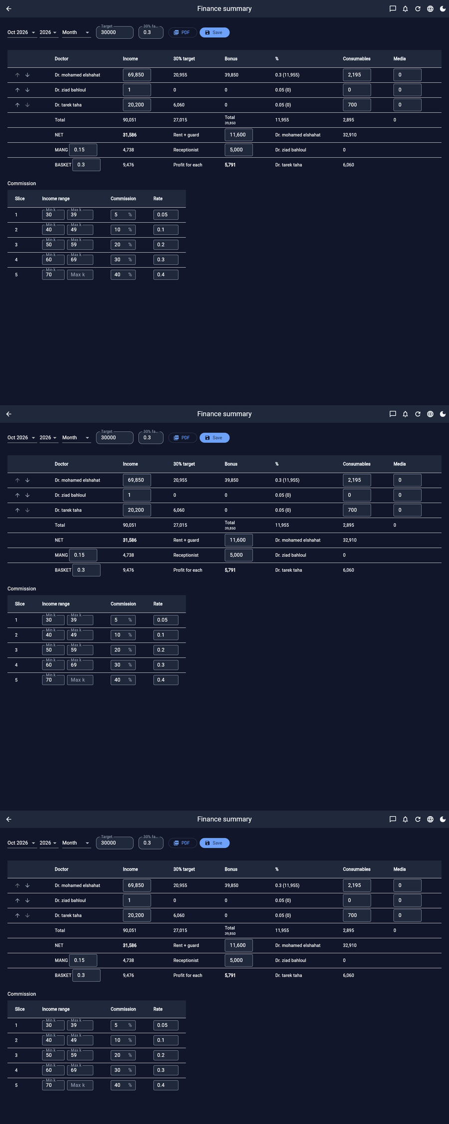
Desktop · Finance summary full tall capture

4.1 Header controls
- Month / Year
- Period selectors
Choose month & year for the sheet.
- Month / Quarter / 6 months / Year
- Range mode
Aggregates months; config scales for multi-month ranges.
- Target
- Clinic target
Editable money target for the period.
- 30% factor
- Percent factor
Usually 0.3 — drives “30% Target” column = income × factor.
- 📄 PDF
- Export PDF
Bilingual PDF with Amiri + Arabic reshaper.
- 💾 Save
- Save config
Persists target, rates, slices, doctor order for the month.

4.2 Doctor performance table (columns)
Column / control | Meaning
↑ ↓ arrows | Reorder doctors (saved order).
Doctor | Doctor display name.
Income | Sum of that doctor’s income in range.
30% Target | Income × 30% factor (c30).
Bonus | Bonus amount derived from target logic.
% | Commission % from slices + computed value.
Consumables | Mapped expense bucket for that doctor.
Media | Media expense bucket.
Total row | Sums across doctors.

4.3 NET / MANG / BASKET block
Cell | Meaning
NET | Net after doctor-level deductions — basis for splits.
Rent + guard | Editable shared clinic overhead (from Rent expenses / config).
Receptionist | Editable shared salary line (from Salary expenses / config).
MANG (rate) | Management share of NET (e.g. 0.15 = 15%). Editable rate.
BASKET (rate) | Basket/pool share of NET (e.g. 0.30). Editable rate.
Profit for each | Remaining profit figure after MANG/BASKET logic.
Per-doctor Net side column | Individual net after commission/consumables.

4.4 Commission slices table
Column | Meaning
Slice | Tier index.
Income range | Min–max income band for the tier.
Commission | Percent for that band (editable).
Rate | Decimal form of commission (kept in sync).
This screen is the commercial heart for partner clinics: transparent doctor income, targets, overhead, and MANG/BASKET splits — exportable as PDF for monthly meetings.

5. Other screens (full-page desktop)
شاشات أخرى — التقاط كامل

Dashboard
Welcome + role, date/time card, quick actions (Add patient, Find patient, Book appointment, Today’s count), period chips, doctor filter, search, appointment rows with supervisor/performer.
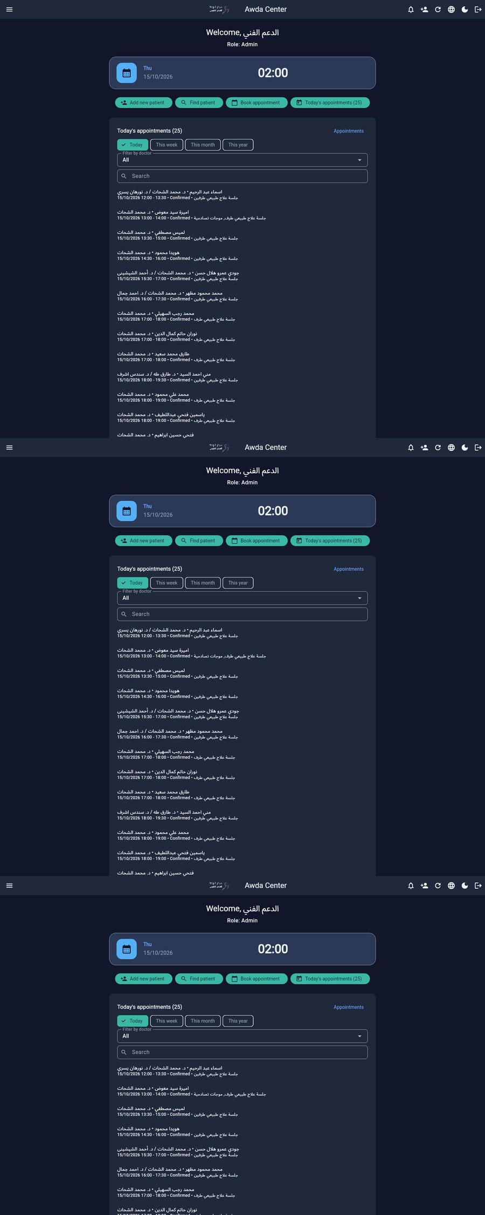
Desktop · Dashboard full page

Admin Dashboard KPIs
Total users, active users, today’s / week’s appointments, patients, doctors — plus deeper charts (income, workload, expenses) further down the scrollable page.
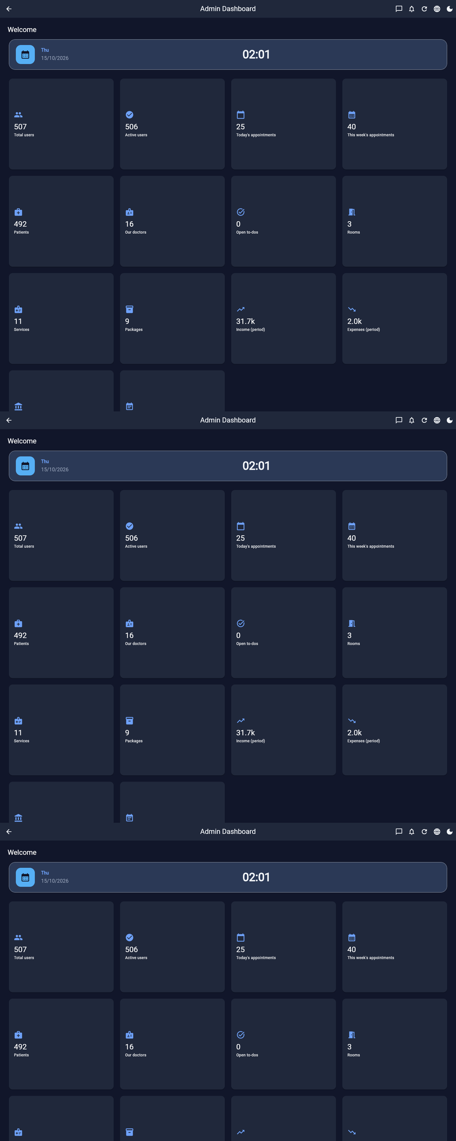
Desktop · Admin dashboard

Patients · Users · Reports · Audit
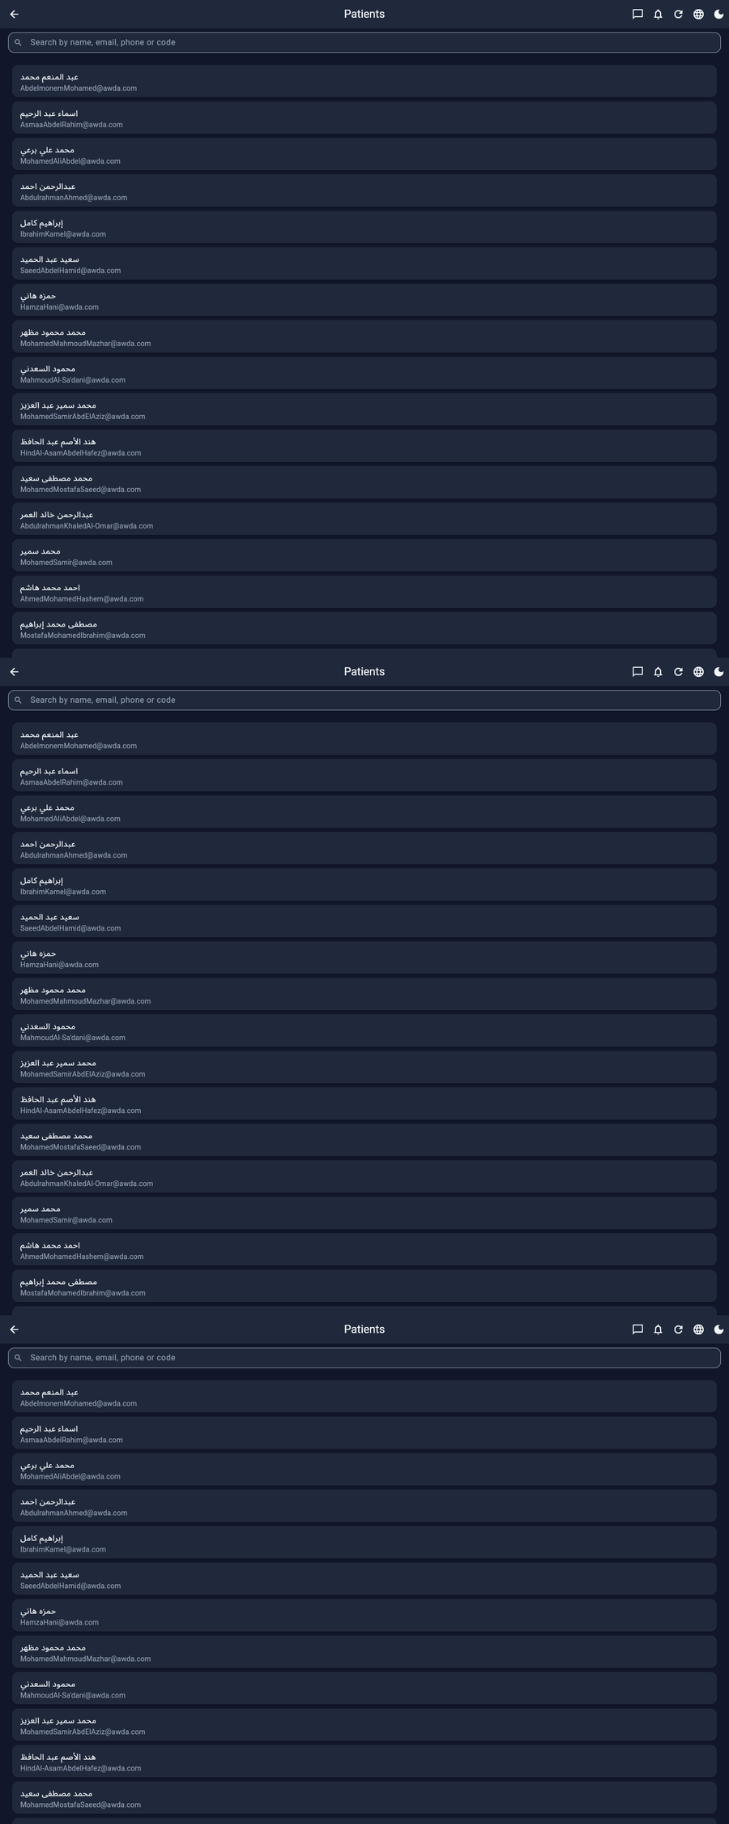
Patients directory
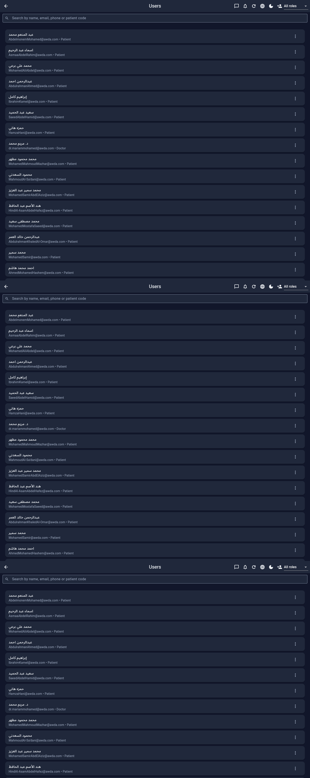
Users & roles
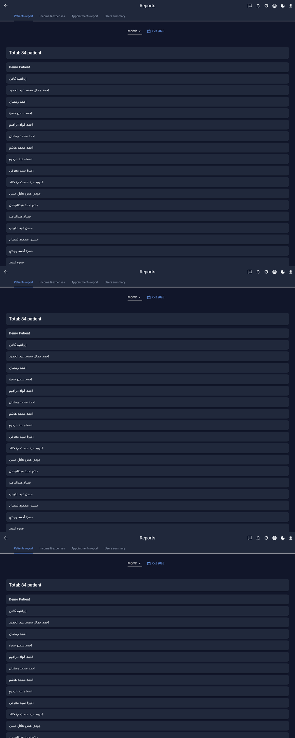
Reports hub
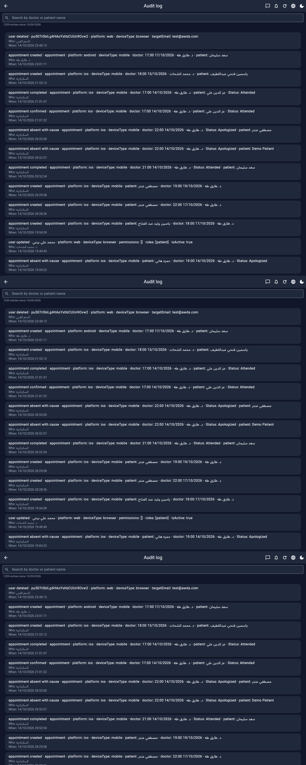
Audit log (platform + device on each row)

6. Mobile views (real phone viewport)
واجهات الموبايل — نفس الميزات بتخطيط عمودي
Captured at ~390×2800 CSS px (2× DPR). Same icons and filters; stacked layout for one-handed clinic use.

Dashboard (mobile)
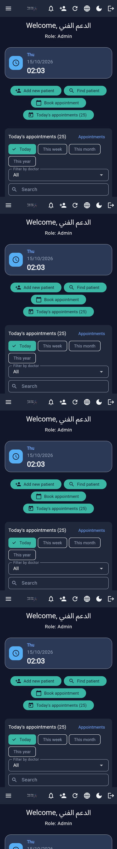
Mobile dashboard

Appointments (mobile)
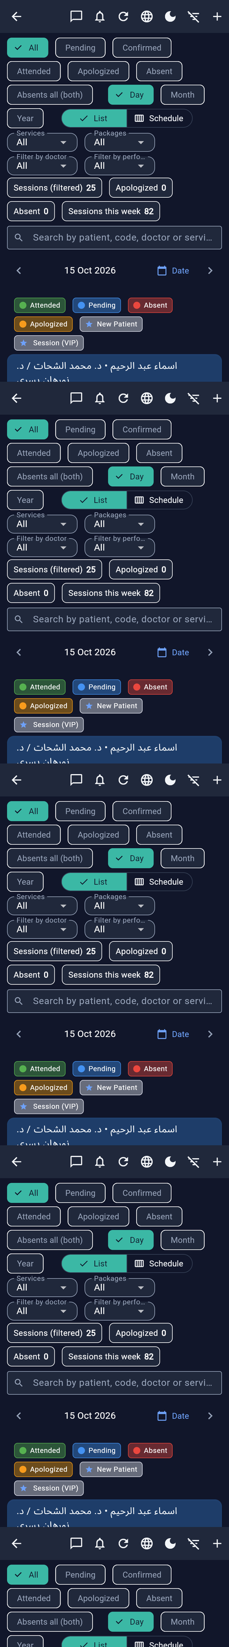
Mobile appointments

Income & Expenses (mobile)
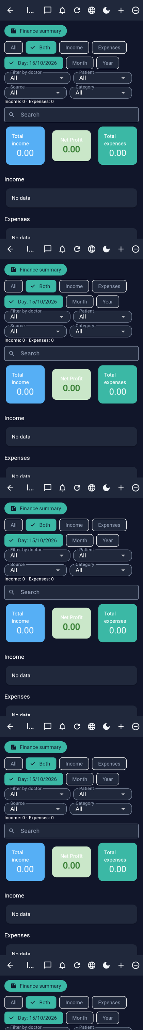
Mobile income & expenses

Finance summary (mobile)
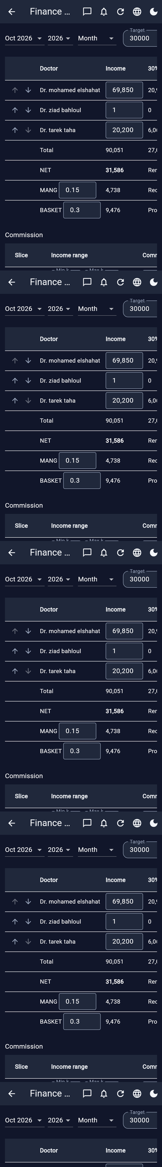
Mobile finance summary — horizontal scroll for wide tables

7. Platforms & roles
 | Web | Android | iOS
Full UI | ✓ | ✓ | ✓
FCM push | ✓ | ✓ | ✓
Local reminders | — | ✓ | ✓
PDF / Excel | ✓ | ✓ | ✓
APK in-app update | — | ✓ | —
Roles: Admin · Supervisor · Secretary · Doctor · Trainee · Patient — with multi-role + per-user privilege overrides (including fine-grained chat media permissions).

8. ملخص عربي
البروشور ده بيشرح بالتفصيل أيقونات الشريط العلوي (شات، إشعارات، تحديث، لغة، ثيم)، وكل فلاتر المواعيد (حالة، يوم/شهر/سنة، قائمة vs جدول، خدمات، باقات، مشرف، قائم بالجلسة)، وشاشة الدخل/المصروف بالكامل، وجدول الملخص المالي (Target، 30%، Bonus، Consumables، Media، NET، MANG، BASKET، شرائح العمولة) — مع صور ديسكتوب كاملة الطول وصور موبايل.
- قائمة المواعيد للبحث والحالات · جدول المواعيد للغرف ونصف الساعة
- اللغة عربي/إنجليزي مع RTL · الثيم فاتح/غامق
- المالية بالجنيه جاهزة لاجتماعات الشركاء وتصدير PDF

Clinic OS
بروشور تفصيلي للبيع — HTML · PDF · Word
White-label · Desktop + Mobile · Icon-level documentation

