Plan (25 pages)

1. **Changement structurel dans le monde : schémas observés et théories (5 pages)**
   1. Revue de littérature : théorie
   2. Revue de la littérature : empiriques
      1. Généralités : faits stylisés marquants.
      2. Études de cas : et leçons
   3. Discussion – mes observations :
      1. La réduction des inégalités productives : U inversée : tous les secteurs manufacturiers
   4. Revue de la littérature sur le Maroc
      1. En quoi je me démarque : mobiliser plusieurs sources/ je me focalise sur les faits stylisés : la nature et la question du papier purement exploratoire
   5. Méthodologie, données, questionnements généraux :
      1. Description des sources de données : GGDC, UNIDO, CNSS
      2. Le Maroc et la frontière (dernières années : à la fois 10 grands secteurs et branches du secteur manufacturier et au départ) : commenter les progrès/ recul.
      3. Point de méthodologie : de quoi faut-il se soucier, valeur ajoutée ou emploi ?
2. **Changement structurel au Maroc : le potentiel manqué.** *(10-12 pages)*

En termes de composition VA/En termes de composition de l'emploi/ En termes de décomposition de la croissance : j’aborde les traits du changement structurel au Maroc, que sont + partout une périodisation et discussion des politiques

* 1. Choisir deux pays de référence : qui vont accompagner dans l’analyse (la chine étant donné qu’en 2005 nous avons le même PIB :
     1. La méthode de ah Joon change
     2. Mes clusters (utilise le nombre optimal de clusters 2-4)
  2. **Contribution de l’agriculture :** 
     1. Gains de productivités==>plus grands contributeurs par ses gains internes durant toutes les décennies sauf années de sécheresse 80’s
     2. Ruraux, urbanisation, Maroc vert, élargissement de la demande ?
     3. Ralentissement des flux sortants !
     4. Sur les salaires au secteurs agricoles, ont-ils augmentés suite au gains de productivité – données *CNSS* au moins ?
  3. **Une stagnation de l’industrie manufacturière :** 
     + 1. Stagnation des parts de l’emploi et de la valeur ajoutée- désindustrialisation prémature.
       2. Baisse de la productivité relative !!
       3. De la contribution positive au changement structurel à la contribution négative.

1. *Le déplacement du travail en dehors de la manufacture était bien ou non ? cela dépend du secteur qui les a absorbés ?* ***Nous pouvons creuser à la base de données de la CNSS[1], en suivant les travailleurs.***
   * + 1. Une baisse de la productivité relative du secteur manufacturier
       2. Comportement % la frontière mondiale (ouverte)
       3. Sur la dynamique des exportations
       4. ***Un retour sur le secteur manufacturier s’impose dans un autre papier, ou chapitre : ici on rajoute un mot sur les politiques industrielles en général (périodisation)***
   1. **Le secteur aberrant : Finance-Services Immobiliers et Services à l’entreprise.** 
      * 1. Le secteur champion : Productivité relative trop élevée et une performance comparable aux meilleurs.
        2. Des entreprises championnes-exportatrices, ou bien uniquement au Maroc ?
        3. Peut il être le secteur porteur :
           1. Part de l’emploi et l’éducation.
           2. Quelques pays qui ont pu en profiter ?
   2. **Les services non-échangeables : Transport-entreposage-communication/ Commerce-réparation-tourisme-hôtels.**
   3. **Les services sociaux :** en profiter pour parler de leurs lacunes et comment cela entrave le within/ 1 page.
2. **Panorama des politiques industrielles au Maroc vs les meilleurs pratiques (Ha Joon Chang)**
   1. Les politiques horizontales : réalisations et limites
   2. Les politiques verticales : réalisations et limites

Empirical findings about the structural change in Morocco with comparisons[2]

Table des matières

**1-On structural change patterns (from data only)** 5

**2- Aborted structural change in Moroco:** 6

**3- A premature deindustrialization** 9

**4- Relative productivities:** 11

**5- Effets d’entrainements** 12

**6- Structural change and human capital (as determiant of direction).** 13

**8- A geographical analysis.** 15

**9-Morocco and wages** 15

**7-A cluster Analysis** 16

**9- DATA DEFINITIONS** 18

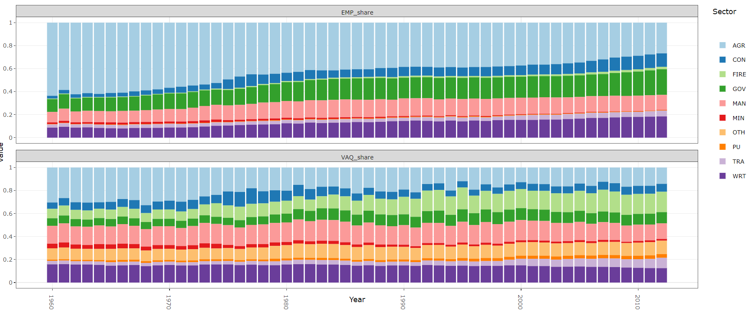

Use cnss data for geographical comparisons

**1-On structural change patterns (from data only)**

Which structure: emp or va

* The change is faster in value structure than in employment structure China, Egypt India, Indonesia, Japan, Malaysia, Taiwan.
* It takes ten years more than change in vaq.[3]
* The manufacturing sector, is never the most productive sector, he may be headed by PU and MIN sectors that are very intensive in capital, risky, etc (by FIRE in Morocco bizarre)…BUT he is the most productive among the large contributors to the Value added (unlike PU and MIN or FIRE sectors) in the economy, so he is the most productive Relevant sector.
* Hence we can observe that manufacturing becomes the biggest (or in comparison to agriculture) contributor to total value added while not employing the biggest part…
* In African experience, most countries have the same pattern and they are quitting manufacturing as quickly as they have 8 k or 10 k $/pc, which corresponds to the late 70’s and early eighties with a noticeable exception of Mauritius, which has grown manufacturing share until 90’s around ¼ of value added.
* Most of African countries have done little effort in growing the share of manufacture beyond the colonial legacy. (are they the same companies?)
* 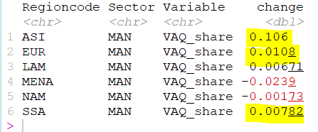
* Disparity inside manufacturing is lower than disparity among all economy sectors:

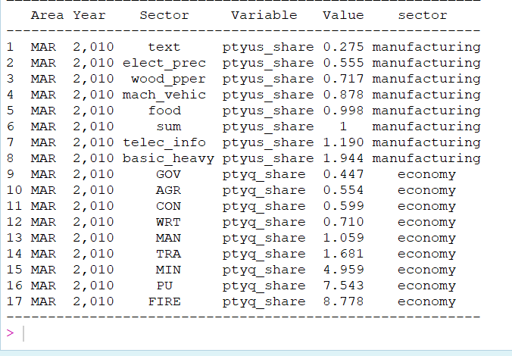

**More to say about disparity:**

UNIDO DATA

#there is no continuum of productivity for each time, each sector there is a bimodal-or more productivity distributions with practically two or three separate islands of production.

#An increase in productivity gap and a decrease in all sectors since 1999.

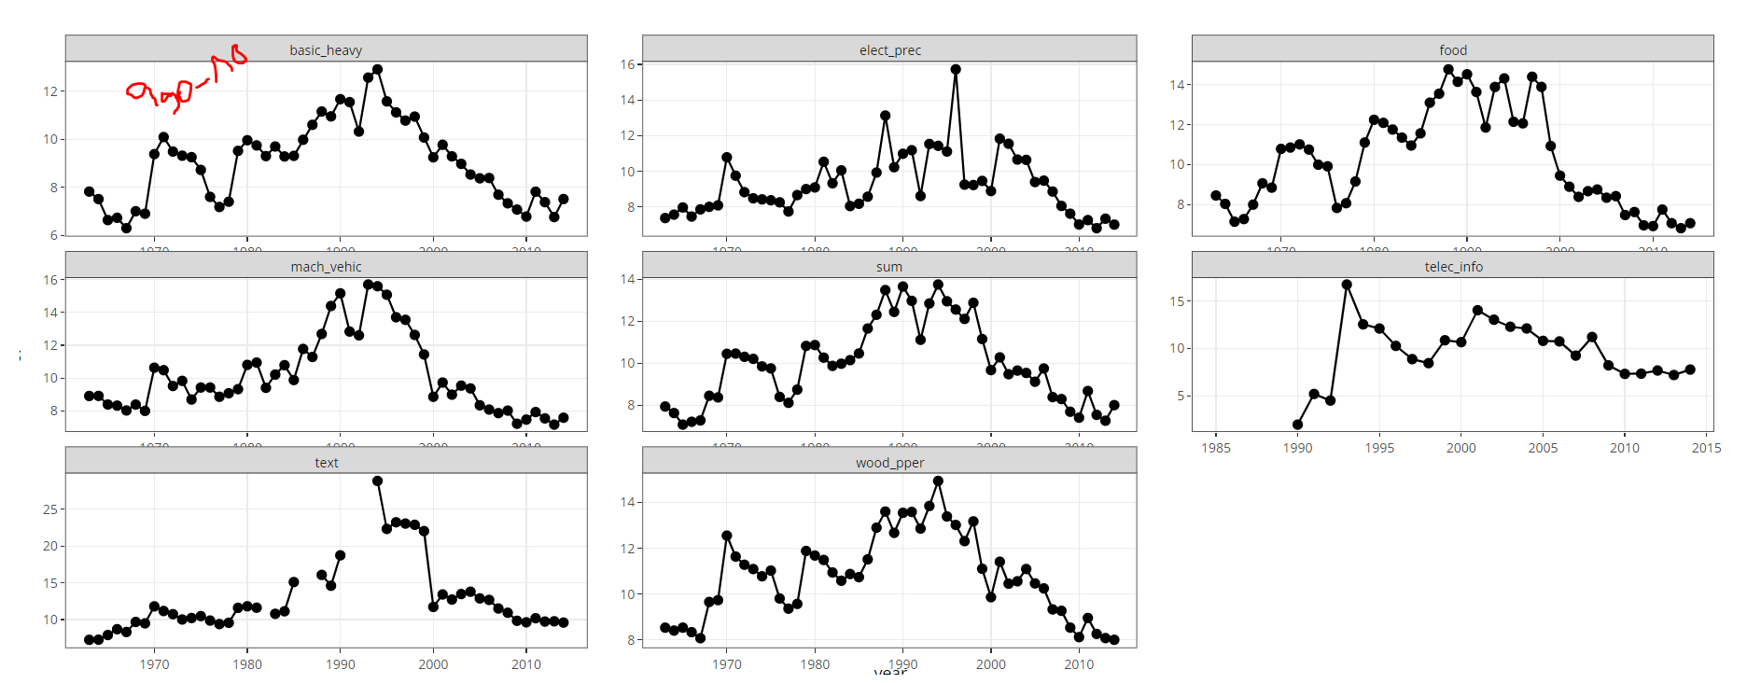

**2- Aborted structural change in Moroco:**

Structure of VAQ: While many countries has substantially changed in favor of manufacturing Morocco abandoned that in the early eighties (where the share of agriculture has substantially decreased). But Morocco structure was also stagnating during the 60’s, the only window of transformation was in the 70’s. During the whole period, the sectors that gained importance are GOV, FIRE and TRA.

-GOV 76-84: from 6 to 10%

-FIRE (72-74 then 83-95: from 8 to 18 %),

-TRA (97-2012: from 4 to 9%)

-AGR(68-84: from 32 to 16%)

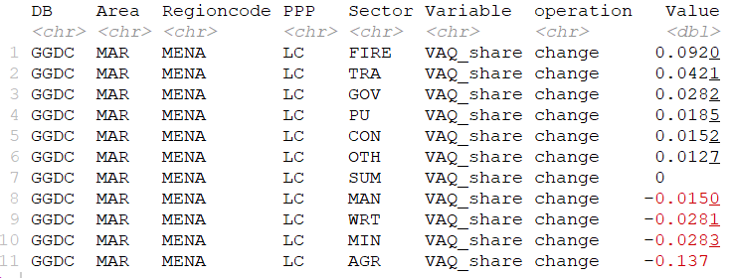

(71-82) -While we noticed during this period a drop in the share of agriculture, from 30 to 15 which is compared to china is very small, and limited in time only between 1971 and 1981.. However we saw no emerging sector that lead the change. All sectors has increased their shares but only in an insignificant way 1 to 2%). Except for construction sector who boomed in the second half of the decade 74-77(why?).

84-onward- One can say that Morocco has aborted structural change: the relative shares of major sectors has remained the same, except FIRE sector who continued growing until 2008, more importantly, the share of agriculture has not decreased (only -2% since mid eighties): this reflects the increase in its relative productivity since 2000

Structure of EMP:

For the whole period, change in emp shares is more remarkable than in VA shares

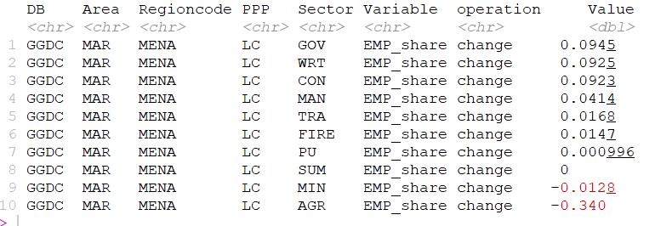

The flow was primarily directed to government services, WRT and construction +9%each and then manufacturing (+4%)

This slow change in the sectoral composition

We also notice that the slowdown in the flow out from agriculture in the 80’s, here, we also noticed a drop in the 2000’s, in the share of labor, but not in the share of VAQ that says that productivity has increased and also relative productivity. **This drop in the share of employment is also accompanied by a decrease in the absolute employment in agriculture and a stabilization of rural population (see data WP1, there is a lag in the starting year of the drop but nobroblem**)

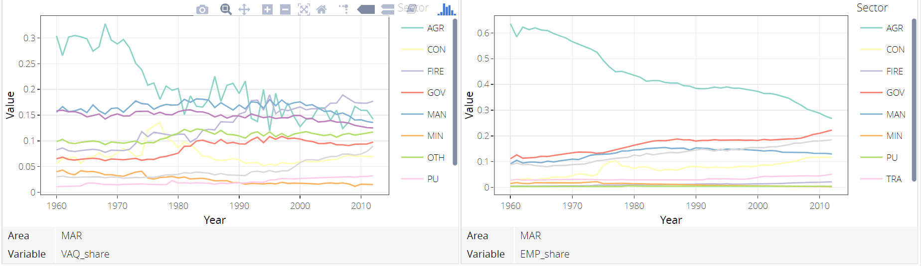

*The composition fallacy*: Morocco may seem to have similar structure to some post industrial countries (Brazil) but in reality the share of agriculture is very high in Morocco. Agriculture still create more value than industry in morocoo as by 2015.(see the cluster analysis)

Morocco is similar in what is outside agriculture, but agriculture is high so the similitude is fallacy. The fact that agriculture is still important implicate that we still need to go through industry because we said it is the most productive among the significant sectors.

**2-2- From a between-within perspective: What does it mean for within and between components**

Over the long period, the contribution of

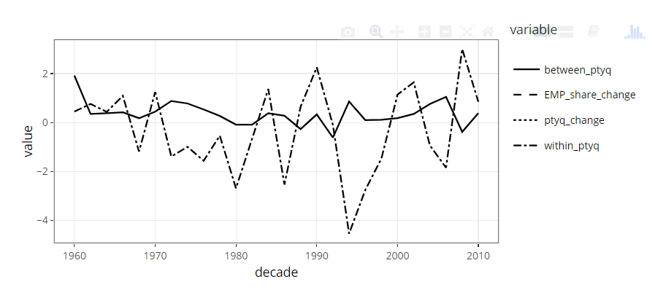

Within contribution is very volatile, while structural change component seems to be following a steady decrease.

**The aberrant relative size (va) and productivity of FIRE sector in Morocco.**

It is no where the case except in Morocco and if it is the case, its is in the past or I 3 African countries, Senegal Tanzania, Kenya, or in Germany. The most productive sectors are PU, Mining and FIRE (but much less than the two first sectors). Some countries looks like Morocco in that regard like china, but only for the last years-not the whole period. It is only lately that the FIRE sector started doing the eighties-financial deregulation, which also affected this sector productivity. However in Morocco the productivity gap in favor of FIRE seems to follow its own logic. In comparison to the international, the FIRE sector in morocco is among the most productive in the world. It is also, as we mentioned above close to US productivity levels.

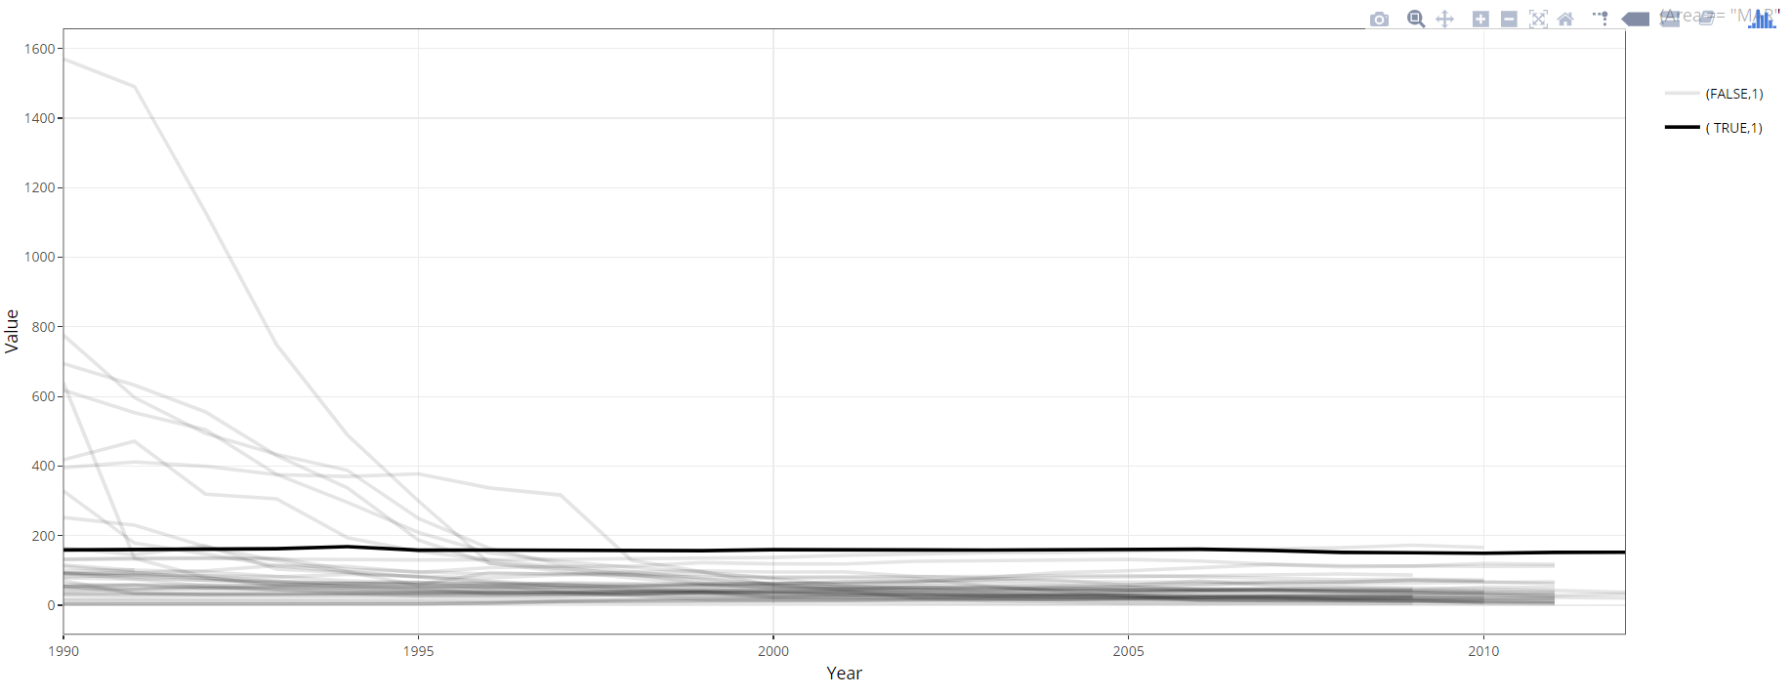



Figure 1Productivité du secteur FIRE au Maroc et au Monde- PPP

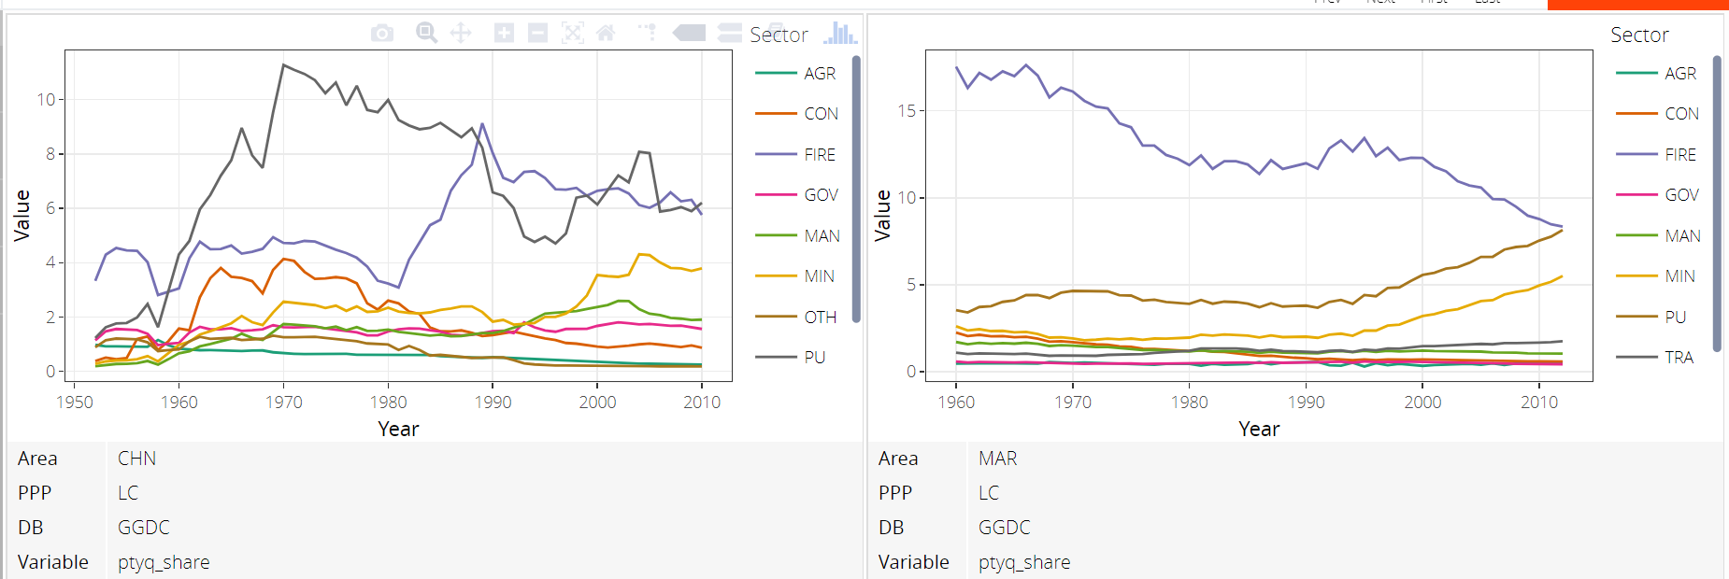

*Inequality*: this is a source of inequality, because value is not captured by employees but by the capital detainers, think of banking sector, accounting, audit, legal services, and even if it is captured by employees it is aberrant relative to other countries

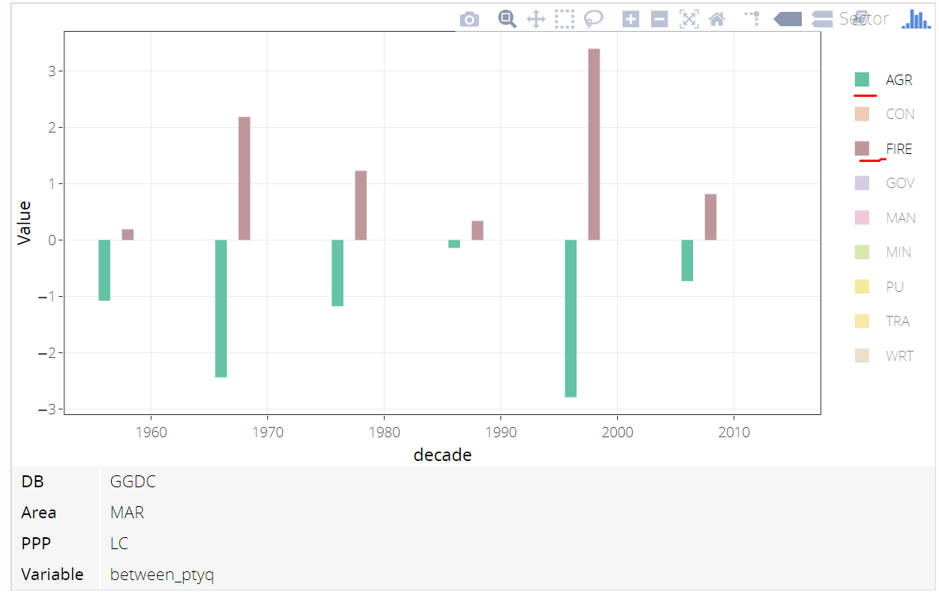

The government Sector:

**3- A premature deindustrialization**

Not only Morocco but all African countries are deindustrializing at very low levels of gdp_per capita and value share of manufacturing, except Mauritius, Egypt and South Africa who where above 20% and more than 6k Contrary to developed countries

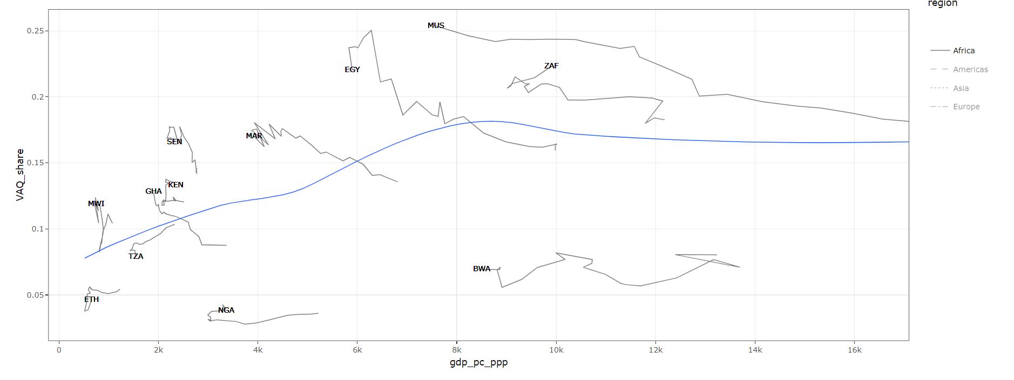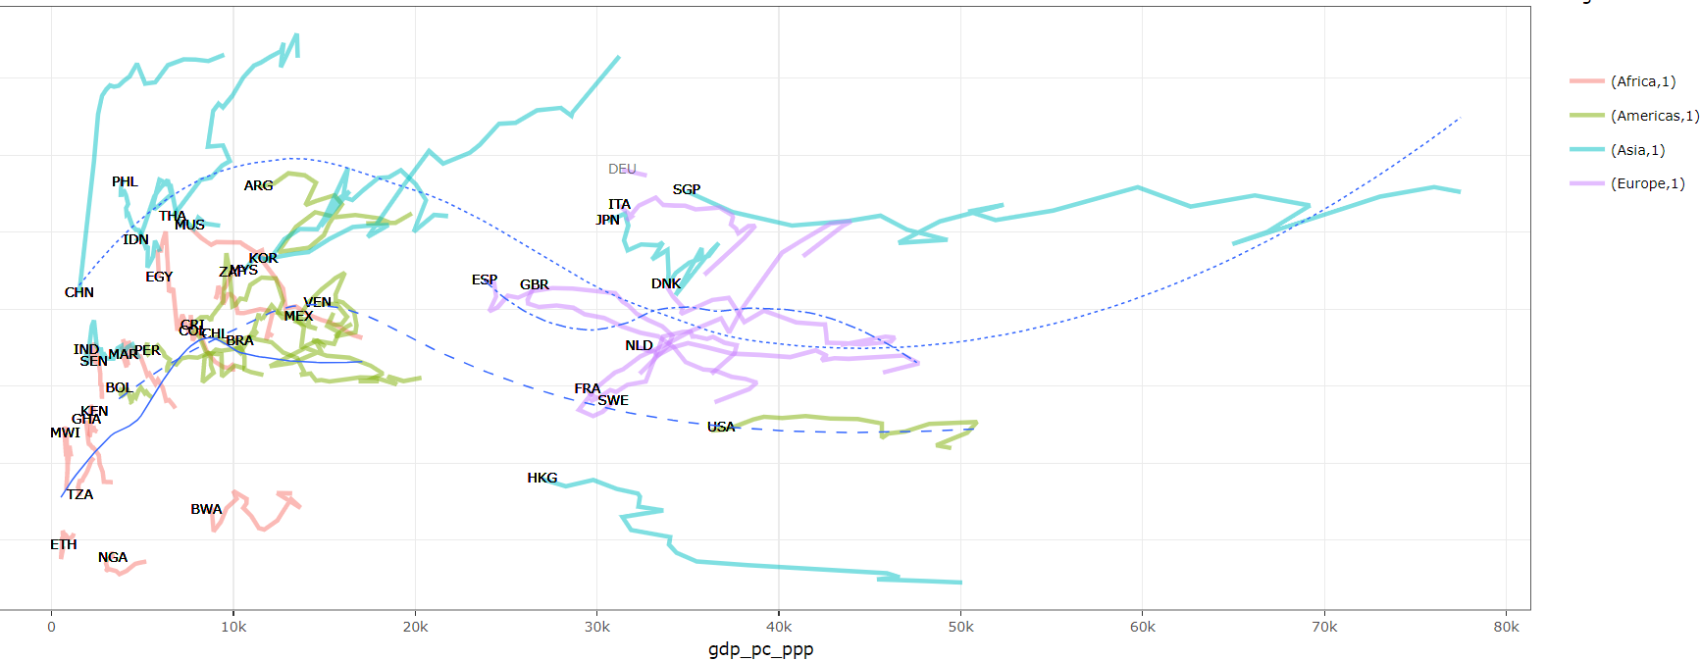

Or to Asian countries:

The less developed group of Asia are growing while transforming their economies toward manufacturing, the group of rich Asians, are deindustrializing but only marginally compared to the African ones, so that In japan when it decreased the most it only decreased by 2%, both Sgp and jpn are still have more than 20%, but more importantly they are deindustrializing at higher levels of income (those are among the richest in the world)



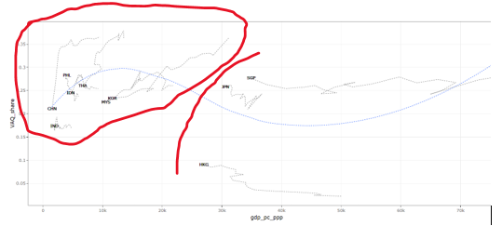

**Divergent trajectories-countries that where close**

Why gdp and manuf share in one graph?

Because of the composition fallacy, the significance of manuf share differs from countries in the beginning of transformation: still having much pple to take out of agri and a country yhat has transited to services.

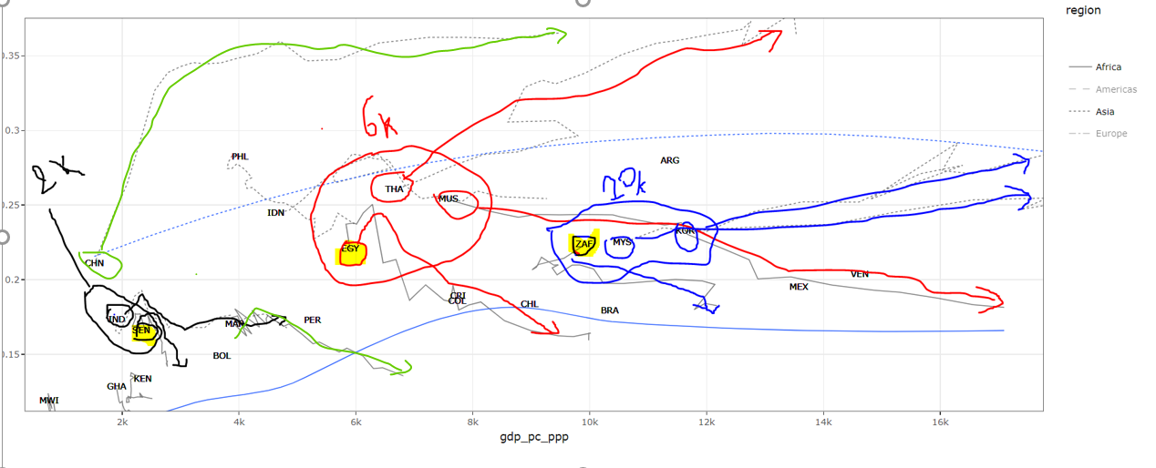

Industrializing countries grow faster, but why Asia industrialize, African not. Look at the Chinese pattern, industrialize first, then grow boom

**Morocco and the frontier:**

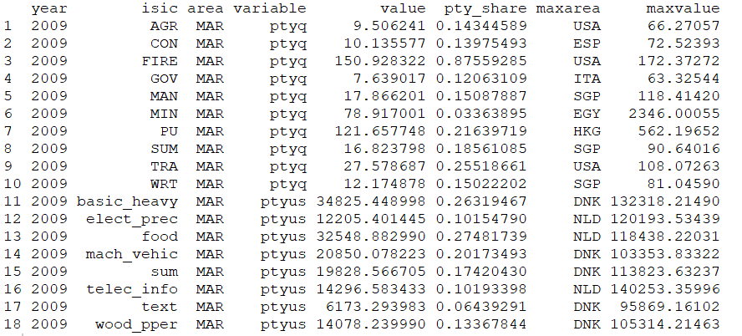

Remark that Morocco is performing very well in FIRE services: he is the closer sector to the frontier 0.8 US productivity. While manufacturing activities, the closer one is food-beverages-tobacco production. I need data on human capital in each sector to see why FIRE is very productive.

**4- Relative productivities:**

Why do we care about ptyshares?: Because in the context of structural change, this is a good measure of differences in productivity between sectors. Yet the best waay is to describe the productivity of each sector by a vector evolving its relation to all other sectors productivities, but will be cumbersome,

We accept for instance to compare each sector to overall productivity to have the ability to say: if we ignore where people are coming from they would better go to a sector for which the productivity is higher than the average pty.

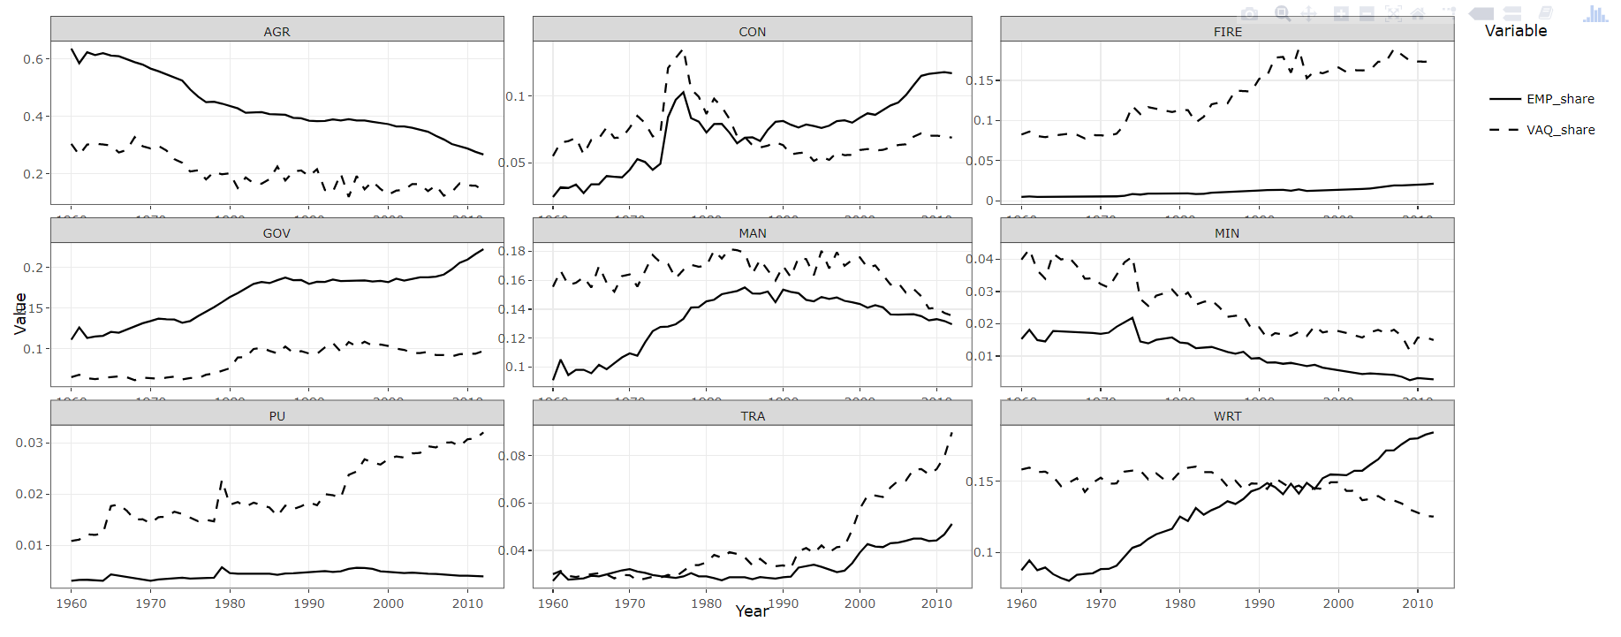

Increase in ptyq



Small Productivity gains in agriculture esp. since the 2000’s…needs a section

The sectors that are employing larger shares of labor force beyond agriculture: government services(+27%), construction, WRT, are performing below the average productivity since (by the 2000’s) they all using larger shares of labor force than their share-contributions to value added. The manufacturing sector that employed 4% more since the 60’s, has seen its relative productivity decreasing since the same years.

In terms of labor productivity, the manufacturing sector has lagged behind in comparison to other sectors: his relative productivity has been constantly decreasing similar to SSA (except form NGA), and opposed to what is happening in Europe and North America.

This trend in relative productivity means that pulling people out of manufacturing into more productive sectors like PU,MIN, TRA or FIRE will enhance overall productivity. However those sectors has little potential in absorbing labor force. Combined, they only employ 8 to 9% of working force.in morocco

1. But this low relative productivity is only in morocco: no not in value but in trends: we said hat manufacturing is nowhere the most productive sector its productivity is

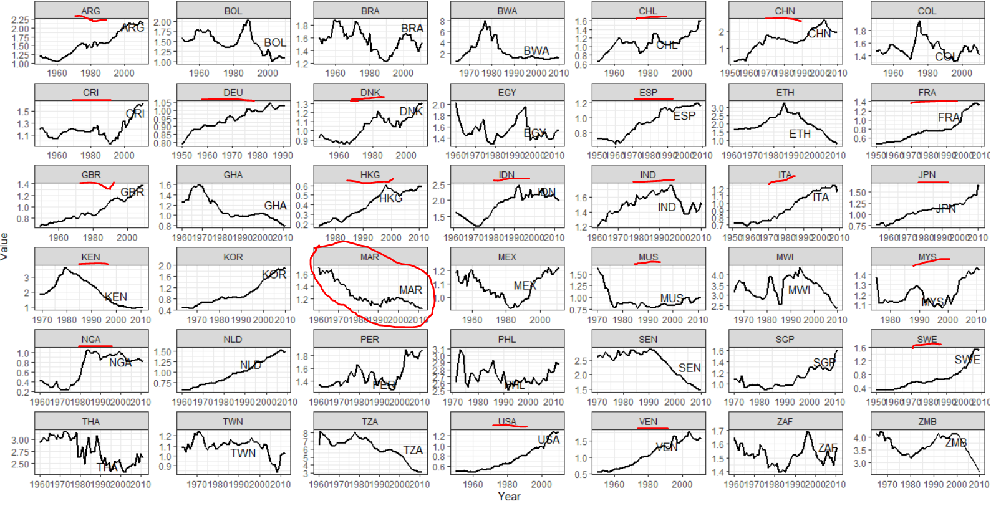



But it is the sector to which its is losing that is aberrant FIRE, that employ half what manuf is employing

1. **Since PU, and Mining sectors is employing only a very thin fraction of population as we can observe see in all countries see the brown/yellow in cluster analysis, It remains the FIRE and the Trade sectors**
2. ====================================================
3. PU+MIN+FIRE 194 195 196 197 198 199 200 201
4. ----------------------------------------------------
5. 1 ASI NA 0.04 0.03 0.04 0.05 0.07 0.09 0.1
6. 2 EUR 0.08 0.06 0.06 0.07 0.09 0.11 0.14 0.15
7. 3 LAM NA 0.05 0.05 0.06 0.07 0.08 0.09 0.11
8. 4 MAR NA NA 0.03 0.03 0.03 0.03 0.03 0.03
9. 5 MENA NA NA 0.02 0.02 0.03 0.04 0.05 0.05
10. 6 NAM NA 0.09 0.1 0.12 0.15 0.17 0.19 0.19
11. 7 SSA NA 0 0.03 0.03 0.03 0.03 0.04 0.05
12. ----------------------------------------------------

**5- Effets d’entrainements**

See the pairs plts of emp shares…if manuf is not entraining (fr) transport sector and construction: says nothing

See in cnss regions that has manuf( in what manufacturing) if they have externalities among other jobs**?**

Voir si Fire est diffus dans les regions ou non (non en tanzanie 😊)🡺voir cnss, maroc

**6- Structural change and human capital (as determiant of direction).**

Structural change is about direction: we are not only interested in how much sectors can contribute to overall productivity (the between component), but also to how much people they can absorb and at what conditions-wages-, for employment itself and wages are important dimensions for evaluating a structural change.

Morocco is one country where the pictures given by economy structure, and development if we look only at the shares of value added or to the structural change composition

DB Area Regioncode PPP Sector `1960` `1970` `1980` `1990` `2000`

1 GGDC MAR MENA LC FIRE 0.191 2.18 1.23 0.340 3.39

2 GGDC MAR MENA LC SUM 1.60 5.79 1.32 0.158 2.19

The fire sector is in fact the first contributor in structural change (in value added). However this sector is employing very little people-can we expand it and keep the high value added ?-

. Yet, after all, we are looking for sectors with “higher” productivity; however hence when we use the total contribution of the between component, , we are looking whether the direction it takes depends on fundamentals. like levels of education

**Stylized facts:**

**FIRE sector requires human capital.**

Can we hope that the services (fire) replace offer as many employment as manufacturing or can play an important role in the economy of high share of population (labor): the answer is yes, as we can see in the cluster analysis below, but only high income and developed countries that have this pattern (I mean those having absorbed the whole agricultural population)

In fact actually he is not employing much of Moroccan labor force, Morocco is I the tail of

It appears clearly that FIRE sector is demanding in terms of education at high and secondary levels specifically. (1st row)

Its productivity advantage vanishes with development and with accumulation of education (2nd row)

*And as we can expect education has little to do in determining the share of the sector in the total value added*, because its relative productivity is not only depending on how much it can absorb (which is determined by the education level of the offer of labor) but also and to a large extet to its productivity and the producvity of other sectors. In morocco for example,

Even if it employs little number of workers it contributes by more than 16%, being the largest sector in the economy in terms of value added.

This is because it is the one having the highest pty and not only on Morocco but I the world in PPP terms.

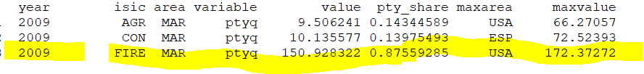

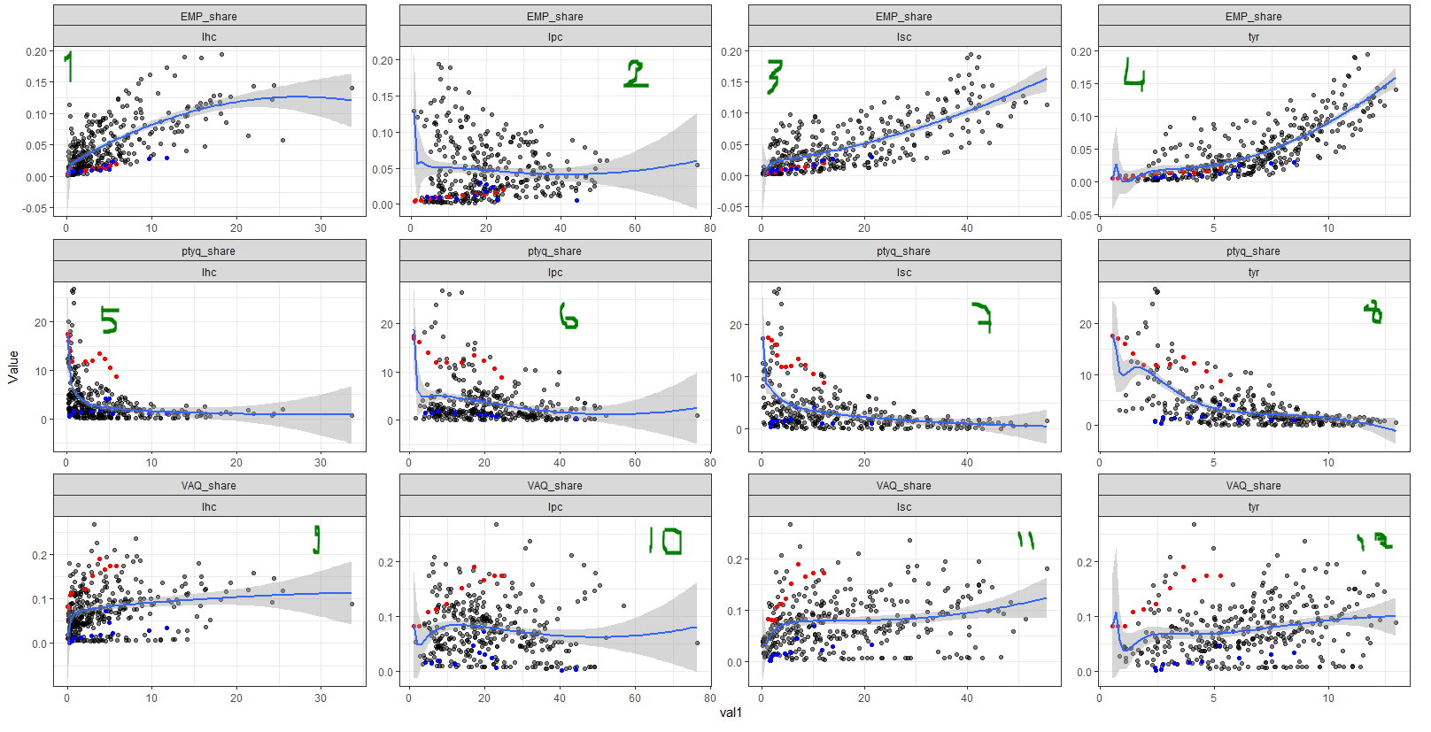

The question what are those graphs exclude, what they authorize:

1- it is impossible to have high productivity shares of fire sector (>5 times average pty) when more than 10%of population has completed higher education(lhc)

2-Except Morocco (see colors, his is the fucking outlier)-case 5

**Manufacturing requires no human capital**

There is a clear positive relationship between emp share and primary education completion, but no correlation elsewhere, the share of manufacturing value added and its relative productivity does not seem to be related to the level of education, as most fitting curves are horizontal.

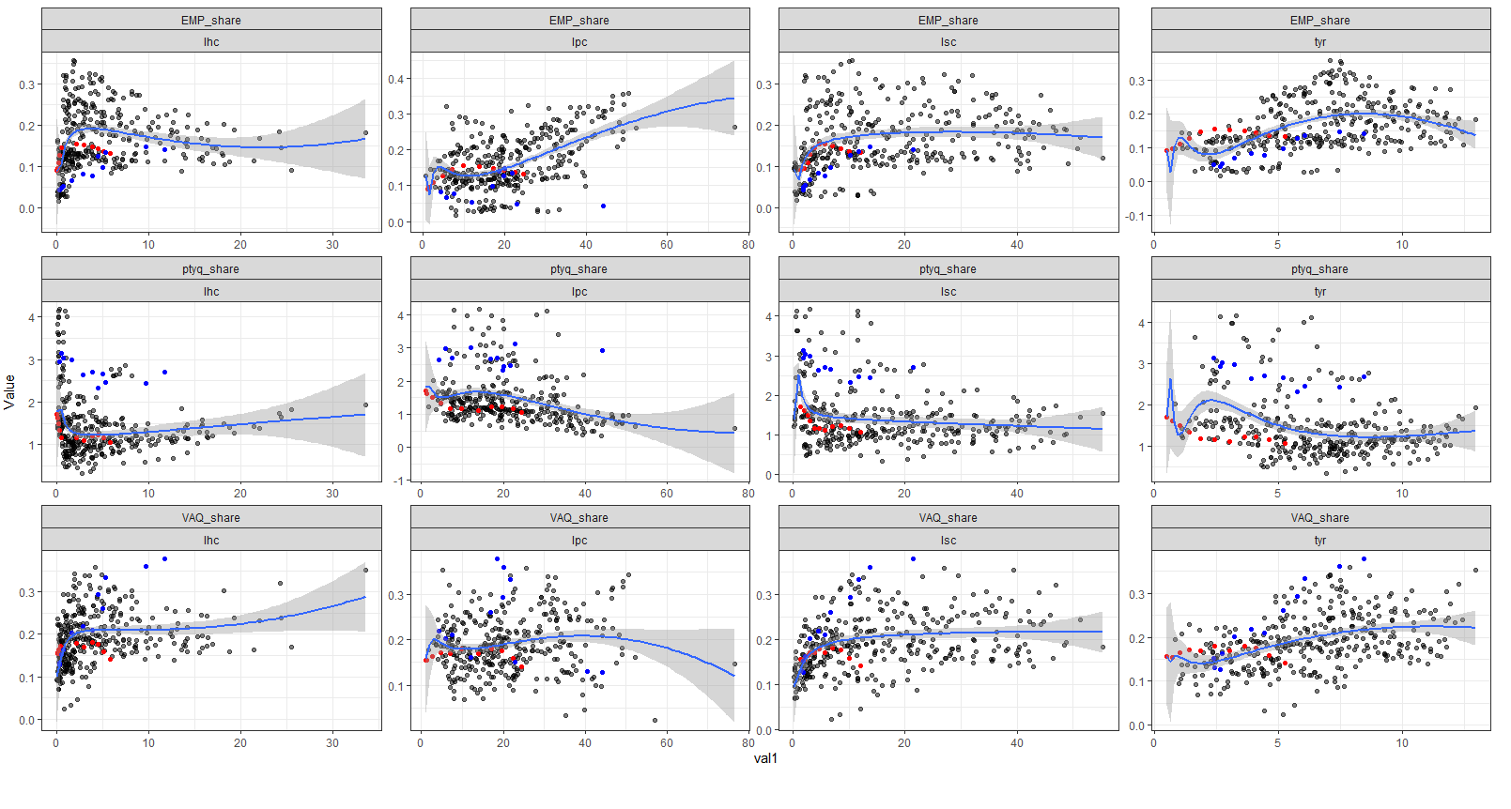

**Absolute productivity and education,**

No clear patterns except for Agriculture FIRE and SUM, the following table exhibits the correlation coefficients between Sectors productivity (in PPP) and education indicators, we only kept significant correlations (p-value<0.05)

============================================================================

Variable var1 AGR CON FIRE GOV MAN MIN OTH PU SUM TRA WRT

----------------------------------------------------------------------------

1 ptyq lhc 0.18 0.1 -0.19 0.09 0.17 0.02 0.16 0.28 0.22 -0.06 0.04

2 ptyq lpc 0.05 -0.06 0.04 0.04 0.04 -0.21 0 -0.1 0 -0.07 0.04

3 ptyq lsc 0.29 -0.04 -0.33 0 0.04 0.17 -0.07 0.04 0.14 -0.12 -0.07

4 ptyq tyr 0.4 0.05 -0.35 0.1 0.14 0.14 0.02 0.13 0.26 -0.07 -0.01

Its seems that agricultural sector is the only sector which productivity is affected by broad base education efforts.

**8- A geographical analysis.**

Use cnss data for geographical comparisons, wages, emloyment, number of firms and their evolutions…

**9-Morocco and wages**

**7-A cluster Analysis**

Cluster of employment:

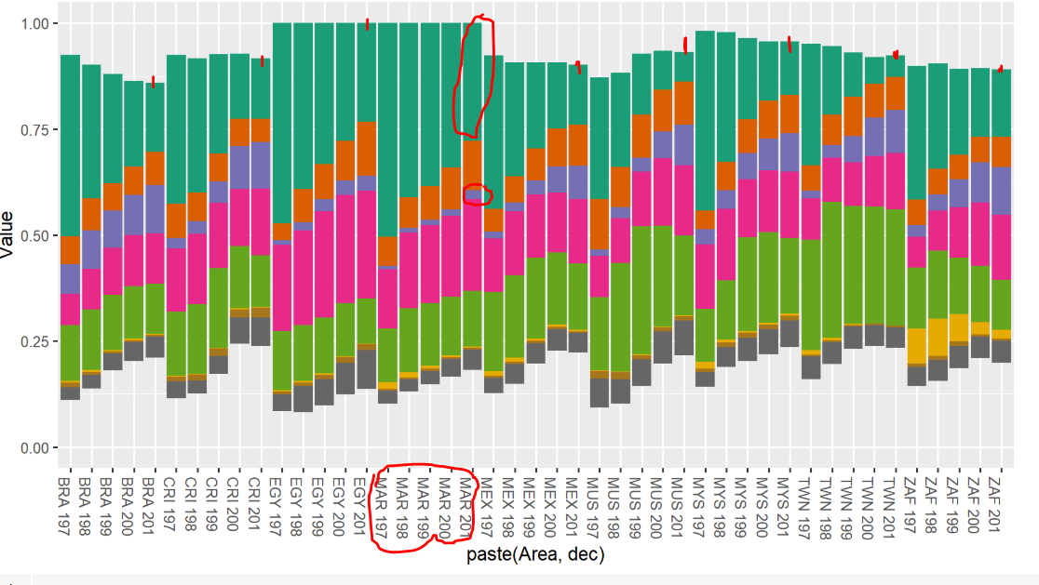

This is a composition fallacy: Morocco has the structure of much richer countries

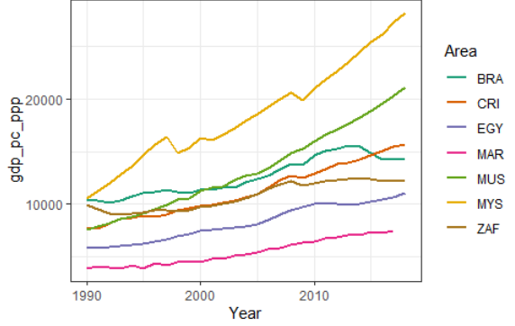

**Cluster of value added**

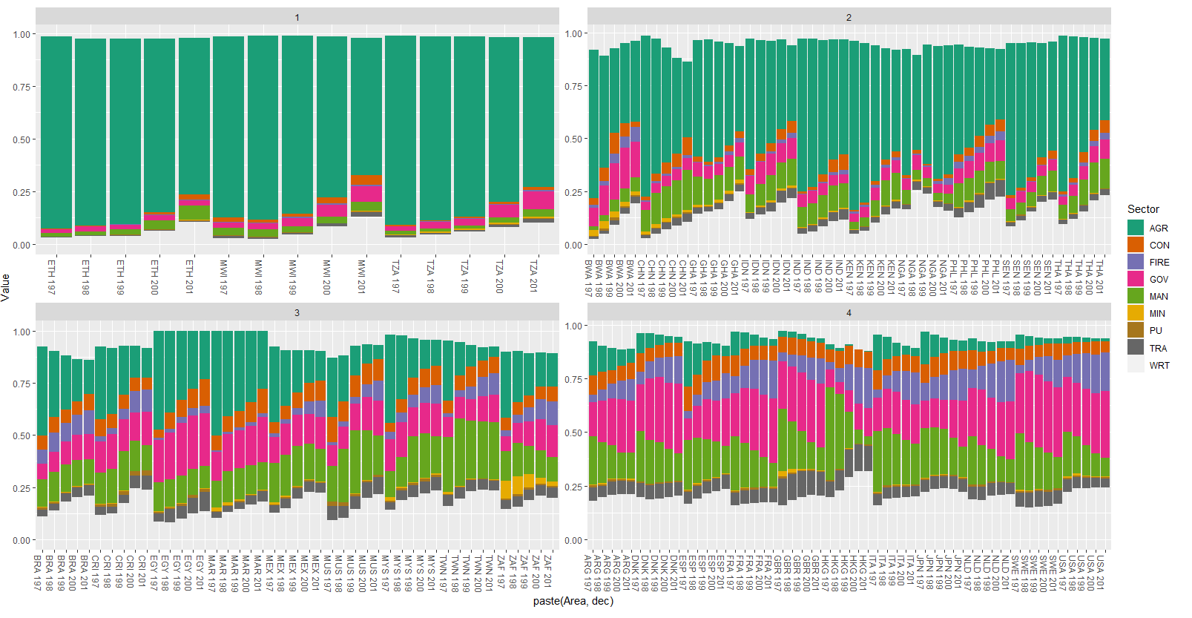

**9- DATA DEFINITIONS**



1. Caisse nationale de la sécurité sociale.
2. -growth rates of real GDP (compare GDP and total VA), real GDP, Investment (public, private)

   -Initial relative productivity log(1990-pty) vs change in employment share (circle size=initial employment)+geom_smooth (“lm”)---par pays

   -Plot productivity coefficient of variance vs average pty.

   -The ratio of productivities (between manufacturing and agriculture, etc.)

   -The structure of ownership (family vs formal// of companies/ by sector?)
3. Except India, Indonesia, china who are extremely rural Egypt (this one deindustrialised prematurely) and who where lagging behind by having 20% of labor force in agriculture more than the other countries who moved much of labor out of agriculture and to manufacturing.