Polytechnic Institute of Bragança
School of Technology and Management of Bragança (ESTiG)
Information Systems Course



Java/RMI Browser Project Report

Created by : Benarous Ahmed Omar farouq

Content Of the Report

1- Introduction
2-Development options
2.1 programming language used
2.2 builder used
2.3 IDE used
3-Development process
3.1 server
3.2 methodes
3.3 client
5-Conclusions

1- Introduction :

Remote method invocation, better known by the acronym RMI is programming interface (API) for theJava language that allows calling remote methods, on the principle of ORB .The use of this API requires the use of anRMI register on the remote machine hosting these objects that you want to call where they were registered. This programming interface is very often used in parallel with the JNDI directory APIor with the specification of EJB transactional distributed componentsof the Java language.

This library, which is standard in Java SE , allows communication over HTTP (or IIOP , since version 1.3 of JDK) between Java objects that are physically remote from each other, ie running on virtual machines separate java. RMI facilitates the development of distributed applications by masking the client / server communication to the developer.

This is a brief introduction to Java Remote Method Invocation (RMI). Java RMI is a mechanism that allows one to invoke a method on an object that exists in another address space. The other address space could be on the same machine or a different one. The RMI mechanism is basically an object-oriented RPC mechanism. CORBA is another object-oriented RPC mechanism. CORBA differs from Java RMI in a number of ways:
- CORBA is a language-independent standard.
- CORBA includes many other mechanisms in its standard (such as a standard for TP monitors) none of which are part of Java RMI.
- There is also no notion of an "object request broker" in Java RMI.

2-Development options

2.1 Programing language used is java :
Java is an object-oriented programming language created by James Gosling and Patrick Naughton , employees of Sun Microsystems , with the support of Bill Joy (co-founder of Sun Microsystems in 1982 ), officially introduced on23 mai 1995at SunWorld .
Sun was then acquired in 2009 by Oracle, which now owns and maintains java .
The particularity and the central purpose of Java is that the software written in this language must be very easily portable on several operating systems such as Unix , Windows , Mac OS or GNU / Linux , with few or no modifications, but which have the disadvantage of being heavier at runtime (in memory and processor time) because of its virtual machine. For this, various platformsand associated frameworks aim to guide, if not guarantee, this portability of applications developed in Java.

2.2 Builder Gradle Version 4.9:

Gradle is a production engine running on the Java platform. It allows to build projects in Java , Scala , Groovy or even C ++.
Gradle combines the strengths of Apache Maven and Apache Ant : it combines the use of conventions in the manner of Maven (convention rather than configuration) with the flexibility of Ant to describe the tasks of constructions, with a strong coherence in the interface of programming tasks.
Gradle allows you to write build tasks in a build file using the Groovy language. It is possible to import standard tasks which make it possible to build programs using one or several languages ,(Java, Groovy ...) or which allow to execute software engineering activities such as to execute the unit tests , to ensure the quality of the software. Code ( SonarQube , Checkstyle ) .

2.3 IDE Intilij jetbrains :

IntelliJ IDEA is a Java commercial IDE developed by JetBrains . It is frequently called by the simple name of "IntelliJ", "IDEA" or "IDJ".

Every aspect of IntelliJ IDEA is specifically designed to maximize developer productivity , some features of intilij :

Deep intelligence
After IntelliJ IDEA has indexed your source code, it offers a blazing fast and intelligent experience by giving relevant suggestions in every context: instant and clever code completion, on-the-fly code analysis, and reliable refactoring tools.

Out-of-the-box experience
Mission-critical tools such as integrated version control systems and a wide variety of supported languages and frameworks are all to hand — no plugin hassle included.

Smart code completion
While the basic completion suggests names of classes, methods, fields, and keywords within the visibility scope, the smart completion suggests only those types that are expected in the current context.

Framework-specific assistance
While IntelliJ IDEA is an IDE for Java, it also understands and provides intelligent coding assistance for a large variety of other languages such as SQL, JPQL, HTML, JavaScript, etc., even if the language expression is injected into a String literal in your Java code.

Productivity boosters
The IDE predicts your needs and automates the tedious and repetitive development tasks, so you can stay focused on the big picture.
3-Development process

as we know rmi had to be implemented in three parts server client methodes(interface +class) :

3.1 server :
first I had to create the server class tha contains all the information about the server wich is locations port etc and also I have made it in wich the user can set this informations as an inputs and also create a registry name under the name of “remoteObject” this name allows the user to find the server in the registry

manual to run the server :
first you have to go to the line 70 and customize the location of the server (in my case was linux )

// The location of the server files 'IMPORTANT CHANGE IT IF YOU DO NOT HAVE THIS PATH '
String serverpath ="/home/benarousfarouk/Desktop/OISD_Distributed_systesms/serverrmi";
and then follow this steps :
gradle server → write start and click enter → set the port number for example 1099 this will be used when you run the client → it will shows an message tell you tha the server is running

3.2 Create the methods (operations that the user can do in the server ) :

of course this part is devided into two parts the first one is to implement the interface that contains only the signature of the functions
the SECOND is To implement the class that contains this functions

Interface :

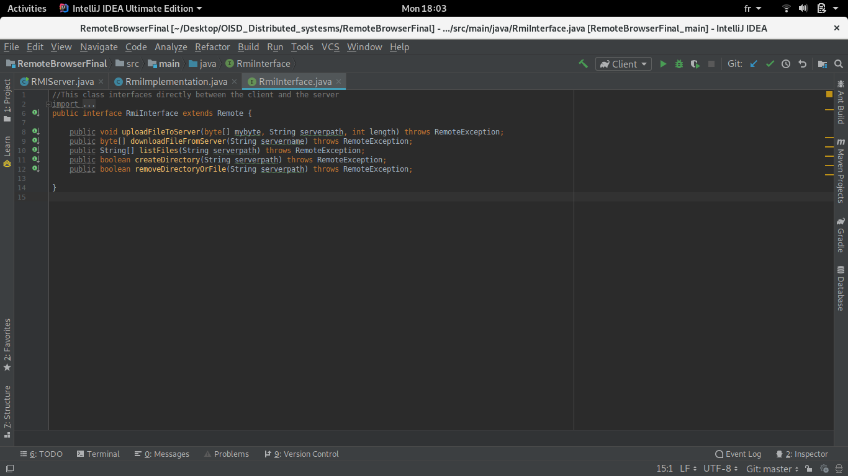

class :

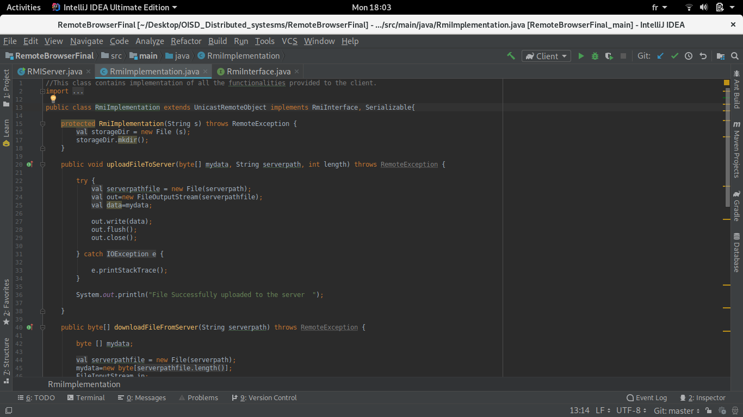
of course im not gonna go through the details because its just simple java code read it and you will understand

3.3 the client :
the client side was the most difficult part of the development first thing that tou should do is to go to the line 37 and change the gradle.proporties path because in my case was linux so you have to set it to mach with your os just go to the gradle/wrapper/gradle.properties and copy the full path

so the first operation that the user have to do is get the registryadress specified as an argument “gradle -pregistryadress = 192.x.y.z:1099 ” and when it get this adress it will conect to it through also the port specified whe the connection succeed now it will look for the “remote object ”(the server) in the registry
when it find it a message will be printed “Connected suceessfuly to the server”
when you arrive to this case you can user thr program as it shows through the messages (operations listed etc etc )

screenshot of the code :

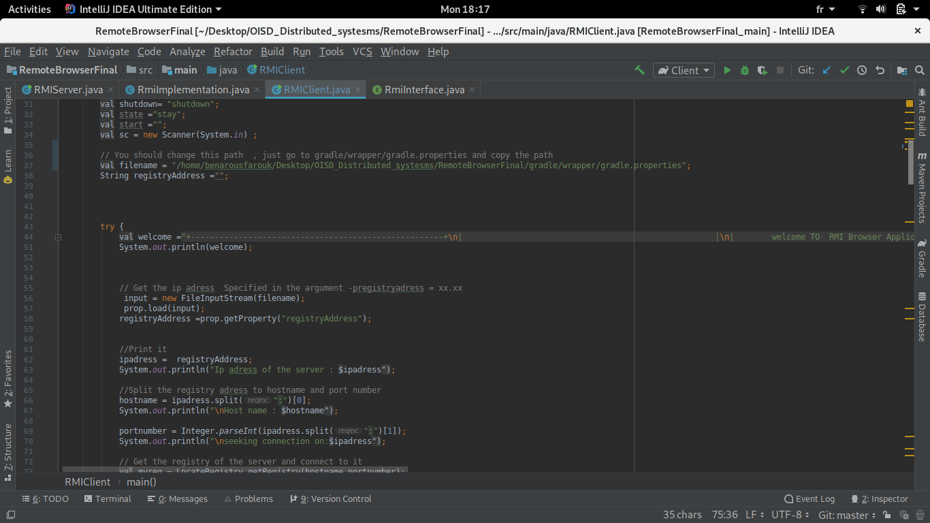
5-Conclusions
The goal of our mini project was to design and implement aRMI browser wich allows the users to access to a server and browse the files (list add delete .. .
As we all know This projec is just for acadimic purposes it cant be used or let’s say useful in realworld projects

Java RMI has recently been evolving toward becoming more compatible with CORBA. In particular, there is now a form of RMI called RMI/IIOP ("RMI over IIOP") that uses the Internet Inter-ORB Protocol (IIOP) of CORBA as the underlying protocol for RMI communication.

