Polytechnic Institute of Bragança
School of Technology and Management of Bragança (ESTiG)
Information Systems Course



AI Report
( Breast cancer Diognostics using Neural Network)

Teacher :Pedro João Soares Rodrigues

Created by : Benarous Ahmed Omar farouq

College year=2018/1019

Content Of the Report

1- Introduction
2-Used Tools
2.1 programming language used
2.2 Framework
2.3 ML model
3-Development process
5-Conclusions

1.Introduction
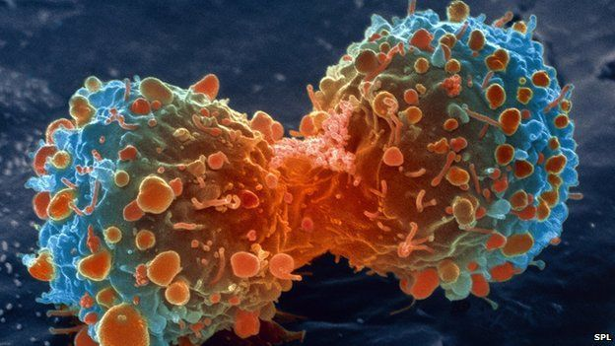

What Is Cancer ?
Cancer is the name given to a collection of related diseases. In all types of cancer, some of the body’s cells begin to divide without stopping and spread into surrounding tissues.
Cancer can start almost anywhere in the human body, which is made up of trillions of cells. Normally, human cells grow and divide to form new cells as the body needs them. When cells grow old or become damaged, they die, and new cells take their place.

Differences between Cancer Cells and Normal Cells ?
Cancer cells differ from normal cells in many ways that allow them to grow out of control and become invasive. One important difference is that cancer cells are less specialized than normal cells. That is, whereas normal cells mature into very distinct cell types with specific functions, cancer cells do not. This is one reason that, unlike normal cells, cancer cells continue to divide without stopping.
When Cancer Spreads ?
A cancer that has spread from the place where it first started to another place in the body is called metastatic cancer. The process by which cancer cells spread to other parts of the body is called metastasis.
Metastatic cancer has the same name and the same type of cancer cells as the original, or primary, cancer. For example, breast cancer that spreads to and forms a metastatic tumor in the lung is metastatic breast cancer, not lung cancer.
Under a microscope, metastatic cancer cells generally look the same as cells of the original cancer. Moreover, metastatic cancer cells and cells of the original cancer usually have some molecular features in common, such as the presence of specificchromoso mechanges.

artificial intelligence (AI)?
In computer science, artificial intelligence (AI), sometimes called machine intelligence, is intelligence demonstrated by machines, in contrast to the natural intelligence displayed by humans and other animals. Computer science defines AI research as the study of "intelligent agents": any device that perceives its environment and takes actions that maximize its chance of successfully achieving its goals. More specifically, Kaplanand Haenlein define AI as “a system’s ability to correctly interpret external data, to learn from such data, and to use those learnings to achieve specific goals and tasks through flexible adaptation”. Colloquially, the term "artificial intelligence" is applied when a machine mimics "cognitive" functions that humans associate with other human minds, such as "learning" and "problem solving"

Is it a boon or a bane to the future of human existence?,
is an ongoing debate.
The very idea to create an artificial intelligence is to make the lives of humans easier. Researchers of artificial intelligence want to bring in the emotional quotient to the machines along with the general intelligence.
Now as we have got an idea of what is AI (artificial intelligence), let us have a deeper understanding on things related to it as well.

Goals of AI:
The main AI goals are mentioned below

Creating expert systems:
The systems which are mentioned here should have the ability to display intelligent behaviour, learn, demonstrate, explain, and provide the users with best advices.

Implementing Intelligence in machines:
This intends to develop systems which can understand, think, learn, and behave like humans.

Applications of AI:
Artificial intelligence AI has a huge impact on many of the fields and some of them are mentioned below,

Gaming :
It plays an important role in strategic games like chess, tic tac toe etc. Here the machine should be able to think of multiple possible steps based on heuristic knowledge.

Natural Language Processing:
Able to communicate with the computers that understand human used natural language.

Expert Systems:
There are a few applications which incorporate machine, programming, and some special data to confer thinking and prompting. They give clarification and exhortation to the users.

Vision Systems:
These type of systems are able to understand, interpret and grasp visual input on the computer.
Ex: A spying plane or drone takes pictures, which are utilized to make sense of spatial data or guide of the zones and areas.

Speech Recognition:
You will find some systems which are able to understand the language which is used by humans and talk to them. They can even understand the slang, background noise, accent etc.

Handwriting Recognition:
This special software will be able to read the text written either by a pen or stylus on paper or screen respectively. It also understands the letter shapes and will convert it into editable text.

Intelligent Robots:
Robots are one of the best creation by humans. They can do multiple tasks within no time. Though they cannot be alternate to humans but are very efficient when doing any tasks.
They are comprised of sensors which detects few physical data like light, heat, temperature, movement, pressure etc just like humans. They also possess good processors and huge memory.
The best part about these systems is that they are adaptable to the environment around them.Now, let us look into the pros and cons of artificial intelligence.

AI Advantages | AI Disadvantages
Error Reduction | High Cost
Difficult Exploration | No Replicating Humans
Daily Application | No Improvement with Experience
Digital Assistants | No Original Creativity
Repetitive Jobs | Unemployment
Medical Applications
No Breaks
2. Used Tools
2.1 Why pyhton :
Why this trend ?
The Beginning
Back in 1991 when Guido van Rossum released Python as his side project, he didn’t expected that it would be the world’s fastest growing computer language in the near future. If we follow the trends, Python turns out as a goto language for fast prototyping.
if we look at the philosophy of the Python language, you can say that this language was built for its readability and less complexity. You can easily understand it and make someone understand very fast.
You can read it for yourself. Just use below command in Python
Also Python wins the hearts of the users. According to the Hackerrank 2018 developer survey(https://research.hackerrank.com/developer-skills/2018/) “JavaScript may be the most in-demand language by employers, but Python wins the heart of developers across all ages, according to our Love-Hate index.”
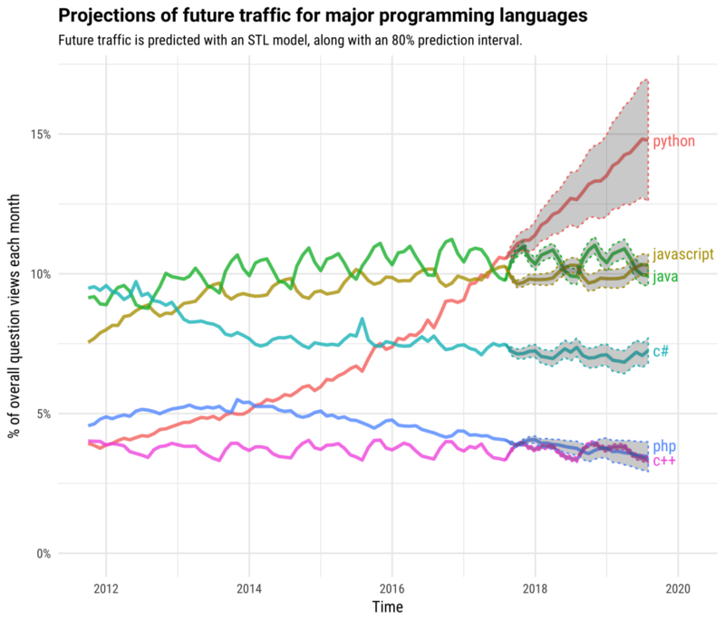

2.2 Why tensorFlow

Features of Tensorflow

Responsive Construct
With TensorFlow, we can easily visualize each and every part of the graph, which is not an option while using Numpy or SciKit.

Flexible
One of the very important Tensorflow Features is that it is flexible in its operability, meaning it has modularity and the parts of it that you want to make standalone it offers you that option.

Easily Trainable
It is easily trainable on CPU as well as GPU for distributed computing.

Parallel Neural Network Training
TensorFlow offers pipelining in the sense that you can train multiple neural networks and multiple GPUs, which makes the models very efficient on large-scale systems.

Large Community
Needless to say, if it has been developed by Google, there is already a large team of software engineers who work on stability improvements continuously.

Open Source
The best thing about this Machine Learning library is that it is open source, so anyone can use it as long as they have internet connectivity.
People manipulate the library in ways unimaginable and come up with an amazing variety of useful products. It has become another DIY community that has a huge forum for people getting started with it and for those who find it hard to use it or to get help with their work.

Feature Columns
Tensorflow has feature columns that could be thought of as intermediaries between raw data and estimators, therefore, bridging input data with your model.

The figure above describes how the feature column is implemented.

Availability of Statistical Distributions
The library provides distribution functions including Bernoulli, Beta, Chi2, Uniform, Gamma, which are important especially while considering probabilistic approaches such as Bayesian models.

Layered Components
TensorFlow includes functions like tf.contrib.layers that produce layered operations of weights and biases and also provide batch normalization, convolution layer, dropout layer, etc.
tf.contrib.layers.optimizers has optimizers such as Adagrad, SGD, and Momentum, which are often used to solve optimization problems for numerical analysis. It provides initializers with tf.contrib.layers.initializers used to maintain the gradient scale.
This type of TensorFlow Features makes it what it is today.

Visualizer (With TensorBoard)
With TensorBoard, you can inspect a totally different representation of a model and make the changed necessary while debugging it.

Event Logger (With TensorBoard)
Just like UNIX, where you use tail –f <log_file > to monitor the output of tasks at the cmd and do quick checks, logging events in Tensorflow allows doing the same by logging events and summaries from the graph and the output over time with TensorBoard.
As a as a conclusion to why tensor flow its is the only framework that gives you the ability of building models easily and in the same time allows you to access to the low level informations

2.3 why neural network
how to choose mL model ?
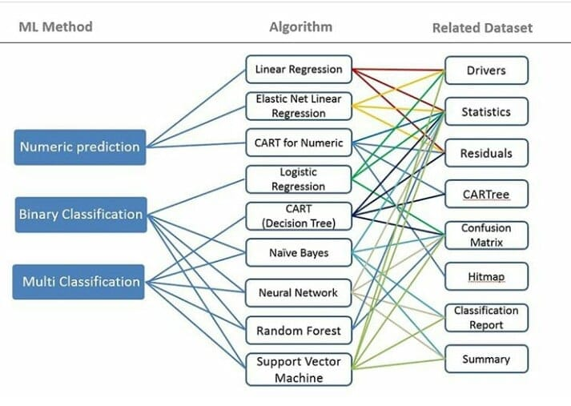
1. because my problem was an clasification Problem
2. most popular ML model
3 gave me better performance

3 .Development process
activation function : Sigmoid
Optimazer : RMS Optimazer based on gradient decent
number of inputs :12 wich are the features of the cells :
'radius ', 'texture', 'perimeter', 'area', 'smoothness ', 'compactness ', 'concavity', 'concave '' dimension', 'points', 'symmetry', 'fractal',

number of hidden layers : 4 in the best cases
number of output : 1 because its an binary clasification (Malignant begningn)
how the prediction works ?
So first to to train my model I have too a dataset bunch of examples of Cells whather its benign of malignant and train my model with it after I finished the training you get the Best optimal parameters to make the predictions

illustration of The Neural Network that I have built
fractl
dimension
symmetry
points
concave
concavity
compactness
smoothness
Sigmoid
Sigmoid
Sigmoid
Sigmoid
OutPut
Benign
Melignant
1
0

4. Conclusion

As an conclusion of my work i’m gonna just mention few stuff that I took from this experience
1. best programming framework for Machine learning Python
2. the best online course to get started with ML : Machine learning for datascience taught by andrew-ng (nicknamed Leader of IA) Stanford university
3 latest payper of Machine learning :
Residual neural network (microsoft ) showed best performance in the image recognition

Neural Differential Equations submitted by reaserchers of toronto wich can choose its own depth they treat NN as a same block not that the clasical idea that it is a diffe rent block of operations

4. my opinion about AI f its good or bad for the future : I will summarize it in just few words I think that AI gonna grow more in the next few years and its gonna be running our daily life and in the other side of course its gonna be used for bad purposes like creating an smart viruses hack software …..

so as final word for this i’m gonna say that It doesn’t depends AI it self to say if its good or bad it depends on how we use it and for what we use it , if we want to make an analogy we could say that AI its like FIRE you can be smart it can give you warmth but you could be stuped and it can Burn You (Over use)

