**Output:**

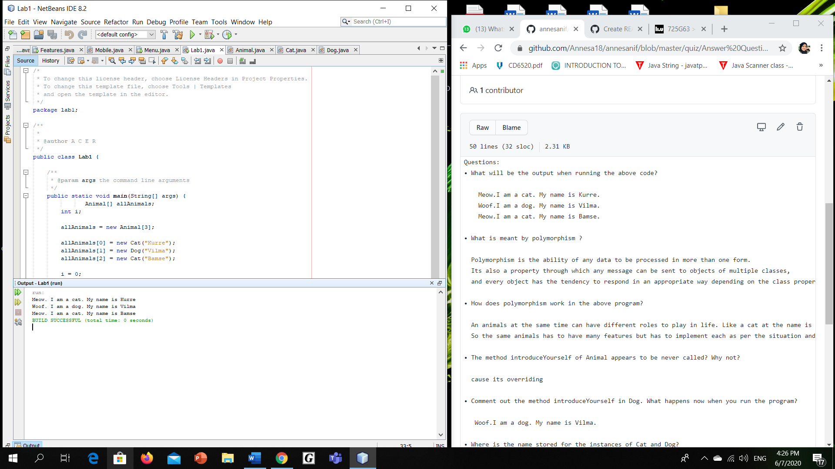

**Put also this class in its own file, which therefore should be named Lab1Stage1.java  
Questions:**  
**• What will be the output when running the above code?**

Meow. I am a cat. My name is Kurre

Woof. I am a dog. My name is Vilma

Meow. I am a cat. My name is Bamse

**• What is meant by polymorphism?**

**-** Polymorphism means "many forms", and it occurs when we have many classes that are related to each other by inheritance. Like we specified in the previous chapter; Inheritance lets us inherit attributes and methods from another class. Polymorphism uses those methods to perform different tasks.

**• How does polymorphism work in the above program?**

-When in the class lab1, we call method introduceYourself(), but it won’t run the method n the parents class. But, it will run the method introduceYourself() in each class.

**• The method introduceYourself of Animal appears to be never called? Why not?**

**-**because the method introduceYourself() in class Dog and Cat will be override in method introduceYourself() in the class Animal which is parent class. **• Comment out the method introduceYourself in Dog. What happens now when you run the program?**

**-** Woof. I am a dog. My name is Vilma

**• Where is the name stored for the instances of Cat and Dog? (In what / which classes did you put the instance variable that refers to the name of the animal? Both Cat and Dog, or just in Animal?)**

**-**both class. I put the instance variable of name in both cat and dog class.

**• How does the code in the test program work?**

-made an array called animal and set the array size to 3.

-then, fill the array with calling dog and cat classes with their name in the constructor.

-initialize integer i to 0.

-while i less than the length pf allAnimals array, it will call the method introduceYourself() in each animal child in class array then Add +1 to i.

-repeat until value of I is greater than the length of the allAnimals array and stop.

**• How does an array work?**

-while i less than the length pf allAnimals array, it will call the method introduceYourself() in each animal child in class array then Add +1 to i.

-repeat until value of I is greater than the length of the allAnimals array and stop.

**• In the above programs we have used a while loop to step through the array and to get information about the animals. But there is a more appropriate loop statement here. What is it?**

for loop.

for (int i=0; i<animals.length; i++);