**HEALTH BUDDY-ANDROID**

**ABSTRACT**

"Health Buddy" is a comprehensive Android application designed to assist users in managing their health and wellness. The app offers essential features like user registration and login for personalized health tracking. Users can input their diet information, calculate their Body Mass Index (BMI), and monitor their body water levels, all through easy-to-use interfaces. The app also suggests fitness routines based on the user’s health data and provides insights into potential vitamin deficiencies. These personalized health recommendations empower users to make informed decisions about their wellness. The application offers a secure and intuitive experience with a seamless logout feature, ensuring user privacy and data security. By providing useful health tools and guidance, "Health Buddy" aims to promote a healthier lifestyle for all users.

**Keywords:** Health app, BMI calculator, Body water level, Fitness suggestions, Vitamin deficiency, User registration, User login, Android app, Health monitoring, Wellness, Personalized recommendations, Logout, Data security, Android development.

**STATEMENT ABOUT THE PROBLEM**

The Managing personal health through manual processes or multiple separate apps can be inefficient and overwhelming. Individuals often struggle to maintain accurate records of their diet, exercise, and health metrics, leading to inconsistent tracking and potential inaccuracies. There is also a lack of personalized guidance for managing fitness, nutrition, and vitamin deficiencies, which can hinder users from making informed decisions about their health. This results in a need for an integrated, easy-to-use platform that consolidates all health tracking tools and provides real-time insights and recommendations. The "Health Buddy" app aims to address these challenges by offering a unified solution for managing health effectively.

**WHY IS THE PARTICULAR TOPIC CHOSEN?**

The topic of "Health Buddy" was chosen due to the increasing need for accessible and personalized health management tools in today’s fast-paced lifestyle. Many individuals struggle to track their diet, fitness, and health metrics consistently, often using multiple disconnected methods or apps. By consolidating these features into a single, user-friendly platform, "Health Buddy" aims to simplify health management and provide actionable insights. This app not only empowers users to make informed decisions about their well-being but also promotes healthier lifestyles. With rising awareness of health issues and a focus on preventive care, this solution is both relevant and timely.

**SCOPE**

The scope of "Health Buddy" is to offer a suite of tools that users can utilize to track and improve their health. The application will support key features such as user registration and login, diet logging, BMI and body water level calculators, personalized fitness suggestions, and an educational section on vitamin deficiencies. It will be available on Android devices and will be designed to ensure ease of use, personalization, and data privacy. The app will cater to individuals of all fitness levels and will provide health insights that are both actionable and practical for everyday use.

**OBJECTIVE OF THE PROJECT:**

The objective of the "Health Buddy" Android application is to provide users with a comprehensive platform for managing their health and wellness. The app aims to help users track their diet, calculate important health metrics like BMI and body water levels, and receive personalized fitness suggestions based on their health data. Additionally, it aims to educate users about potential vitamin deficiencies and offer actionable insights to improve their overall well-being. By integrating these features into a user-friendly application, "Health Buddy" strives to make health management more accessible and convenient for everyone.

**EXISTING SYSTEM:**

In currently, individuals track their health metrics manually, often using paper logs or separate apps for diet, exercise, and health tracking. BMI and body water levels are typically calculated using online calculators or by consulting health professionals. Fitness routines are generally based on personal research or generic recommendations, while vitamin deficiencies are self-diagnosed through online sources. This manual approach is time-consuming, inconsistent, and lacks personalized guidance for individuals.

**DISADVANTAGES:**

* Manual tracking of health data is slow and requires significant effort to update and maintain records.
* Current methods fail to offer tailored fitness or dietary suggestions based on individual health data.
* Without real-time calculations and feedback, users may rely on inaccurate information or generic advice, leading to suboptimal health management.

**PROPOSED SYSTEM**

The proposed system for "Health Buddy" will consist of an Android application developed using Kotlin, with a secure backend for user authentication, data storage, and retrieval. Upon registering or logging in, users will have access to tools that allow them to log their daily diet and physical activity. The BMI and body water level calculators will provide real-time health insights based on user input. Additionally, the app will suggest personalized fitness routines and identify potential vitamin deficiencies through simple questionnaires or data analysis. The system will also ensure that user data is securely stored and that their privacy is protected with a straightforward logout option..

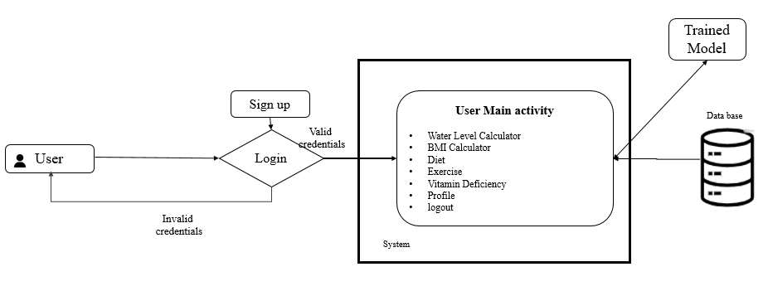

**ADVANTAGES:**

* The app offers customized fitness suggestions, diet tracking, and health insights based on user data.
* Designed with a user-friendly interface, the app makes it simple for individuals of all ages to use and navigate.
* The app ensures user data security with a secure login system and protects sensitive information.

**SOFTWARE FRONT END REQUIREMENTS**

# **H/W CONFIGURATION:**

* Processor - I3/Intel Processor
* RAM - 8 GB
* Hard Disk - 1TB

**S/W CONFIGURATION:**

* Operating System - Windows 10
* JDK - java
* Plugin - Kotlin
* SDK - Android
* IDE - Android studio
* Database` - MY SQL

**MODULES/IMPLEMENTATION**

**USER:** The User Registration and Login module ensures secure user authentication and personalized data access. The Diet Tracker module allows users to log their daily meals and monitor nutritional intake. The BMI and Body Water Level Calculators provide instant feedback on critical health metrics. The Fitness Suggestions module offers personalized workout routines based on user profiles, while the Vitamin Deficiency Checker helps identify potential nutritional gaps. Finally, the Logout module ensures user privacy by securely ending sessions.