

M FARRUKH MUBEEN
01-1342451-033- BSCS-2B

Project report

Subject: Object oriented programming Lab
Submitted to: Mam SAIMA JAVAD and Sir Abdul Raheem
Department of Computer Science

Learning Management System (LMS) Project Report

1. Problem Statement
The objective of this project is to design and implement a console-based Learning Management System (LMS) using Object Oriented Programming principles in C++. The system facilitates secure login for Admin, Faculty, and Students, enabling efficient management of academic activities such as subject allocation, student enrollment, attendance management, lecture notes, assignments, scores, and feedback. The project addresses the need for a centralized academic management platform.

2. Object-Oriented Programming Concepts Used

Encapsulation:
Each class (Student, Faculty, Subject, Admin, Portal) encapsulates its data members and related methods.
Abstraction:
Abstract base class Person provides a common interface using virtual functions.
Inheritance:
Student, Faculty, and Admin classes inherit from the Person base class.
Polymorphism:
The showMenu() function is overridden in derived classes to provide role-specific behavior.
Modularity:
The system is divided into multiple classes handling distinct responsibilities.
File Handling:
Persistent storage is implemented using file streams (ifstream, ofstream).

3. System Overview
The LMS is a menu-driven console application with the following features:
- Secure login for Admin, Faculty, and Students
- Student enrollment in subjects
- Faculty allocation to subjects
- Attendance marking and tracking
- Uploading and viewing lecture notes and tasks
- Score management and feedback system
- Persistent data storage using text files

4. Classes Used and Their Responsibilities
Person:
Abstract base class handling authentication and defining a common interface.
Student:
Stores student profile, registered subjects, attendance, scores, and feedback.
Faculty:
Manages allocated subjects, attendance, notes, tasks, and student scores.
Admin:
Controls system-level operations including adding/removing students, faculty, and subjects.
Subject:
Handles subject-related data such as enrolled students, attendance, notes, tasks, reviews, and scores.
Portal:
Acts as the central controller managing all system operations and data persistence.

5. Key Functions
Authentication Functions:
- verifyAuth(), setAuth()
Student Functions:
- showMenu(), addSubLocal(), removeSubLocal()
Faculty Functions:
- takeAttendance(), addNote(), addTask(), setScore()
Admin Functions:
- addStudent(), removeStudent(), addFaculty(), addSubject(), assignSub()
Portal Functions:
- saveAll(), loadAll(), login(), enrollStudent()

6. Class Relationships
Inheritance:
Student, Faculty, and Admin inherit from Person.
Association:
Portal manages Student, Faculty, Subject, and Admin objects.
Aggregation:
Subjects aggregate students and faculty allocations.

7. User Interface Development using Qt
Although the current implementation is console-based, the system design supports GUI integration using Qt.
Qt Features Considered:
- Login screen using QLineEdit and QPushButton
- Dashboard using QTableWidget
- Course views using QTabWidget
- File access using QFileDialog
- Notifications using QMessageBox
Qt Integration:
Backend logic from classes such as Student, Faculty, and Subject can be connected to Qt slots, allowing real-time data visualization and interaction.

8. UML Diagram:
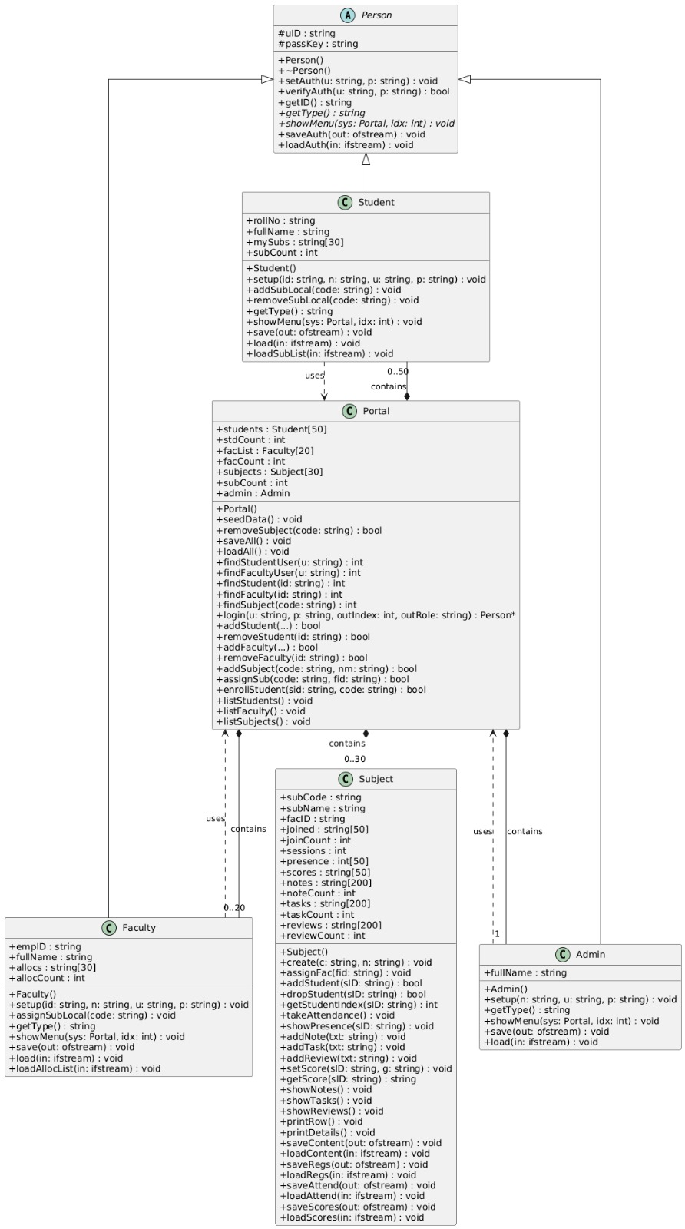

9. GITHUB:
GitHub: https://github.com/farrrukhmobeen01-tech/LMS-PROJECT

10. Conclusion
The LMS project successfully demonstrates the practical application of Object Oriented Programming concepts in C++. The system provides a structured, modular, and extensible solution for academic management. With Qt-based GUI integration, the system can be enhanced into a full-scale application suitable for real-world deployment.

